
KHYBER PAKHTUNKHWA INTEGRATED TOURISM DEVELOPMENT PROJECT
(KITE - PMU C&WD)

CONSTRUCTION ACTIVITIES IN SELECTED SEVEN ARCHEOLOGICAL SITES IN SIX DISTRICTS OF KHYBER PAKHTUNKHWA

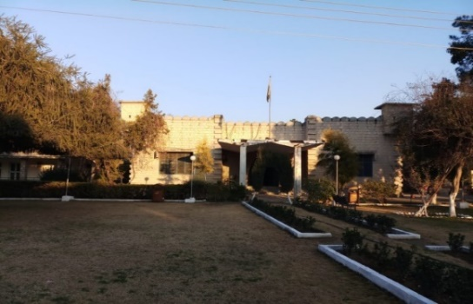  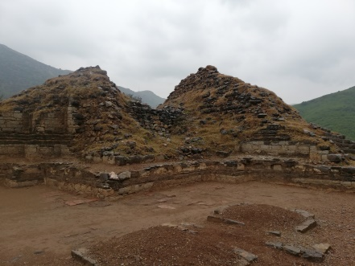 | 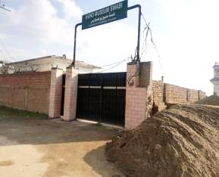  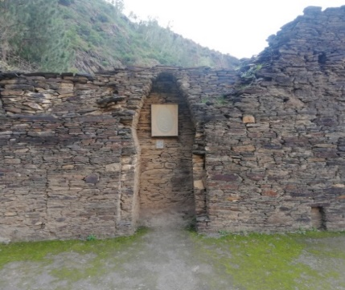 | 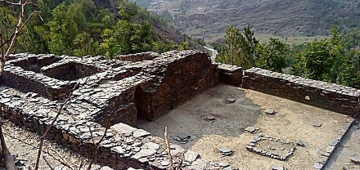  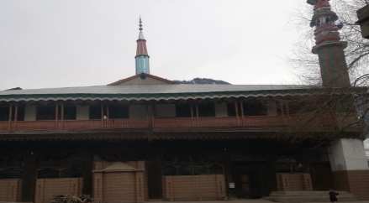  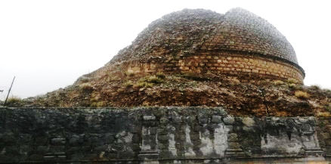
ENVIRONMENTAL AND SOCIAL MANAGEMENT PLAN (ESMP)

SEPTEMBER, 2021

Construction Activities in Selected Seven Archeological Sites in Six Districts of Khyber Pakhtunkhwa

ENVIRONMENTAL AND SOCIAL MANAGEMENT PLAN (ESMP)

TABLE OF CONTENTS

Page No.

TABLE OF CONTENTS i
LIST OF TABLES vi
LIST OF FIGURES vii
LIST OF ABBREVIATONS viii

EXECUTIVE SUMMARY ES-1

1 INTRODUCTION 1-1
1.1 GENERAL 1-1
1.2 PROJECT BACKGROUND 1-1
1.3 OBJECTIVES OF ESMP 1-3
1.4 THE PROPONENT 1-4
1.5 APPROACH & METHODOLOGY TO WORK 1-4
1.5.1 Approach 1-4
1.5.2 Methodology 1-4
1.6 STRUCTURE OF REPORT 1-6
1.7 INCLUSION OF SAFEGUARDS DOCUMENTS IN THE BIDDING DOCUMENTS 1-7

2 LEGAL AND ADMINISTRATIVE FRAMEWORK 2-1
2.1 GENERAL 2-1
2.2 APPLICABILITY OF WORLD BANK SAFEGUARD POLICIES 2-1
2.3 OTHER RELEVANT WORLD BANK GUIDELINES AND POLICIES 2-2
2.3.1 Guidance Note on Labor Influx 2-2
2.3.2 Environmental, Health & Safety Guidelines 2-2
2.3.3 World Bank Group Gender Strategy (2016-2023) 2-2
2.4 KEY NATIONAL AND PROVINCIAL LAWS, REGULATIONS AND POLICIES 2-3
2.4.1 National Laws, Regulations and Policies 2-3
2.5 PROVINCIAL LAWS, REGULATIONS AND POLICIES 2-8
2.5.1 KP Environmental Protection Act, 2014 2-8
2.5.2 KP Tourism Policy, 2015 2-8
2.5.3 KP Tourism Act, 2019 2-9
2.5.4 KP Wildlife & Biodiversity Act, 2015 2-9
2.5.5 KP Forest Ordinance 2002 2-9
2.5.6 Khyber Pakhtunkhwa Antiquities Act, 2016 2-9
2.5.7 KP Climate Change Policy 2016 2-10
2.5.8 Culture Policy, Khyber Pakhtunkhwa, 2018 2-10
2.5.9 KP Commission on Status of Women 2-10
2.5.10 National Disaster Management Act, 2010 2-10
2.5.11 Khyber Pakhtunkhwa Water Act, 2020 2-11
2.6 APPLICABLE INTERNATIONAL CONVENTIONS 2-11
2.6.1 Convention on Biological Diversity, 1997 2-11
2.6.2 United Nations Framework Convention on Climate Change, (1994) 2-11
2.6.3 Sustainable Development Goals (SDGs) 2-11
2.7 ADMINISTRATIVE FRAMEWORK 2-12

3 DESCRIPTION of subprojects 3-1
3.1 PROJECT OBJECTIVE 3-1
3.2 PROJECT ADMINISTRATIVE JURISDICTION 3-1
3.3 PROJECT IMPLEMENTATION SCHEDULE 3-1
3.4 LOCATION AND ACCESSIBILITY OF THE PROJECT AREA 3-1
3.5 PROJECT COMPONENTS 3-1
3.6 WORKFORCE REQUIREMENT 3-4
3.7 SOURCE OF WATER 3-4
3.8 EXPECTED EQUIPMENT’S FOR CONSTRUCTION 3-4
3.9 CONSTRUCTION CAMPS 3-4
3.10 CONSTRUCTION METHOD 3-5

4 DESCRIPTION OF THE ENVIRONMENT 4-1
4.1 GENERAL 4-1
4.2 DELINEATION OF AREA OF IMPACT 4-1
4.3 PHYSICAL ENVIRONMENT 4-1
4.4 HARIPUR DISTRICT 4-2
4.4.1 Topography 4-2
4.4.2 Soil 4-2
4.4.3 Geology 4-2
4.4.4 Seismicity 4-2
4.4.5 Water Resources 4-6
4.4.6 Solid Waste and Sewerage System 4-6
4.5 LOWER DIR DISTRICT 4-8
4.5.1 Physiography & Topography 4-8
4.5.2 Geography 4-8
4.5.3 Seismology 4-8
4.5.4 Hydrology 4-12
4.6 SWABI DISTRICT 4-12
4.6.1 Topography 4-12
4.6.2 Geology 4-15
4.6.3 Soil 4-17
4.6.4 Seismology 4-17
4.6.5 Surface Water Hydrology and Drainage 4-17
4.6.6 GROUND WATER 4-17
4.7 MARDAN DISTRICT 4-20
4.7.1 Physiography 4-20
4.7.2 Topography 4-20
4.7.3 Regional Geology 4-20
4.7.4 Soil 4-24
4.7.5 Seismology 4-24
4.7.6 Streams and Rivers 4-24
4.8 KHYBER DISTRICT 4-27
4.8.1 Topography 4-27
4.8.2 Geology 4-27
4.8.3 Soil 4-27
4.8.4 Seismology 4-27
4.8.5 Surface Water Hydrology and Drainage 4-31
4.8.6 Ground Water 4-31
4.9 SWAT DISTRICT 4-33
4.9.1 Topography 4-33
4.9.2 Geology 4-33
4.9.3 Seismicity 4-33
4.9.4 Surface water 4-40
4.9.5 Climate 4-43
4.9.6 Landuse 4-46
4.10 ECOLOGICAL ENVIRONMENT 4-46
4.10.1 Kalam Mosque Site 4-46
4.10.2 Odigram Mosque Site 4-55
4.10.3 Bhamala Site, Haripur 4-58
4.10.4 Hund Museum (District Swabi) and Mardan Museum (District Mardan) Site 4-60
4.10.5 Chakdara Museum, Dir Lower Site 4-62
4.11 SOCIO-ECONOMIC ENVIRONMENT 4-64
4.11.1 District Mardan 4-65
4.11.2 District Sawat 4-66
4.11.3 District Swabi 4-67
4.11.4 District Haripur 4-68
4.11.5 Khyber District 4-69
4.11.6 District Lower Dir 4-69
4.11.7 Common Characteristic in all the Districts 4-70

5 PROJECT ALTERNATIVE 5-1
5.1 GENERAL 5-1
5.2 ALTERNATIVE I: NO PROJECT OPTION 5-1
5.3 ALTERNATIVE II: CONSTRUCTION ALTERNATIVE 5-1

6 Public Consultation and Information Disclosure 6-1
6.1 GENERAL 6-1
6.2 OBJECTIVES AND PRINCIPLES OF CONSULTATION 6-1
6.3 PROJECT STAKEHOLDERS 6-3
6.4 FORUMS CONSULTED 6-3
6.5 APPROACH ADOPTED FOR THE CONSULTATION 6-4
6.6 INFORMATION DISSEMINATED 6-4
6.7 STAKEHOLDERS CONCERNS TOWARDS THE PROJECT 6-4

7 potential ENVIRONMENTAL IMPACTS AND MITIGATION MEASURES 7-1
7.1 GENERAL 7-1
7.2 NOTION OF SIGNIFICANCE 7-1
7.3 DELINEATION OF AREA OF INFLUENCE 7-1
7.4 POTENTIAL POSITIVE IMPACTS 7-2
7.5 POTENTIAL ENVIORNEMNTAL IMPACTS AND MITIGATION MEASURES 7-2
7.6 POTENTIAL ENVIRONEMNTAL IMPACTS DURING PRE-CONSTRUCTION PHASE 7-2
7.6.1 Technical Design and Layout Planning 7-2
7.6.2 Drinking Water Contamination 7-3
7.6.3 Drainage 7-3
7.6.4 Seismology 7-4
7.6.5 Electircal Hazards 7-4
7.6.6 Ecological Impacts 7-5
7.7 POTENTIAL ENVIRONEMNTAL IMPACTS DURING CONSTRUCTION PHASE 7-5
7.7.1 Soil Erosion and Contamination 7-5
7.7.2 Excavation of Earth 7-6
7.7.3 Surface and Groundwater 7-6
7.7.4 Traffic Issues 7-8
7.7.5 Air Quality 7-8
7.7.6 Noise/Vibration 7-10
7.7.7 Borrow Areas 7-11
7.7.8 Construction Camps / Camp Sites 7-11
7.7.9 Wastewater Generation at Construction Camps 7-12
7.7.10 Solid Waste (Construction, Municipal and Hazardous Waste) 7-15
7.7.11 Resource Conservation 7-16
7.7.12 Natural and Man-Made Disasters 7-17
7.7.13 Ecological Environment 7-17
7.7.14 Disturbance to Wildlife 7-18
7.8 POTENTIAL ENVIRONEMNTAL IMPACTS DURING OPERATIONAL PHASE 7-18
7.8.1 Landscape 7-18
7.8.2 Air Quality 7-19
7.8.3 Noise 7-19
7.8.4 Solid Waste Generation 7-20
7.8.5 Road Safety 7-20
7.8.6 Drinking Water Quality 7-21
7.8.7 HSE Considerations 7-21
7.8.8 Soil Erosion and Contamination 7-22
7.8.9 Ecological Impacts 7-22
7.9 POTENTIAL Social Impacts AND MITIGATION MEASURES 7-22
7.10 POTENTIAL Social Impacts during pre-construction Phase 7-22
7.10.1 Land Acquisition, Resettlement and Compensation 7-22
7.10.2 Public Utilities 7-23
7.11 POTENTIAL SOCIAL IMPACTS DURING CONSTRUCTION PHASE 7-24
7.11.1 Accessibility Issue 7-24
7.11.2 Community Health and Safety 7-24
7.11.3 Occupational Health and Safety 7-26
7.11.4 Coronavirus Disease (COVID-19) 7-27
7.11.5 Labor Influx 7-28
7.11.6 Gender Issues 7-30
7.12 POTENTIAL SOCIAL IMPACTS DURING OPERATIONAL PHASE 7-30
7.12.1 Traffic Issues during Peak Seasons 7-30
7.12.2 Employment Opportunities 7-31
7.12.3 Change in Land Value 7-31
7.12.4 Economic Boost 7-31

8 environmental and Social management Plan 8-1
8.1 GENERAL 8-1
8.2 INCLUSION OF ESMP IN BIDDING/ CONTRACT DOCUMENTS 8-1
8.3 INSTITUTIONAL ARRANGEMENTS 8-1
8.3.1 Directorate of Archaeology and Museums and C&WD PMU 8-4
8.3.2 Environmental and Social Safeguard Unit (ESSU) – PMU C&WD 8-4
8.3.3 Supervisory Consultant 8-5
8.3.4 Contractors 8-5
8.3.5 Monitoring and Evaluation Consultant (MEC) 8-5
8.4 ENVIRONMENTAL MANAGEMENT 8-5
8.4.1 Mitigation Plans 8-5
8.4.2 Project and Site-Specific Management Plan 8-6
8.5 ENVIRONMENTAL AND SOCIAL MITIGATION AND MONITORING PLAN 8-6
8.6 MONITORING PLAN 8-20
8.6.1 Monitoring Mechanism 8-20
8.6.2 Monitoring Plan 8-20
8.7 TREE PLANTATION 8-24
8.8 CHANGE MANAGEMENT PLAN 8-24
8.8.1 Category ‘A’ Change 8-24
8.8.2 Category ‘B’ Change 8-24
8.8.3 Category ‘C’ Change 8-24
8.9 CAPACITY BUILDING/STRENGTHENING 8-25
8.10 AUDITS AND ANNUAL REVIEW OF ESMP 8-26
8.11 GRIEVANCES REDRESS MECHANISM 8-26
8.11.1 Composition of GRC 8-26
8.11.2 Grievance Reporting 8-28
8.12 REPORTING 8-30
8.13 COST FOR IMPLEMENTATION OF ESMP 8-30
8.13.1 Cost for Testing of Noise and Water Qaulity 8-30
8.14 COST FOR TRAINING AND CAPACITY BUILDING/STRENGTHENING 8-34
8.15 COST FOR PERSONAL PROTECTIVE EQUIPMENT (PPE) 8-35

ANNEXES

Annex-I: ESMP Team Composition
Annex-II: Environmental and Social Checklists
Annex-III IFC Environmental, Health and Safety Guidelines
Annex-IV: List of Participants for Stakeholder Consultations
Annex-V: Chance Finds Procedure
Annex-VI: Guidelines to combat with COVID-19
Annex-VII: Template Form for Environment and Social Monitoring
Annex-VIII: Tree Plantation Plan

PHOTOLOG

LIST OF TABLES

Table 2-1: Applicability of World Bank Policies 2-1
Table 3-1: Components of the Proposed Site (s) 3-2
Table 4-1: Average Temperature in Subproject Areas from 1981-2010 4-43
Table 4-2: Average Precipitation in Subproject Areas from 1981-2010 4-44
Table 4-3: Average Relative Humidity in Project Area from 1981-2010 4-45
Table 4-4: Average Wind Speed in Project Area from 1981-2010 4-46
Table 4-5: Major Floral Species of the Study Area 4-54
Table 4-6: Major Wildlife of the Study Area 4-55
Table 4-7: List of Common Birds in Study Area 4-55
Table 4-8: Trees of the Study Area 4-56
Table 4-9: List of Mammals in the Study Area 4-57
Table 4-10: Birds Found in Study Area 4-58
Table 4-11: List of common trees in the Study Area 4-58
Table 4-12: List of Mammals in Study Area 4-59
Table 4-13: Avifauna of the Study Area 4-59
Table 4-14: Names of Trees Encountered in the Study Area 4-60
Table 4-15: List of Common Mammals of the Study Area 4-61
Table 4-16: List of Birds in Study Area 4-61
Table 4-17: List of common trees in the Study Area 4-62
Table 4-18: List of Local Mammals in Study Area 4-63
Table 4-19: Birds Found in Study Area 4-64
Table 5-1: Comparison between Asphalt and Cement Concrete 5-2
Table 6-1: Frameworks for Consultation 6-2
Table 6-2: Categories of Project Stakeholders 6-3
Table 6-3: Summary of Consultation Meetings with the Primary and Secondary Stakeholders 6-3
Table 6-4: Concerns raised During the Consultation Meetings and their Responses 6-1
Table 7-1: Estimated Wastewater Generated by Workers in Construction Camps 7-12
Table 7-2: Details of Land Fencing and Access Road 7-23
Table 8-1: Roles and Responsibilities of Key Role Player for Implementation of ESMP 8-3
Table 8-2: Environmental and Social Mitigation and Monitoring Plan 8-7
Table 8-3: Environmental Monitoring Plan 8-21
Table 8-4 : Training Subjects for Inclusion in Contractors Training Plan 8-25
Table 8-5: Reporting during Implementation and Operation Phases 8-30
Table 8-6: Environmental Monitoring and Testing Cost Estimate 8-32
Table 8-7: Cost for Institutional Strengthening 8-34
Table 8-8: Institutional Training for Implementation 8-34
Table 8-9: Break-up for Personal Protective Equipment Cost 8-35

LIST OF FIGURES

Figure 1-1: Subprojects Location Map 1-2
Figure 4-1: The Topography Map of the Subproject Area 4-3
Figure 4-2: Geological Map of the Subproject Area 4-4
Figure 4-3: Seismicity of the Subproject Area 4-5
Figure 4-4: Surface Water Resources Map of the Subproject Area 4-7
Figure 4-5: Topography Map of Subproject Area 4-9
Figure 4-6: Geological map of Subproject Area 4-10
Figure 4-7: Seismicity Map of Subproject Area 4-11
Figure 4-8: Surface Water Resource Map of Subproject Area 4-13
Figure 4-9: Topography Map of the Subproject Area 4-14
Figure 4-10: Geology Map of the Subproject Area 4-16
Figure 4-11: Seismic Zoning Map of the Subproject Area 4-18
Figure 4-12: Surface Water Resource Map of the Subproject Area 4-19
Figure 4-13: Topography Map of Proposed Subproject 4-21
Figure 4-14: Regional Geological Map of the Subproject Area 4-23
Figure 4-15: Seismic Zoning Map of the Subproject Area 4-25
Figure 4-16: Water Resources Map in the Subproject Area 4-26
Figure 4-17: The Topography Map of the Subproject Area 4-28
Figure 4-18: Regional Geological Map of the Subproject Area 4-29
Figure 4-19: Seismic Zoning Map of the Subproject Area 4-30
Figure 4-20: Surface Water Resources Map of the Subproject Area 4-32
Figure 4-21: Topographical Map of Subproject Area (Odigram) 4-34
Figure 4-22: Topographical Map of Subproject Area (Kalam) 4-35
Figure 4-23: Geological Map of Subproject Area (Odigram) 4-36
Figure 4-24: Geological Map of Subproject Area (Kalam) 4-37
Figure 4-25: Seismicity Map of Subproject Area (Odigram) 4-38
Figure 4-26: Seismicity Map of Subproject Area (Kalam) 4-39
Figure 4-27: Surface Water Resources Map Subproject Area 4-41
Figure 4-28: Surface Water Resource Map Subproject Area 4-42
Figure 4-29: Landuse Map of Bhamala 4-47
Figure 4-30: Landuse map of Dir Museum 4-48
Figure 4-31: Landuse Map of Hund Museum 4-49
Figure 4-32: Landuse Map of Mardan Museum 4-50
Figure 4-33: Landuse Map of Shapula Stupa 4-51
Figure 4-34: Landuse Map of Odigram Mosque 4-52
Figure 4-35: Landuse Map of Kalam Mosque 4-53
Figure 7-1: General Drawing of Septic Tank 7-14
Figure 8-1: Institutional Arrangement for Implementation of ESMP 8-2
Figure 8-2: Flow Chart of the Proposed Grievances Redress Mechanism 8-29

LIST OF ABBREVIATONS

AMSL Above Mean Sea Level
AOI Area of Influence
AP Affected Person(s)
ARAP Abbreviated Resettlement Action Plan
BOD Biological Oxygen Demand
C&WD Communication & Works Department
COD Chemical Oxygen Demand
COO Chief Operating Officer
COP Conference of Parties
EA Environmental Quality
EGL Existing Ground Level
EHS Environmental Health and Safety
EHSG Environment, Health and Safety Guideline
EHSMP Environmental Health and Safety Management Plan
EIA Environmental Impact Assessment
EPA Environmental Protection Agency
EPAs Environmental Protection Agencies
ERP Emergency Response Plan
ESMF Environmental and Social Management Framework
ESMP Environmental and Social Management Plan
ESSU Environmental and Social Safeguard Unit
EUAD Environment and Urban Affairs Division
GoKP Government of Khyber Pakhtunkhwa
GoP Government of Pakistan
GRC Grievance Redress Committee
GRM Grievance Redress Mechanism
ILO International Labour Organization
IR Involuntary Resettlement
IUCN International Union for Conservation of Nature
KITE Khyber Pakhtunkhwa Integrated Tourism Project
KP Khyber Pakhtunkhwa
LPS Lightning Protection System
M&E Monitoring and Evaluation
MEC Monitoring and Evaluation Consultant
MEC Monitoring and Evaluation Consultant
MMT Main Mantle Thrust
MSDS Material Safety Data Sheets
NCS Pakistan National Conservation Strategy
NCS National Conservation Strategy
NEP National Environmental Policy
NEPA National Environmental Protection Agency
NEQS National Environmental Quality Standards
NGOs Non-Government Organizations
NOC No-Objection Certificate
NW North West
O&M Operation and Maintenance
OP Operational policy
PAP Project Affected Persons
PCC Pre-Cast Concrete
PEPA Pakistan Environmental Protection Act
PEPC Pakistan Environmental Protections Council
PGA Peak Ground Acceleration
PMU Project Management Unit
PPE Personal Protective Equipment
QA Quality Assurance
RCC Reinforced Cement Concrete
SBC Seismic Building Code of Pakistan
SC Supervisory Consultant
SDGS Sustainable Development Goals
SDO Sub-divisional Officer
SPM Suspended Particulate Matter
TDS Total Dissolved Solids
ToR Terms of Reference
UNFCCC United Nations Framework Convention on Climate Change
UNCED United Nations Conference on Environment and Development
WB World Bank
WHO World Health Organization

EXECUTIVE SUMMARY

ES-1 Introduction

This Environment and Social Management Plan (ESMP) has been prepared for the
Communication & Works Department (C&WD), Government of Khyber Pakhtunkhwa (GoKP). This study covers the impacts from the conservation and development of the seven (07) archaeological sites under Project Management Unit (PMU) Khyber Pakhtunkhwa Integrated Tourism Development (KITE) financed by the World Bank. The proposed subprojects involve conservation and development of seven (07) selected archaeological sites including Bhamala Stupa, District Haripur, Dir Museum District Dir (Chakdara), Hund Museum District Swabi, Mardan Museum, District Mardan, Shapula Stupa, Landi Kotal District Khyber, Odigram Mosque District Swat and Kalam Mosque District Swat.

This document presents a consolidated ESMP for all the above mentioned archaeological sites to outline the control measures that must be implemented to reduce environmental and social adverse impacts during the construction of the proposed subprojects. This report has been prepared based on the ESMF, 2020 and to meet compliance with the World Bank’s Safeguard policies applicable to these proposed subprojects. However, Physical Cultural Resource Management Plan will be prepared separately for the archeological sites.

The GoKP through PMU KITE-C&WD is the executing agency for the project, headed by the Project Director.

ES-2 Legal, POLICY and Administrative Framework

Applicable World Bank Policies include, Environmental Assessment (OP/BP 4.01), Physical Cultural Resource (OP/BP 4.11) and Involuntary Resettlement (OP/BP 4.12) for managing the risks of adverse impacts on Communities from Temporary Project, Induced Labor Influx, Environmental, Health & Safety Guidelines.

The Government of Pakistan (GoP) has promulgated laws/acts, regulations and standards for the protection, conservation, rehabilitation and improvement of the environment. Relevant National laws and regulations include Pakistan Environment Protection Act 1997, Guidelines for Environmental Assessment, Pakistan Environmental Protection Agency. National Environmental Quality Standards; National Conservation Strategy,1992; Land Acquisition Act, 1894 including Later Amendments; Hazardous Occupations Rules, 1963 Protection of Trees and Bushwood Act, 1949, The Forest Act (1927) including later amendment; Employment of Child Act, 1991, Draft Solid Waste Management Guidelines (2005). Applicable provincial laws and policies include Khyber Pakhtunkhwa Environmental Protection Act, 2014; Khyber Pakhtunkhwa wildlife and biodiversity act, 2015; Climate change policy, Khyber Pakhtunkhwa, 2016; Tourism Policy, 2015; Culture Policy, Khyber Pakhtunkhwa, 2018.

C&WD will be responsible for the implementation of subprojects through PMU.

ES-3 Description of subprojects

The project includes improvement of tourism-enabling infrastructure, enhance tourism assets and strengthen destination management for sustainable tourism development in Khyber Pakhtunkhwa. The planned civil works activities by subprojects (site) are given below:

Conservation and Development of Bhamala Stupa includes provision of fencing (2200 Rft) around the Stupa, Provision of Site Office, Construction of Store, Construction of Information Desk, Construction of Public Wash Rooms (06 Nos), Construction of Tuck Shop, Construction of Boring of Tube Well & Allied Works, Construction of Ground Reservoir Tank (5000 Gallons), Making of Lawns, Green Belts and Plantation of trees. .

Conservation and Development Dir Museum includes Civil & Allied Works including external development works, existing building repairs (roof treatment), sewerage & sanitation of new buildings, internal electrification improvement, ventilators improvement of existing building, Provision of Site Office, Construction of Store, Construction of Information Desk, Construction of Public Wash Rooms (06 Nos), Construction of Tuck Shop, Solar Facility, Lawns, Developmental works, Sheds for Tourists, Provision of CCTV Cameras System.

Conservation and Development Hund Museum includes Civil & Allied Works, Provision of Site Office, Construction of store, Construction of Information Desk, Construction of Public Wash Rooms (06 Nos), Construction of Tuck Shop, Lawns, Developmental works, Sheds for Tourists, External Lighting / Electrification, Parking Shed, Provision of protection wall on river side (440 Rft).

Conservation and Development of Mardan Museum includes Civil & Allied Works including flooring, replacement of windows, dismantling of existing washrooms; Public Wash Rooms (06 Nos), Construction of Tuck Shop, Lawns, Sheds for Tourists, Electrification, Provision of CCTV Cameras System at the site.

Conservation and Development of Shapula Stupa, Road Work (800 M), Fencing (2400 Rft), Boring of Tube Well, Ground Reservoir Tank (5000 Gallons), Making of Lawns, Green Belts and Plantation of trees, Purchase of Equipment, Shapula Tourist View Point, Shifting of H.T Electric Pole etc.

Conservation and Development of Odigram Mosque includes Fencing (4100 Rft), Provision of Site Office, Construction of store, Construction of Information Desk, Construction of Public Wash Rooms (06 Nos), Construction of Tuck Shop, Ground Reservoir Tank (5000 Gallons), Making of Lawns, Green Belts and Plantation of trees, Purchase of Equipment, External Lighting / Electrification, Tourist View Point and Provision of Sheds.

Conservation and Development of Kalam Mosque includes Water Supply, Sanitary Sanitation & Sewerage, Sewerage, and Electrification.

Tentative workforce required for each proposed Project during construction phase will be about forty-five (45) workers/employees. The implementation period for each sub-project is twelve (12) months.

ES-4 Description of the Environment

Physical Environment

The existing environment in and around the subproject areas has been studied with respect to the physical, ecological and socio-economic conditions.

The surrounded topography of the subprojects areas is predominately sub mountainous and eroded by intervening flat valleys. The environmental conditions by district are briefly described here below:

District Haripur: Haripur District of the Hazara Division exhibits a suit of meta-sedimentary rocks of slates, phyllites, phyllitic-slate, quartzite and crystalline limestone. The Project Area is located in Seismic Zone 2B (moderate hazard), where 2B represents Peak Horizontal Ground Acceleration (PGA) from 0.16g to 0.24g. The important rivers of the district are river Indus, Sirin, Dauor and Haro.

District Lower Dir: The total area of District Lower Dir is 1,582 km². Average elevation of the district is 4,660 ft. Two distinct varieties of gneisses can be characterized in the project area i.e. Granite Gneiss and Schistose Gneiss. According to Building code of Pakistan 2007, the subproject area falls in Seismic Zone 2B of Pakistan (moderate hazard) with PGA from 0.16g to 0.24g.

District Swabi: Topography of Swabi district is divided into northern hilly areas and southern plain area. The plain of Swabi District has developed from river alluvium or loses plains. Geology of Swabi district include Salkhala Formation, Manki Formation, Sobra Formation, Tanawal Formation, Ambar Formation, Miri Bnda Quartzite, Panjpir Formation, Granite and Doleritic dykes. According to Building code of Pakistan 2007, the project area falls in Seismic Zone 2B of Pakistan (moderate damage) with PGA from 0.16 to 0.24g. Main River of the district is Indus River, which rises from Gadoon area at Satkhaiter flowing with eastern and southern boundary and entering the Nowshera and Attock districts at Khund.

District Mardan: The total area of the District Mardan is 1,632 square kilometers. In the district, the highest points in these hills are Pajja or Sakra, 2,056 meters high and Garo or Pato, 1816 meters high. The south western half of the district is mostly composed of fertile plain with low hills strewn across it. Geographically the province could be divided into two zones: the Northern zone extending from the ranges of the Hindu Kush to the borders of Peshawar basin and the southern zone extending from Peshawar to the Derajat basin. The southern zone is arid with hot summers and relatively cold winters and scanty rainfall. According to Building code of Pakistan 2007, the project area falls in Seismic Zone 2B of Pakistan (moderate hazard) with PGA from 0.16 to 0.24 g. Generally, stream flows from north to the south. Most of the streams drain into Kabul River. Kalpani, an important stream of the district rises in the Baizai and flowing southwards join Kabul River.

District Khyber: The total area of the Khyber District is 2,576 sq.kms. It is dominated by barren and rugged mountainous terrain with narrow strips of valleys. The mountainous terrain of Khyber District has small basins and valleys, with scattered settlements and agricultural fields. This is the geological region of Pre-aravallis, metamorphic in general including Precambrian and younger intrusions. The soil of the Khyber District is mainly from the local weathering of bedrock, deposited by streams and rivers. Landforms in the area are varied and include piedmont plains, valleys, gravel fans, rough broken land and gullied land. Level areas are loamy, while lowlands are slightly strongly calcareous. According to Building code of Pakistan 2007, the project area falls in Seismic Zone 3 of Pakistan (high hazard) with PGA from 0.24 to 0.32g. Two main rivers in the Khyber District are the Bara and Chora Rivers. On the northern border of district, River Kabul runs between the area of Shalmanis and Mullagoris.

District Swat: Swat is a mountainous region, located among the foothills of the Hindukush mountain range. Average elevation of swat district is 980 m (3,220 ft). The project area is located in Seismic Zone 3 (high hazard), where 3 represents PGA from 0.24g to 0.32g. River Swat is the main source of surface water commencing at Kalam with the confluence of Ushu and Utror Rivers. It flows for about 160 km across the valley up to Chakdara, while its total length is 250 km upto River Kabul near Charsadda.

Average annual temperature of Haripur District for period of 30 years (1981-2010) is 16.5, Dir 15.3, Swat, 18.9, whereas, Swabi, Mardan, and Khyber is 22.8 respectively. Average annual precipitation of Haripur District for period of 30 years (1981-2010) is 1324.7, Dir 1447.2, Swat, 1081.5, whereas, Swabi, Mardan, and Khyber is 507.9 respectively. Average annual humidity of Haripur District for period of 30 years (1981-2010) is 63.1, Dir 70.0, Swat, 73.5, whereas, Swabi, Mardan, and Khyber is 63.7 respectively. Average annual wind speed of Haripur District for period of 30 years (1981-2010) is 0.5, Dir 0.7, Swat, 0.4, whereas, Swabi, Mardan, and Khyber is 3.2 respectively.

Ecological Environment

In the Study Area/AoI of Swat District, the mountainous environment of the region in the Himalaya and Hindukush Ranges that harbor several unique species of fauna and flora including many globally important species. Generally, these species and their habitats are gradually on decline due to anthropogenic changes coupled with natural calamities. The proposed Kalam subproject area is falling in dry temperate forest eco-zone, dominated by deodar species along the road side and nailed the high hills as well. Blue pine, fir, spruce and walnut is also found in the Study Area/AoI which is providing habitat to wildlife species like Ermine, Kashmir Flying Squirrel and Yellow Throated Marten etc.

In District Haripur, scrub and chir forest is providing habitat to many different wildlife species and having good forest cover which is playing a role in regional stability and environmental balance.

The avian fauna of the Study Area was rich because the flora was thick. As per phyto-geographical classification of the area, major flora of the region is, chir pine, Olive, Ber etc.

The forest cover is depleting with passage of time in the District Swabi and Mardan due to anthropogenic pressures and natural hazards.

The Study Area/AoI represents 140 taxa with 63 families. Habitat class showed that herbaceous cover was dominant with 58.571% of the total flora followed by trees layer of 25%, Shruby layer of 11.42% and remaining 5.71% were climbers in area.

The high hills of the Lower Dir Site are endowed with a rich variety of mammalian, avian and reptilian fauna. Vegetation of the Project Area falls under humid–temperate latifoliate forest. Dominate tree species consists of Chir pinr, Eucalyptus, and Kao etc. Fruit trees in Study Area include Apple, Pear, Peaches, Walnut and Guava. Grasses consist of Nari, Lavindar, Deela, Trakla.

Socio-economic Environment

The socioeconomic environment has been studied with respect to human and economic development and quality of life values of the population residing in the vicinity of the project site.

Administrative settings are same in all the districts. The Deputy Commissioner supervises all the departments in the district and stationed at the head quarter. He is assisted by the Assistant Commissioners in each sub- division. The sub-divisions have a revenue set up of Tehsildar, Naib Tehsildar who have a number of Girdawar under them.

District Mardan: The population of Mardan district, according to 2017 consensus, is 2,373,061 and the average household size of the district is 8.4 persons according to 1998 census which was 6.5 persons in 1981. The population of the district is almost Muslim who constitutes 99.51 of the total population. The main minorities are ahmadi and christian who are 0.32 and 0.14 percent respectively. Mardan district is mainly inhabited by the Yusafzai Pathans but the Lundkhwar valley has sizeable Khattak population. Mardan is rich in sugar cane, tobacco, poplar and sheesham wood.

District Sawat: Provisional results of the 2017 census show District Swat with a population of 2,309,570 capita, which comprises 50.8% male and 49.2% female population. The people of Swat are peaceful, hospitable, friendly with the majority being ‘Pashto’ speaking. Swat is ethnically and linguistically diverse. The main ethnic groups living in the area are Torwali, Gawri, Gujar, Oshojo, Qashqari (Khowar), and Pashtun Communities.

District Swabi: Swabi District is divided into four tehsils namely swabi tehsil, topi tehsil, lahor and razar tehsil. The population of Swabi district, according to the 2017 census, is 1,624,616. Swabi has a total area of 1543 sq.kms with a population size of 1,624,616 which comprises 50.2% (approx.) male and 49.8% female population. District Swabi is one of the economically developed region of KP Province. According to the Population Census of 1998, about 97% of the population of the Swabi and Haripur districts is Muslim, while the remaining 3% of the population consist of minorities such as “Ahmadis”, Christians, Hindus and other scheduled castes.

District Haripur: District has two sub divisions i.e Haripur and Ghazi. According to Census of 2017, the population of Haripur District is 1,003,031 with an average annual growth rate of 1.97 percent from 1998 to 2017. According to census report 2017, the average household size for the district is 6.1 persons. Sex ratio, i.e. number of males for every 100 females, is 98.81 per cent recorded in 2017 Census. The population of the District is predominantly Muslim i.e. 99.6 percent. Hindko is the predominant language being spoken by majority of the population of the district.

Khyber District: The population of Khyber District, according to the 2017 census, is 986,973. The majority of the tribes in Khyber Agency are Afridis. Khyber District is currently subdivided into four tehsils i.e. Bara, Landi Kotal, Jamrud and Mula Gori. Khyber district is the most literate of all the Tribal Areas, with a literacy rate of 34.2%, as of 2007. The majority of the residents of the Khyber Pakhtunkhwa overwhelmingly follows and professes the Sunni principles of Islam while the small followers of Shia principles of Islam are found among the Isma'ilis in the Chitral District.

District Lower Dir: Lower Dir has a total area of 1,583 sq.kms with a population size of 1,435,917 which comprises of 49% (approx.) male and 51% female population. Agriculture, horticulture, mining and construction are the main sources of income generation for the population. It has four tehsils namely adenzai, lal Qilla, samarbagh and timergara.

ES-5 Project Alternatives

The No Project Option (NPO) requires no actions to be taken. Inadequate site management or unavailability of related facilities will result in further deterioration and/or destruction of the archeological site(s) and its related social, historical, educational, and economic values. Therefore, this option is not feasible in terms of cultural resource and economic aspects.

As road construction is involved in case of subproject - Shapula Stupa, Landi Kotal District Khyber, so as a “Design Alternative”, two (02) types of construction alternatives (depending upon pavement type) were compared based on environmental effects. Taking into account the expected service life or durability of the two pavement types, it would be a more realistic to compare the annualized environmental burdens. However, the design life of pavements depends on many local factors, such as climate, types and volumes of traffic, and quality of work, materials, sub-base, and so forth. Based on the analysis, the design consultant has proposed the asphalt based pavement solution.

ES-6 Public Consultation and Information Disclosure

The consultation and information disclosure to the Project Affected Persons (PAPs) and other stakeholders including were conducted with local communities at Kalam Mosque, Chakdar Dir, Bhamala Site, Mardan Museum, Odigram Mosque Swat, Shapola Stupa Khyber, Assistant Director of Swabi Museum, Assistant Research Officer Directorate of Archeology and Meuseums, Bhamala. Some concerns were raised by the participants including replacement costs for land acquired by the subprojects, social and environmental issues and design related aspects. Improvement of these proposed project sites not only improve the infrastructures facilities at the historical site but also change the socio-economic conditions of the area through tourism development. Therefore, locals actively participated at the meetings and participants expressed their willingness to support the subprojects at each site.

ES-7 Potential Environmental and Social Impacts and their Mitigations

The proposed activities will have both positive and negative impacts during the construction and operational phases.

The project aims to enhance under-utilized potential of Khyber Pakhtunkhwa’s (KP’s) tourism sector for generating income and revenues, by providing an enhanced tourism experience to domestic and international tourists. The increased tourism promotion has led to an unprecedented rise in tourist traffic in the province, resulting in growth in economic activity in the province. The project will provide an opportunity to the tourist to explore new areas to visit and will enhance tourism experience. The project will provide socio-economic benefits to the inhabitants of the area associated with increase in tourism and services in the vicinity of all the archaeological sites which create micro economic benefits to local people.

Major impacts identified during construction are: soil erosion & contamination, surface and groundwater contamination, traffic issues, deterioration of air quality, noise and vibrations, generation of solid waste and wastewater from construction camps, disturbance to wildlife, social conflicts due to labor influx, land acquisition and resettlement, community health and safety, occupational health and safety issues and spread of COVID-19. However most of these adverse impacts are assessed as low to moderate in intensity, temporary in nature (during construction activities), site specific and could be managed through appropriate mitigation measures proposed in this ESMP.

Impacts anticipated during operational phase include increase in air pollution and noise level and generation of solid waste due to increase in number of tourists and road safety issues.

Mitigation measures include: prohibition of use of heavy machinery on wet soil to prevent damage to soil structure, provision of temporary runoff collection system to contain the construction runoff, safe storage and disposal of oil, lubricants, chemical and other hazardous substances, removal of left-over material from site, traffic management and adoption of work safety measures and good workmanship practices, comply with IFC Environmental, Health and Safety guidelines, regular water sprinkling to control dust, compliance with National Environmental Quality Standards (NEQS) and IFC/WHO guidelines whichever is stringent (as per advised of Environmental Specialist), plantation of trees by implementing plantation plan, use of Personal Protective Equipment (PPEs), ensure safe disposal of domestic and construction waste and wastewater (compliance with applicable standards as per advise of Environmental Specialist), prohibition of hunting, poaching and harassing of animals and birds, obey local cultural and norms, ensure compensation of land based on national law and World Bank OP 4.12 and it should be at least the prevailing market rates, ensure implementation of site specific health and safety plan based on IFC Environmental, Health and Safety guidelines and compliance with updated/latest guidelines of GoP and WHO.

Impacts anticipated during operational phase include increase in air pollution and noise level and generation of solid waste due to increase in number of tourists and road safety issues. Mitigation measures include: proper waste management plan should be prepared for onsite storage, collection and disposal of waste, monitoring of ambient air quality and noise level in accordance with NEQS and IFC/WHO guidelines whichever is stringent (as advised by Environmental Specialist, if required) with ensure provision of adequate parking facilities at cheap rates and indulge traffic police in traffic management plan and allocation of parking facilities.

ES-8 Environmental and Social Management Plan

ESMP is to provide institutional arrangement for the implementation of the proposed mitigation measures during the construction and operational phases of the proposed sub-project. The ESMP defines roles and responsibilities, reporting mechanism, training needs and schedules; and budget to implement the ESMP. The impacts, mitigation measures, monitoring indicators, frequency and responsibility have been documented in ESMP.

Project Steering Committee will be responsible for overall project implementation while Directorate of Archaeology and Museums and PMU Communication & Works Department will be responsible for overall implementation of ESMP of the sub-project. Environmental and Social Safeguard Unit (ESSU)-PMU C&WD consisting of environment and social expert assisted by one (01) environmental inspector// nominated person and one (01) social inspector/ nominated person will be established in PMU C&WD to ensure compliance of ESMP by the Construction Contractor. Monitoring and Evaluation consultant will carry out third party monitoring for implementation of ESMP on yearly basis. The Contractor will be responsible for the implementation of ESMP for the proposed subprojects.
Environmental Monitoring will be undertaken during pre- construction, construction and operational phases to ensure the effectiveness of the proposed mitigation measures. Certain environmental parameters will be selected and quantitative analysis will be carried out to comply with national (NEQS) and international standards (IFC/WHO/FAO) whichever is stringent (as per advised of Environmental Specialist).

The total estimated cost required to effectively implement the mitigation measures is PKRs. 17.3 Million.

INTRODUCTION

General

Communication & Works Department (C&WD) through GoKP intends to conserve and develop the seven (07) archaeological sites under PMU KITE.

Project Background

Tourism is an important contributor to KP’s economy and job creation, and the number of domestic tourists traveling to KP keeps growing rapidly. KP is blessed with diverse tourism attractions, catering to all interest types. KP’s rising value in the tourism sector is also evident from the fact that its expenditure in tourism sector rose from Rs. 86.23 million in the financial year 2012-13 to Rs. 791 million in financial year 2018-19. The increased tourism promotion has led to an unprecedented rise in tourist traffic in the province, resulting in growth in economic activity in the province and the creation of new employment opportunities for the local population.

The GoKP has received loan from International Development Association (administered by the World Bank) towards the KITE. The KITE project aims to enhance under-utilized potential of KP’s tourism sector for generating income and revenues, by providing an enhanced tourism experience to domestic and international tourists, while focusing on preservation of environment, wildlife, culture and heritage.

In this connection, seven (07) archaeological sites including Bhamala Stupa, District Haripur, Dir Museum District Dir (Chakdara), Hund Museum District Swabi, Mardan Museum, District Mardan, Shapula Stupa, Landi Kotal District Khyber, Odigram Mosque District Swat and Kalam Mosque District Swat) have been selected for conservation and development.

This document presents a consolidated ESMP for all the above mentioned archaeological sites to outline the control measures that must be implemented to reduce environmental and social adverse impacts during the construction of the proposed subprojects. However, Physical Cultural Resource Management Plan will be prepared separately for the archeological sites. Location map is attached as Figure 1.1. This ESMP remains a live document, subject to modifications as the project design and technical specifications are finalized or modified prior to the implementation stage.

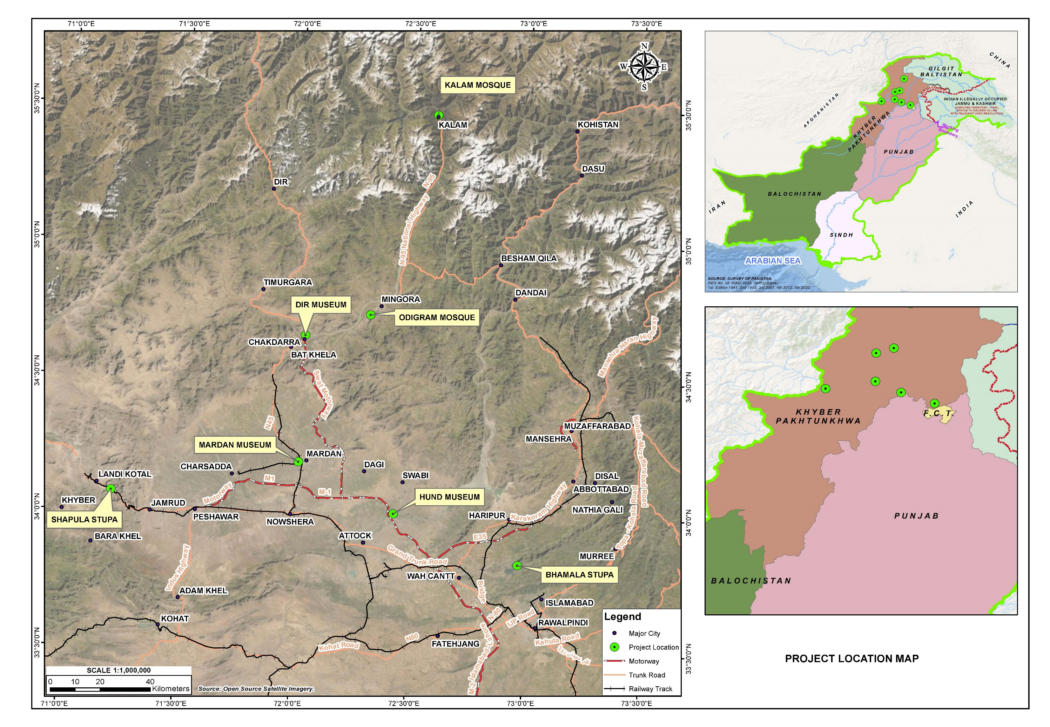
Figure 1-1: Subprojects Location Map

This report has been prepared based on the ESMF, 2020 and to meet compliance with the World Bank’s Safeguard policies applicable to these proposed subprojects.

According to the World Bank Operational Policy OP 4.01 ‘Environmental Assessment’ the proposed subprojects falls under Category ‘B’ as potential adverse environmental impacts of the proposed subprojects on human populations or environmentally important areas are less adverse than those of Category A projects. These impacts are site-specific; few if any of them are irreversible; and mitigation measures can be designed more readily than for Category A.

Objectives of ESMP

The main objective of this ESMP study is the identification of the possible and induced impacts of the proposed subprojects on both short and long-term basis. The impact identification process focuses particularly on physical, ecological, socio-economic and cultural aspects of the environment. Based on the level and nature of these observations, the ESMP then delineates proper mitigation measures. As a planning tool, the ESMP aims to ensure that environmental, socio-economic and cultural issues throughout the entire project lifecycle are anticipated and considered by the project proponent. It also serves as a framework for establishing project controls to reduce or prevent adverse environmental or socio-economic impacts. Three (03) separate Abbreviated Resettlement Action Plans (ARAPs) have been prepared to deal with the land acquisition, resettlement and rehabilitation issues for Shapula Stupa Landi Kotal District Khyber, Bhamala Stupa, District Haripur and Hund Museum, District Swabi.

The specific objectives of this ESMP are:

- To assess the existing environmental and socioeconomic conditions of the Project Area;
- To identify potential impacts of the proposed subprojects on the physical, ecological and social aspects of the Project Area, to predict and evaluate these impacts and determine their significance;
- To propose appropriate mitigation measures that should be incorporated in the design of the subprojects to avoid or minimize if not eliminate the potentially adverse impacts, and to implement during implementation and operational phases as well.
- To assess the compliance status of the proposed activities with respect to the national/provincial environmental legislation and WB's OPs;
- To provide institutional, monitoring, reporting and documentation measures for environmental safeguards compliance; and
- To aid decision makers to take informed decisions.

The Proponent

The GoKP through PMU KITE-C&WD is the executing agency for the project, headed by the Project Director.

Head Office Address: Secretary to Government of Khyber Pakhtunkhwa, Tourism, Sports, Culture, Museum, Archeology and Youth Affairs Department.
Telephone & Fax Number: 091-9212086
Email: secretarytourismkp@gmail.com
Contact Person: Mr. Abid Majeed

Project Office Address: PMU KITE – C&WD House No. 8-P, Mardan House, Park Road, University Town, Peshawar
Telephone/ Cell No: 091- 9224344-45
Email: pdkitecwd@gmail.com
Contact Person: Engr. Aamir Jamal
Designation: Project Director

Detail of ESMP team is given in Annex-I.

Approach & Methodology to Work

Approach

The study has been conducted in accordance with the World Bank Safeguards policies (OP4.01, OP4.11 and OP4.12) applicable to this project; and Environmental Protection Agency (EPA), Government of Pakistan (GoP) Guidelines, 1997, and. The study is based on both primary and secondary data and information. The primary data includes data collected from field. The secondary data includes a review of relevant information from literature and published reports. Discussions were held with stakeholders including government officials, and community representatives. The main purpose of this approach was to obtain an impartial impression of the people’s perceptions about the project and its environmental and social impacts.

Methodology

The following methodology was adopted for carrying out the ESMP study of the proposed subprojects activity:

- Data Collection Planning

A detailed data acquisition plan was developed after understanding of the project. The plan included; identification of specific data requirements and their sources; determination of time schedules and responsibilities for their collection; and indication of the logistics and other supporting needs for the execution of the data acquisition plan. Field survey was then conducted based on the data collection plan.

- Field Survey

A site visit was conducted in the month of December 2019 and January 2020 for the preparation of environmental and social screening reports for all the seven (07) archeological sites. For this purpose, checklists (attached as Annex- II) were developed in accordance with the World Bank’s Environmental and Social operational policies; and as per applicable national and provincial legislations. Afterwards a detailed site visit for collection of data was conducted during the month of May, 2021; the field activities were aimed for the for the following:

- Identification of environmental sensitive receptors including air sensitive receivers, noise sensitive receivers and water bodies expected to receive pollutant load;
- Identification of ambient air and noise monitoring points, surface/wastewater and drinking water sampling locations;
- Ecological survey;
- Socioeconomic survey including public consultation; and
- Stakeholders consultations,

- Review of Secondary Data

Previous environmental and social soundness assessment for KP Region and other published and unpublished information was collected in order to gain a complete understanding of existing environmental conditions of the area including:

- Physical environment: topography, geology, soils, surface and groundwater resources and climate;
- Biological environment: habitat types, flora and fauna (particularly rare or endangered species), critical habitats /zones and vegetation communities within the project area;
- Socio-economic environment: settlements, socio-economic conditions, infrastructure and land use; and
- Heritage aspects: sites of cultural, archaeological or historical significance.

- Area of Influence (AoI)

AoI/ Study Area includes the actual subproject area as well as the area in the surroundings in which positive and adverse impacts may be foreseen due to the implementation of the proposed subprojects.

The AoI for the baseline survey of each archeological site is taken as 100 m from the center.

- Stakeholder Consultations

For this ESMP study, stakeholder consultation was carried out. The ESMP team met with the government functionaries, affected persons and local communities along the proposed route. The objective of the consultation was to disseminate information on the project and its expected impact, long-term as well as short-term, among primary and secondary stakeholders and to gather information on relevant issues so that the feedback received could be used to address these issues at an early stage.

- Environmental and Social Impact Assessment

The data collected from the field was analyzed and the impacts of the proposed subprojects on the physical, ecological and socio-economic environment prevalent in the project area were identified and characterized with respect to significance and probability of occurrence at the design, construction, and operation phases. Possible mitigation measures and implementation mechanisms are proposed so that the impacts can be mitigated / controlled and the project implementation remains sustainable.

- Development of Environmental and Social Management Plan (ESMP)
An ESMP for the proposed subprojects activities was prepared. The ESMP provides
a plan for implementing and managing the mitigation and monitoring measures. The ESMP includes the following:

- Mitigation and monitoring plan;
- Definition of roles and responsibilities of the proponent, contractors and monitoring teams;
- Requirements for communication, documentation and training during the project.
- Restrictions on design, timing and conduct of the project; and
- Change Management Plan to cover unforeseen events / environmental conditions during the project.

Structure of Report

This document is a part of environmental and social safeguard documents prepared in the light of ToRs for KITE Project. The structure of this report is listed below:

Section 1: Introduction presents the project background, objectives, methodology and need of the ESMP study.

Section 2: Legal and Administrative Framework Lists national as well as provincial laws, regulations and procedures and applicable World Bank OPs.

Section 3: Description of Subprojects provides an overall description of the project including project components, implementation schedule, manpower requirement, waste generation, expected machinery and material requirements.

Section 4: Description of Environment gives a description of baseline physical, ecological and socio-economic conditions of the project area.

Section 5: Project Alternatives enlists no project option for proposed subprojects including design alternative option, where applicable.

Section 6: Public Consultation and Information Disclosure identifies the main stakeholders and their concerns raised during scoping sessions and deals with the measures to mitigate the social impacts.

Section 7: Potential Environmental and Social Impacts and their Mitigations Measures identifies, predicts and evaluates impacts of the project activities during the construction and operation stages and deals with the measures proposed to mitigate potential environmental impacts of the proposed subprojects.

Section 8: Environmental and Social Management Plan This section outlines organizational framework, mitigation and monitoring plans training requirements, defines roles and responsibilities, estimates budgets requirements for satisfactory implementation.

Inclusion of Safeguards Documents in the Bidding Documents

This ESMP will be a part of the Request for Proposals package/ Bid Documents and its compliance is mandatory. The contractor will be required to prepare site-specific plans as stipulated in ESMP. These site-specific plans will then be embedded into the civil works contracts and therefore will be legally binding on the contractor. The site-specific plans must be submitted to the PMU / Project Director for review and clearance within 30 days of the signing of the contract / before mobilization on site/ as advised by PMU/PD.

LEGAL AND ADMINISTRATIVE FRAMEWORK

General

This section deals with the current environmental policy as well as legal and administrative framework required to carry out the ESMP of the proposed subprojects. All relevant provisions of Environmental Policies laid out by the GoP, GoKP along with applicable World Bank Safeguards Policies have been duly discussed and the Project Proponent will be required to adhere to these regulations throughout the course of the project.

Applicability of World Bank Safeguard Policies

The development objectives of the World Bank safeguard policies are based on sustainability, transparency, fairness, accountability, governance, informed decision making, rights, participation and meaningful consultation for investment projects financed by the World Bank. Among total twelve safeguard policies, there are six environmental, two social, and two legal policies with their detailed Bank procedures can be found on the World Bank website. The disclosure and access to information policy is applicable to all investment projects and programs funded by the World Bank. Based on available information the applicability of World Bank policies is summarized below, Table 2.1:

Table 2-1: Applicability of World Bank Policies
WB Safeguard Policies Triggered by the Project | Triggered |  | Explanation
WB Safeguard Policies Triggered by the Project | Yes | No | Explanation
Environmental Assessment (OP/BP 4.01) | [√] | [ ] | The WB requires that an environmental assessment of all WB financed projects is carried out by the borrower to ensure that a project is environmentally sound and sustainable. As such, this policy has been triggered by KITE Project.  The ESMP in hand is fully committed to the requirements determined in the WB Safeguard Policy. The environmental works carried out have been essentially guided by these rules as enunciated in the OP 4.01.
Physical Cultural Resources (OP/BP 4.11) | [√] | [] | This policy is triggered where there is a potential impact to movable or immovable objects, sites, structures, groups of structures and natural features and landscapes that have archaeological, paleontological, historical, architectural, religious, aesthetic or other cultural significance. The construction activities will be in and around the archaeological sites, therefore, this OP will trigger.
Involuntary Resettlement (OP/BP 4.12) | [√] | [ ] | The WB policy on involuntary resettlement is triggered in any project with the potential to result in the involuntary taking of land which results in the relocation or loss of shelter, loss of assets or access to assets, or loss of income sources as well as involuntary restriction of access to legally designate parking and protected areas resulting in adverse impacts on livelihood.  Land will be acquired from public/ private landholders. Hence this OP will trigger.

Other Relevant World Bank Guidelines and Policies

Guidance Note on Labor Influx

A Guidance Note for “Managing the Risks of Adverse Impacts on Communities from Temporary Project Induced Labour Influx” was issued by World Bank in 2016. This Note provide guidance on identifying, assessing and managing the risks of adverse social and environmental impacts that are associated with the temporary influx of labor resulting from Bank supported projects. It contains guiding principles and recommendations to be considered as part of the design and implementation of projects with civil works that require labor from outside the project’s area of influence. It does not introduce new requirements, but rather seeks to provide concrete guidance on how to approach temporary labor influx within the environmental and social assessment process.

Environmental, Health & Safety Guidelines

In addition to OP, the World Bank has also established its Environmental, Health and Safety (EHS) guidelines for all the interventions that are financed by the group. These EHS Guidelines are technical reference documents with general and sector-specific examples of Good International Industry Practice (GIIP).
General EHS Guidelines: Issues associated with the construction and operation of
maintenance facilities are addressed in the General EHS Guidelines with other key
element like Environment and Occupational, Health and Safety (OHS) at workplace as well as for community. Summarized IFC Environmental and Health and Safety guidelines are provided in Annex- III.
(https://www.ifc.org/wps/wcm/connect/topics_ext_content/ifc_external_corporate_site/sustainability-at-ifc/policies-standards/ehs-guidelines)

World Bank Group Gender Strategy (2016-2023)

The 2015 Gender Strategy recognizes that stronger and better-resourced efforts are needed to address gender inequalities in access to jobs as well as control over and ownership of productive assets are key levers of change for women, their communities and economies and fundamental drivers of economic growth and poverty reduction. Gender equality is central to the World Bank Group’s own goals of ending extreme poverty and boosting shared prosperity in sustainable manner.

Key National and Provincial Laws, Regulations and Policies

Government of Pakistan has promulgated laws and regulations to safeguard the environment. At national level Ministry of Climate Change is the responsible authority & at provincial level KP-EPA is responsible for promulgation & implementation of environment related laws. Besides environmental statutes, a number of laws governing the social performance of the project also exist, e.g. Land Acquisition Act. The following description presents a brief overview of the relevance of various existing national policies, legislation and guidelines:

National Laws, Regulations and Policies

Pakistan Environmental Protection Act (PEPA), 1997
The Act was enacted on December 06, 1997 by repealing the Pakistan Environmental Protection Ordinance, 1983. It provides the framework for implementation of the Pakistan National Conservation Strategy (PNCS), 1992, establishment of provincial sustainable development funds, protection and conservation of species, conservation of renewable resources, and establishment of Environmental Tribunals, appointment of Environmental Magistrates, Initial Environmental Examinations (IEE) and Environmental Impact Assessments (EIA). Section 12 of the Act stresses the need to carry out EIA/IEE study prior to construction or operation of a project. PEPA will play its role in relation to enforcement of other environmental laws in project’s execution.

National Conservation Strategy, 1992

Pakistan National Conservation Strategy (NCS) approved by the federal cabinet in March 1992 is the principal policy document on environmental issues in the country (EUAD/IUCN, 1992). The NCS outlines the country's primary approach towards encouraging sustainable development, conserving natural resources, and improving efficiency in the use and management of resources. The NCS has 68 specific programs in 14 core areas in which policy intervention is considered crucial for the preservation of Pakistan's natural and physical environment. Part 3 of NCS provides action agenda & implementation strategy of 14 program areas for priority implementation. These are mainly, maintaining soils in croplands, increasing irrigation efficiency, protecting watersheds, supporting forestry and plantations, restoring rangelands and improving livestock, protecting water bodies and sustaining fisheries, conserving biodiversity, increasing energy efficiency, developing and deploying renewable, preventing/abating pollution, managing urban wastes, supporting institutions for common resources, integrating population and environment programs and preserving the cultural heritage.

For each program the long-term goals and expected outputs and physical investment, required within the first 10 years of implementation have been identified. The NCS proposes a seven-level strategy for implementation. The seven levels of federal and provincial leadership, departmental responsibilities, district coordination, community participation, individual action, corporate tasks & government and NGO support.

A midterm review of NCS was prepared by IUCN in Nov 2000 about the achievements, impacts & prospects of Pakistan’s NCS since the beginning of its implementation in 1992. The main conclusions of midterm review are;

- Achievements under NCS have been primarily awareness raising & institution building rather than actual improvements in quality& productivity of environment and natural resources.
- NCS was not designed as national sustainable development strategy
- NCS process has strengthened civil society institution and enhanced the capacity of public institution
- NCS implementation capacity requires much improvement
- NCS continues to have a major catalyst role in furthering Pakistan’s sustainable development agenda.

This strategy will safeguard and conserve natural environment by ensuring sustainable development in relation to project activities.

National Environmental Policy (NEP), 2005

NEP is the primary policy of Government of Pakistan addressing environmental issues. The broad Goal of NEP is, “to protect, conserve and restore Pakistan’s environment in order to improve the quality of life of the citizens through sustainable development”. The NEP identifies a set of sectoral and cross-sectoral guidelines to achieve its goal of sustainable development. It also suggests various policy instruments to overcome the environmental problems throughout the country. The sectoral guidelines include water supply and management, Air quality and noise, waste management, forestry, biodiversity and protected areas, climate change and ozone depletion, energy efficiency and renewable, agriculture and livestock and multi-lateral agreements were as; cross sectoral guidelines include; poverty and environment, population and environment, gender and environment, health and environment, trade and environment, environment and local governance and natural disaster management. NEP will protect the environment by ensuring sustainable development.

Guidelines for Environmental Assessment, Pakistan EPA

The Pak-EPA has published a set of environmental guidelines for conducting environmental assessments and the environmental management of different types of development projects. The guidelines that are relevant to the proposed subprojects are listed below:

- The Pakistan Environmental Protection Ordinance 1997
- Policy and procedures for filing, review and approval of environmental assessments
- Guidelines for the Preparation and Review of Environmental Reports, Pakistan, EPA 1997;
- Guidelines for Public Consultations; Pakistan EPA May 1997;
- Guidelines for Sensitive and Critical Areas, October 1997; and
- Pakistan Environmental Legislation and the National Environmental Quality Standards.

These guidelines will be used as reference in preparation of EA reports (if required), in later stages of the project.

National Environmental Quality Standards (NEQS), 2010

In pursuance of the statutory requirement under clause (e) of sub-section (1) of section (6) of the Pakistan Environmental Protection Act, 1997(XXXIV of 1997), Pakistan Environmental Protection Agency with prior approval of the Pakistan Environmental Protection Council, has published the NEQS in 2010.

The NEQS 2000 specify the following standards:

Maximum allowable concentration of pollutants (32 parameters) in municipal and liquid industrial effluents discharged to inland waters, sewage treatment facilities, and the sea (three separate sets of numbers);

- Maximum allowable concentration of pollutants (16 parameters) in gaseous emissions from industrial sources;
- Maximum allowable concentration of pollutants (two parameters) in gaseous emissions from vehicle exhaust and noise emission from vehicles; and
- Maximum allowable noise levels.

NEQS ensures that air, water and noise levels do not exceed their allowable limits, during project’s implementation.

Land Acquisition Act, 1894 Including Later Amendments

The Land Acquisition Act, 1894, is a “law for the acquisition of land needed for public purposes and for companies and for determining the amount of compensation to be paid on account of such acquisition”. The exercise of the power of acquisition has been limited to public purposes. This law is applicable in resettlement of the community and will ensure provision of adequate compensation of land to the affectees. This law is applicable in resettlement of the community and will ensure provision of adequate compensation of land to the affectees.

Protection of Trees and Brushwood Act, 1949

This Act prohibits cutting or lopping of trees and brushwood without permission of the Forest Department. The Forest Department will be approached for permission to cut trees (if required) in or around the proposed subprojects site. This law is applicable to control the cutting of trees, bushes and shrubs.

Antiquities Act 1975

The protection of cultural resources in Pakistan is ensured by the Antiquities Act of 1975. Antiquities have been defined in the Act as ancient products of human activity, historical sites, or sites of anthropological or cultural interest, national monuments etc. The act is designed to protect antiquities from destruction, theft, negligence, unlawful excavation, trade and export. The law prohibits new construction in the proximity of a protected antiquity and empowers the Government of Pakistan to prohibit excavation in any area, which may contain articles of archaeological significance. No Objection Certificate (NOC) would be requested from Archeological Department for construction within 200 feet of cultural heritage sites. The law protects antiquities and heritage sites during the implementation of the project.

Building Code of Pakistan, 1986

The provision of Building Code of Pakistan shall apply for engineering design of building like structure and related components. The construction in violation of the Building code shall be deemed as violation of professional engineering work. Seismic provisions were later added in 2007 named as ‘Seismic Building Code of Pakistan’. This code stipulates the minimum requirements for seismic safety of building and structures and the provisions of the Building Code of Pakistan (Seismic Provisions-2007) shall apply for engineering design of buildings, like structures and related components.

National Forest Policy 2015

Historically, Forestry remained a provincial subject even after independence of Pakistan. In the Constitution of Islamic Republic of Pakistan 1973, Forestry is purely a provincial subject and not impacted by the eighteenth amendments in the Constitution (2010). However, the federal support to federating units for meeting international obligations and filling their financial gaps is widely acknowledged. Climate mitigation and adaptation measures are the focus of National Forest Policy in view of Pakistan’s high vulnerability to adverse impacts of climate change, in particular to extreme events.

The Forest Act (1927)/Addendum

The Forest Act 1927 is designed to protect forest areas. The law prohibits grazing hunting, quarrying, clearing for the purpose of cultivation, removing forest produce, and felling or looping trees in forest or protected areas. Section 26 of the act prohibits the clearing of land, felling trees, cultivation, grazing livestock, trespassing, mining and collecting forest reserves along with setting traps or snares and poisoning of water. Any person who contravene shall be liable with punishment set by the law. However, after Forest Ordinance Amendment (2016) in sec 27 and 34-A of the Forest Act 1927 a subsection (3) is inserted according to which the government after approval from the provincial cabinet declares reserved forest as no more reserved and can acquire the forest land for purpose of projects of national importance. The forest act also allows the concerned authorities to regulate privately owned forests and land under certain conditions such as protection from floods or landslides, safeguarding roads, bridges and railways and preservation of public health (Sec 55). This law avoids impacts on floral assets in development of tourist’s facilities.

International Labour Organization (ILO)

The ILO aims to ensure that it serves the needs of working women and men by bringing together governments, employers and workers to set labor standards develop policies and devise programs.

The ILO has the following four strategic objectives:

- Promote and realize standards and fundamental principles and rights at work
- Create greater opportunities for women and men to decent employment and income
- Enhance the coverage and effectiveness of social protection for all
- Strengthen social dialogue.

The ILO aims to ensure the needs of working women and men by bringing together governments, employers and workers to set labor standards develop policies and devise programs.

Employment of Child Act, 1991

This act prohibits the employment of children in certain occupations and regulates the conditions of work of children. According to the definition in the act, a child is one who has not completed his 14th year of education. According to Section 3 of the Act, ‘No child shall be employed or permitted to work in any of the occupations set forth in Part I of the Schedule or in any workshop wherein any of the processes set forth in Part II of that Schedule is carried on: Provided that nothing in this section shall apply to any establishment wherein such process is carried on by the occupier with the help of his family or to any school establishment, assisted or recognized by Government’. This Act prohibits the employment of children in any of the proposed subprojects activities.

Occupational Health & Safety Laws

In Pakistan, the OHS in different sectors is covered in various laws. There is no single comprehensive law covering OHS. The following pieces of legislation could be relevant to the project in terms of OHS aspects:

- Factories Act 1934;
- North-West Frontier Province Factories Rules 1975;
- West Pakistan Hazardous Occupations Rules 1963;
- Provincial Employees Social Security (Occupational Diseases) Regulation 1967; and
- Workmen Compensation Act 1923 and Rules 1961.

However, the exact applicability of the above laws to the proposed subprojects is subject to discussion and legal opinion.

National Disaster Risk Reduction Policy, 2013

National Disaster Management Authority (NDMA), being the lead focal agency for disaster preparedness and management, has therefore, embarked upon formulation of a comprehensive National Disaster Risk Reduction Policy through wider consultations with all stakeholders including all provinces, state of AJ&K and regions.

This policy covers disasters risk reduction in a more holistic way and introduces a proactive and anticipatory approach by laying special emphasis on risk assessment and prevention.

Provincial Laws, Regulations and Policies

KP Environmental Protection Act, 2014

Post the adoption of the 18th Constitutional Amendment in 2011, the subject of environment was devolved, and the provinces have been empowered for environmental protection and conservation. Subsequently, the KP Government amended PEPA 1997 as KP Environmental Protection Act 2014, and KP EPA is responsible for ensuring the implementation of provisions of the Act in KP’s territorial jurisdiction. KP EPA is also required to ensure compliance with the NEQS and establish monitoring and evaluation systems. In case any project falls under Schedule I or II of this Act, the relevant IEE (or EIA where required) will be developed and submitted to EPA KP for issuing NOC before commencing any physical work. This law will enforce the implementation of environmental legislations at provincial level and will be responsible for issuing No Objection Certificates (NOCs), if required.

KP Tourism Policy, 2015

This policy identifies key priorities of provincial government for the next few years to develop the tourism sector as the priority sector and transform it into an engine of economic growth by making KP a preferred tourist destination. KP tourism sector vision aims to develop an internationally competitive tourism sector to fully realize its diverse potential; making tourism a leading economic sector for the province through public-private partnership. The policy focuses on sustainable tourism development. The objectives of policy includes; to establish KP as a preferred tourist destination, nationally in the short to medium term and globally in the long term, increase tourist traffic in the province by at least 10% every year over the next five years, Increase private sector investment in the provincial tourism sector in the provincial tourism sector over the next five years, increase workforce quality in the sector provide quality services in the short to medium terms and position KP as a source of world class tourism workforce in the long run. Establish a tourism quality assurance system in the province and ensure compliance in the short to medium term and achieve global service standards in the long term. This policy will provide guidance in planning and implementation of the project activities.

KP Tourism Act, 2019

Khyber Pakhtunkhwa Tourism Act, 2019 which will provide a framework for the Integrated Tourism Zones (ITZs), Provincial Tourism Authority (PTA), tourist police and private sector entities in the tourism and hospitality sectors of KP. The aims of this act includes but not limited to: promote, preserve and revive cultural heritage, cultural traditions, values, festivals and dialects; measures for sustainable development; promote and preserve tangible and intangible cultural assets, values and traditions of province, develop, publish and implement regulations in respect of forests, mountains, water features, lakes, waterfalls, flora and fauna. The authority will have the powers to acquire land for the purpose of promoting tourism and developing resorts, skiing facilities, hotels and other tourism related activities.

KP Wildlife & Biodiversity Act, 2015

KP Wildlife Act is expedient to provide for the protection, preservation, conservation and management of wildlife in KP. The aims and objects of this Act are the:

- Strengthening the administration of the organization to effectively manage wild animals and their habitats;
- To holistically manage Protected Areas in sustainable manners for the best interest of the indigenous communities and local stakeholders;
- Securing appropriately the goods and services produced from wild animals and their habitats at the level of local communities;
- Fulfilling the obligations envisaged under the biodiversity related multilateral environmental agreements ratified by the GoP;
- Promotion of public awareness and capacity building for proper appreciation of the environmental significance and socio-economic values of wildlife; and
- Conservation of biological diversity and realization of its intrinsic and extrinsic values through sustainable use and community participation.

This law is applicable to provide the protection and conservation to the local wildlife.

KP Forest Ordinance 2002

This Ordinance is relevant because the proposed subprojects s are located in or around forested areas. Especially, during construction, the contractors will need to strictly abide by its provisions. This Ordinance prohibits construction of any building or shed, road or enclosure, or any infrastructure, or altering or enlarging any existing road or infrastructure in a reserved forest. It also ban any cutting, felling or uprooting any tree or brushwood listed in Schedule –I. This law is applicable to conserve and protect floral diversity for all project sites.

Khyber Pakhtunkhwa Antiquities Act, 2016

This act pertains to protect, preserve, develop and maintain antiquities in the Province the KP. It extends to the whole of the Province of the KP. This act contains VII Chapters. Clause 55& 56 of Chapter IV, Development Schemes, New Construction and use of Movable Antiquities is applicable and require NOC from Directorate in case of vicinity of any protected immovable antiquity.

KP Climate Change Policy 2016

Pakistan has drafted its National Climate Change Policy in 2012. However, after the 18th amendment in the constitution of Pakistan, the Govt. of KP decided to formulate a Provincial Climate Change Policy to be more specific, target oriented and also in line with National Climate Change Policy of Pakistan 2012 - thus a Provincial Climate Change Policy was formulated for the first time in June, 2016, to the specific needs of the Province.

The Policy highlights sectors that need mitigation measures such as energy, transport, wastes, industries, urban planning etc. It also gives emphasis, to streamline Climate Change in different sectors of the economy and developmental projects in the Province to make a sustainable development and create resilience to natural disasters. Successful implementation of the Policy in relevant sectors like agriculture, water resources, forestry, wildlife etc. will help in achieving targets pertaining to Climate Change resilience. This law will enforce the implementation of mitigation measures such as energy, transport, wastes, industries, urban planning etc.

Culture Policy, Khyber Pakhtunkhwa, 2018

The KP culture policy goals are to create an enabling environment in which Cultural Heritage Sector can flourish and play a significant and defining role in nation building, safeguarding of identity and socioeconomic development. The primary objective of KP cultural policy is to achieve the economic and social development and moderate the problems faced by existing cultural sector. KP culture policy aims to provide an environment conducive to the protection, growth and promotion of indigenous culture heritage. This policy will protect the cultural integrity of the province throughout the project area.

KP Commission on Status of Women

The KP Commission on the Status of Women is a statutory advisory body established under the Khyber Pakhtunkhwa Act XIX of 2009 which was amended by the Khyber Pakhtunkhwa Assembly under the new Act XXVIII of 2016. The Commission in KP is the ﬁrst ever Provincial Level Commission in the country, established with functions to oversee implementation of laws, policies and programs related to women and propose new measures where gaps exist. The third term of the Provincial Commission on the Status of Women was notiﬁed in January 2017.

National Disaster Management Act, 2010

National Disaster Management Act, 2010. Amended in March 2020 as “The National Disaster Management (Khyber Pakhtunkhwa) (Amendment) Act, 2020. National Disaster Management Act, 2010 was passed by Parliament of Pakistan in 2010. The Act applies to whole Pakistan. The Act was passed in backdrop of 2010 Floods in Pakistan and strengthens Disaster Management system.

Khyber Pakhtunkhwa Water Act, 2020

Khyber Pakhtunkhwa Water Act, 2020 was passed by provincial assembly in July 2020. The Act applies to comprehensive management of water resources in KP and regulate their use in conservation and sustainability. This act is applicable as the proposed subprojects will utilize the ground water resources and dispose of waste water during the operation phase.

Applicable International Conventions

Pakistan is signatory to a number of international conventions and agreements on biodiversity conservation, environmental protection, and sustainable development. The major conventions and agreements that are relevant to the project are the following:

Convention on Biological Diversity, 1997

Also known informally as the Biodiversity Convention, it is a multilateral treaty. The Convention has three main goals including: the conservation of biological diversity (or biodiversity); the sustainable use of its components; and the fair and equitable sharing of benefits arising from genetic resources.

The Convention requires parties to develop national plans for the conservation and sustainable use of biodiversity, and to integrate these plans into national development programmes and policies. Parties are also required to identify components of biodiversity that are important for conservation, and to develop systems to monitor the use of such components with a view to promoting their sustainable use.

Relevance: This convention is relevant to conserve, protect and manage the biological diversity of all sub project sites.

United Nations Framework Convention on Climate Change, (1994)

The UN Framework Convention on Climate Change (UNFCCC) is a multilateral agreement to address the issue of climate change. The Convention, was set out and opened for signature at the June 1992 UN Conference on Environment and Development (UNCED), also known as the Rio Earth Summit. The UNFCCC entered into force on 21 March 1994. Pakistan being signatory of this treaty is bound to control the GHG emissions and climate change. Recent conference of parties (COP) for UNFCCC was held from 6 to 17 November, 2017 in Bon Germany.

Relevance: Being a signatory to UNFCCC, the activities under the project must avoid GHG emissions.

Sustainable Development Goals (SDGs)

Sustainable Development Goals (SDGs) are a collection of 17 global goals set by the United Nations General Assembly in 2015, and adopted by Pakistan as its national goals. The goals are broad and interdependent, yet each has a separate list of targets to achieve. The SDGs cover social and economic development issues including poverty, hunger, gender equality, water, sanitation, energy, health, education, global warming, urbanization, environment and social justice. Relevance: The project has direct relevance with SDG 6 (Clean Water & Sanitation), SDG 8 (Decent Work & Economic Growth), SDG 11 (Sustainable Cities & Communities), SDG 13 (Climate Action) and SDG 15 (Life on Land).

Administrative Framework

The C&WD PMU will be established within the head office of C&WD in Peshawar. It will monitor and coordinate all project implementation activities including financial management, procurement, recruitment of staff, consultants and contractors, and overseeing the implementation of ESMP.

DESCRIPTION of subprojects
Double space between Chapter’s TOC

Project Objective

The project development objective is to improve tourism-enabling infrastructure, enhance tourism assets, and strengthen destination management for sustainable tourism development in KP.

Project Administrative Jurisdiction

The seven (07) selected archeological sites are located in six districts of Khyber Pakhtunkhwa. These districts are Swat, Dir, Mardan, Swabi, Haripur and Khyber.

Project Implementation Schedule

The tentative implementation period for each Project is twelve (12) months.

Location and Accessibility of the Project Area

The proposed sub projects are located in Swat, Dir, Mardan, Swabi, Haripur and Khyber districts. These sites can be accessible through motorways / national highways, railways and airways.

Project Components

The civil works activities are planned to be implemented in seven selected archeological sites in six districts of Khyber Pakhtunkhwa. These districts are Swat, Dir, Mardan, Swabi, Haripur and Khyber. These sites are already established but in poor conditions. These were therefore selected to ensure a balanced approach towards site development. The four main criteria for site selection are:

- Tourism attributes (connectivity, seasonality, drawing power and facilities);
- Current visitation (number of tourists);
- Development potential and alignment with the objectives of KITE and the Khyber Pakhtunkhwa Tourism Policy 2015; and
- Sustainability and replication value of the site development.

The seven (07) selected archeological sites for conservation and development are:

- Bhamala Stupa, District Haripur;
- Dir Museum District Dir (Chakdara);
- Hund Museum District Swabi;
- Mardan Museum, District Mardan;
- Shapula Stupa, Landi Kotal District Khyber;
- Odigram Mosque district Swat; and
- Kalam Mosque District Swat.

The proposed components of individual sites are presented in Table 3.1:

Table 3-1: Components of the Proposed Site (s)
Sr. No. | Name of Proposed Site | Components of the proposed site
 | Conservation and Development of Bhamala Stupa, District Haripur | - Provision of Fencing (2200 Rft) around the Stupa;  - Provision of Site Office;  - Construction of Store;  - Construction of Information Desk;  - Construction of Public Wash Rooms (06 Nos);  - Construction of Tuck Shop;  - Construction of Boring of Tube Well & Allied Works;  - Construction of Ground Reservoir Tank (5000 Gallons);  - Making of Lawns, Green Belts and Plantation of trees. The tree plan will be provided by the contractor, and supervisory consultant, according to the actual status, how much tree are cutting, and how many trees are indigenous, and where the trees will be re-planted, also the contractor will allocate land and GPS coordinates, where the tree/ or indigenous tree can be re-planted. This list will be shared.  - Purchase of Equipment;  - External Lighting / Electrification;  - Shifting of H.T Electricity Pole & Allied Works.
2. | Conservation and Development  Dir Museum District Dir (Chakdara), | - Civil & Allied Works including external development works, existing building repairs (roof treatment), sewerage & sanitation of new buildings, internal electrification improvement, ventilators improvement of existing building;  - Provision of Site Office;  - Construction of store;  - Construction of Information Desk;  - Construction of Public Wash Rooms (06 Nos);  - Construction of Tuck Shop;  - Solar Facility;  - Lawns;  - Developmental works, Sheds for Tourists;  - Provision of CCTV Cameras System
3. | Conservation and Development Hund Museum District Swabi, | - Civil & Allied Works;  - Provision of Site Office;  - Construction of store;  - Construction of Information Desk;  - Construction of Public Wash Rooms (06 Nos);  - Construction of Tuck Shop;  - Lawns;  - Developmental works;  - Sheds for Tourists;  - External Lighting / Electrification;  - Parking Shed;  - Provision of protection wall on river side (440 Rft);
4. | Conservation and Development of  Mardan Museum, District Mardan | - Civil & Allied Works including flooring, replacement of windows, dismantling of existing washrooms;  - Public Wash Rooms (06 Nos);  - Construction of Tuck Shop;  - Lawns;  - Sheds for Tourists;  - Electrification;  - Provision of CCTV Cameras System at the site.
5. | Conservation and Development of  Shapula Stupa, Landi Kotal District Khyber. | - Road Work (800 M);  - Fencing (2400 Rft);  - Boring of Tube Well;  - Ground Reservoir Tank (5000 Gallons);  - Making of Lawns;  - Green Belts and Plantation of trees;  - Purchase of Equipment;  - Shapula Tourist View Point;  - Shifting of H.T Electric Pole etc.
6. | Conservation and Development of Odigram Mosque district Swat. | - Fencing (4100 Rft);  - Provision of Site Office;  - Construction of store;  - Construction of Information Desk;  - Construction of Public Wash Rooms (06 Nos);  - Construction of Tuck Shop;  - Ground Reservoir Tank (5000 Gallons);  - Making of Lawns;  - Green Belts and Plantation of trees;  - Purchase of Equipment;  - External Lighting / Electrification;  - Tourist View Point;  - Provision of Sheds;  - Shifting of H.T Electric Pole & Allied Works;  - Water Supply Sanitary;  - Sewerage.
7. | Conservation and Development of Kalam Mosque District Swat. | - Water Supply;  - Sanitary Sanitation & Sewerage;  - Sewerage;  - Electrification

Workforce Requirement

Manpower demand estimation is an essential component to facilitate deployment of manpower. Tentative workforce required for each proposed subprojects during construction phase will be about forty-five (45) workers/employees. These will be distributed as following:

Contractor
- Project Manager
- Quantity Surveyor (02 No.)
- Chief Surveyor (01 No.)
- Site Engineer (03 No.)
- Skilled Labour (10 No. each lot)
- Un-Skilled Labour (20 No. each lot)

Consultant
- Chief Resident Engineer
- Assistant Resident Engineer (02 No.)
- Site Inspector (03 No.)

PMU(KITE) CWD
- Project Director
- Infrastructure Engineer-II
- (Road Engineer -II

Source of Water

Contractor will be responsible to arrange water for construction works. However, it is supposed that water tanks will be used by the contractor on the site for construction activities. The source of water during the operation phase for the proposed subprojects will be the tube wells installed inside the project boundary.

Expected Equipment’s for Construction

The machinery and the equipment expected to be used for the proposed sub projects are excavator, concrete mixer machine, tractor trolley, water tankers, dozer and generators.

Construction Camps

Construction camps for the construction of proposed subprojects components will be located within the premises of proposed subprojects.
However, if construction camp is to be located outside the project boundary, following criteria shall be adopted by the Contractor to identify and for the establishment of the construction camp sites before start of the construction:

- There should be no or minimum resettlement issues for the location of the camps;
- Camp site should be away from the residential areas and sensitive receptors;
- Selection of sites for construction camps shall be near the project area having proper access to the nearby main/link road;
- The camps must be located in a place where the drainage from and through the camps will not threaten any domestic or public water supply;
- Camp site must be adequate in size to prevent overcrowding of necessary structures;
- The camp site should consider avoiding any damage of property, vegetation, irrigation, and drinking water supply systems;
- The camp site must not be subject to periodic flooding; and
- There should not be any ecological sensitive areas e.g. wildlife sanctuaries, game reserves, national parks, forest areas, etc. near to the construction camp site.

Construction method

At all the locations, ground will be leveled and excavated for foundation with brick masonry and Plain Cement Concrete (PCC) / Reinforced Cement Concrete (RCC) foundation base. Walls will be constructed with bricks and plastered with cement plaster. Floor will be with cement concrete covered with glazed ceramic/vitrified tiles. RCC roof will be provided for the toilets. Each toilet will have two polyethylene septic tanks with soak pits and rain water harvesting structures. They will be constructed by excavating soil. All the excavations will be done manually and the excavated soil will be used for leveling the compound. Any excess soil will be disposed at appropriate locations.

DESCRIPTION OF THE ENVIRONMENT

General

For any development project, the existing environmental conditions need to be assessed prior to the stages of designing, execution and infrastructure development works of the proposed subprojects. Identification of physical, biological, ecological and social aspects of environment and collection of relevant data is essentially important for the evaluation of impacts as well as for the suggestion of adequate mitigation measures, which forms the basis for the implementation of the proposed subprojects in terms of prevailing environmental and social conditions in the AoI.

Delineation of Area Of Impact

The existing environmental conditions of the proposed subprojects have been considered within radius of 100 m from the proposed subprojects (Area of Influence). The information has been collected from variety of sources, including published literature, DCRs, field observations, monitoring and surveys, conducted specifically for this project have been analyzed for this study. Consultations were also held with the general public and stakeholders of the subproject areas in order to seek the public opinion on the implementation of the proposed subprojects.

Physical Environment

The following section provides an overview of the information on physical environment of the proposed subprojects collected from primary as well as secondary sources. The major parameters covered include Physiographic and Topography, Geology, Soil, Seismicity, Climate and Meteorology, Water Resources, Solid Waste, and Land Use etc.
The project activities will be executed in six districts of Khyber Pakhtunkhwa. The conservation and rehabilitation activities on selected archeological sites fall in following six (06) districts;
- Haripur;
- Lower Dir;
- Swabi;
- Mardan;
- Khyber; and
- Swat.

Haripur District

Topography

The surrounded topography of the subproject area is predominately sub mountainous and eroded by intervening flat valleys. The Bhamala Stupa subproject lies in district Haripur. Geographically, Haripur District is divided into four regions. The first is Maidan-e-Hazara which consists of plain area of Haripur District surrounded by the mountains of Tanawal in north, Koh-e-Gandgar in the west and Khanpur in the south. Haripur City and majority of the villages of Haripur District are located in Maidan-e-Hazara. The second region Tanawal which is mainly mountainous, is sub-divided into Upper Tanawal and Lower Tanawal which lies in the north of Maidan-e-Hazara. The third region is Khanpur Punjkatha which is a well-watered plain lying in the south-eastern corner of the Haripur District. The last and fourth region is Chhachh (Maidan-e-Khari) in the west of Haripur City. All of this is submerged under the reservoir of Tarbela Dam. Elevation of the subproject area ranges from 535 to 540 meters. The topographic map of the subproject area is provided as Figure 4.1.

Soil

The subproject is exposed to geological material in the area is generally silty sand, sandy gravel and silty clay which is either product of in-situ weathering or deposited by the action of gravity and water. Below this over burden of silty sandy gravel soil, alternating layer of sedimentary rock comprising of sandstone, shell mudstone, siltstone and limestone are present.

Geology

Haripur District of the Hazara Division exhibits a suit of meta-sedimentary rocks of slates, phyllites, phyllitic-slate, quartzite and crystalline limestone. Four lithological units can be differentiated in the northern part of the area, namely the Manki formation, Tanwal formation, Utch Khattak and Shakot undivided and Shekhai formation. These are the extension of the Attock-Cherat range. In the southern part of the area four units, the Dakhner, Samana suk, Lockhart and Patala formations are exposed. Figure 4.2 provides geological map of the proposed subproject.

Seismicity

The subproject area is located in the NW Himalayan Fold and Thrust Belt, which lies near the collisional zone of the Indian tectonic plate with the Eurasian plate. Due to the collisional tectonic, the site region is seismically active. The region in which the project is located has been subjected to severe shaking in the past due to earthquakes. The subproject (Bhamala Stupa) is located in Seismic Zone 2B (moderate hazard), where 2B represents peak horizontal ground acceleration from 0.16g to 0.24g. Figure 4.3 shown the seismic map of proposed subprojects.

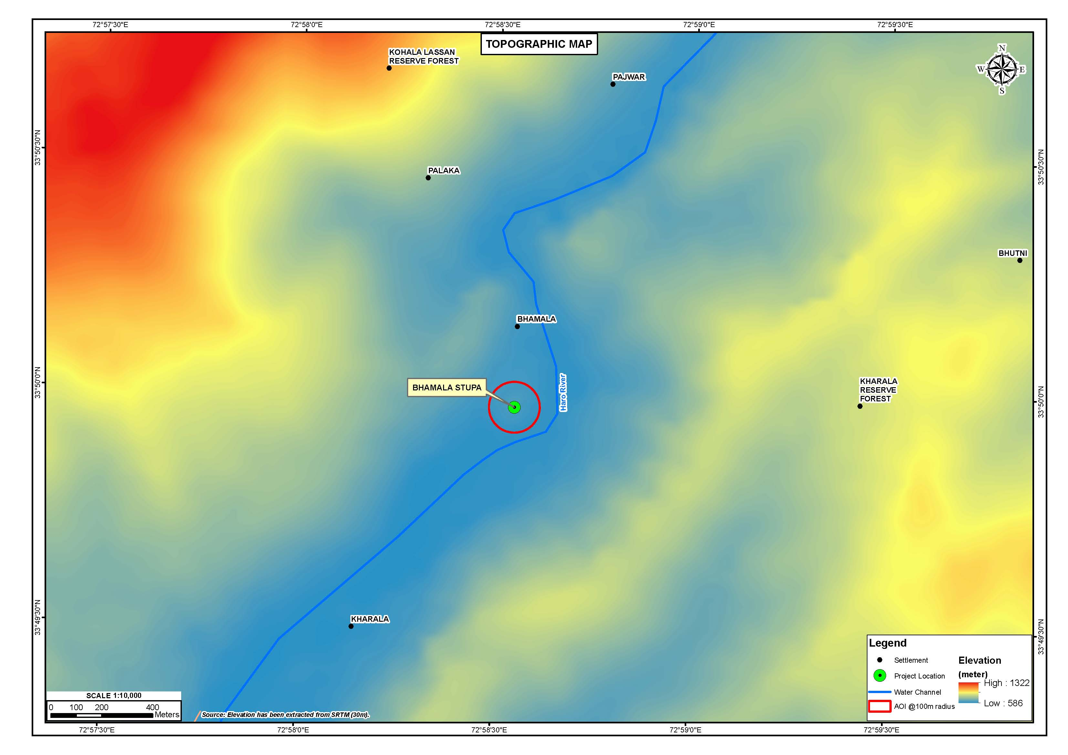
Figure 4-1: The Topography Map of the Subproject Area

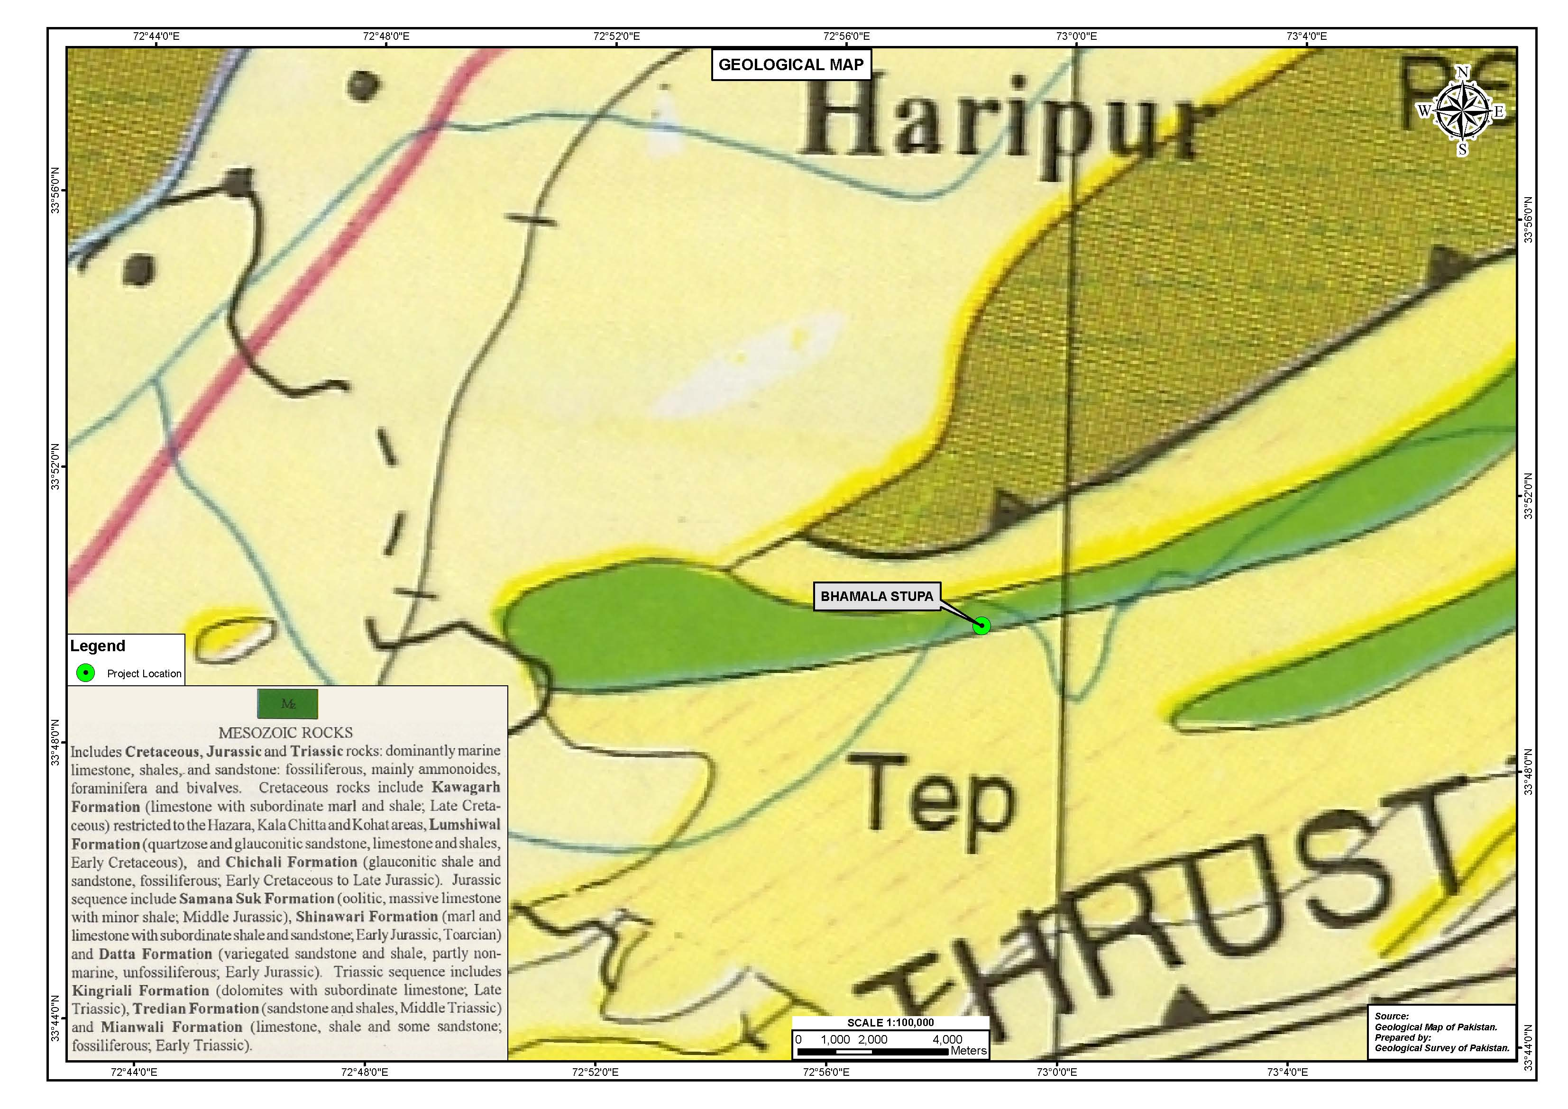
Figure 4-2: Geological Map of the Subproject Area
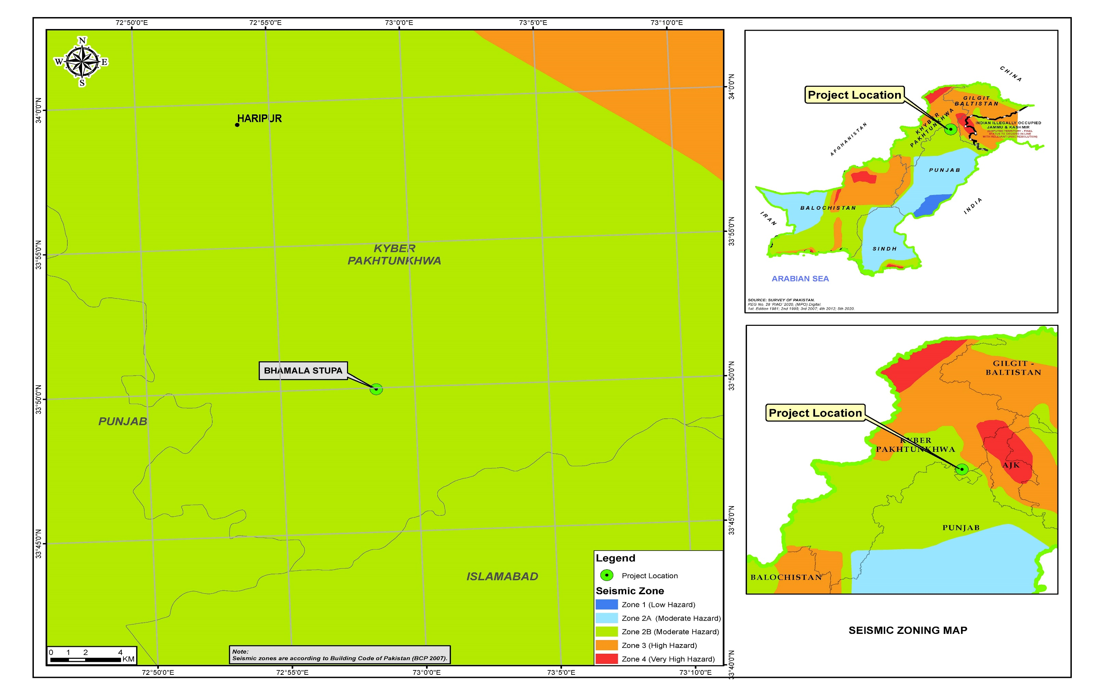
Figure 4-3: Seismicity of the Subproject Area

Water Resources

Surface Water

The important rivers of the district are river Indus, Sirin, Dauor and Haro. River Indus enters the district Haripur at Darband in the north-west taking its course along the western boundary of Haripur, makes its exit from the district at Ghazi. River Indus is the main source of Tarbela Lake. River Sirin being a tributary to Indus River enters the district at Bir and it merges with Tarbela Lake in the vicinity of Bir.

The Dauor contains much less water and has a shorter and more rapid course than the Sirin River. It originates at the northern end of Dunga Gali range and flows through the plains of district and joins the Sirin near the north-eastern Gandger range 8km above Tarbela. It irrigates a large area in Haripur District.

The Haro River emanates from the southern end of Dunga Gali range where it has two main branches. The eastern known as Dhund and the western is known as Karral Haro. The two streams unite at the head of Khanpur track.

Harrow River and Khanpur Dam are present at the near vicinity of the sub-project site, approximately at 3-4 km and 1 km distance respectively. Figure 4.4 shows the Surface Water Resources Map of the subproject area.

Groundwater

The groundwater depth in the subproject area is about 200-250 feet.

Solid Waste and Sewerage System

In the subproject area, no conventional solid waste management system exists. Most of the solid waste is found to be stored in the form of small heaps at various locations near the villages and open burning of waste is a common practice. The major constituents of solid waste in the area are paper, plastic, and organic waste (food waste, garden waste, animal waste). The areas lack proper sewerage system with only some open drains constructed in the vicinity for the discharge of wastewater.

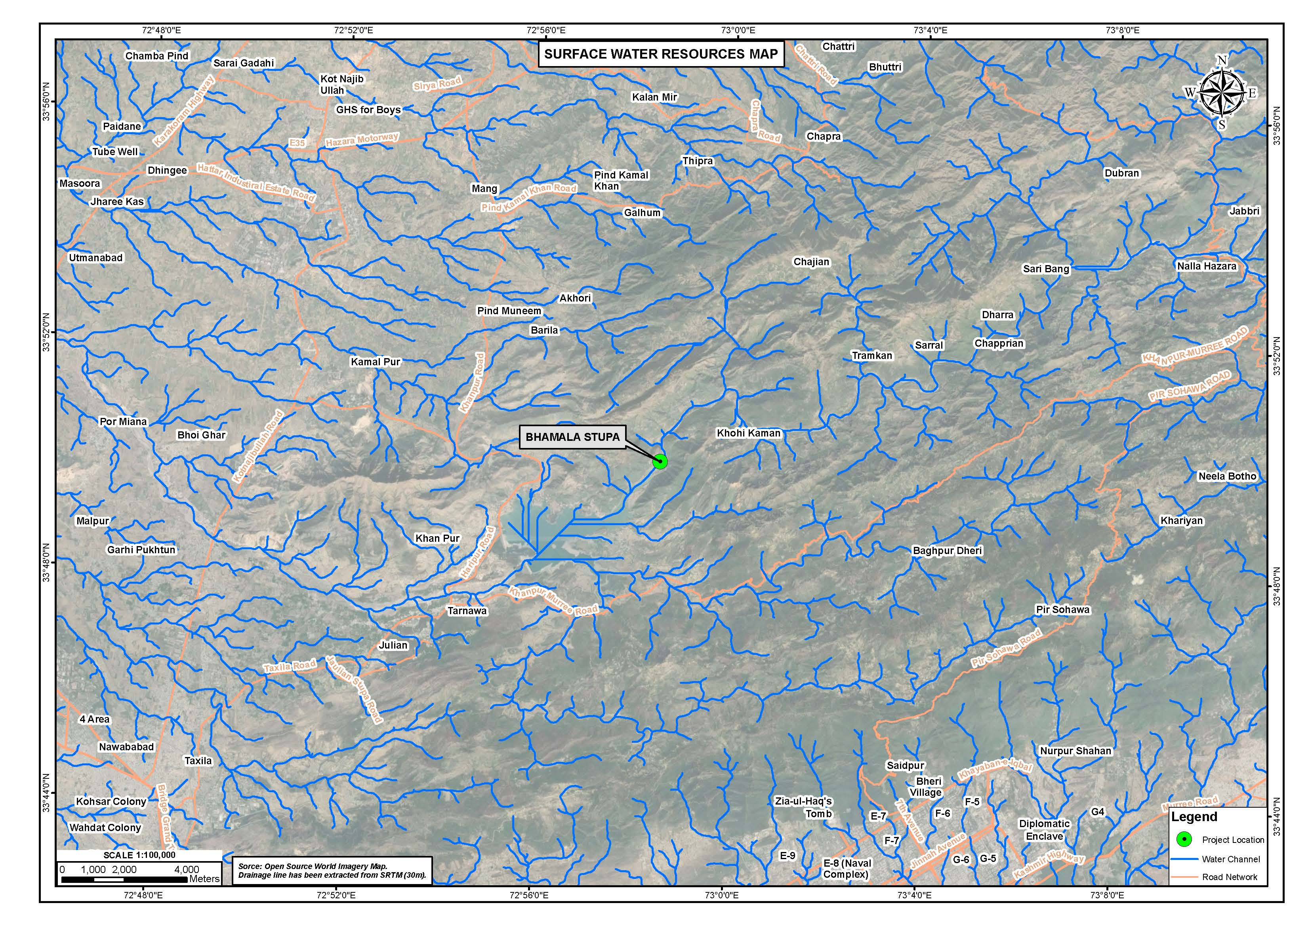
Figure 4-4: Surface Water Resources Map of the Subproject Area

Lower Dir District

Physiography & Topography

The total Area of Lower Dir is 1,582 km². The district borders Swat District on its East, Afghanistan on its West, Upper Dir and Chitral on its North and North-West respectively and Malakand and Bajaur Agency on its South. Average elevation of the district is 4,660 ft. The topographic map of the Project Area is provided as Figure 4.5.

Geography
The project area lies at the margin of Kohistan island arc and Higher Himalaya near the Main Mantle Thrust, MMT. The southern part of project area is comprised of Higher Himalayan rocks while the northern part comprised of rock of Kohistan sequence. Higher Himalayan rocks are comprised of granite gneisses and its cover metamorphosed amphibolites. These units further extended westward to Dir, Bajaur and Afghanistan. Two distinct varieties of gneisses can be characterized in the project area i.e. Granite Gneiss and Schistose Gneiss. Rocks of Kohistan sequences are found in the north of MMT and it is comprised of ultramaficsmafic rocks of ophiolites and Kamila amphibolites and volcanics.
Stratigraphic sequence of the project area consists of Indian mass rocks of lower Sawat Buner group mainly consists of granitic gneiss (Chakdara Granite Gneisses), it is granite with siliceous schist layers on the peripheries. These rocks are medium to coarse grained with association of Schistose Gneisses and Quartz mica Schist phyllitic gneiss, Phyllite and quartzite intercalations have been observed in the project area at higher elevations.
Major rock group of the project area are Granitic gneiss and widely spread along weir, Intake area, Sand trap, intake of tunnel, along the tunnel and power house areas. Poorly to well outcropped in and around Tunnel and outlet portal, in most of the reaches along Tunnel, rock of the area is well exposed and widely distributed under thin to thick cover of Secree/Colluviums and terrace deposits. Figure 4.6 provides geological map of the proposed subprojects.

Seismology

According to Building code of Pakistan 2007, the project area falls in Seismic Zone 2B of Pakistan (moderate hazard) with PGA from 0.16 to 0.24g. A moderate intensity earthquake can adversely impact the proposed development. This factor requires special consideration in the design. Figure 4.7 shows the seismic zoning map of the project area falling under Seismic Zone-2 B.

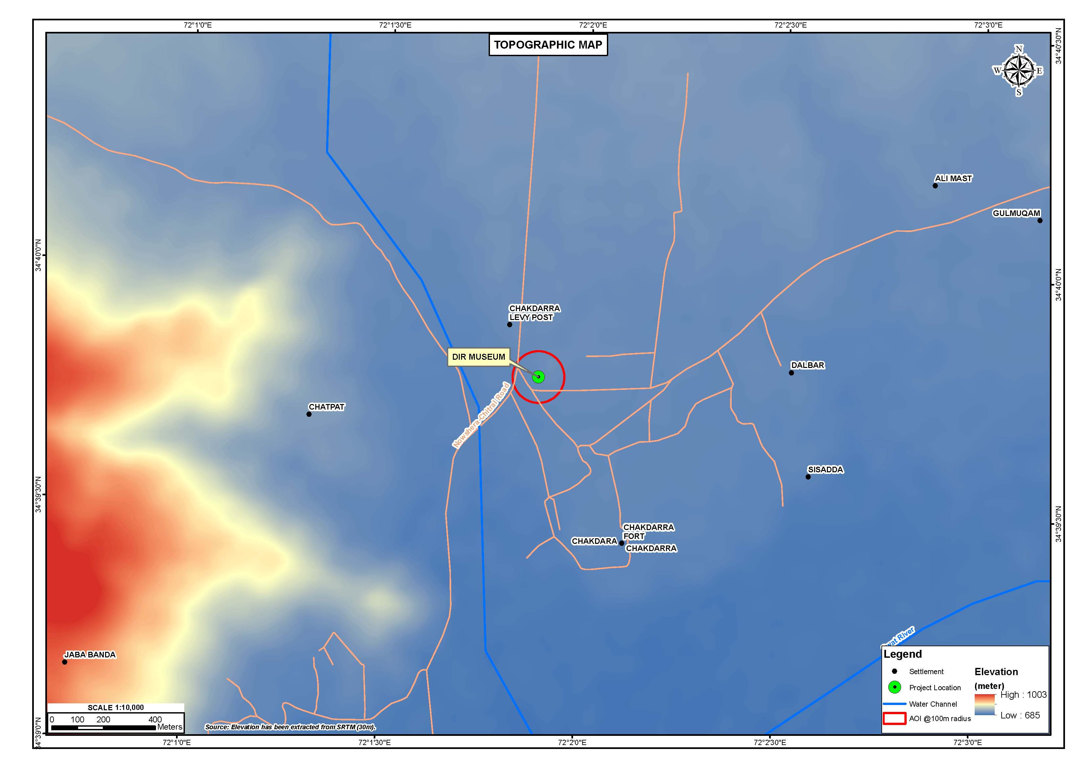
Figure 4-5: Topography Map of Subproject Area

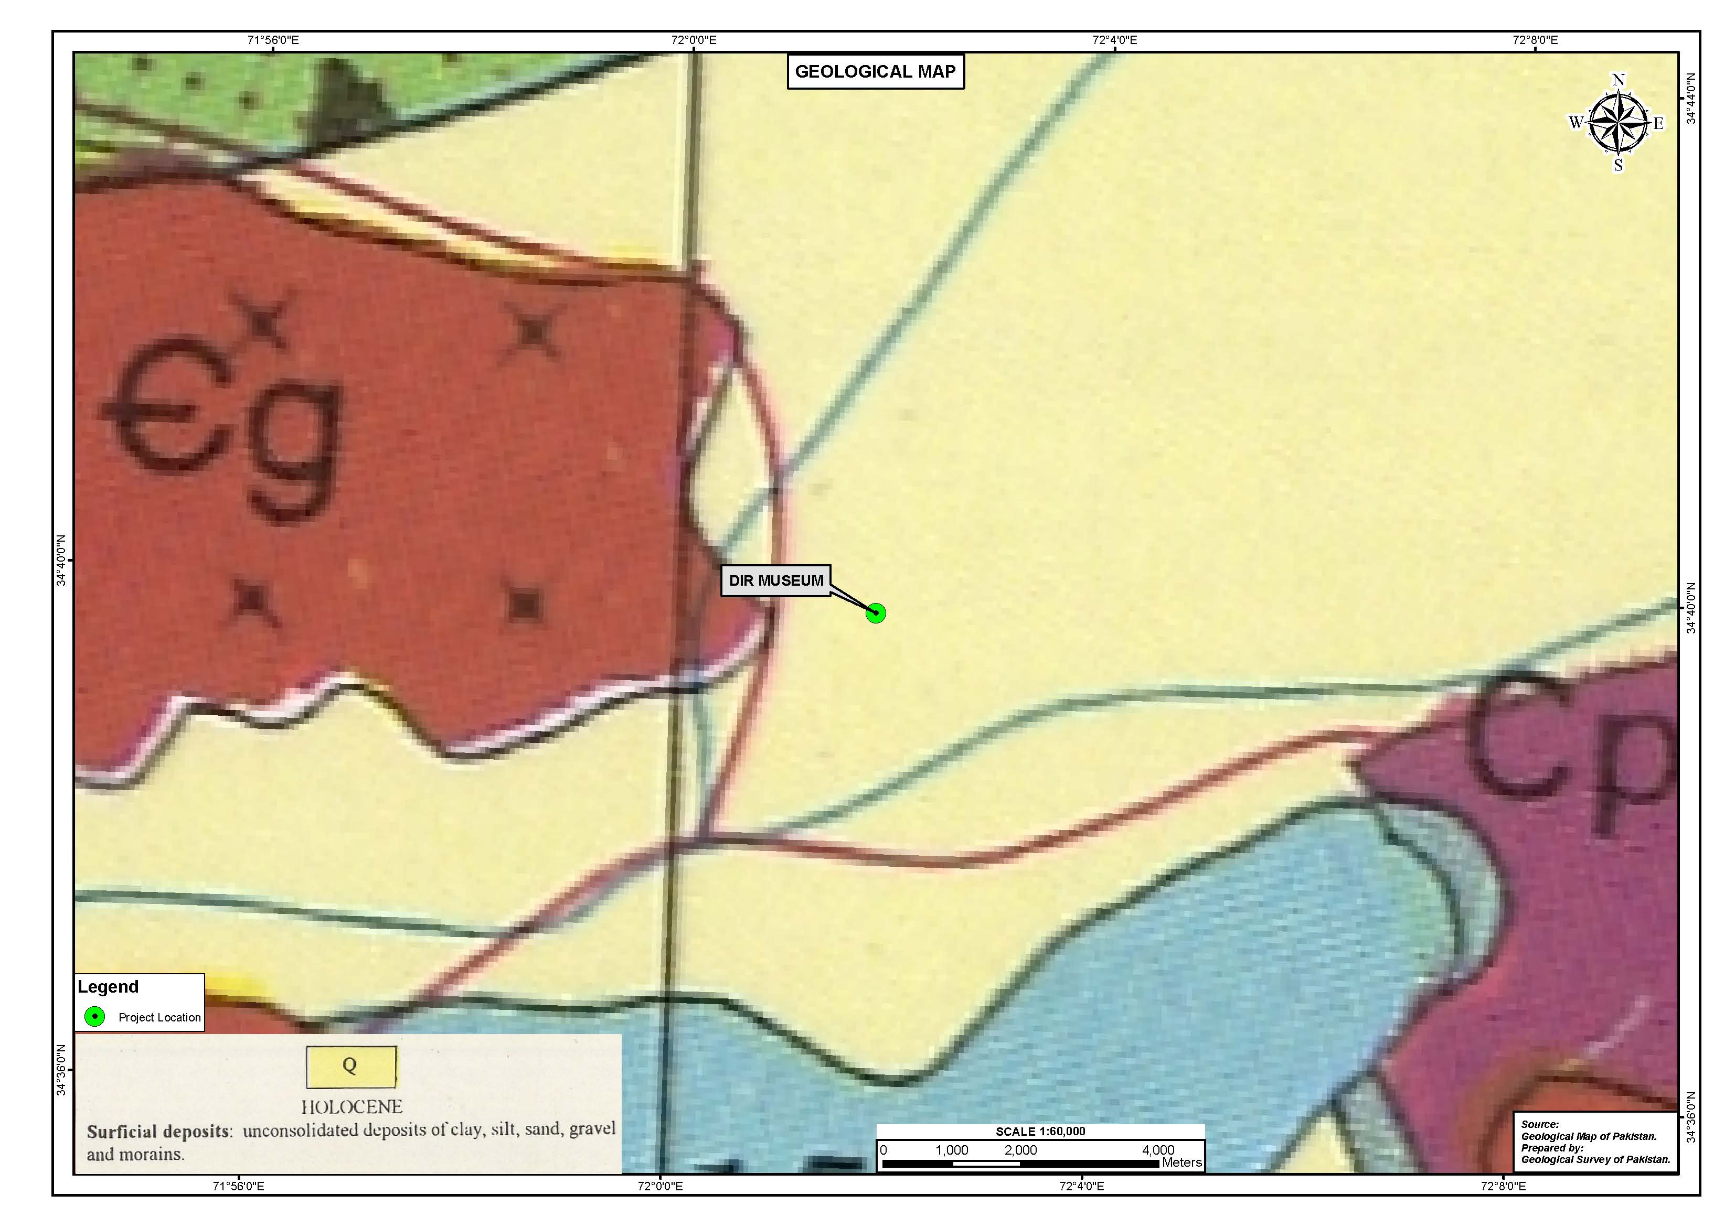
Figure 4-6: Geological map of Subproject Area
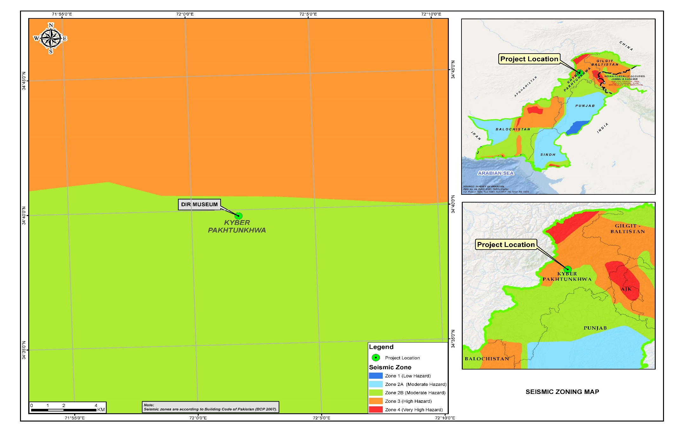
Figure 4-7: Seismicity Map of Subproject Area

Hydrology

Main river of the district is River Punjkora which is originating from Dir Kohistan. At Chukiatan 7 kilometers below Upper Dir the Punjkora is joined by the Dir and Barrawal rivers. Water in the river Punjkora is in abundance but could not be utilized for irrigation purpose in the district.due to high mountains on both side of the river throughout the district. The river is fed by a number of small streams/ Nullahs through various valley of Usheri Dara, Nehag dara, Karo Dara, Akhgram and Barawal etc. Irrigation mainly depends on rain or on the streams (Nullahs) falling from top of the hills into the river Punjkora. These Nullahs are also non-perennial. The irrigation department and local government working for the provision/ utilization of water resources of the district for the irrigation purpose. The district council and private individuals are also executing irrigation schemes through the wells to improve irrigation in the district. The main schemes are as under:

- Irrigation scheme Gundigar; and
- Irrigation scheme Darora.

Figure 4.8 shown the surface water resource map of proposed subproject.

Swabi District

Topography

Topography of Swabi district is divided into two parts, northern hilly areas and southern plain area. The major part of hills are in Gadoon area in the north east. These are the continuation of the Mahaban hills. Naranji hills are situated in north-western side of this district with height ranges between 750-1400 meters above sea level. Other isolated and small hills can be found in south of Swabi town and also along the border with Nowshehra District which are the part of Khattak hill, north of Kabul river.

Plain area of Swabi district which is start from foot of hills and runs down towards the Kabul River and its lower southern half of the district has its slope toward Indus River. There are numerous small streams and ravines in plain area of this district. The most important stream is Naranji Khawar which flow from Naranji hills in south-western direction and join Kalapani stream in Mardan district. Badri khwar is another important stream which flows from north close to Swabi town and join Indus River near village Hund. The Indus River flows along the southern boundary of the district. Figure 4.9 shows the topography map of the AoI.

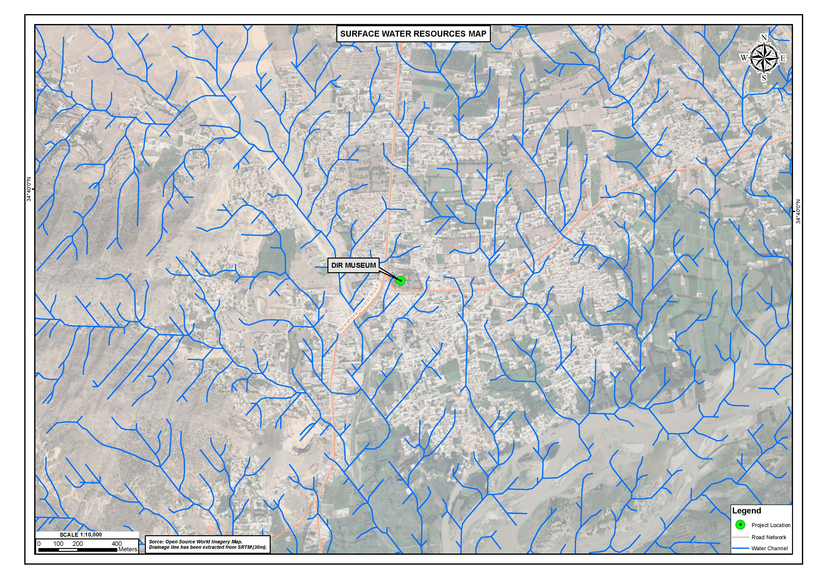
Figure 4-8: Surface Water Resource Map of Subproject Area
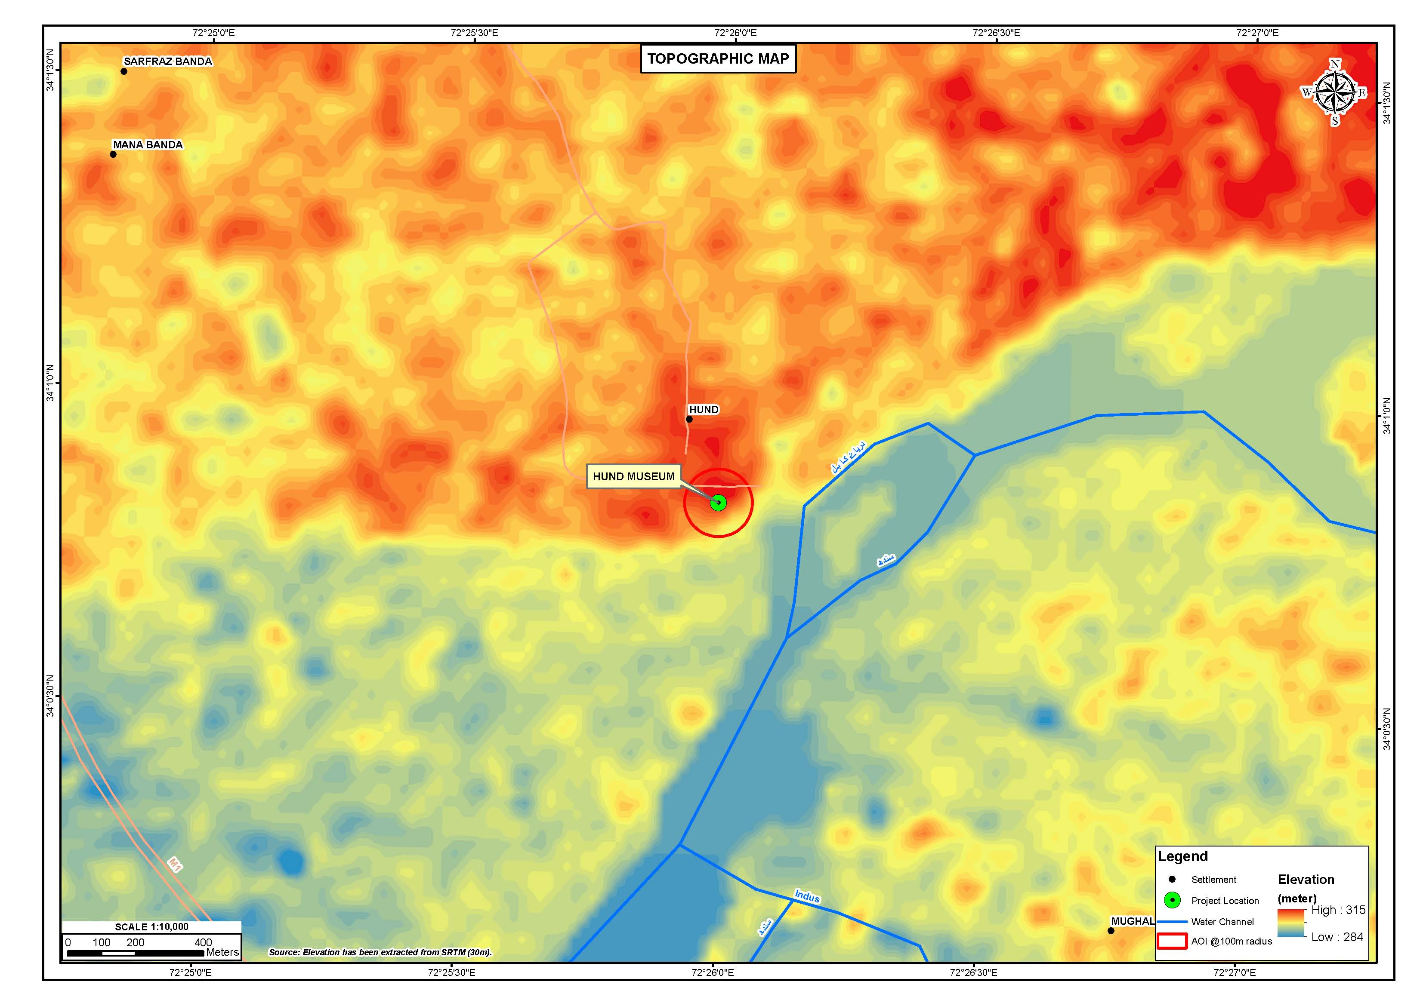
Figure 4-9: Topography Map of the Subproject Area

Geology

The plain of Swabi district has developed from river alluvium or loses plains. It is observed that the subproject area is dominated by high mountains. Geology of Swabi district include following rock units.

- Salkhala Formation This formation is of pre-Cambrian age and oldest unit of this area. It comprises chlorite quartzite –mica schist, graphitic schist, calcareous schist, marble and quartzite.
- Manki Formation Manki formation assigned a pre-Cambrian age. It is characterized by phyllites, slates and subordinate gray wakes, limestone and quartzite lenses.

- Sobra Formation The age of this formation is pre-Cambrian. It consists of limestone with subordinate quartzite and sandstone.
- Tanawal Formation This formation is of pre-Cambrian age. It is quite thick and comprised predominantly, quartzite, quartz’s sandstone and sub ordinate argillite.
- Ambar Formation Amber formation is of Cambrian age and consists of dolomitic limestone with inters collection of quartzite and phyllite.
- Miri Bnda Quartzite The age of formation is early to middle Ordovician. It consisted of quartzite with subordinate argillite and lenses of conglomerate.
- Panjpir Formation The age of this formation is silnan. It dominantly comprised argillite phyllite and subordinate lenses of limestone and quartzite.
- Granite and Doleritic dykes In addition the area shows some granitic rocks and doleritic dykes at places which have been given Permian to carboniferous age.

Figure 4.10 shows the regional geological map of the AoI.

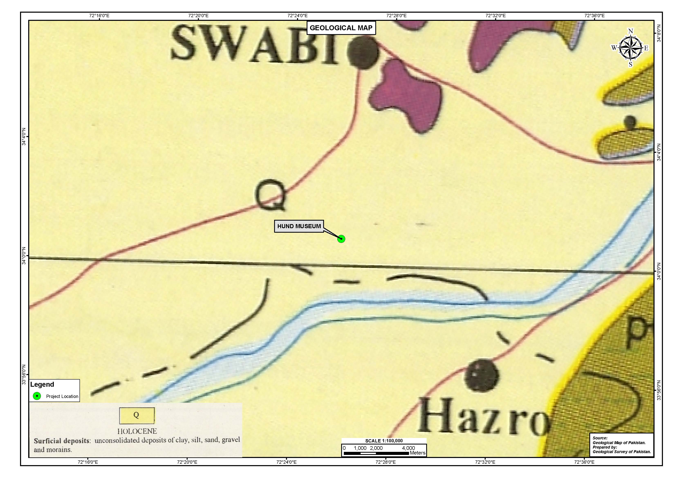
Figure 4-10: Geology Map of the Subproject Area

Soil

The soil of Swabi District is arable. The soils have developed either from river alluvium or loess plains. Texture of river alluvium is sandy loam to loamy sand, loam approaching clay loam. The soil of loess plains ranges in texture from silt loam to silty clay. Soil is irrigated for general cropping purpose with canal and where irrigation is not feasible, used for dry farming of wheat gram and groundnuts.

Seismology

According to Building code of Pakistan 2007, the project area falls in Seismic Zone 2B of Pakistan (moderate damage) with PGA from 0.16 to 0.24g. Figure 4.11 shows the seismic zoning map of the study area.

Surface Water Hydrology and Drainage

Main River of the district is Indus River, which is rises from Gadoon area at Satkhaiter flowing with eastern and southern boundary and entering the Nowshera and Attock districts at Khund. The river is fed by a number of small streams/ Nullahs, the most important Nullahs of the AoI are as follows:

- Badrai Nullah: It flows from the North close to swabi town and joins the Indus river near Hund.
- Naranji Nullah: It enters the district at Narangi from the North- east Mountains passes through Nawa killi, Turlandi villages and leaving the district at Islamia village enters the Mardan District.
- Shagai Nullah: It enters at Chack Nodeh of Swabi District.

Irrigation mainly depends on rain or on the streams (Nullahs) falling from top of the hills into the river Indus. These Nullahs are also non-perennial. The irrigation department and local government working for the provision/ utilization of water resources of the district for the irrigation purpose. Figure 4.12 shows the Surface Water Resources Map of the subproject area.

Ground Water

The groundwater is available mostly at the optimum depth for various purposes by the local inhabitants. The shape of groundwater table generally follows the surface topography. The discharge from the groundwater reservoir in District Swabi occurs mainly through existing water wells and outflow to rivers. The water table in the district rises during rainy season, especially monsoons and recedes during dry season of winters and summers. During the dry
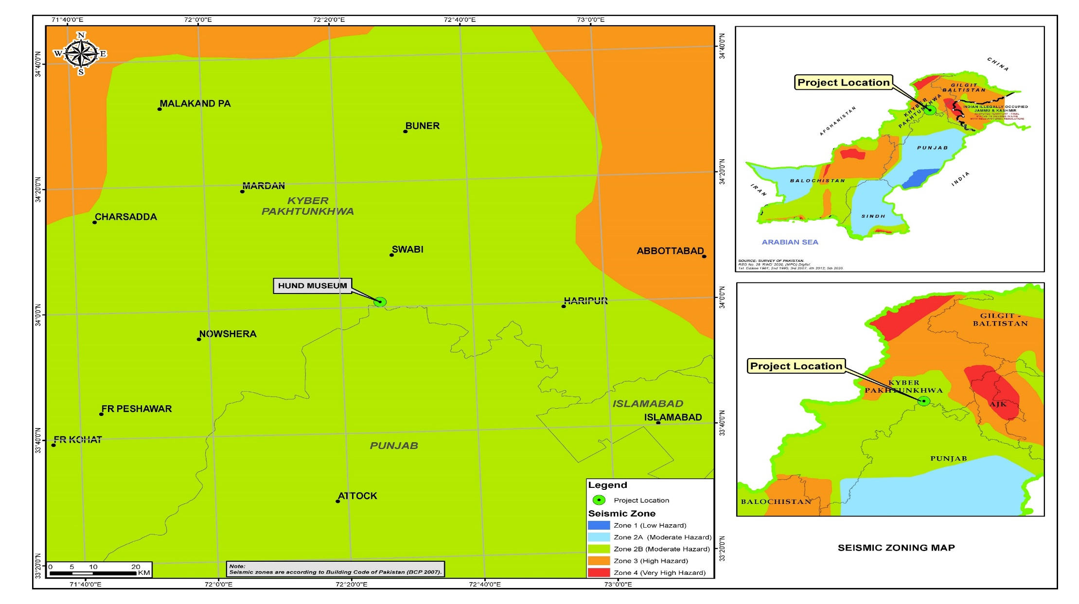
Figure 4-11: Seismic Zoning Map of the Subproject Area
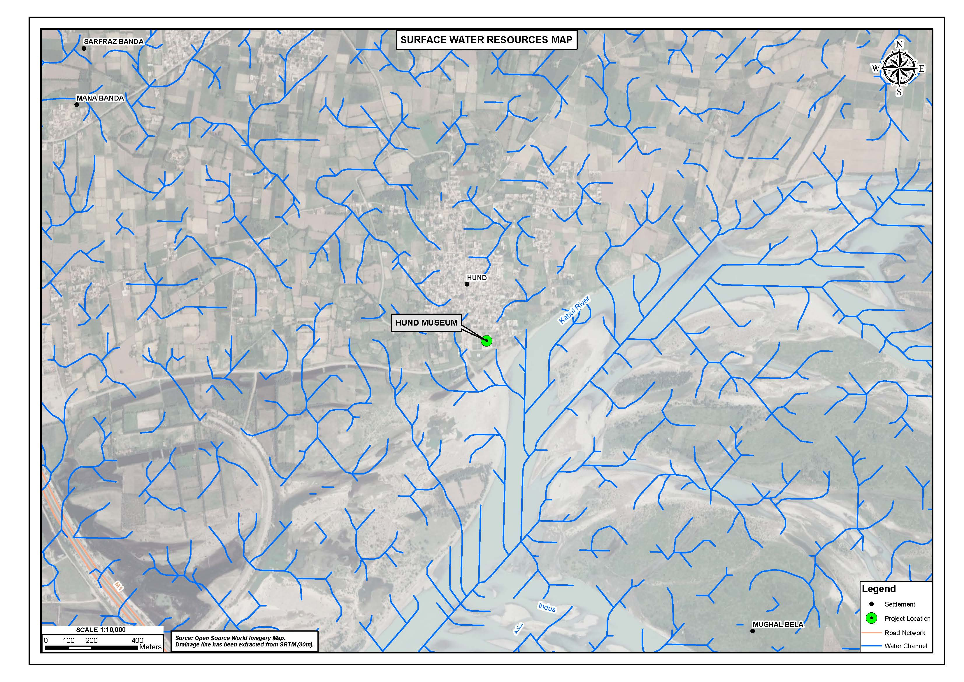
Figure 4-12: Surface Water Resource Map of the Subproject Area

season, the groundwater abstraction is also higher. The quality of drinking water in Swabi district has been assessed as High, Medium and Low level of contamination as given below:

- High: values 30 % or higher contamination than the WHO standards;
- Moderate: 10 % higher than the WHO standards; and
- Low: Within 5 % range of WHO standards.

mardan District

Physiography

The district lies from 34° 05 to 34° 32' north latitudes and 71° 48 to 72° 25' east longitudes. It is bounded on the north by Buner district and Malakand protected area, on the east by Swabi and Buner districts, on the south by Nowshera district and on the west by Charsadda District and Malakand protected area. The total area of the district is 1632 square kilometers.

Topography

Mardan District may broadly be divided into two parts, north eastern hilly area and south western plain. The entire northern side of the district is bounded by the hills. In the district, the highest points in these hills are Pajja or Sakra, 2,056 meters high and Garo or Pato, 1816 meters high. The south western half of the district is mostly composed of fertile plain with low hills strewn across it. It is generally accepted that this plain once formed the bed of a lake which was gradually filled up by the load of the river flowing into from the surrounding hills. From the foothills the plain runs down at first with a steep slope which carried the rain water to the lower levels and ultimately to the Kabul river.

Figure 4.13 represents the topography of the study area of the proposed subproject.

Regional Geology

Khyber Pakhtunkhwa sits primarily on the Iranian plateau and comprises the junction where the slopes of the Hindu Kush Mountains on the Eurasian plate give way to the Indus-watered hills approaching South Asia. This situation has led to seismic activity in the past.
Geographically the province could be divided into two zones: the Northern zone extending from the ranges of the Hindu Kush to the borders of Peshawar basin and the southern zone extending from Peshawar to the Derajat basin.

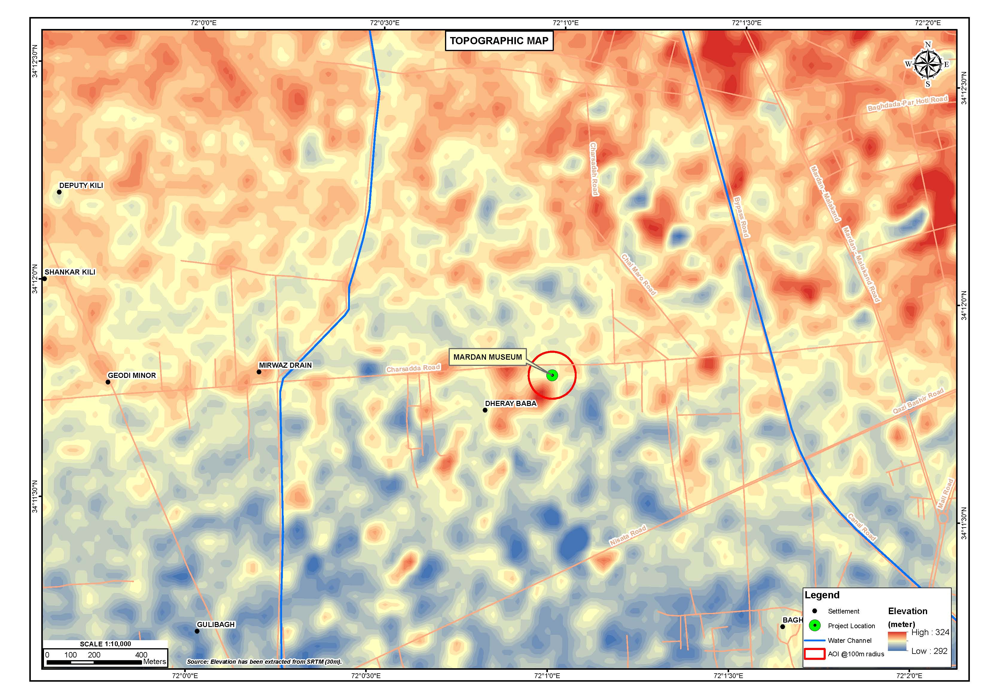
Figure 4-13: Topography Map of Proposed Subproject

The southern zone is arid with hot summers and relatively cold winters and scanty rainfall. The Sheikh Badin Hills, a spur of clay and sandstone hills that stretch east from the Sulaiman Mountains to the Indus River, separates Dera Ismail Khan District from the Marwat plains of the Lakki Marwat. The highest peak in the range is the limestone Sheikh Badin Mountain, which is protected by the Sheikh Badin National Park. Near the Indus River, terminus of the Sheikh Badin Hills is a spur of limestone hills known as the Kafir Kot hills, where the ancient Hindu complex of Kafir Kot is located. The major rivers that crisscross the province are the Kabul, Swat, Chitral, Kunar, Siran, Panjkora, Bara, Kurram, Dor, Haroo, Gomal and Zhob. Its snow-capped peaks and lush green valleys of unusual beauty have enormous potential for tourism. Figure 4.14 represents the geology of the AoI of the proposed subproject.

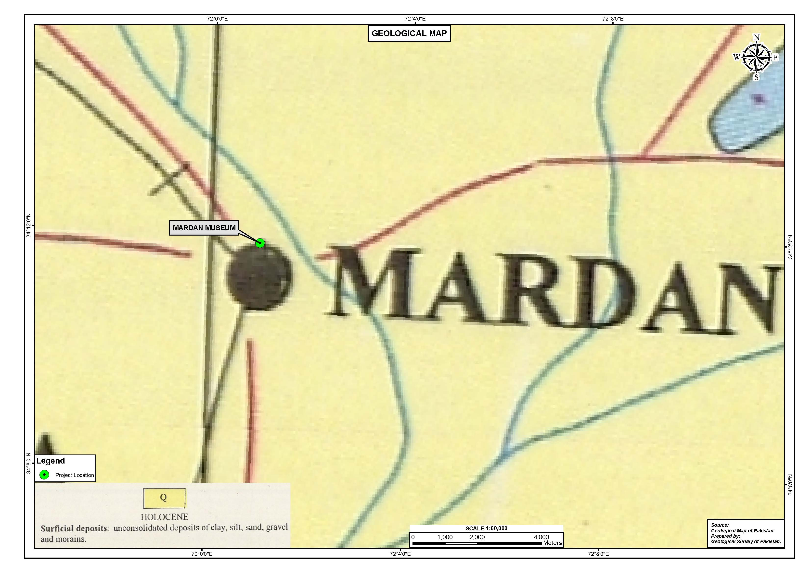
Figure 4-14: Regional Geological Map of the Subproject Area

Soil

The ground comprises of Very Soft to Soft to Firm to Stiff Lean Clay/Silty Clay/Silt/ up to a depth of 7.0 m underlain by Medium Dense to Very Dense Poorly Graded Sand with Silt/Silty Sand, with a sandwiched layer of Very Stiff to Hard Silty Clay/Lean Clay/Sandy Silt, up to a depth of 21.0 m underlain by Stiff to Very Stiff to Hard Lean Clay/Silty Clay/Silt up to maximum investigated depth of 25.0 m below Existing Ground Level (EGL).

Seismology

According to Building code of Pakistan 2007, the project area falls in Seismic Zone 2B of Pakistan (moderate hazard) with PGA from 0.16 to 0.24 g. A moderate intensity earthquake can adversely impact the proposed development. This factor requires special consideration in the design. Figure 4.15 shows the seismic zoning map of the subproject area falling under Seismic Zone-2B.

Streams and Rivers

Generally stream flows from north to the south. Generally stream flows from north to the south. Most of the streams drain into Kabul River. Kalpani, an important stream of the district rises in the Baizai and flowing southwards join Kabul River. Other important streams which join Kalpani are Baghiari Khawar on the west and Muqam Khawar, coming from Sudham valley and Naranji Khawar from the Narangi hills on the left. The various streams flow in and around the city of subproject area are shown in Figure 4.16.

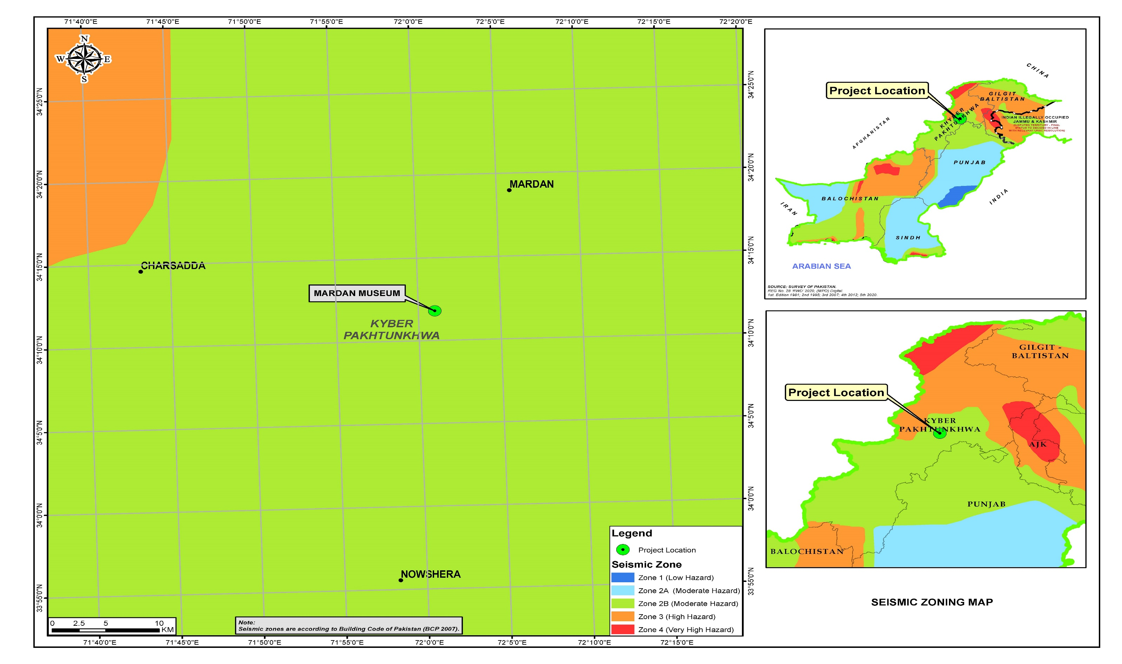
Figure 4-15: Seismic Zoning Map of the Subproject Area

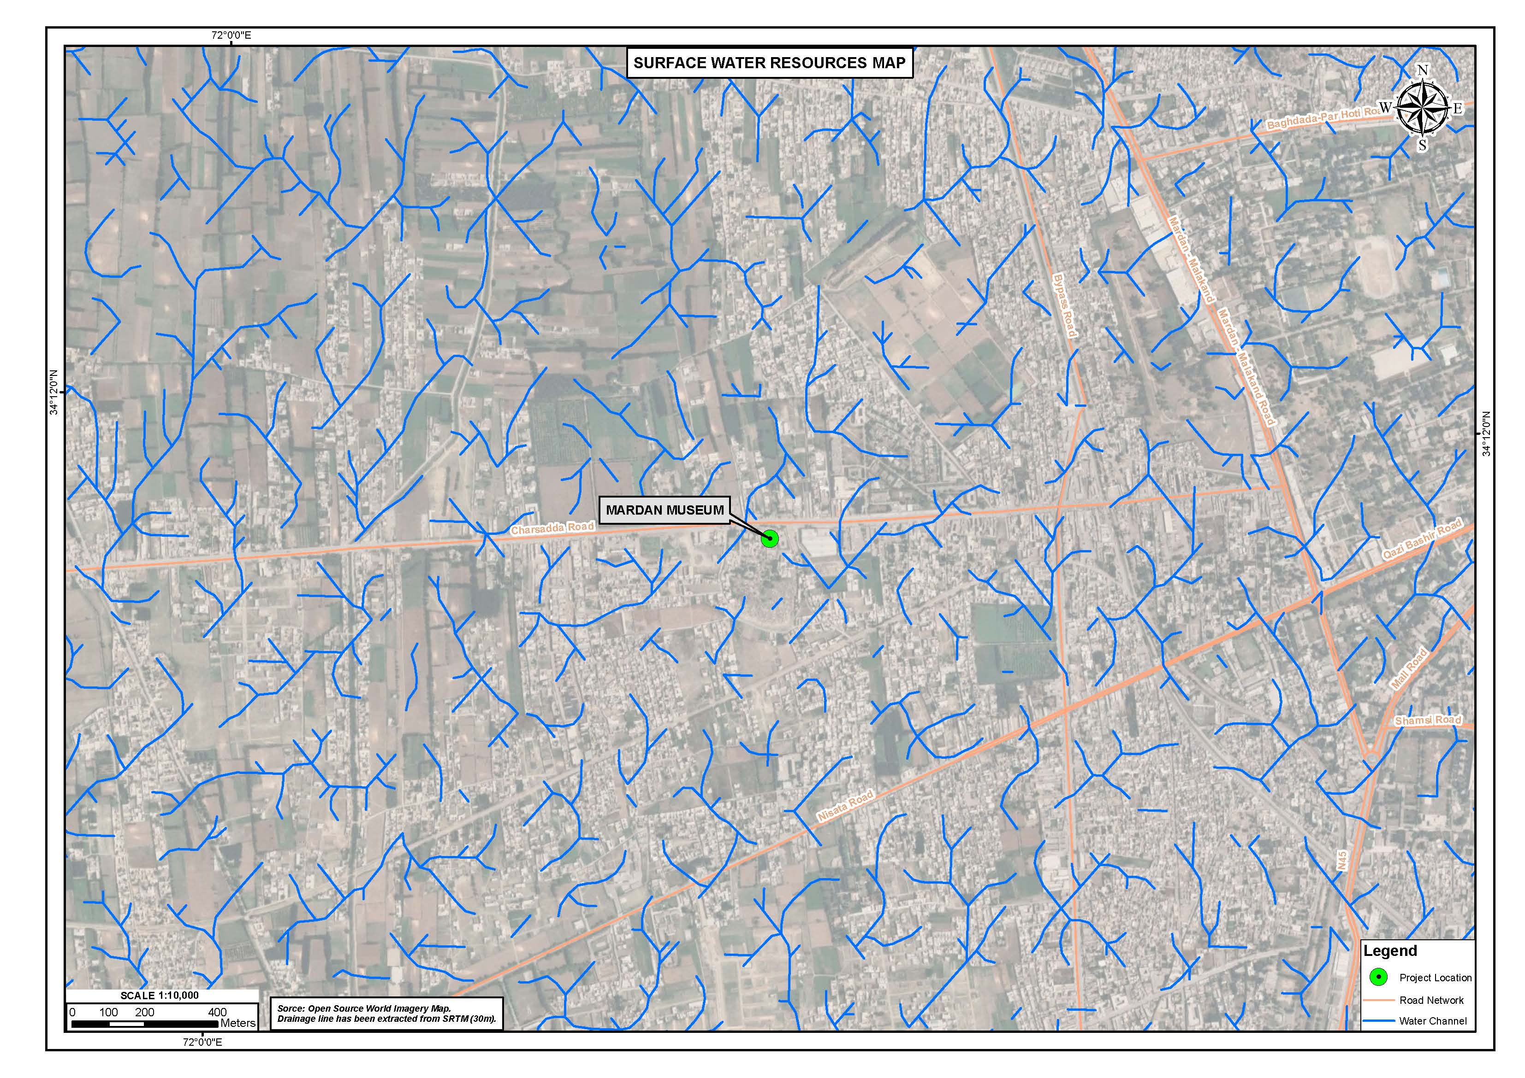
Figure 4-16: Water Resources Map in the Subproject Area

Khyber District

Topography

The Khyber District is located between 33° 33' to 34° 27' north latitudes and 70° 28' to 71° 51' of east longitudes. Khyber District is dominated by barren and rugged mountainous terrain with narrow strips of valleys. The district share its borders with District Orakzai in south, Kurram District to south west, Peshawar to the east and Mohmand District in north. The total area of the district is 2,576 sq.kms. Figure 4.17 shows the topography map of the AoI.

Geology

The mountainous terrain of Khyber District has small basins and valleys, with scattered settlements and agricultural fields. This is the geological region of Pre-aravallis, metamorphic in general including Precambrian and younger intrusions. The massive grey limestone with sand and clay beds that makes up the Carboniferous Khyber Formation and the slate, phyllites, and schists with minor limestone and quartzite beds of the Ordovician-Silurian LandiKotal Formation found in the eastern part of the Khyber Agency. However, Mesozoic sediments occur in the western part of the District. Figure 4.18 shows the regional geological map of the AoI.

Soil

The soil of the Khyber District is mainly from the local weathering of bedrock, deposited by streams and rivers. Landforms in the area are varied and include piedmont plains, valleys, gravel fans, rough broken land and gullied land. Level areas are loamy, while lowlands are slightly strongly calcareous. The soil of low permeability strata consists of silt, clay and rarely fine sand. While the soil of high permeability strata is generally composed of sand and gravel from a depth of 30 m to 150 m. The content of organic matter and available phosphorus is very low.

Seismology

According to Building code of Pakistan 2007, the project area falls in Seismic Zone 3 of Pakistan (high hazard) with PGA from 0.24 to 0.32g. Figure 4.19 shows the seismic zoning map of the AoI.

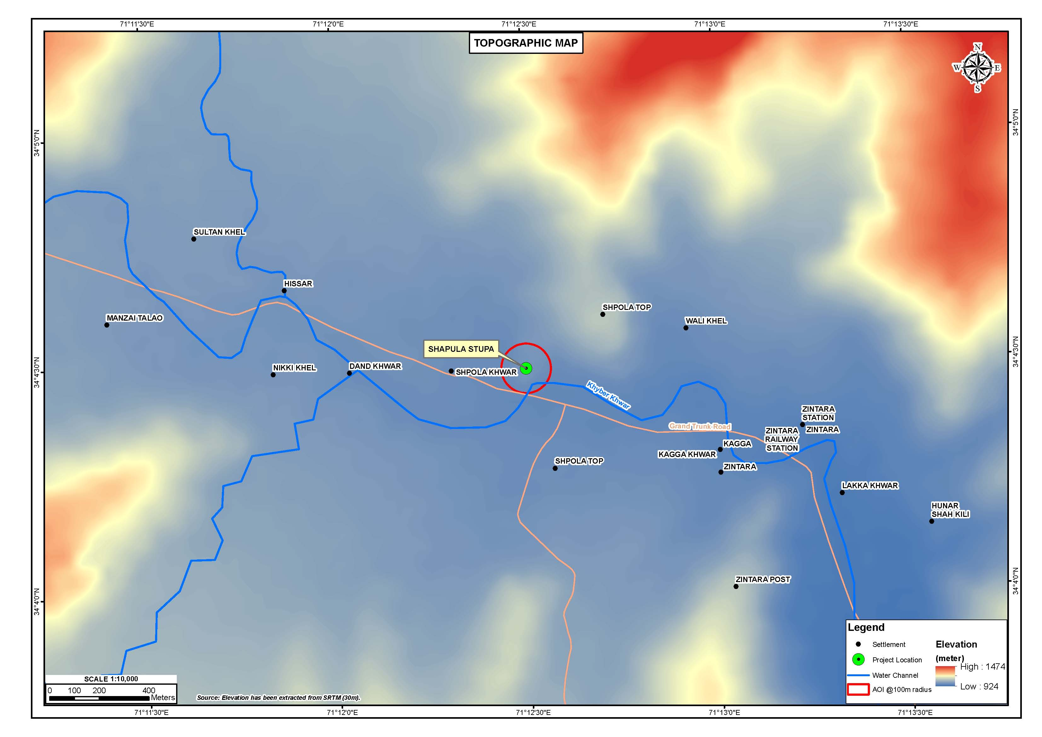
Figure 4-17: The Topography Map of the Subproject Area
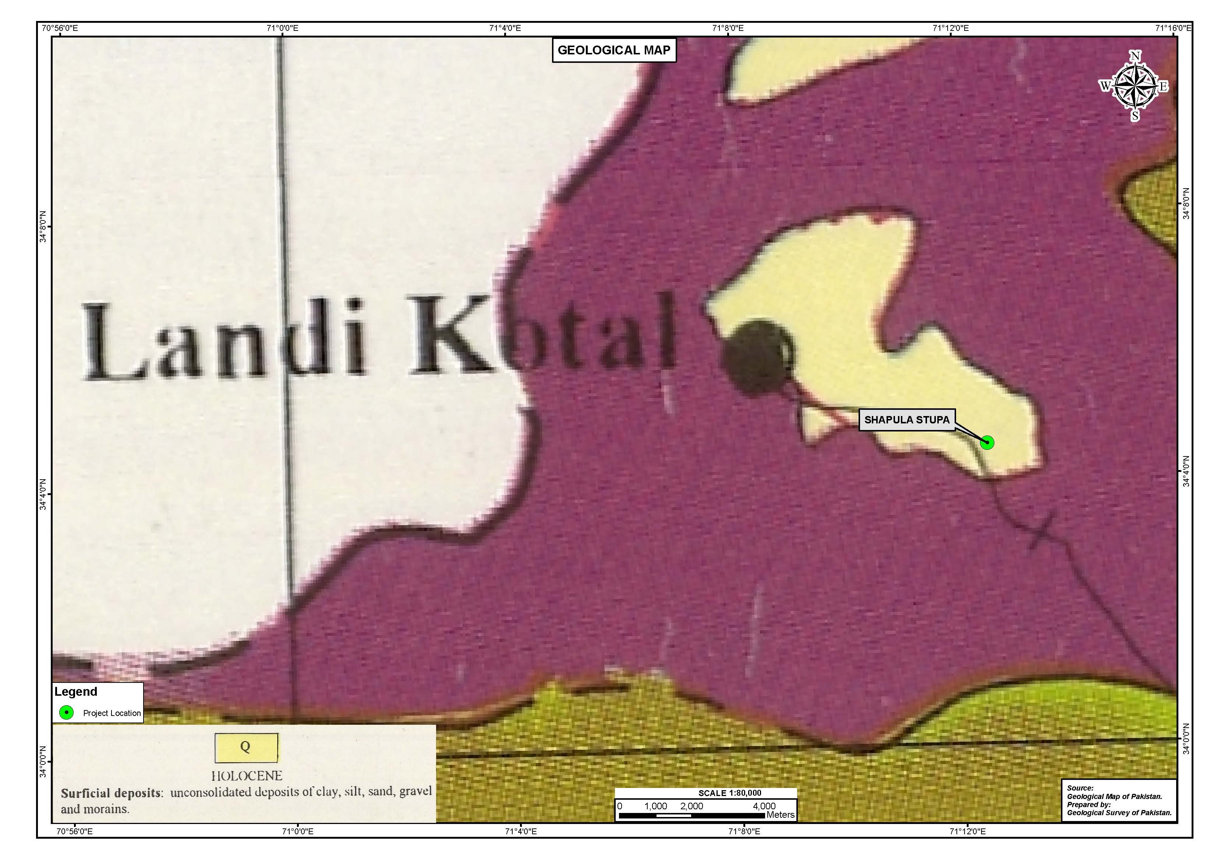
Figure 4-18: Regional Geological Map of the Subproject Area

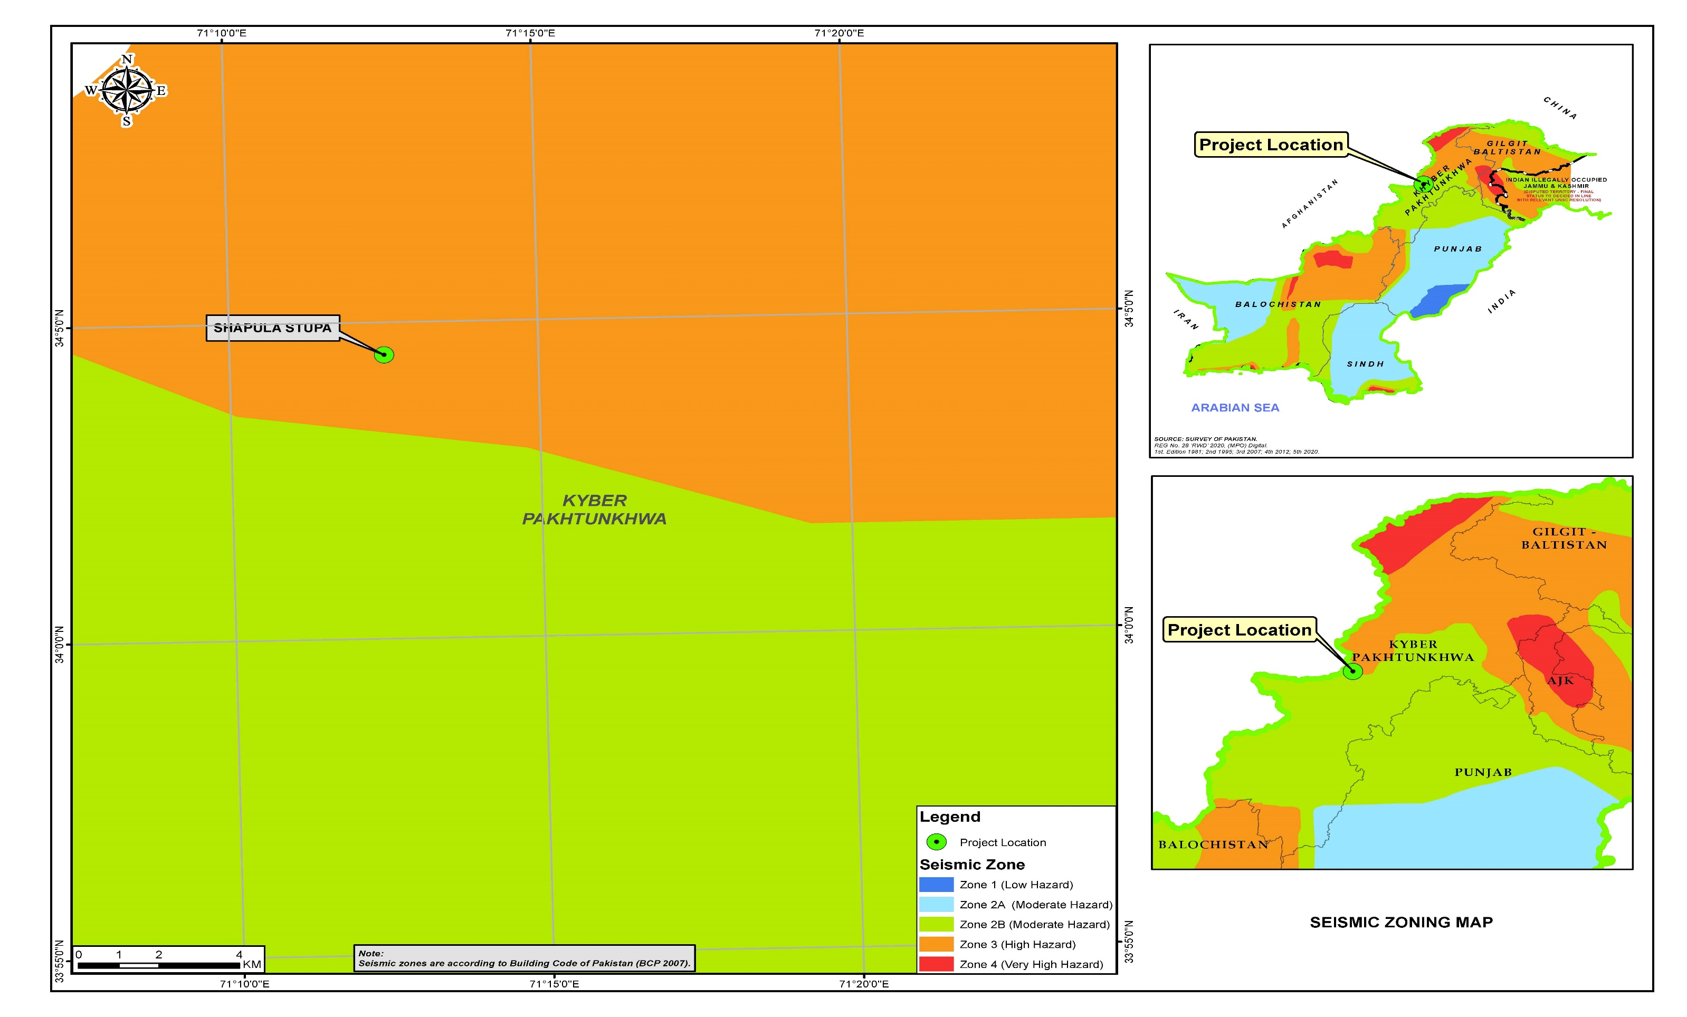
Figure 4-19: Seismic Zoning Map of the Subproject Area

Surface Water Hydrology and Drainage

There are a number of rivers and their tributaries in the Khyber Agency that have perennial flow from snow melt. Two main rivers in the Khyber District are the Bara and Chora Rivers. On the northern border of district, River Kabul runs between the area of Shalmanis and Mullagoris. The details of different surface water resources present in and around the
AoI is given below:

Bara River
Bara River originates in the southeast of Khyber Agency from Rajgah and Malik Din Khel watersheds. It drains into the Kabul River near Nissata, after passing through the settled areas. The high flow months are of April and May while January records minimum flows.

There are three canals off-taking from the river, within and outside Khyber Agency that includes Sangu Branch, Shekhan Branch and Bara River Canal.

Kabul River
Kabul River originates from Chitral, and enters in Afghanistan at Arandu, making a semi-circle around Kabul City reaches in the vicinity of Jalalabad where it is called Kunar River. Kabul River re-enters Pakistan in Mohmand Agency and after traversing a few kilometers it turns into a boundary river between Mohmand and Khyber agencies.

The major tributaries of the Kabul River are the Logar, Panjshir, Alingar, Surkhab, Kunar, Bara, and Swat rivers. There are 07 canals off taking from the Kabul River for irrigation purposes.

Other Streams

The major streams draining the Khyber Agency are Nakai, Bazar, Aladand, Khangai, KamShilmen, Lashira, Malal, Ghalanai, etc.

Figure 4.20 shows the Surface Water Resources Map of the AoI.

Ground Water

Khyber Agency is mountainous without any well-developed alluvial plain. According to the available information, approximately 20 test-and tube wells have been drilled in different valleys. The lithological data on two boreholes in the Jamrud – LandiKotal area indicate an ill-sorted mixture of clay and gravels, probably with low transmissivity values.

Groundwater is usually found at a depth of 55 - 70 meters, where annual recharge is 85.41 MCM for an average year, 46.18 for a dry year and 146.06 MCM for a wet year.

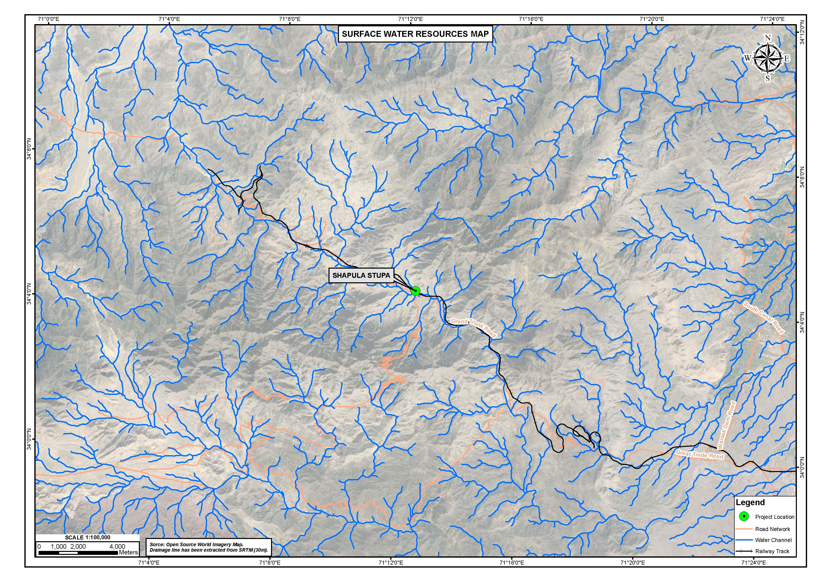
Figure 4-20: Surface Water Resources Map of the Subproject Area

Swat District

Topography

Swat is a mountainous region, located among the foothills of the Hindukush mountain range. The elevation of Swat river valley, at the southern boundaries of the district, is over 600 meters above sea level (AMSL) and rises rapidly towards the north. There are several mountain peaks ranging from 4,500 to over 6,000 AMSL. The Swat region, containing the meandering Swat River, is also home to lush green valleys, snow–covered glaciers, forests, meadows and plains. Average elevation of swat district is 980 m (3,220 ft). Figure 4.21 & 4.22 shows the topographical map of subprojects (Odigram and Kalam Mosques) area.

Geology

The project area is situated in the middle-western part of the Kohistan Tectonic Zone and comprises plutonic igneous rocks. The predominant rock type at the site is a medium-grained slightly foliated gabbroic rock, classified as Norite. This rock type is in intrusive contact with another plutonic igneous rock called Diorite. The contact between the two rock types passes almost midway between Kedam and Mankial. Minor rock types in the area include Amphibolites, Pegmatites and fine grained basic dykes. None of them are in significant large proportions to affect the mechanical strength of rocks in the site area. Figure 4.23 & 4.24. shows the Geological map of subprojects (Odigram and Kalam Mosques) area.

Seismicity

According to Building code of Pakistan 2007, the project area falls in Seismic Zone 3 of Pakistan (high hazard) with PGA from 0.24 to 0.32g. Figure 4.25 & 4.26. shows the seismic zoning map of subprojects (Odigram and Kalam Mosques) area.

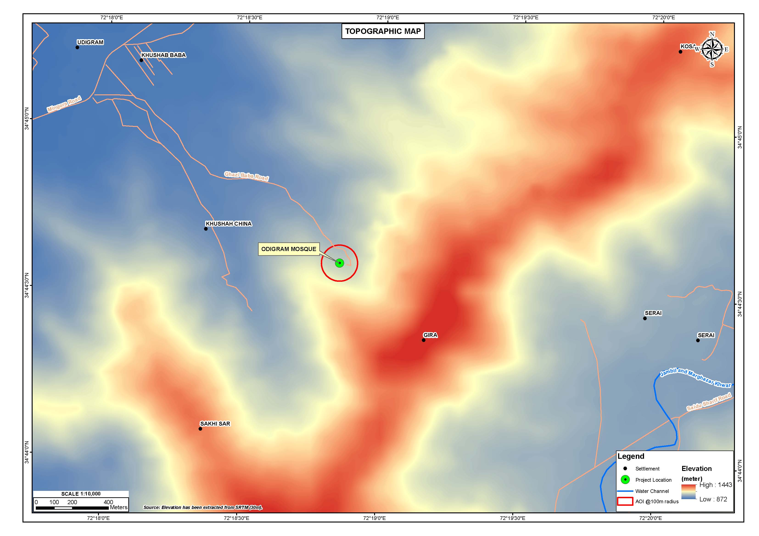
Figure 4-21: Topographical Map of Subproject Area (Odigram)
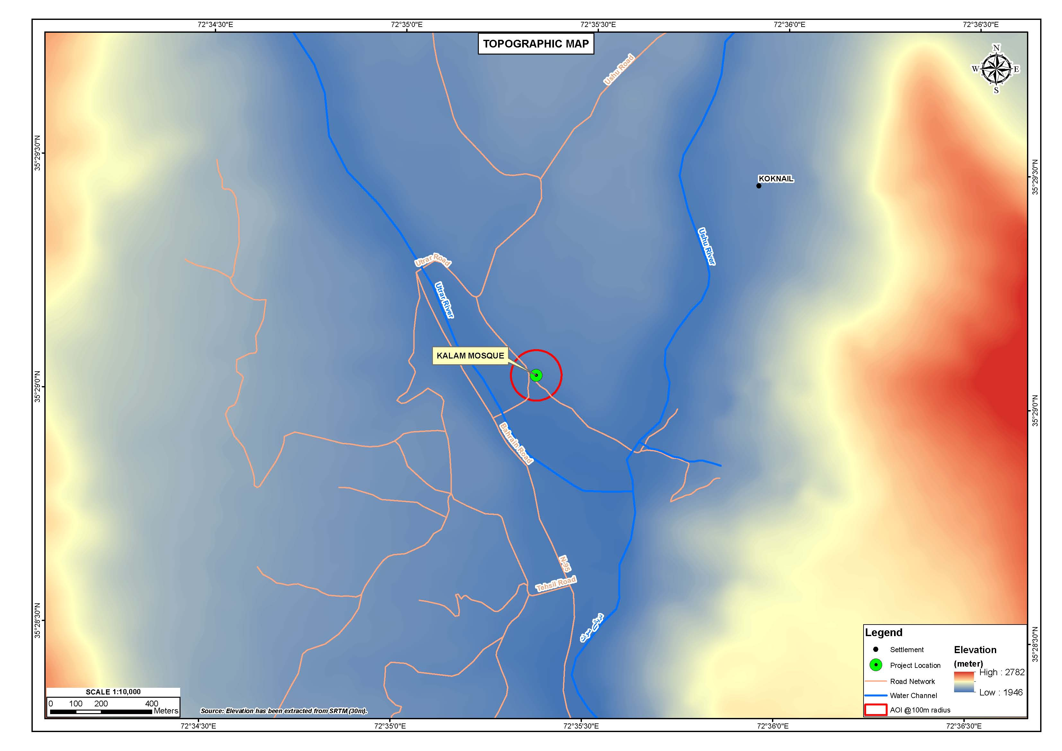
Figure 4-22: Topographical Map of Subproject Area (Kalam)
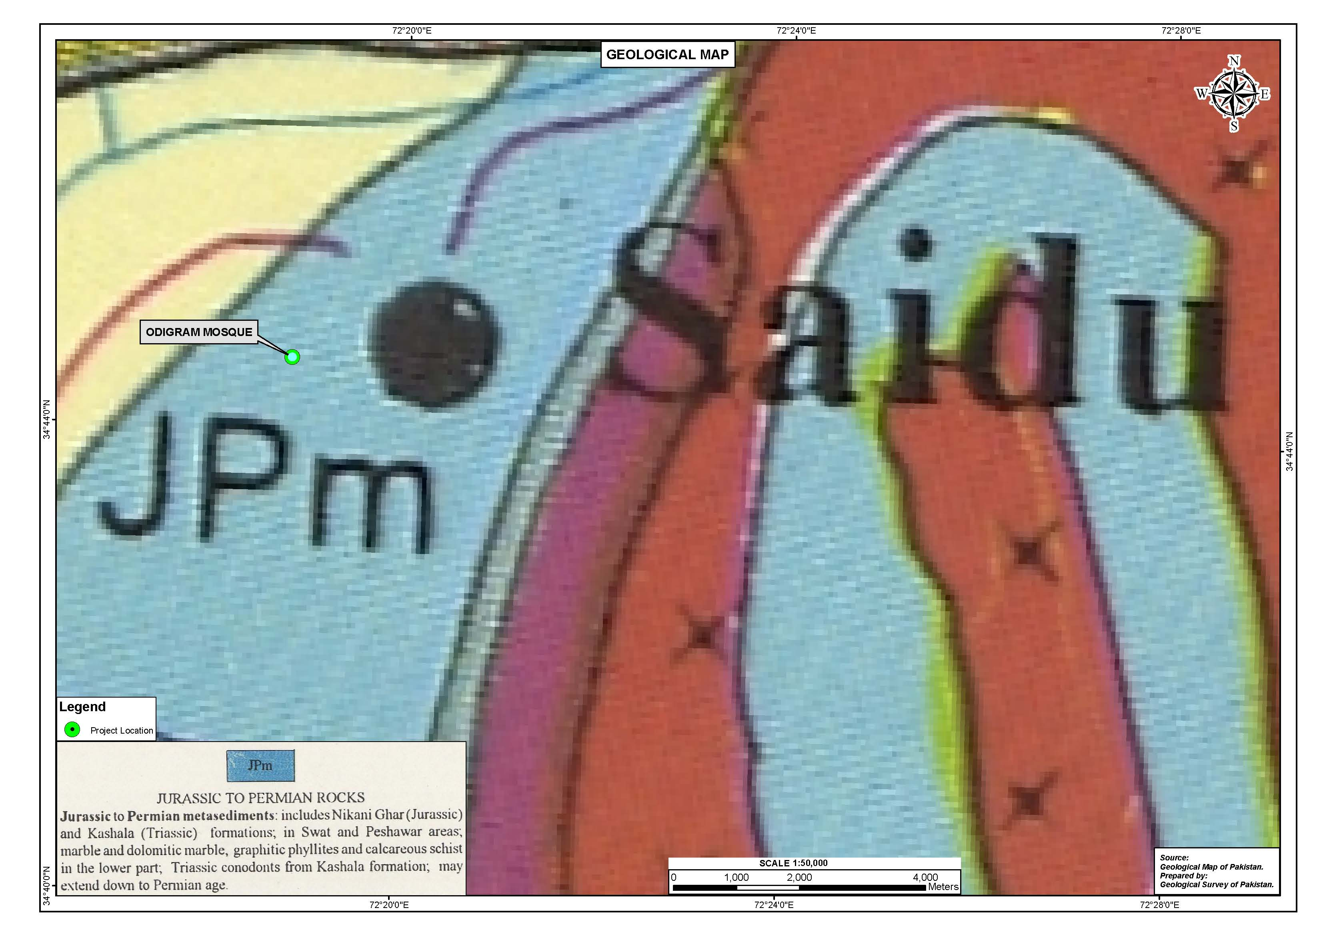
Figure 4-23: Geological Map of Subproject Area (Odigram)
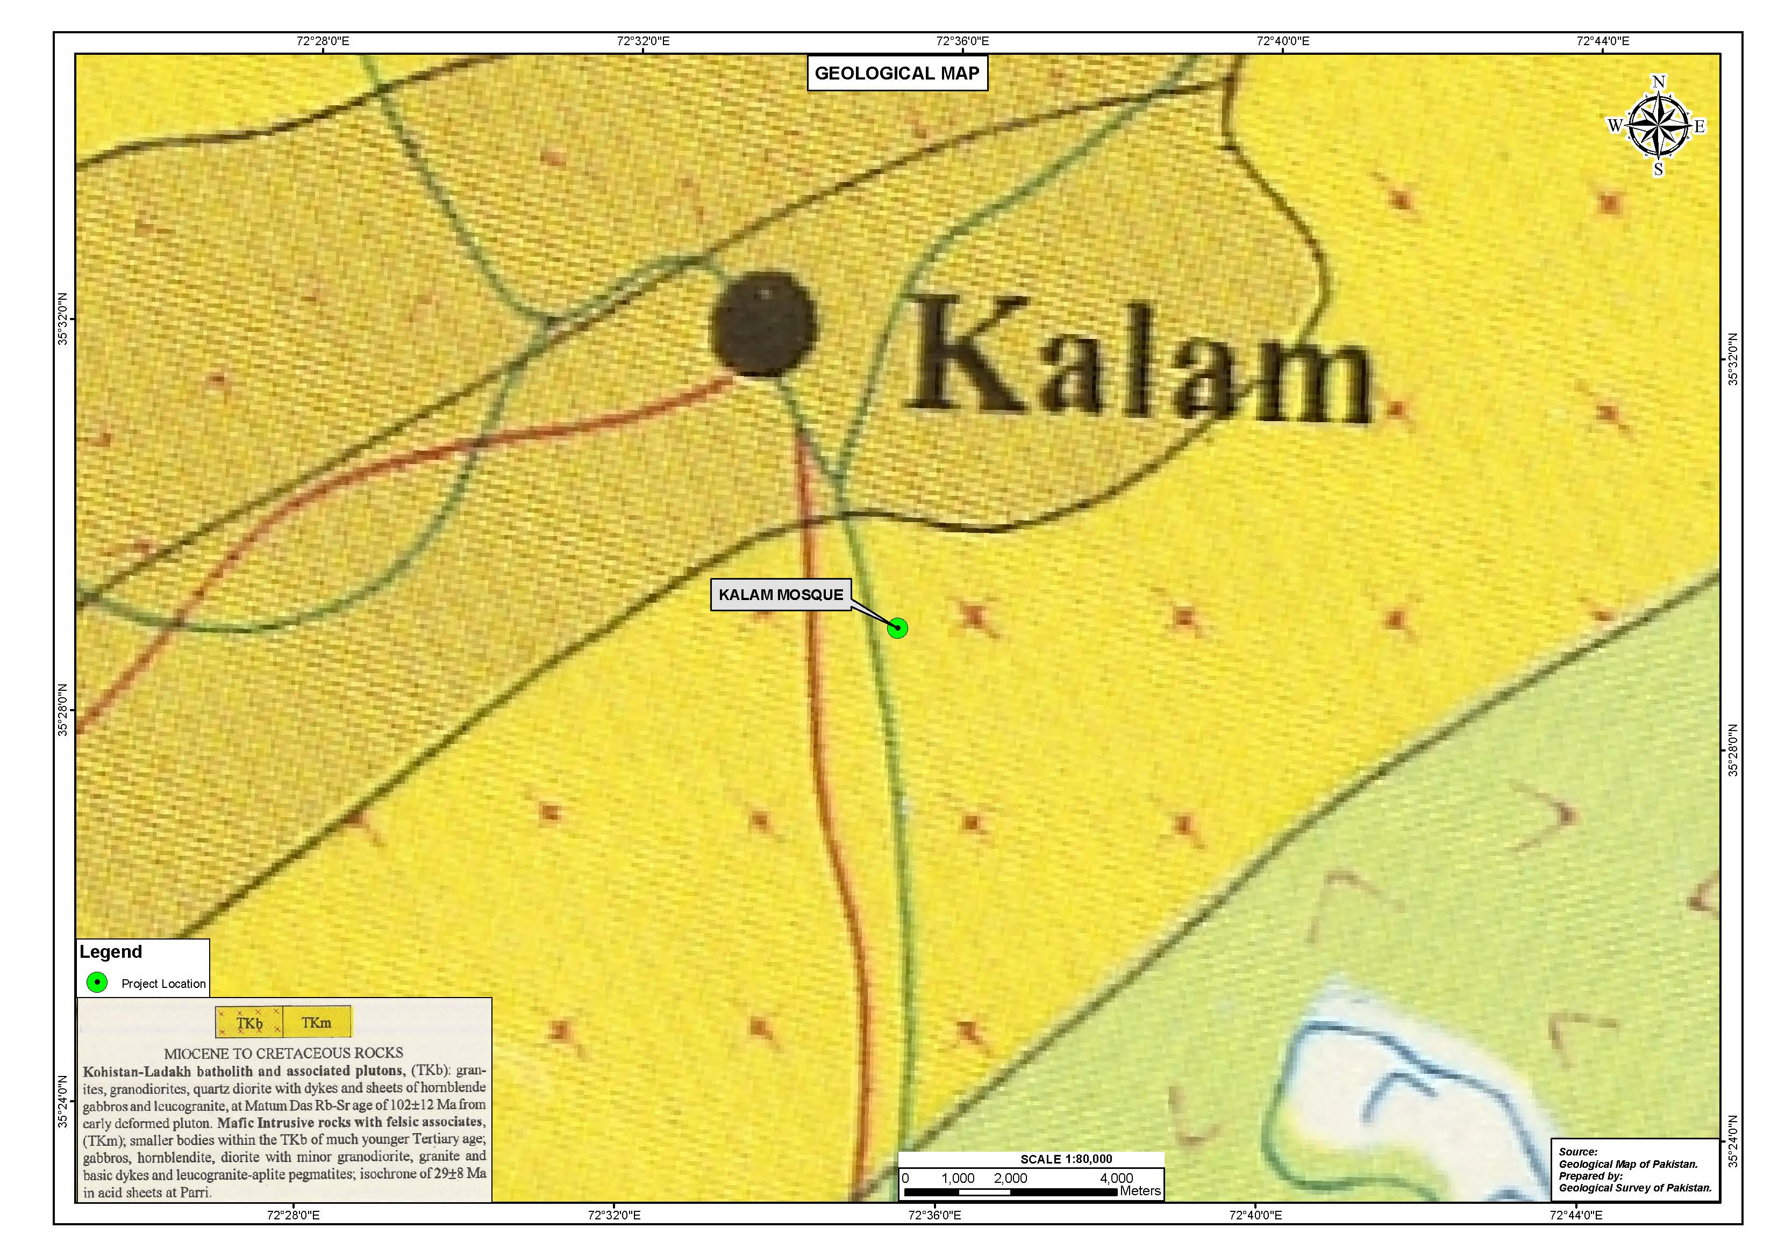
Figure 4-24: Geological Map of Subproject Area (Kalam)
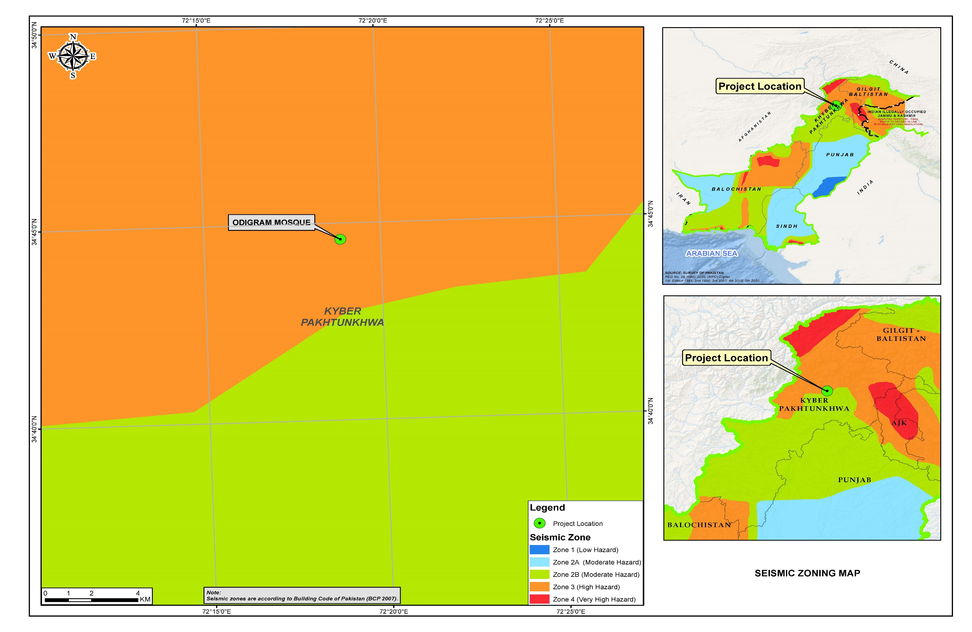
Figure 4-25: Seismicity Map of Subproject Area (Odigram)
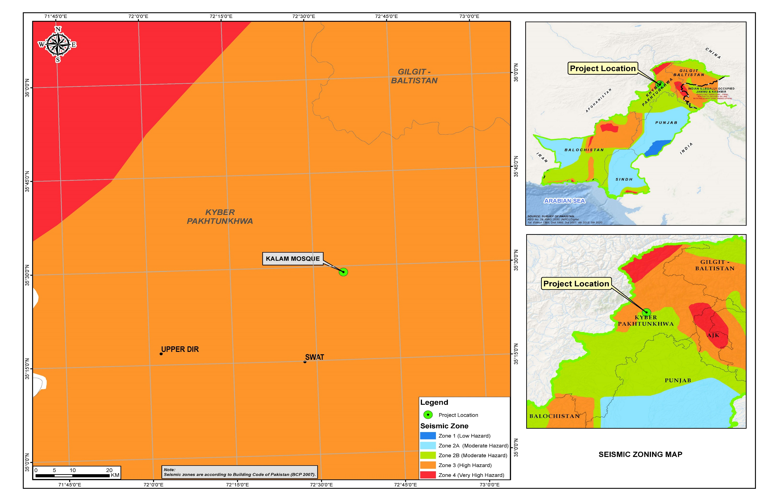
Figure 4-26: Seismicity Map of Subproject Area (Kalam)

Surface water

  - Irrigation Water
In district Swat, about 41% of the cultivated area is irrigated by canals (both Government and private), another 23% by wells (groundwater) for irrigation, while the rest is irrigated by other sources.

  - Swat River and Streams
River Swat is the main source of surface water commencing at Kalam with the confluence of Ushu and Utror Rivers. It flows for about 160 km across the valley up to Chakdara, while its total length is 250 km upto River Kabul near Charsadda. Many large and small tributaries like Gahil, Mankial, Daral, Chail, Barwai, Arnowai, Jambil and Marghazar streams join the river along its course. A number of streams in the lower Swat, Swat Ranrizai and Adinzai also contribute to the river. The river with its tributaries forms the drainage basin for the valley. Bashigram, Mahodand, Kundal, Daral Dand and Saif Ullah are major lakes and tourists’ spots of the district Swat. Maps showing surface water resources of the subproject areas (Odigram and Kalam Mosques) are provided as Figure 4.27 & 4.28.

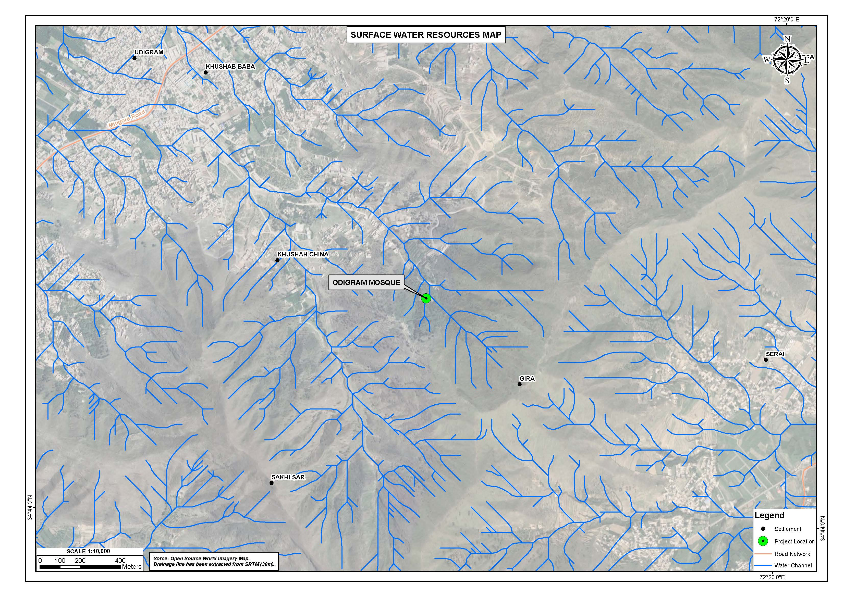
Figure 4-27: Surface Water Resources Map Subproject Area
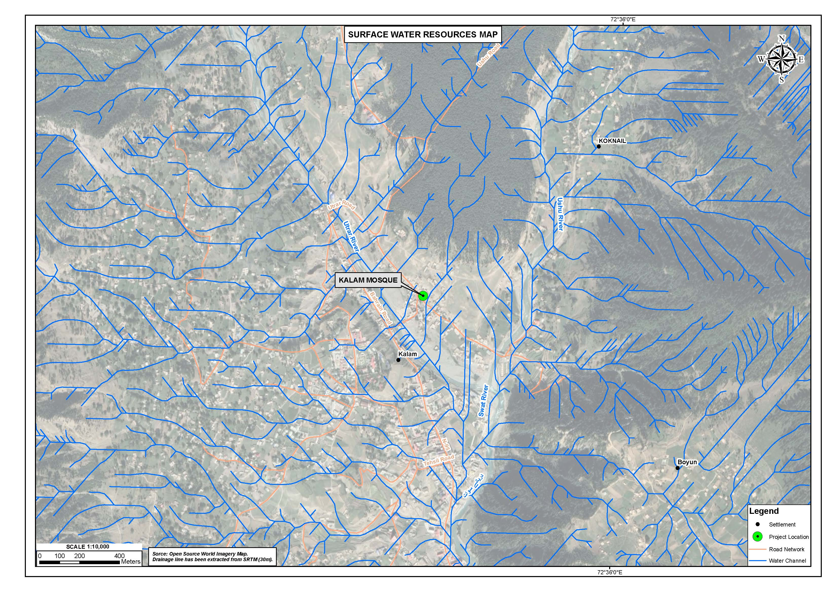
Figure 4-28: Surface Water Resource Map Subproject Area

Climate

The climatic conditions i.e. Average temperature, precipitation, humidity and wind speed of each district for period of 30 years (1981-2010) is given below.

Temperature

District Haripur: In District Haripur, the coldest month is February with mean temperature 2.1°C and June is the hottest month with the mean temperature of 25.1°C.

District Lower Dir: The coldest month in Lower Dir is January with 4.9°C mean temperature, whereas May and June are the hottest months with mean temperature of 26.1°C.

District Swabi, Khyber, Mardan: District Peshawar is the nearest climatic station for these sub-project areas. Based on the Table 4.1, the coldest month is January (11.5°C) whereas May and June are the hottest months with mean temperature of 32.8°C in all the three districts.

District Swat: The coldest month of District Swat is January in which the mean temperature is 8.3°C and hottest months are May and June with mean temperature of 27.9°C.

Mean monthly temperature data for all the subproject areas (1981-2010) is presented in Table 4.1.

Table 4-1: Average Temperature in Subproject Areas from 1981-2010
Temperature (ºC) in Months | HARIPUR | DIR | SWABI | MARDAN | KHYBER | SWAT
January | 6.8 | 4.9 | 11.5 |  |  | 8.3
February | 2.1 | 6.1 | 13.6 |  |  | 10.1
March | 12.2 | 10.2 | 17.8 |  |  | 14.1
April | 17.2 | 15.2 | 23.7 |  |  | 19.1
May | 21.7 | 26.1 | 29.4 |  |  | 24.3
June | 25.1 | 23.8 | 32.8 |  |  | 27.9
July | 24.5 | 25.1 | 32.2 |  |  | 27.9
August | 23.7 | 24.4 | 30.9 |  |  | 26.7
September | 21.9 | 21.4 | 29.0 |  |  | 24.3
October | 17.7 | 16.3 | 23.8 |  |  | 19.5
November | 13.3 | 11.3 | 17.8 |  |  | 14.2
December | 9.0 | 6.8 | 13.0 |  |  | 9.9
Average | 16.5 | 15.3 | 22.8 |  |  | 18.9
Source: Pakistan Meteorological Department
Precipitation

District Haripur: The maximum rainfall occurs in District Haripur during the month of July. The annual rainfall of the district is about 1324.7 mm.

District Dir: In District Dir, the maximum rainfall occurs during the monsoon season, the annual rainfall of district is approx. 1447.2 mm.

District Swabi, Khyber, Mardan: March is the wettest month in all these sub-project areas, and annual rainfall of the region is about 507.9 mm.

District Swat: The maximum rainfall occurs during the monsoon season in the month of March with annual rainfall of about 1081.5 mm.

Average precipitation data for all the subprojects areas (1981-2010) is presented in Table 4.2.

Table 4-2: Average Precipitation in Subproject Areas from 1981-2010
Mean Precipitation (mm) | HARIPUR | DIR | SWABI | MARDAN | KHYBER | SWAT
Mean Precipitation (mm) | Mean
January | 69.8 | 112.5 | 40.9 |  |  | 82.6
February | 104.4 | 176.0 | 60.1 |  |  | 120.0
March | 143.6 | 256.5 | 80.7 |  |  | 157.1
April | 111.9 | 166.0 | 62.1 |  |  | 125.0
May | 70.2 | 90.5 | 22.6 |  |  | 63.1
June | 88.9 | 56.4 | 20.4 |  |  | 57.5
July | 257.5 | 154.5 | 58.3 |  |  | 166.0
August | 235.6 | 147.5 | 77.1 |  |  | 124.7
September | 100.6 | 76.0 | 29.4 |  |  | 73.0
October | 50.6 | 72.3 | 22.1 |  |  | 46.8
November | 31.1 | 59.1 | 13.8 |  |  | 33.4
December | 60.4 | 79.9 | 19.9 |  |  | 51.6
Annual | 1324.7 | 1447.2 | 507.9 |  |  | 1081.5
Source: Pakistan Meteorological Department

Average Relative Humidity

District Haripur: The relative humidity, wind speed and direction has been recorded at three different times (e.g. 00 UTC, 03 UTC. 12 UTC) of the day. The relative humidity varies from lowest mean value of 52.6 % in June to highest mean value of 80.9 % in August.

District Dir:
The relative humidity of the district is varies from lowest mean value of 56.1 % in June to highest mean value of 75.9 % in February.

District Swabi,Khyber, Mardan:
The relative humidity of the sub-project areas varies from lowest mean value of 47.1 % in June to highest mean value of 77.7 % in December.

District Swat:
The relative humidity varies from lowest mean value of 54 % in June to highest mean value of 77.3 % in August.

Average Relative Humidity data for all the subprojects areas (1981-2010) is presented in Table 4.3.

Table 4-3: Average Relative Humidity in Project Area from 1981-2010
Relative Humidity  (%) | HARIPUR | DIR | SWABI | MARDAN | KHYBER | SWAT
January | 64.4 | 75.4 | 69.4 |  |  | 73.5
February | 65.8 | 75.9 | 65.4 |  |  | 72.6
March | 64.4 | 73.4 | 66.1 |  |  | 68.7
April | 59.8 | 67.4 | 59.8 |  |  | 65.0
May | 52.7 | 60.4 | 47.3 |  |  | 57.0
June | 52.6 | 56.1 | 47.1 |  |  | 54.0
July | 74.8 | 71.0 | 63.0 |  |  | 70.8
August | 80.9 | 76.8 | 71.3 |  |  | 77.3
September | 72.1 | 73.5 | 68.0 |  |  | 73.1
October | 61.2 | 69.2 | 66.1 |  |  | 68.6
November | 57.7 | 68.5 | 69.5 |  |  | 69.9
December | 60.6 | 72.5 | 71.7 |  |  | 73.5
Average | 63.1 | 70.0 | 63.7 |  |  | 73.5
Source: Pakistan Meteorological Department

Wind Speed

District Haripur: The average wind speed of the district is about 0.5 knots.

District Dir: The average wind speed of the district is about 0.7 knots.

District Swabi, Khyber, Mardan: The average wind speed of the sub-project areas is about 3.2 knots.

District Swat: The average wind speed of the district is about 0.4 knots.

Average wind speed data for all the subprojects areas (1981-2010) is presented in Table 4.4.

Table 4-4: Average Wind Speed in Project Area from 1981-2010
Wind Speed  (knots) | HARIPUR | DIR | SWABI | MARDAN | KHYBER | SWAT
Wind Speed  (knots) | Mean
January | 0.4 | 0.5 | 1.7 |  |  | 0.2
February | 0.5 | 0.6 | 2.7 |  |  | 0.3
March | 0.7 | 0.7 | 3.0 |  |  | 0.5
April | 0.6 | 0.8 | 3.5 |  |  | 0.7
May | 0.7 | 0.9 | 4.3 |  |  | 0.9
June | 0.7 | 0.9 | 4.9 |  |  | 0.8
July | 0.6 | 0.9 | 5.4 |  |  | 0.6
August | 0.5 | 0.7 | 4.7 |  |  | 0.3
September | 0.5 | 0.7 | 3.6 |  |  | 0.2
October | 0.4 | 0.6 | 1.9 |  |  | 0.2
November | 0.3 | 0.5 | 1.2 |  |  | 0.1
December | 0.3 | 0.5 | 1.3 |  |  | 0.2
Average | 0.5 | 0.7 | 3.2 |  |  | 0.4
Source: Pakistan Meteorological Department

Landuse

There are different classes of landuse i.e. barren/open area, built-up, roads/tracks, trees/bushes, park, graveyard, railway track and river. Landuse of the proposed subprojects based on the GIS landuse map in the AoI (100 m radius from the center of each archaeological site) are given from Figure 4.29 to 4.35.

Ecological Environment

Kalam Mosque Site

The ecological survey of the proposed subprojects site has been carried out to assess the existing biodiversity of the area, as well as to assess the impacts of construction activities on flora and fauna.

The mountain environments of the region in the Himalaya and Hindukush Ranges harbour several unique species of fauna and flora including many globally important species. Generally, these species and their habitats are gradually on decline due to anthropogenic changes coupled with natural calamities.

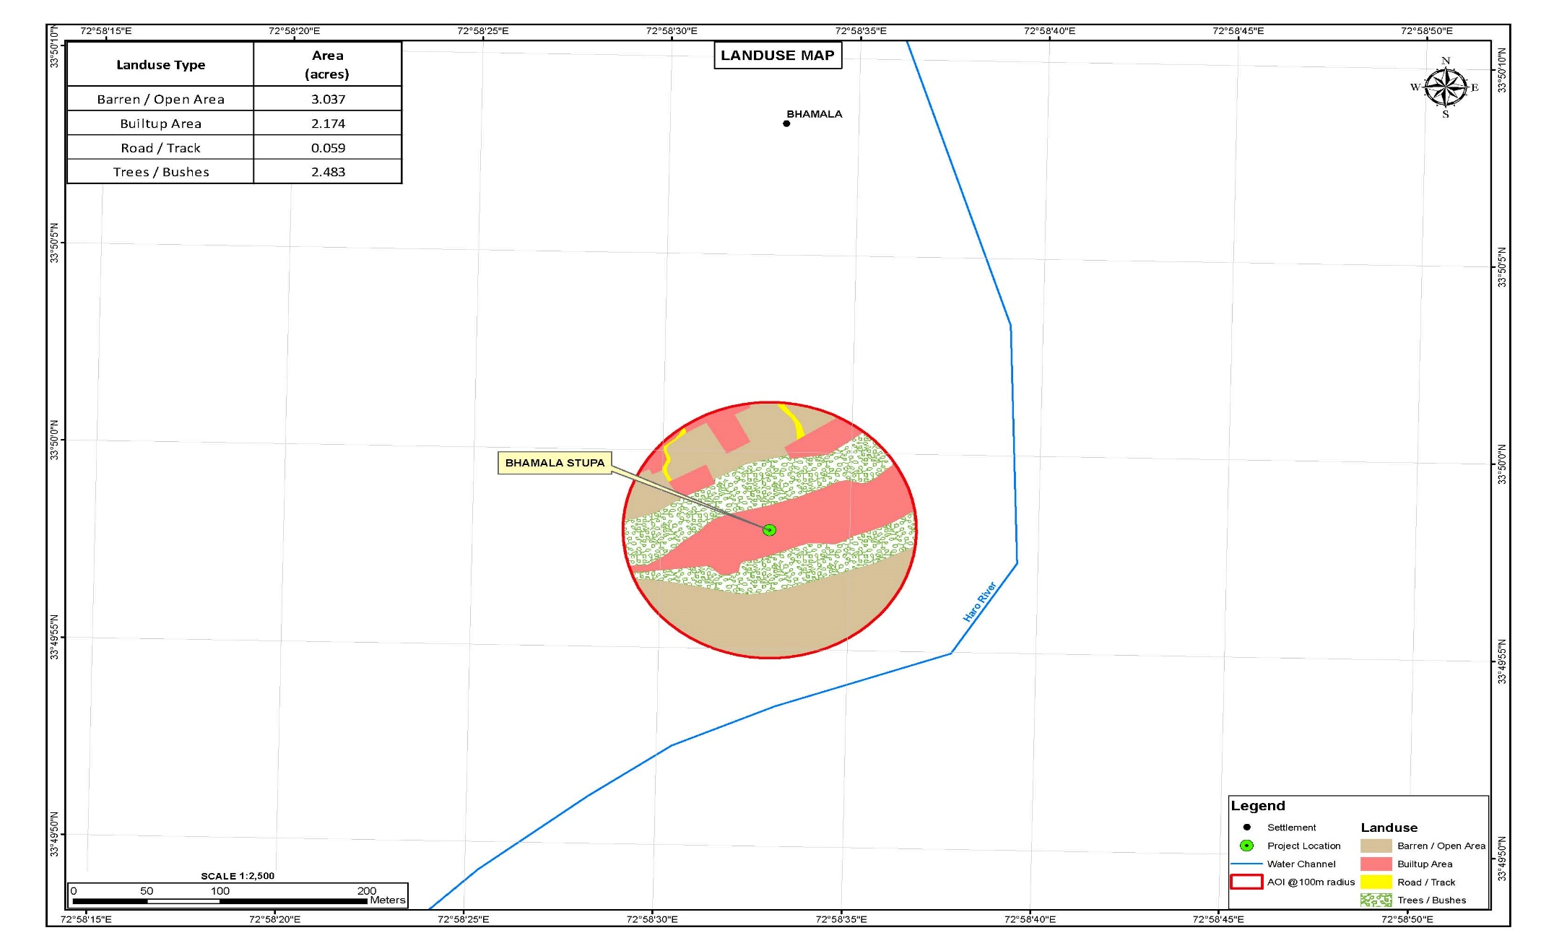
Figure 4-29: Landuse Map of Bhamala
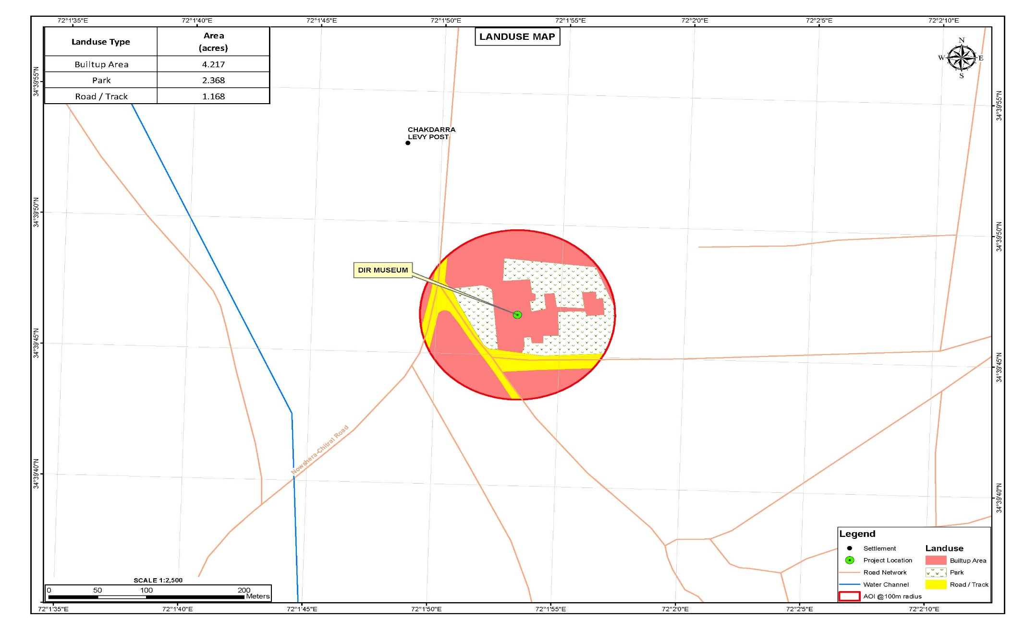
Figure 4-30: Landuse map of Dir Museum
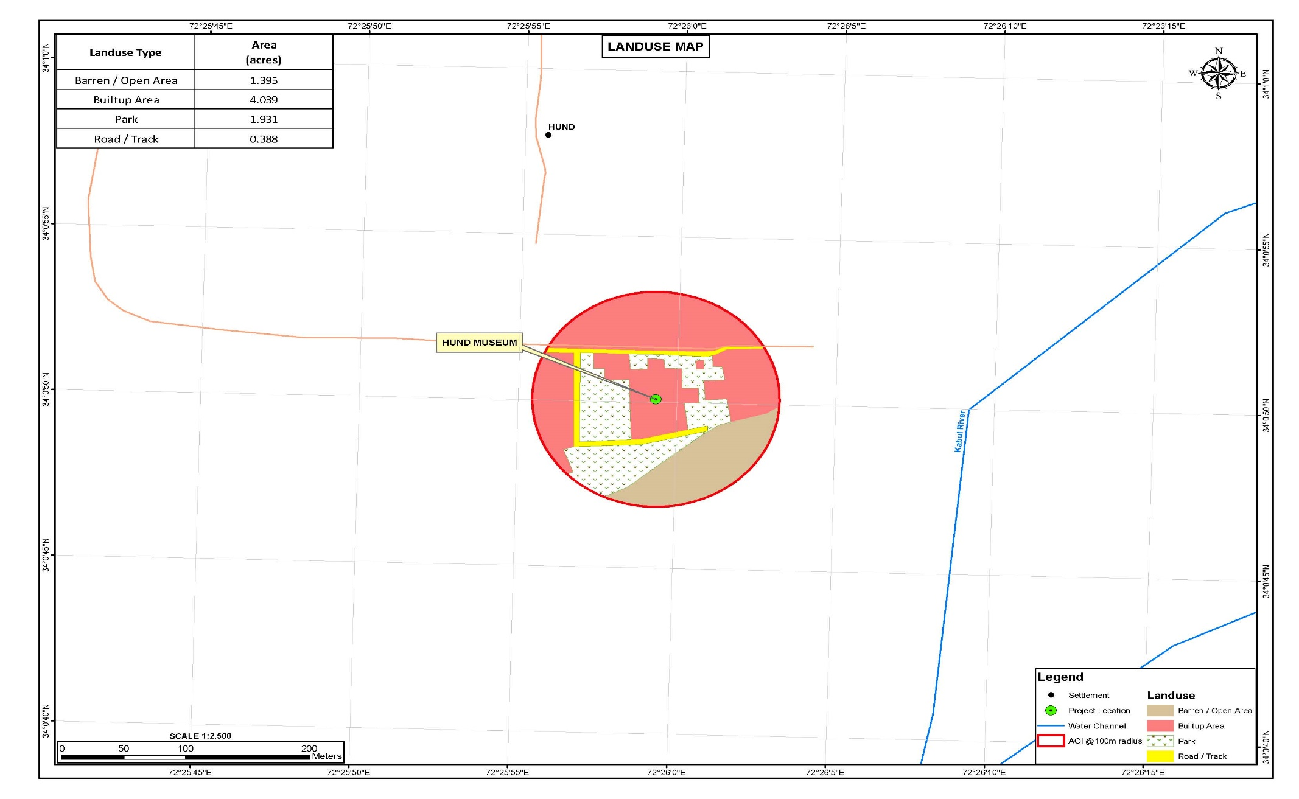
Figure 4-31: Landuse Map of Hund Museum
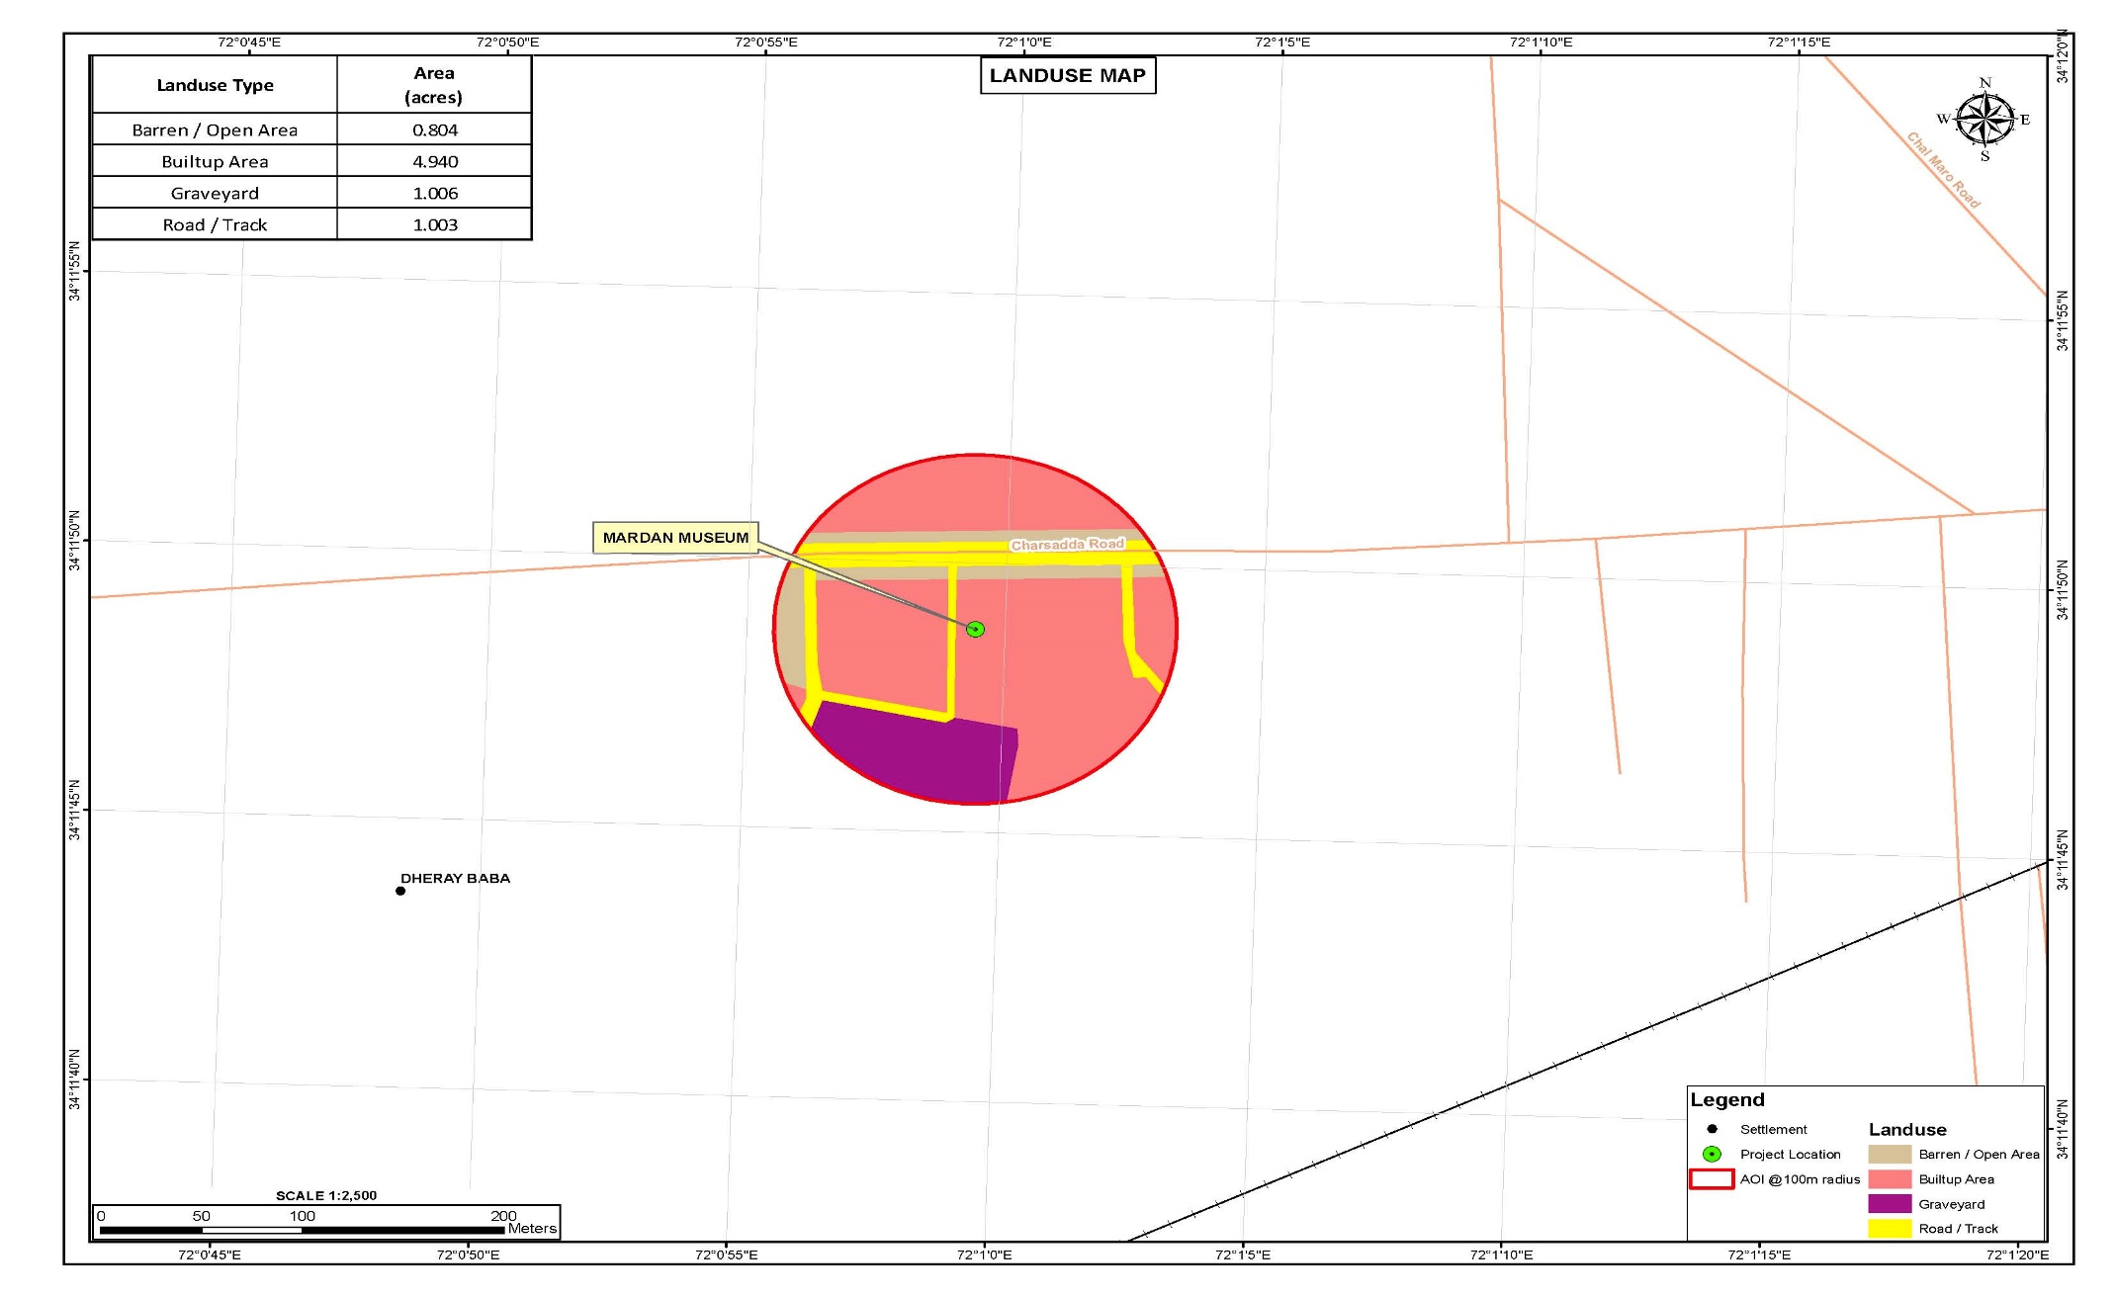
Figure 4-32: Landuse Map of Mardan Museum
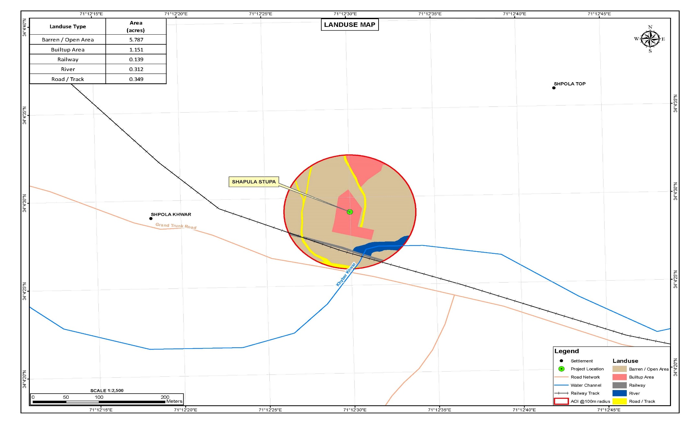
Figure 4-33: Landuse Map of Shapula Stupa
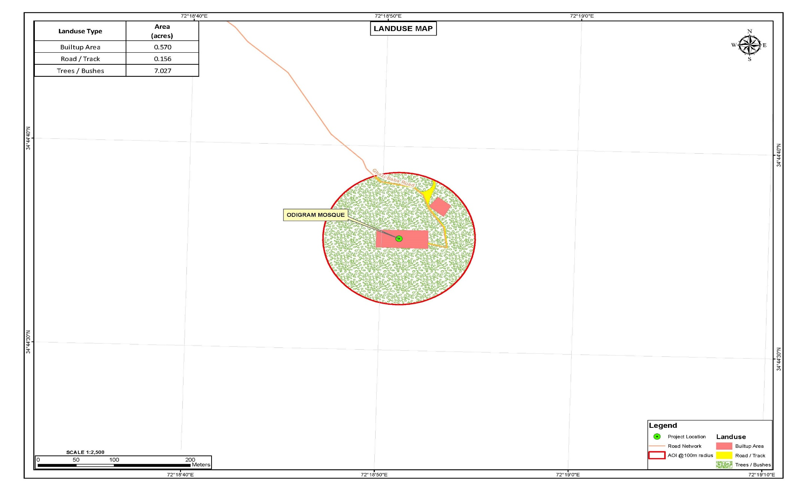
Figure 4-34: Landuse Map of Odigram Mosque
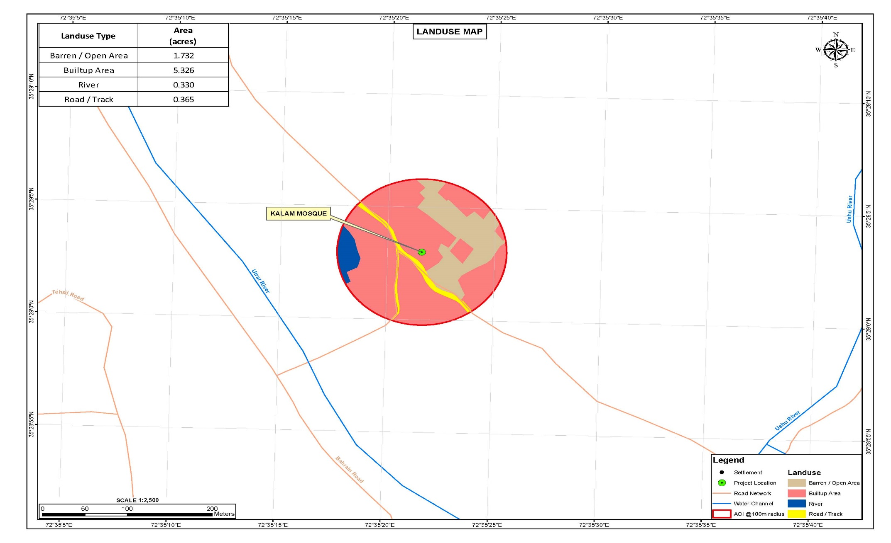
Figure 4-35: Landuse Map of Kalam Mosque
- Flora

The proposed Kalam subproject area is falling in dry temperate forest eco-zone, dominated by deodar species along the road side and nailed the high hills as well. Blue pine, fir, spruce and walnut is also found in the AoI. The anthropogenic pressures such as deforestation and grazing are destroying the characteristic of vegetation that has resulted in loss of herbaceous and shrubby vegetation.

The surrounding area of the proposed subproject (Kalam Site Mosque) is witnessed to scattered shrubs, and small trees including juniper Juniperus excelsa, commonly called the Greek juniper),/ Sagar/ kusum tree(Schleichera), plum (Prunus domestica), Guava (Psidium guajava), andwild vegetable (disambiguation).

Some major floral species of the Study Area / AoI are presented in Table:4.5

Table 4-5: Major Floral Species of the Study Area
Sr. No. | Local/English Name | Scientific Name
1 | Deodar/Diyar | Cedrus deodara
2 | Blue pine/Kail | Pinus wallichiana
3 | Walnut/Ghuz | Juglans regia
4 | Oak/Bunj | Quercus ilex
5 | Poplar/Supedar | Populus cilicata/nigra
6 | Toor Amlook | Diospyrus lotus
7 | Sur Amlook/Persiman | Debregeasia saeneb
8 | Ashan/Ban kor | Aesculus indica
Source: Field Observations and Literature Review
- Fauna

The faunal diversity in the area (specifically) is highly degraded due to its commercial status and urbanization in Kalam Bazar. The upper reaches and valleys of the Kalam Valley are highly important interims of natural resources and habitats/assets of wildlife.

The rapidly growing human population, increased poverty and great dependence on natural resources are leading to gradual habitat loss. Lack of the required legislation and polices with no recognition of local’s communities in the planning and management of natural resources have traditionally segregated communities, thus a decreased sense of local level ownership persists across the resource rich areas.

- Mammals

Some of the major wild life species in the subproject area is presented in Table:4.6

Table 4-6: Major Wildlife of the Study Area
Sr. No. | English/Local Name | Scientific Name | Conservation Status-IUCN
1 | Ermine | Mustela ermine | LC
2 | Kashmir Flying Squirrel | Eoglaucomys fimbriatus | LC
3 | Yellow Throated Marten | Martes flavigula | LC
4 | Wolf | Canus lupus | LC
5 | Small asian mongoose | Herpestes auropunctatus | LC
6 | Cape hare | Lepus capensis | LC
7 | Long-tailed marmot | Marmota caudata | LC
8 | Smooth-coated otter | Lutra prespcillata | LC
9 | Eurasian otter | Lutra lutra | LC
10 | Jackal | Canis aureus | LC
Source: Field Observations and Literature Review

- Avifauna

The Study Area / AoI is habitat to variety of birds like King Fisher (Alcedinidae Spp), Myna (Acridotheres tristis), Sparrow (Passeridae), Brown Accentors (Prunella fulvescens) and Green Dipper (Cinclus).

The list of common birds Found in the Study/Kalam area presented in Table:4.7

Table 4-7: List of Common Birds in Study Area
Sr. No. | English/Local Name | Scientific Name | IUCN/Conservation Status
1 | Jungle crow | Corvus macrorhynchos | LC
2 | Common sparrow | Passer domesticus | LC
3 | King Fisher | Alcedinidae Spp | LC
4 | Little brown dove/ laughing dove | Spilopelia senegalensis | LC
5 | Koklas pheasant | Pucrasia macrolopha | LC
6 | Monal pheasant | Lophophorus impejanus | LC
7 | Chukar | Alectoris chukar | LC
8 | Himalayan Snow Cock | Tetraogallus himalayensis | LC
9 | Goshawk | Accipiter gentilis | LC
10 | Common Kestrel | Falco tinnunculus | LC
Source: Field Observations and Literature Review

No other or conservation importance wildlife species are reported in and around the subproject area due to its commercial status and urbanization as discussed above.

Odigram Mosque Site

Particularly in the Study Area / AoI of Odigram, district Swat and Pakistan in general large number of valuable Multi-Purpose Fruit Tree Plants (MPFTP) naturally grow mostly in fragile ecosystems that are predominantly inhabited by poor rural and indigenous communities. The sustainable management of these traditionally used MPFTP not only help conserve nationally and globally important biodiversity, but also provide critical resources to sustain livelihoods.

Himalayan mountain region, for example, has in abundance, a diverse range of these species that have significant medicinal value and other importance whose local uses are known to indigenous community for centuries, but are currently threatened due to lack of concerted conservation efforts.

In all parts of the Study Area / AoI, MPFTP play a significant role in the subsistence economy of the people, especially those living in the rugged and impoverished hills, mountains and rural interiors. The collection, simple processing and trading of MPFTP contribute significantly to the cash income of the poor and women in the Study Area.

The high hills are providing stable and precious habitats to local wildlife. Those areas are intact which are away from human interference and untouched from hunting and poaching and the forest cover is good.

The subproject area (specifically) is falling under degraded habitat/modified habitat status and the forest cover is vanished and the land is converted into agricultural use and to commercial and residential buildings as well.

- Flora

The climate of the area has a typical version of humid subtropical climate, with five seasons. The Study Area majorly lies in sub-tropical scrub zone and sub-tropical chir pine zone. The dominant trees species of this natural zone are Chir pine, (Pinus roxburghii) Khau (Olea ferruginea), Phulai (Acacia modesta) and sanatha (Dodonaea viscosa). These forests type have been subjected to heavy felling and lopping as well as excessive grazing in the past and are now found in degraded condition.

The subproject area has some shrubs and small trees, refer Table 4.8. Commonly found plants and tree species near and around are Guava (Psidium guajava) and okra (Abelmoschus esculentus).

Table 4-8: Trees of the Study Area
Sr. No. | Common Name | Scientific Name
1 | Chir Pine | Pinus roxburghii
2 | Phulai | Acacia modesta
3 | Wild olive | Olea ferruginea
4 | Sanatha | Dodonaea viscosa
5 | Dhak | Butea frondosa
6 | Anar | Punica granatum
7 | Pear | Pyrus pasha
8 | Beri | Zizyphus mauritiana
9 | Poplar | Populus sp.
10 | Dharek | Melia azedarach
Source: Field Observations and Literature Review
- Fauna

Mammals

The study was once considered as good habitat to many wild species but due to expansion of population and commercialization the habitats of many species are decaled as degraded.
However, there is no wild mammalian species observed in the subproject area except some domesticated animals including cats, dogs, etc. However, the following Table 4.9 shows the list of mammalian species present in the region, as the Project Area is to be considered highly degraded in terms of wild fauna.

The Study Area / AoI (Odigram) is providing habitat to the following faunal species.

Table 4-9: List of Mammals in the Study Area
Sr. No. | Mammals | Scientific Name | Conservation Status-IUCN
1 | Jackal | Canis aureus | LC
2 | Fox | Vulpes vulpes | LC
3 | Jungle Cat | Felis chaus | LC
4 | Palm Squirrel | Funambulus palmarum | LC
5 | Mongoose | Herpestes auropunctatus | LC
6 | Indian mole rat | Rattus rattus | LC
7 | Field mouse | Funambulus pennant | LC
8 | Porcupine | Hystrix indica | LC
Source: Field Observations and Literature Review

- Avifauna

Many bird species have been reported in and around the Study Area. These include passage migrants, vagrant, resident, breeding and irregular visitors. The migratory birds descend from higher altitudes during the winter months but the Project Area does not have any potential and attraction for migratory birds.

The following birds are adding color to the Udiram Study Area/ AoI, refer Table 4.10.

Table 4-10: Birds Found in Study Area
Sr. No. | Common Name | Scientific Name | Conservation Status-IUCN
1 | Rock Pigeon | Columba livia | LC
2 | Myna | Acrido therestritis | LC
3 | Grey Partridge | Perdix perdix | LC
4 | House Sparrow | Passer domesticus | LC
5 | Red-billed chough | Pyrrhocorax pyrrhocorax | LC
6 | Magpie | Pica pica | LC
7 | Alpine Chough | Pyrrhocorax graculus | LC
8 | Grey shrikes | Lanius excubitor | LC
9 | Spotted doves | Spilopelia chinensis | LC
Source: Field Observations and Literature Review

Bhamala Site, Haripur

The district Haripur scrub and chir forest is providing habitat to many different wildlife species and having good forest cover which is playing a role in regional stability and environmental balance.

Forest cutting, urbanization, population growth, no planning toward land use, hunting and habitat destruction are major threats to wildlife. Fauna of an area depends on the flora present in the area because it provides food and shelter to the fauna and destruction of the habitats also results in the elimination or migration of species. The avian fauna of the Study Area was rich because the flora was thick.

- Flora

As climate of Study Area is subtropical, the vegetation of the area falls under subtropical broad leaved evergreen scrub and chir pine forest type as per phyto-geographical classification of the area. Major flora of the region is, chir pine, Olive, Ber etc.

The tract, in which the project site exists, was once covered with native vegetation consisting, of trees and thick cover of bushy vegetation, but with the onslaught of civilization, this vegetation was cleared for agricultural and other commercial purposes.

The entire surrounding area of the proposed site are scattered shrubs, and small trees including sylvestris (Phoenix sylvestris), grasses (Saccharum), Smilax aspera (rough bindweed). Following is the major floral variety of the Study Area, refer Table 4.11.

Table 4-11: List of common trees in the Study Area
Sr. No | Common/Local Name | Botanical Name
1. | Chir pine | Pinus roxburghii
2. | Sufaida | Populas alba (White poplar)
3. | Tooth/Mulbery | Morus alba
4. | Eucalyptus | Eucalyptus camaldulensis
5. | Bikyana | Ficus benjamina
6. | Phulai (Khona) | Acacia modesta
7. | Wild Pomegranate  (Annar) | Punica granatum
8. | Sanatha | Dodonaea viscosa
9 | AaK | Calatropis procera
10 | Sanatha | Dodonea viscossa
11 | Ber/Mullah | Ziziphus nummularia
Source: Field Observations and Literature Review
- Fauna

Mammals

The habitat health in the proposed subprojects area may be consider as degraded and poor, as on ground there is no attraction and safe havens for wildlife to stay and produce. The targeted Study Area/AoI is supporting habitat for the following mammalian species, refer Table 4.12.

Table 4-12: List of Mammals in Study Area
Sr. No. | Local/English Names | Scientific Names | Conservation  Status-IUCN
1 | Indian mole rat | Rattus rattus | LC
2 | Field mouse | Funambulus pennant | LC
3 | Porcupine | Hystrix indica | LC
4 | Rabbit | Oryctolagus cuniculus | LC
5 | Cape hare | Lepus capensis | LC
6 | Masked palm civet | Paguma larvata | LC
7 | Wild boar | Sus scrofa | LC
Source: Field Observations and Literature Review

- Avifauna

The proposed Study Area/AoI is not ecologically rich and may not be considered the home to rich biodiversity, following are some local birds of the area presented in Table 4.13

Table 4-13: Avifauna of the Study Area
Sr. No. | Local/English Name | Scientific Name | Conservation Status-IUCN
1 | House Sparrow | Passer domesticus | LC
2 | Red-billed chough | Pyrrhocorax pyrrhocorax | LC
3 | Magpie | Pica pica | LC
4 | Alpine Chough | Pyrrhocorax graculus | LC
5 | Grey shrikes | Lanius excubitor | LC
6 | Spotted doves | Spilopelia chinensis | LC
Source: Field Observations and Literature Review

Hund Museum (District Swabi) and Mardan Museum (District Mardan) Site

The forest cover is depleting with passage of time in the Study Area due to anthropogenic pressures and natural hazards. To conserve and protect the biodiversity bassline information in needed for management and planning purposes as well. Biodiversity management and conservation initiatives are only possible with the appropriate information on forest and wildlife and its habitat. Wildlife and forest habitat basically comprises soil, temperature food, cover, and water. Each species requires a particular habitat or the space, food, shelter, and other needs of survival so much so that species are said to be the product of their habitat

- Flora

The Study Area represents 140 taxa with 63 families including 4 Pteridophytic, 3 Gymnospermic and 56 Angiospermic families including 10 Monocots and 46 Dicots. Asteraceae was the top most in term of number of species (13 sp) followed by Poaceae (9 sp) and Solanaceae (9 sp) each. Fabaceae having 7 species followed by Moraceae, Amaranthaceae, Brassicaceae, Lamiaceae, Myrtaceae and Rosaceae 6 species each. Habitat class showed that herbaceous cover was dominant with 58.571% of the total flora followed by trees layer 25%, Shruby layer 11.42% and remaining 5.71% were climbers in area. Plant status concluded that 51.42% of plants were wild while 48.57% are cultivated. Biological spectra depicted that Therophytes were the dominant 40.71% followed by Micro-phanerophytes 18.57% in life form class while Microphyll, 43.57% were highest in leaf size class followed by Nannophyll 20.71%. Following are the major flora for the subject Study Area/AoI, refer Table 4.14.

Table 4-14: Names of Trees Encountered in the Study Area
Sr. No. | Common Name | Scientific Name
1 | Phulai | Acacia modesta
2 | Wild olive | Olea ferruginea
3 | Sanatha | Dodonaea viscosa
4 | Dhak | Butea frondosa
5 | Anar | Punica granatum
6 | Pear | Pyrus pasha
7 | Chir Pine | Pinus roxburghii
8 | Eucalyptus | Eucalyptus camaldulensis
9 | Tooth/Mubery | Morus alba
10 | Poplar | Populs euamericana
11 | Ber | Zizyphys mauritiana
12 | Kikar | Acacia modesta
13 | Sumbal | Bombax ceiba
Source: Field Observations and Literature Review
It is concluded that over utilization, over collection, over exploitation, habitat degradation, overharvesting, deforestation, population explosion and over grazing are the conspicuous biotic stresses which severely threatened the flora in the area which affect the population sustainability on earth crust.

- Fauna

The subject area was once/in past considered as suitable habitat for different wildlife species even for kalbi markhor and other game species but due to habitat loss, commercialization, illicit forest cutting, illegal hunting and ill planed urbanization the above ideal condition were converted to into degraded habitats and forest were converted into agricultural land and commercial and residential buildings. The subproject area is found degraded and almost barren and not supporting any designated habitats. The Study Area/AoI is supporting following Wildlife species, refer Table 4.15.

Table 4-15: List of Common Mammals of the Study Area
Sr. No. | Mammals | Scientific Name | Conservation Status-IUCN
1 | Jackal | Canis aureus | LC
2 | Fox | Vulpes vulpes | LC
3 | Indian mole rat | Rattus rattus | LC
4 | Field mouse | Funambulus pennant | LC
5 | Porcupine | Hystrix indica | LC
6 | Rabbit | Oryctolagus cuniculus | LC
7 | Cape hare | Lepus capensis | LC
Source: Field Observations and Literature Review

- Avifauna

The Mardan and Swabi area is majorly falling in subtropical evergreen scrub forest which is supporting/habitat to following birds as presented in Table. 4.16.

Table 4-16: List of Birds in Study Area
Sr. No. | Local/English Name | Scientific Name | Conservation Status-IUCN
1 | Myna | Acrido therestritis | LC
2 | Grey Partridge | Perdix perdix | LC
3 | House Sparrow | Passer domesticus | LC
4 | Red-billed chough | Pyrrhocorax pyrrhocorax | LC
5 | Magpie | Pica pica | LC
6 | Alpine Chough | Pyrrhocorax graculus | LC
7 | Grey shrikes | Lanius excubitor | LC
8 | Spotted doves | Spilopelia chinensis | LC
Source: Field Observations and Literature Review

Chakdara Museum, Dir Lower Site

The high hills of the Study Area are endowed with a rich variety of mammalian, avian and reptilian fauna. Vegetation of the subproject arae falls under humid–temperate latifoliate forest.

Dominate tree species consists of Chir pinr, Eucalyptus, and Kao etc. The other varieties found in the Project Area. Fruit trees in Study Area include Apple, Pear, Peaches, Walnut and Guava. Grasses consist of Nari, Lavindar, Deela, Trakla. Rich ground flora of many herbs including vibrunum, lonicera. A number of medicinal plants are also found in the area including Tarkha (Artemizia species), Unab (Zizyphus Sativa), Althea (Althaca Officinalis), Banafsha (Viola serpens), Mushki Bala (Valeriana species) and Sufed (Aspargus species).

The project is witnessed and experiencing altered condition. The previously natural habitats were recoded as degraded and modified habitats after clearing of vegetation and hunting and poaching of local precious fauna.

- Flora

The climate of the Study Area/AoI has a typical version of humid subtropical climate, with five seasons. The Study Area/AoI majorly lies in sub-tropical scrub zone and sub-tropical chir pine zone. The dominant trees species of this natural zone are Chir pine, Kau (Olea ferruginea), Phulai (Acacia modesta) and sanatha (Dodonaea viscosa). Some common trees in the Study Area are presented in Table:4.17.

Table 4-17: List of common trees in the Study Area
Sr. No. | Common/Local Name | Botanical Name
1. | Chir pine | Pinus roxburghii
2 | Poplar | Poplus euamericana
3 | Sufaida | Populas alba (White poplar)
4 | Tooth | Morus alba
5 | Eucalyptus | Eucalyptus camaldulensis
6 | Bikyana | Ficus benjamina
7 | Phulai (Khona) | Acacia modesta
8 | Wild Pomegranate  (Annar) | Punica granatum
9 | Sanatha | Dodonaea viscosa
10 | AaK | Calatropis procera
11 | Sanatha | Dodonea viscossa
12 | Ber/Mullah | Ziziphus nummularia
Source: Field Observations and Literature Review

- Floristic Composition

The Study Area falls in sub-tropical broad leaved evergreen scrub forest and sub-tropical chir pine zone. Dominant tree species Chir pine, include Phulai (Acacia modesta), Wild olive (Olea ferruginea), Sanatha (Dodonaea viscosa), Black berries (Monotheca buxifolia), Reptonia buxifolia, Beri (Zizyphus mauritiana), Royle's Spike Thorn (Gymnosporia royleana), Baikarh (Adhatoda vasica), Zebrawood (Pistacia integerrima), Tecoma undulate, and Capparis decidua on drier slopes. These are low branching small evergreen trees with varying densities. Some of these tree species are thorny. Most of these tree and shrub species produce substantial feed and fodder for wildlife and livestock. In subproject area, specifically 09 species of young acacia crop were observed.

These forests types have been subjected to heavy felling and lopping as well as excessive grazing in the past and are now found in degraded condition.

- Fauna

Mammals
The Chakdara Subtropical board leaved eco zone is witnessed to the different wild mammalian species. Most of the fauna in the Project Area is local or domestic. The birds such jungle crow, kite and common sparrow, King Fisher, Monal, Little brown dove can be seen.

The bird population is thin in subproject area. In early days when the shrubs and bushes covered slopes and foothill areas, the rabbits, porcupine, fox, jackal, wolf, pigs, and hyenas were in large number. Now the need for fuels decreased the scrubs and trees, so these animals have decreased considerably. Following Table 4.18 presenting mammalian species of the Study Area/AoI.

Table 4-18: List of Local Mammals in Study Area
Sr. No. | Mammals | Scientific Name | Conservation Status-IUCN
1 | Jackal | Canis aureus | LC
2 | Fox | Vulpes vulpes | LC
6 | Jungle Cat | Felis chaus | LC
7 | Palm Squirrel | Funambulus palmarum | LC
8 | Mongoose | Herpestes auropunctatus | LC
9 | Indian mole rat | Rattus rattus | LC
10 | Field mouse | Funambulus pennant | LC
11 | Porcupine | Hystrix indica | LC
12 | Rabbit | Oryctolagus cuniculus | LC
13 | Cape hare | Lepus capensis | LC
14 | Masked palm civet | Paguma larvata | LC
15 | Wild boar | Sus scrofa | LC
Source: Field Observations and Literature Review

- Avifauna

The following Avifauna was reported from the Study Area/AoI as presented in Table.4.19.

Table 4-19: Birds Found in Study Area
Sr. No. | Common Name | Scientific Name | Conservation Status-IUCN
1 | Rock Pigeon | Columba livia | LC
2 | Myna | Acrido therestritis | LC
3 | Grey Partridge | Perdix perdix | LC
4 | House Sparrow | Passer domesticus | LC
5 | Red-billed chough | Pyrrhocorax pyrrhocorax | LC
6 | Magpie | Pica pica | LC
7 | Alpine Chough | Pyrrhocorax graculus | LC
8 | Grey shrikes | Lanius excubitor | LC
9 | Spotted doves | Spilopelia chinensis | LC
Source: Field Observations and Literature Review

- Livestock

The subproject area is located in Chakdara. The livestock includes cattle, buffalos, sheep, goats, camels, horses, asses and mules.

- Agriculture

The land of Chakdara, Malakand District as compared to other areas is very fertile. Rice is the principal crop of Malakand.

- Endangered Species

No Endangered species were encountered in subproject areas.

- Game Reserves/ Wildlife Sanctuaries/National Park/Protected and Reserve Forest

There is no protected area falling in the subproject areas and no impact on such areas is anticipated.

Socio-economic Environment

The socioeconomic environment has been studied with respect to human and economic development and quality of life values of the population residing in the vicinity of the project site. The human and economic development will mainly focus on population and communities, industrial development, situation of infrastructure availability, institutions, transportation network, prevailing land use, power sources and agricultural pattern of the Project Area. Quality of life will include socio-cultural values, situation of public health, recreational resources & development and archaeological/historical and cultural sites etc. District wise socio-economic environment is discussed below:

Political and Administrative Settings in all Districts

Administrative settings are same in all the districts. The Deputy Commissioner supervises all the departments in the district and stationed at the head quarter. His major responsibility is to maintain law and order situation in the district as District Magistrate and look after the revenue records as District Collector. He is incharge of the treasury. He is assisted by the Assistant Commissioners in each sub- division. The Assistant Commissioners decide revenue cases as well as criminal case in the sub-divisions and also look after the law and order situation. The sub-divisions have a revenue set up of Tehsildar, Naib Tehsildar who have a number of Girdawar under them. The Girdawar stay in the Girdawar halqas and maintain an update record of the halqa with the help of Patwaris.

The judicial system is based on the Criminal Procedure Code and Civil Procedure Code likewise other district in the country. The District and Session Judge, assisted by Senior Civil Judge hear the civil and criminal cases. The public prosecutor contests the cases on behalf of the state. There is a well-established Bar of lawyer at the head quarter as well as the sub-division level.

The police department headed by Superintendent of Police who supervises and controls the police force in maintaining the law and order situation in the district. He also control and supervise the investigation in the criminal cases. He is assisted by the Sub-Divisional Police Officers on sub-division level.

District Mardan

The population of Mardan district, according to 2017 consensus, is 2,373,061 and the average household size of the district is 8.4 persons according to 1998 census which was 6.5 persons in 1981. As per 1998 census the urban proportion of the district is 20.2 percent of the total population whereas rural proportion is 79.8 percent. The population of the district is almost Muslim who constitutes 99.51 of the total population. The main minorities are ahmadi and christian who are 0.32 and 0.14 percent respectively. Other minority is hindu who are 0.02 percent of the total population. Mardan district is mainly inhabited by the Yusafzai Pathans but the Lundkhwar valley has sizeable Khattak population. The other main tribe of Mardan is Khattak. Besides these main tribes, some Sayyeds and Gujars are also found in the district.

A small industrial estate has been set up wherein a total of 66 factories were established out of which 36 are operating while the rest have been closed. Mardan is rich in sugar cane, tobacco, poplar and sheesham wood.

There is a lot of industrial activity for the production of sugar and manufacturing of cigarettes. In 1997-98, there are 77 industrial units of sugar, tobacco, match, furniture, marble, flour mills, steel industries, aluminum goods and handi crafts etc. In Mardan there is one Post Graduate College, 6 Degree Colleges, 1 Commerce College, 1 Vocational, 10 Higher Secondary Schools, 87 High Schools, 112 Middle Schools, 1141 Primary Schools, 10 Community Model Schools, JICA - Model Schools. There are 2-Civil Hospital. 5-Rural Health Centre, 50-Basic Health Centre, 2-Sub Health Centre, 13-Dispensaries, 2-M.C.H Centre and one Leprosy Clinic in the district. There are several place for visit such as Shahbaz Garhi, Kashmir Ghar, Sawal Dher, Jamal Garhi, Takht Bhai, Sari Behlol etc.

District Sawat

Swat District is in Malakand Division of KP province in Pakistan. Centered upon the upper portions. Provisional results of the 2017 census show District Swat with a population of 2,309,570 capita, which comprises of 50.8%male and 49.2% female population. The area has seen a population growth of approximately 84% in the last 19 years. Urban and rural population comprised of 695,900 and 1,613,670 inhabitants respectively. In addition to its dramatic and natural beauty, Swat valley has rich and diverse cultural tapestry with its cultural heritage. The people of Swat are peaceful, hospitable, friendly with the majority being ‘Pashto’ speaking. Swat is ethnically and linguistically diverse. This complicates lessons in the primary schools and beyond. The main ethnic groups living in the area are Torwali, Gawri, Gujar, Oshojo, Qashqari (Khowar), and Pashtun Communities.

There were 1,631 government schools in Swat, 1,367 were primary and of them 593 schools were for girls. According to the Alif Ailaan Pakistan District Education Rankings for 2017, Swat District with a score of 53.1, is ranked 86 out of 155 districts in terms of education.

To meet the health demands of the people, there are numerous clinics and hospitals in Mingora city. Saidu Teaching Hospital is located in Swat which is the 5th largest teaching hospital and institution of KP. The institution consists of two wings which are 1.5 km apart from each other. The institution has 1300 beds and further extension to 2000 beds new building is near to completion. The catchment area is Malakand Division and parts of Kohistan District. Moreover, the Jalil International Hospital, Sikandar Medical Infirmary Hospital, Hazara Medical and Hassan Medical Complex in Swat are providing better health facilities to the local communities.

Swat was home to Gandharan Buddhism and Hinduism, which lasted until the 10th century, after which most of the area converted to Islam. As per social survey almost 100 % people are Muslim in the proposed project area. The language spoken in the valley is Pashto, with a minority of Torwali and Kalami speakers in the Swat Kohistan region of Upper Swat. Specifically, in proposed project area, the Torwali and Gojri languages are being spoken on large scale. Yusufzais, Akhund Khel, Miangan (Syed), Chitralis, Kohistanis, Nooristani, Awans and Gurjar (Gujar or Gurjar, its people are divided in different clans including the Khatana, Bajar, Chechi, Ahir, Chauhan, Parmara, Gangal etc.) are the major tribes of the district Swat. Moreover, The Dardic people of the Kalam region in northern Swat are known as Kohistanis. They speak the Torwali and Kalami languages. Some Khowar speakers reside in the Kalam region. Tourist Attractions in Swat Valley.
Swat boasts great biodiversity and natural beauty, the valley has dramatic natural beauty and there are many places which have attractions for the tourists. The area has seven beautiful valleys and offers picturesque treks to Chitral, Ghizer, Indus Kohistan and upper Dor. It has some beautiful lakes such as Mahi Dhaan (Mahudand), Saidgey, Bishigram, Kandol Lake, Daral and Shaitaan Goot. Beside this, major attractive places of the district are Kalam Valley, Kumrat Valley, Madyan, Bahrain, Marghazar, Saidu Sharif, Malam Jabba and Fizaghat.

District Swabi

Swabi district is divided into four tehsils namely sabwabi tehsil, topi tehsil, lahor and razar tehsil. The population of Swabi district, according to the 2017 census, is 1,624,616. Swabi has a total area of 1543 sq.kms with a population size of 1,624,616 which comprises of 50.2% (approx.) male and 49.8% female population. The area has seen a population growth of approximately 36% in the last 19 years. District Swabi is one of the economically developed region of KP Province. The sectors on which the future development of district stands are Agriculture (cereal crops), Manufacturing (potentially leather, textiles, light and heavy engineering) and Mining (limestone, marble etc.). Additionally, the economy of this district can support a world class Knowledge City.

According to the Population Census of 1998, about 97% of the population of the Swabi and Haripur districts is Muslim, while the remaining 3% of the population consist of minorities such as “Ahmadis”, Christians, Hindus and other scheduled castes. All people belong to the Muslim “Sunni “school of thought. The Major tribes in the district are as follows: (a) Razzar (b) Utman (c) Jadoon (d) Umar Khel (e) Aba Khel (f) Khattak (in small numbers). Pushto is the main language of the district. However, Hindko is also spoken in few villages i.e. Jehangira, Tordher, Manki and Jangidher etc. People wear the traditional pakhtoon dress of Shalwar Kameez, turban and Chaddar with Peshawari Chappal as footwear. The women wear Shalwar Kameez and Dopatta in their houses while outside their homes, they use Chaddar for “Purdah”. In upper class women, the use of gold ornaments is popular. Ornaments made of silver (Chandi) are used by the women folk of lower classes. Most of the houses are made of bricks and stones. The house generally consists of 2 / 3 rooms with veranda. There are several educational Institutions exists in the District. Such as Govt; Post Graduate College Gohati (Swabi), Govt Degree College Kotha, Govt Degree College Lahore, Govt Degree College Shewa, Govt Degree College, Yar Hussain, Govt Degree College, Zarobi, Govt Degree College, Gandaf (Gadoon), Govt Girls College Maneri (Swabi), Govt Girls College Marghuz. Govt Girls College Manki, FEF Girls Degree College, Topi, Girls Degree College, Zaida, Govt Girls College, Shewa, Govt; Commerce College Bamkhel, Govt College of Technology, Swabi at Shahmansoor and Vocational College Anbar. The Ghulam Ishaq Khan Institute for Science and Technology in Swabi provides higher education in the disciplines of Science and Technology. In recognition of sacrifices rendered by the Kargil Hero, Karnal Sher Khan Shaheed (NH) Cadet College has been established in Swabi.

Mahaban is a famous mountain, which according to Dr. Stein has been mentioned in the Alexander campaign. It is about 2,182 above sea level. On the top of the ridge that stretches towards the Indus, known as SHAH KOT, old ruins of a fortress are still present. It is partly located in District Buner and the greater portion is in District Swabi. From here it extends into Haripur District. It is a potential hill resort for the people of the area due to its close proximity to Tarbela Dam, Topi, Gadoon Industrial Estate and Mardan; but infrastructure facilities are barely available. There are 7 veterinary hospitals, 24 dispensaries and 11 veterinary centers in the District. They provide health cover to 70% of the animals of different species for different diseases. Industrial Estate Gadoon Amazai was approved by the Federal Government to create job opportunities for the local people in order to stop poppy cultivation in the area. Initially 83 ha land was developed with a Provincial Government grant of Rs.24.800 Million for purchase of land and Rs.20 Million by USAID for construction of infrastructure.

District Haripur

The proposed project area falls in the administrative jurisdiction of Haripur District. Haripur District has two sub divisions i.e Haripur and Ghazi. The total area of the District Haripur was 1,725 square kilometers and there were two municipal committees, namely Haripur and Khalabat according to DCR 1998. According to Census of 2017, the population of Haripur District is 1,003,031 with an average annual growth rate of 1.97 percent from 1998 to 2017. According to census report 2017, the average household size for the district is 6.1 persons. Sex ratio, i.e. number of males for every 100 females, is 98.81 per cent recorded in 2017 Census. The ratio was 98.12 per cent in rural areas and 103.73 in urban areas. According to 2017 census, the rural population of the district is higher than the urban population. As per 2017 census, 876,454 or 87.38 percent of the total population of the district is rural which grew at an average rate of 1.93 percent during 1998-2017. The population of the District is predominantly Muslim i.e. 99.6 percent. The next higher proportion is that of Christians and Ahmadis with 0.1 percent. While other minorities like Hindujati, scheduled casts etc. also live in very small numbers. The population of the project area is also predominantly Muslims. One of the important races and tribes living in the Haripur District are the Tareen, Dilazak, Tarkheli, Gujar, Awan, Mishwani, Pathan, Gakhar, Jadoon, Syed, Tanoli and Turks. The main caste of population in the settlements of the Project area is Awan. While Afghani Pathan are also living in the project area. Hindko is the predominant language being spoken by majority of the population of the district Hazra followed by Urdu, Pashto, Punjabi, Balouchi and Pothohari etc.

Majority of the population of the Project area is running their own small level businesses like small shops, kiosks, mechanic workshops, cold drink shops etc. Beside this, the people of the project area also resort to labor jobs, while others go for government and private jobs in the Project Area. Industrial Estate of Hattar was setup in tehsil Haripur in 1985. About 214 industries including a large number of chemical industries, cotton, fiber, textiles and brick plants are functioning now in the estate. There are two government post graduate colleges in Haripur, which are providing higher level education. Along with these there are four government degree colleges for girls. RITE College for boys, Frontier Institute of Medical Sciences, The University of Haripur and Punjab College Haripur are also providing educational facilities in the district. The major health facilities available in the District are District Headquarter Hospital, two women & children hospital and two civil hospitals. About 200 dispensaries are working in urban and rural areas of the District. According to DCR 1998, there were 39 BHUs, 5RHCs and 12 Dispensaries functioning in the district. The famous recreational sites in the district are Tarbela Dam which is world’s largest earth-filled dam and Khanpur dam.

Khyber District

Khyber District is a district in Peshawar Division of Khyber Pakhtunkhwa province in Pakistan. Until 2018, it was an agency of Federally Administered Tribal Areas, with merger of FATA with Khyber Pakhtunkhwa, it became a district. The population of Khyber district, according to the 2017 census, is 986,973. The majority of the tribes in Khyber Agency are Afridis. However, there are important pockets of Mullagoris, Shilmanis, Bangashs and Shinwaries. It ranges from the Tirah valley down to Peshawar. It borders Nangarhar Province to the west, Orakzai District to the south, Kurram District to south west, Peshawar to the east and Mohmand District in north. The majority of Afridis live in Khyber Agency, Dara Adam Khel, Kohat and Peshawar. Khyber District is currently subdivided into four tehsils i.e. Bara, Landi Kotal, Jamrud and Mula Gori. Khyber district is the most literate of all the Tribal Areas, with a literacy rate of 34.2%, as of 2007. Quite far ahead of the next highest Agency – Kurram at 26.5%. It is also the only Agency where the majority of its men are literate, at 57.2%, which is almost 20% ahead of the next highest agency, Kurram. However, its female literacy rate of 10.1% is 2nd after Kurram's 14.4%.

The most widely spoken language is Pashto, native to 80% of the population. Other languages with significant numbers of speakers include Hindko (9.9%), Saraiki (3.2%), Khowar and Kohistani. The majority of the residents of the Khyber Pakhtunkhwa overwhelmingly follows and professes the Sunni principles of Islam while the small followers of Shia principles of Islam are found among the Isma'ilis in the Chitral district. The tribe of Kalasha in southern Chitral still retain an ancient form of Hinduism mixed with Animism.

District Lower Dir

Lower Dir has a total area of 1,583 sq.kms with a population size of 1,435,917 which comprises of 49% (approx.) male and 51% female population. The area has seen a population growth of approximately 100% in the last 19 years. It is relatively new districts of KP, formed in 1996. Lower Dir, has relatively more plain areas as compared to its Upper counterpart but it is still mountainous. Agriculture, horticulture, mining and construction are the main sources of income generation for the population. It has four tehsils namely adenzai, lal Qilla, samarbagh and timergara.

There are 1,023 villages in district Dir lower in which there are 827 boys primary schools,405 girls primary school, 62 girls middle schools,90 boys middle schools, 14 girls high schools,52 boys high school, 12 boys higher secondary schools,3 girls secondary school, 120 private schools, 2 Boys Colleges, 2 Girls Colleges, 1 University (University of Malakand at Chakdara, Established in 2001).

The adult literacy of the district among the population aged 10 years and above is 93.9% which has increased significantly since 1981 when it was just 10.16 percent. The male literacy ratio is 95.76%> compared to 85.25% percent for females, according to census report 2018.

Common Characteristic in all the Districts

- Family System

Family system and inhabited status play an important role to establish a strong, sustainable and well recognized and identified society/community. It also provides a binding force to unite and to make struggle to achieve their objectives or targets and a large family size is also considered as the strength of the family particularly in Pakhtoon culture.

The Joint family system is the dominant culture in the area. It was observed that the family structure in the area was very strong and members played a pivot role in solving their social and cultural problems.

Most of the families are living in joint family system comprising grandparents, uncles, aunts and lot of cousins, whereas only a small percentage of families are living as a single family (nuclear family system). Although the joint family system is generally undergoing a radical change, with a greater influence of media and education whereas people of the Project Area do not feel good about this change. Because while living in a joint family system a lot of emotional attachments are enhanced and they feel that by separating in nuclear family system, their relationships will be damaged and family ties will be weakened.

As per the locals, joint family system is basically a form of organization. In this organization, there are defined norms and values to be followed strictly by all the members. All the members have their defined tasks and responsibilities to perform. There is an equal share of each and every member of the family with the available resources in the form of money, food and other requirements and locals feel better in joint family system as compare to nuclear family.

During the discussion with the locals, it was clarified that large family size is also treated as the strength of the family.

- Mechanism of Conflict Resolution

The people of the proposed Project Area are peaceful, hospitable and friendly. During the field survey, group discussions held with the local communities, it was observed that most of activities are carried out under the instruction of the head of a family and village committee. Although the project area is very peaceful but disputes are inevitable and take place in all human societies. Hence, the local community of the project area is not immune from having disputes at all levels among individuals, families or even tribes. Most of the conflicts in the Project Area are insignificant, i.e. crossing the boundaries of grazing area and quarrels among youngsters which are mutually resolved within the local communities.

The local community has been using the Jirga system which is the oldest and still one of the typical dispute resolution mechanisms in the society. Although the Jirga system has been very crucial in ensuring the administration of justice and harmony in the community in various ways, it has also been subjected to several criticisms due to its application of unwritten rules and informal structures which sometimes may lead to grave injustice to the parties to the disputes.

But majority of the disputes are being settled at local level through community heads and Jirga system. Sometimes, the conflicts not resolved by the parties would be referred to the police or court of justice.

PROJECT ALTERNATIVE

General

This section outlines different project options considered and compares the environmental and economic aspects associated with these options. The following alternatives have been identified and are discussed in further detail below:

Alternative I: No Project Option

Archaeological tourism has expanded rapidly across the world since the 1990s. It makes a major contribution to national economies and to local prosperity.

Tourism is an important contributor to KP’s economy and job creation, and the number of domestic tourists traveling to KP keeps growing rapidly. KP is blessed with diverse tourism attractions, catering to all interest types. KP’s rising value in the tourism sector is also evident from the fact that its expenditure in tourism sector rose from Rs. 86.23 million in the financial year 2012-13 to Rs. 791 million in financial year 2018-19. The increased tourism promotion has led to an unprecedented rise in tourist traffic in the province, resulting in growth in economic activity in the province and the creation of new employment opportunities for the local population.

To promote the tourism, conservation and development of archeological sites are utmost need as existing sites are not in good condition and lacking basic amenities. The proposed subprojects will ultimately increase the business / employment opportunities for the locals leading to a decrease in poverty. The project aims to enhance under-utilized potential of KP’s tourism sector for generating income and revenues, by providing an enhanced tourism experience to domestic and international tourists, while focusing on preservation of environment, wildlife, culture and heritage. Many tourists from KP and all over Pakistan visit these areas especially in the summer season.

The No Project Option (NPO) considers continuation of no further conservation and development. Inadequate site management or unavailability of related facilities will result in further deterioration or even likely destruction of the archeological site and its related social, historical, educational, scientific and economic potential. Therefore, this option is not feasible in terms of cultural resource and economic aspects.

Alternative II: Construction Alternative

Road construction is a major construction activity. The two (02) most common materials used for pavement construction are asphalt and cement concrete. The proposed subproject (Shapula Stupa, Landi Kotal District Khyber) will, involve the construction of 800 m road, be an asphalt based pavement as proposed by the Design Consultant. However, the option of concrete is also available. Both options have certain advantages and disadvantages with its application. The comparison of both with respect to environmental and quality constraints are provided hereunder, refer Table 5.1:
Table 5-1: Comparison between Asphalt and Cement Concrete
Asphalt | Concrete
Advantages
- New asphalt is quieter than concrete. Though it creates a smooth drive, it also boasts better traction and skid resistance.  - Asphalt is 100% recyclable. When melted down, it can be used again to create new roadways  - Since asphalt is black, it utilizes the natural heat from the sun to help keep the roads clear after storms. Heat absorbing into asphalt creates an ideal atmosphere for moisture evaporation. | - The biggest benefit of concrete road construction is the longevity. Lasting 20-40 years on average, paving in concrete can boast two to four times the lifespan of asphalt.  - Concrete is recyclable. Once crushed into gravel, concrete can be used in a variety of ways.  - High truck volume is better suited to concrete roads, as they hold up better under the weight and pressure.  - Concrete tends to be a greener material. Producing it creates less environmental pollution, and cars run with better fuel efficiency on concrete. Concrete is also produced from limestone, which is widely available.
Disadvantages
- The process of melting asphalt creates greenhouses gasses, which contribute to environmental pollution. This happens regardless of new production or recycling.  - Asphalt is a cheaper and faster solution for short-term projects, but the repairs are sometimes just as extensive as concrete. With only a 10-year lifespan, asphalt must be re-laid or repaired on a much more regular basis. | - Concrete doesn't always make for a smooth ride. In order to create enough grip on the road, texture is brushed into the surface. This, and slabs settling over time, can make for a somewhat bumpy and noisy roadway.  - Though concrete lasts a long time, repairing it is a bigger chore. Holes or cracks can't be simply patched--instead, entire slabs must be replaced.  - The costs of concrete roads are also higher than that of asphalt, both in installation and repair.  - Concrete is not as "grippy" as asphalt, either. Spills, vehicle chemicals, and other pollutants do not absorb into concrete as well as asphalt. This material is also more prone to slippage during rain.

Determining which type of pavement is more environmentally and cost effective is a difficult process which will never be 100% accurate, due to varying stress loads and environmental damage that will occur over time. Establishing the impacts of resource use and waste outputs on sustainable development is a difficult task and requires a life cycle assessment.

The two (02) types of pavements were compared above based on summary environmental effects. It would be a more realistic to compare the annualized environmental burdens, taking into account the expected service life or durability of the two pavement types. However, the design life of pavements depends on many local factors, such as climate, traffic types and volumes, and quality of work, materials, sub-base, and so forth.

Based on the above analysis, the design consultant has proposed the asphalt based pavement solution.

Public Consultation and Information Disclosure

General

The consultation and information disclosure to the PAPs, local community and other stakeholders during project planning, designing and implementation stages is a key to sustainable development. Likewise, participation of stakeholders at all stages of project preparation is essential to meet the objectives of meaningful consultation under resettlement policy. During preparation of the ESMP, PAPS and other stakeholders from different fields of life were consulted to learn their concerns and adopt appropriate measure in project design, resettlement planning and implementation and disseminate requisite information about project impacts, bank policy guidelines and land acquisition parameters.

Objectives and Principles of Consultation

Consultations are key processes through which stakeholders influence project decision making and outcomes. It is the starting point for all resettlement activities. Experiences have shown that many resettlement-related problems are avoidable provided consultation activities are undertaken ahead to engage the community in local decision making. In many ways, stakeholders’ consultations are “problem-solving” opportunities and help find meaningful options to various problems. It is always a two-way process where the executing agency, policy makers, beneficiaries and affected persons discuss and share their concerns in a project process.

The stakeholder’s communication policy is based on the principles of transparency, timeliness, participation, meaningful engagement, and inclusiveness. Means of communication and consultation are to promote participation of those who may otherwise tend to be marginalized such as women, elderly, disabled and the poor. Stakeholder’s communication will encompass institutional stakeholders, communities within the project area, and persons directly affected by the project.

In order to meet the criteria of meaningful consultation process, consultations were held with PAPs and local community from early stages of the project. At the start of the project, during the preparation of environmental and social screening reports during the month of July, 2021 for the preparation of ESMP, a series of consultation sessions were held with the PAPs, local community and institutional stakeholders. These consultation meetings proved very useful for information sharing and consensus building. Concerns raised during the meetings were incorporated in the ESMP.

The consultation process will be continued to share the latest development interventions in the project and solicit responses from the PAPs. Consultation sessions were held in different settlements along the project route.

At this stage, specific objectives of the public consultation were as follows:
- To share fully the information with the affected people about the proposed subprojects, components and activities, latest interventions in the project development;
- To share the views of local people and PAPs about the land acquisition and compensation process;
- To identify possible social impacts during the construction and operational phase of the project;
- To obtain the co-operation and participation of the PAPs in the planning and implementation process;
- To ensure transparency in all the project activities through sharing the information;
- Increase public confidence about the proponent, reviewers and decision makers; and
- The guiding principle underlying consultations is that social safeguard planning and implementation must follow a consultative and participatory process to ensure success of the project. This was further reinforced by the requirements of the World Bank OP 4.12.

The policies which give high priority to public consultation and participation during designing and implementation process are provided in Table 6.1.

Table 6-1: Frameworks for Consultation
Legal/ Policy Source | Regulations/Safeguard Policy Requirements
Government of Pakistan | - Land Acquisition Act (LAA) 1894 requires disclosures i.e. Under/4publication of preliminary notification; under Section/5A public purpose and hearing of objections  - Environmental Protection Agency (EPA) 1997 Guidelines for Public Consultation requires public consultation and involvement in project planning and implementation. The policy and procedures require proponents to consult with affected community and relevant NGO during preparation reports. The guidelines contain a number of references to the need for Public Involvement.
World Bank | - OP.4.01, Clause 14 described that for all Categories A and B projects proposed for IBRD or IDA financing, during the EA process, the borrower consults project-affected groups and local non-governmental organizations (NGOs) about the project’s Environmental aspects and takes their views into account. The borrower initiates such consultations as early as possible. For Category A projects, the borrower consults these groups at least twice: (a) shortly after environmental screening and before the terms of reference for the EA are finalized; and (b) once a draft EA report is prepared. In addition, the borrower consults with such groups throughout project implementation as necessary to address EA-related issues that affect them.  - OP 4.12/Involuntary Resettlement: (i) Displaced persons should be meaningfully consulted and should have opportunities to participate in planning and implementing resettlement plans; (ii) Affected persons should be informed about their options and rights pertaining to resettlement; (iii) APs may be involved in the planning, implementation, and monitoring of the resettlement program, especially in the process of developing and implementing the procedures for determining eligibility for compensation benefits and development assistance; (iv) Establish appropriate and accessible grievance mechanisms; and (v) Particular attention be paid to the needs of vulnerable groups among those displaced, especially those below poverty line, the landless, the elderly, women and children or other displaced persons who may not be protected through national land compensation legislation.

Project Stakeholders

Project stakeholders were engaged in the review and discussions on various project aspects related to social and environmental issues at the early stage of impact assessments for feedback. There are two categories of stakeholders in project as shown in Table 6.2 below:

Table 6-2: Categories of Project Stakeholders
Primary stakeholders | All project affected persons, households, local communities, Project beneficiaries - for instance, residents of the subprojects areas, local shopkeeper and business community, Custodian and users of the proposed sites, tourists and local authorities responsible for the protection and conservation of archaeological relics, historical sites and artifacts.
Secondary Stakeholders | Directorate of Archaeology and Museums and other related government departments/agencies, responsible for the design, management, NGOs, CBOs and implementation of the project, the financing institutions like the World Bank.

Forums Consulted

The following forums were used to carry out the public consultation process.

- Consultative meetings held with the local residents, shop keepers and PAPs in the proposed subprojects sites; and
- Scoping sessions held with the representatives of local communities.

The concerns raised by the stakeholders were considered in developing the ESMP and resettlement planning document, in order to enhance subprojects acceptability among the general public on environmental and social considerations.

Table 6.3 provides a summary of the public consultations carried out at site.

Table 6-3: Summary of Consultation Meetings with the Primary and Secondary Stakeholders
Sr. No. | Location | Date | No. of Participations
1 | Kalam Mosque | 22-08-2021 | 11
2 | Kalam Mosque | 22-08-2021 | 07
3 | Chakdar Dir | 23-08-2021 | 06
4 | Chakdar Dir | 23-08-2021 | 07
5 | Bhamala Site | 24-08-2021 | 04
6 | Mardan Museum | 24-08-2021 | 19
7 | Odigram Mosque Swat | 25-08-2021 | 12
8 | Shapola Stupa Khyber | 26-08-2021 | 03
9 | Assistant Director | 24-08-2021 | 02
10 | Assistant Research Officer DOAM, Bhamala | 25-08-2021 | 02

Approach Adopted for the Consultation

To hold the meetings, PAPs and local communities were gathered at one place before the meeting in each subproject area. During the meetings, PAPs and locals were asked to discuss the social and subproject related issues. The meetings were held in an open encouraging atmosphere where PAPs as well as local communities expressed their concerns and views freely. For meetings with the institutional stakeholders, they were contacted thorough cell phone calls to confirm their availability and meetings were held in their offices at the given times. List of participants along their contact numbers are attached as Annex-IV.

Information Disseminated

Following issues were discussed and disclosed to the stakeholders during the consultation meetings:

- Introduction of the project;
- Description of various project components, its activities and impacts;
- Description of land acquisition process;
- Description of criteria of evaluation of land and other infrastructure;
- Discuss social and environmental impacts;
- Discuss overall land acquisition and construction related impacts for the all archaeological sites; and
- Needs, priorities and reactions of the affected people regarding the proposed subprojects.

Stakeholders Concerns towards the Project

As per stakeholders, the proposed subprojects will have several impacts of varying significance. Despite the impacts, the affected communities have a friendly attitude towards the project although there was some opposition, particularly arising due to lack of information regarding compensation assistance, at the beginning of the social assessment of each site.

The interest of the PAPs and local communities of the proposed subprojects in evidence during the consultation meetings held in July and August, 2021 at different locations of the each project site. The meetings were attended by a large number of residents and shopkeepers. The consultant team encouraged the participants to express themselves and engaged in detailed discussion on subprojects impacts, community consultation, compensation, awareness about the project, resettlement policies and mode of community support for the subprojects. Some concerns were raised by the participants, particularly with regard to replacement costs for land acquired by the subproject. Improvement of these proposed subprojects sites not only improve the infrastructures facilities at the historical site but also change the socio-economic conditions of the area through tourism development. Therefore, locals actively participation at the meetings and participants expressed their willingness to support the subprojects. Table 6.4 shows concerns from the consultation meetings with the local communities an PAPs along with responses.

Table 6-4: Concerns raised During the Consultation Meetings and their Responses
Sr. No. | Concerns Raised | Responses
During the consultation process, social and environment team briefed the proposed subprojects including fencing the sites, construction of the wash room, offices, stores, information desk, tuck shops, ground reservoir tanks, making lawns, green belts, lighting etc. Local residents, business community and the shopkeepers considered the subprojects very positive for the facilitation of tourists flow and emphasized that the rehabilitation of these sites should be completed as early as possible. The conservation/rehabilitation and providing new facilities of these sites will increase the employment and business opportunities for the locals. The various concerns raised related to compensation and construction activities with their responses during the consultation sessions are given below:
During the construction phase of the 800 meter road in Shapula Stupa, Landi Kotal, result in causing inconvenience to the nearby residents and affecting their daily life activities. During construction of the road try to avoid social issues by the Contractor. |  | The contractor will ensure that construction work does not hinder local people’s access to the local route and their ability to cross it safely. Moreover, the Contractor will warn the staff strictly not to involve in any unethical activities and to obey the local norms and cultural restrictions.
Minimize the effects of noise, dust, vibration, traffic and lightening associated with construction activities on the nearby communities living along the subprojects areas. The Contractor should not use heavy machinery which may affect the museum artifacts and PCR items. |  | The Contractor will ensure the regular water sprinkling of the site to suppress excessive dust emission(s). All the construction machinery used during construction activities will be kept in good working condition and be properly tuned and maintained in order to minimize the exhaust emissions and vibration related issues in and around the subprojects areas. Moreover, the Contractor will ensure the compliance with measure recommended in this ESMP.
The Contractor shall dispose solid waste on regular basis. |  | It was briefed that the Contractor will be bound to safely dispose all the solid waste generated in demarcated waste disposal sites.
The sewerage system of Kalam Mosque shall be designed properly to avoid its adverse impacts on downstream communities. |  | The suggestion noted and will be discussed with the design team for consideration.
Private land shall be acquired for Shapula Stupa, Bhamala Stupa and Hund Museum. PAPs expecting market based compensation against this land. |  | Land evaluation will be completed by Revenue Department after the demarcation of land for the proposed subprojects and compensation package will be prepared for all land affected PAPs in the Abbreviated Resentment Action Plan (ARAP) document as per World Bank OP 4.12 and National & Provincial Laws.
Drinking water analysis should be carried out for Shapula Stupa Tube Well, Odigram Mosque, Kalam Mosque and Bhamala Stupa. |  | It was briefed that drinking water monitoring will be carried out as per advise of Environmental Specialist.
The sewerage system for Bhamala Stupa shall be laid down after appropriate design. |  | The suggestion noted and will be discussed with the design team for consideration.
Storm water management system should be ensured for all the proposed subprojects sites. |  | The suggestion noted and will be discussed with the design team for consideration.
Upper floor of Ablution sites seems cracked therefore, technical engineering survey is required prior to start of developmental activities. |  | Reservation noted and will be discussed with the design team for consideration.

PICTORIAL VIEW OF STAKEHOLDER CONSULTATIONS
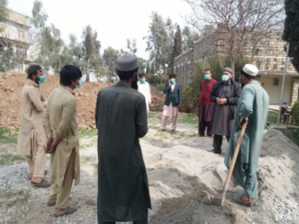 | 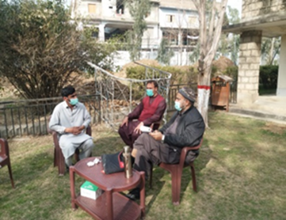
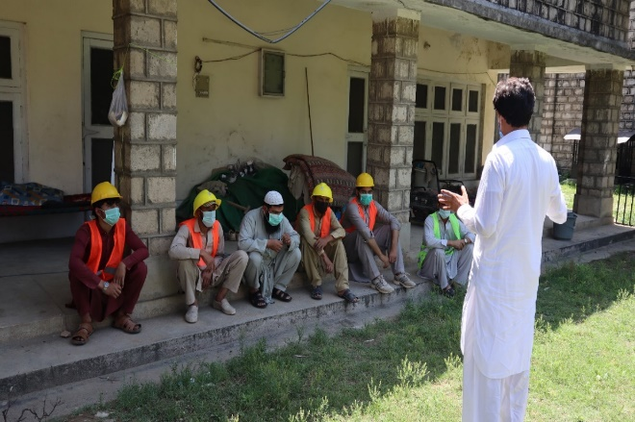
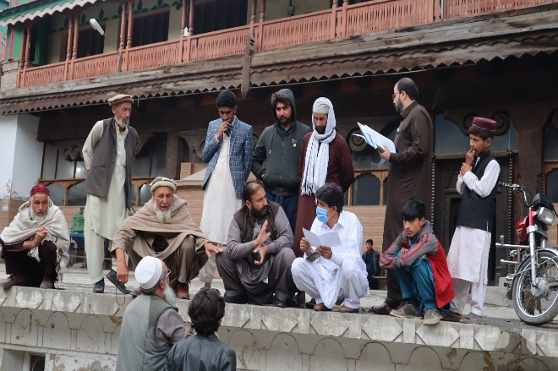 | 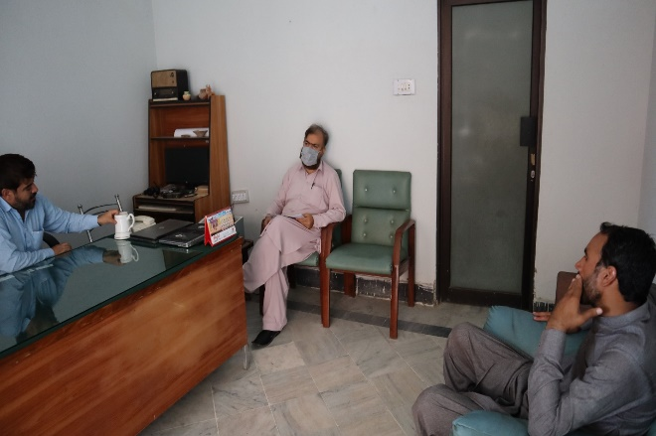
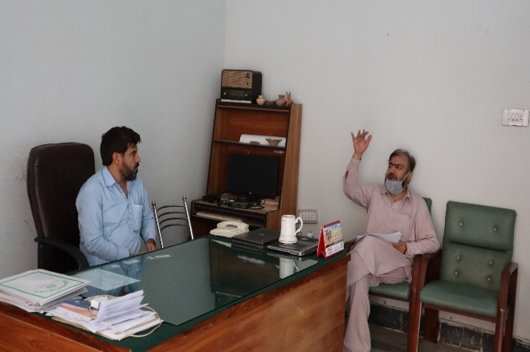 | 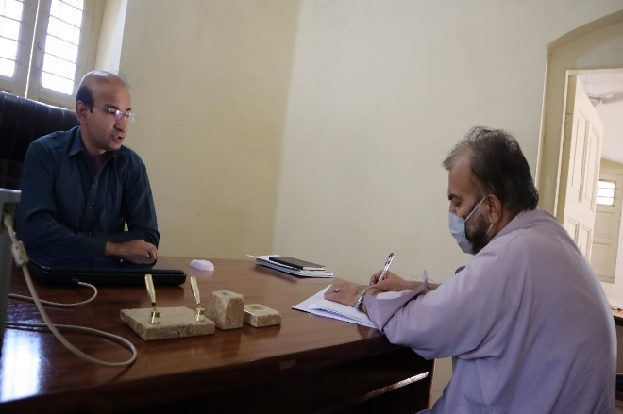
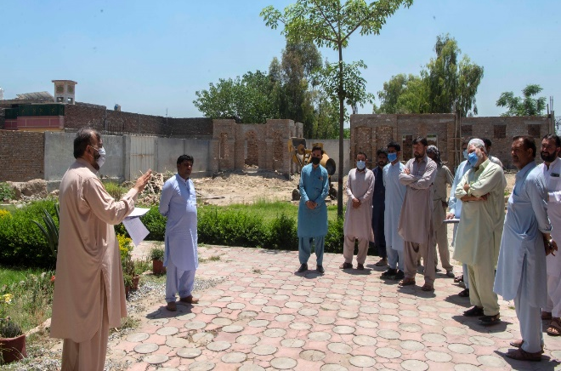 | 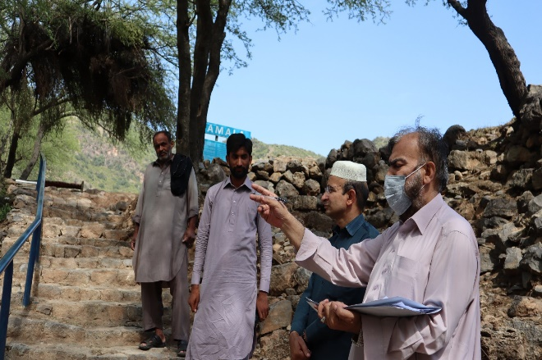

potential ENVIRONMENTAL IMPACTS AND MITIGATION MEASURES

General

This chapter identifies the beneficial as well as the potentially significant adverse environmental and social impacts during design/pre-construction, construction and operation phases of the proposed subprojects on the physical, ecological and socio-economic domains of the environment. The appropriate mitigation and remedial measures are proposed in this chapter. A project impact evaluation matrix has been developed to evaluate the potential impacts of the proposed subprojects. A brief qualitative description of each aspect and the affected environment in AoI is presented below.

Notion of Significance

Impact significance depends on both the nature of the impact and on the sensitivity of the receptor. The more sensitive the receptor is the greater will be the significance of impact from that proposed activity. For this ESMP, activities and nature of impact are combined with the sensitivity of the receptor to evaluate the significance of the impact. The significance of impact is characterized as very low, low, moderate, high, very high, nature, duration of impact, reversibility of impact and consequence of impact. Environmental issues having “moderate”, “high” and “very high” significance are provided with mitigation measures.

In order to identify spatial based impacts, overlays were used. An overlay is based on a set of transparent maps, each of which represents the spatial distribution of an environmental characteristic (for example, land acquisition). Information for an array of variables such as land use, infrastructure, vegetation etc. was collected for the standard geographical units within the project’s AoI, recorded on a series of maps, typically one for each variable. These maps were overlaid to produce a composite map. The resulting composite maps characterize the subproject area’s land use, physical, social, ecological and other relevant parameters related to proposed intervention. The overlays maps used in this ESMP for the quantification of the landuse categories referred in Chapter 4: Description of Environment.

Delineation of area of influence

For this Study, a clear delineation of the AoI is required. AoI is the area within which the potentially significant impacts of the proposed subprojects activities (direct or indirect) are envisaged. In this report, the AoI is the area where the Project impacts on the environment due to the proposed subprojects activities are assessed. Based on the available Google Earth Imagery and ARC GIS software, Project footprints were overlaid on the existing Project Area Imagery. Utilizing the information collected through the detailed site visit, consultations with the locals and concerned departments and foreseen impacts of the proposed subprojects, a tentative AoI was delineated. The AoI for each archaeological site is taken as 100 m from the center for the baseline survey.

Potential Positive Impacts

The positive impacts due to the proposed subprojects are mentioned below:

- The project aims to enhance under-utilized potential of KP’s tourism sector for generating income and revenues, by providing an enhanced tourism experience to domestic and international tourists. The increased tourism promotion has led to an unprecedented rise in tourist traffic in the province, resulting in growth in economic activity in the province;
- The project will provide an opportunity to the tourist to explore new areas to visit and will enhance tourism experience;
- The project will provide socio-economic benefits to the inhabitants of the area associated with increase in tourism and services in the vicinity of all the archaeological sites which create micro economic benefits to local people. There is a possibility of increased economic opportunities and significant growth and extension of the local markets; and
- During the operation of the proposed subprojects (after road work near Shapula Stupa), lesser wear and tear of the vehicles will occur and it will also result in lesser fuel consumption, reduced air emissions and decrease in operating cost.

Potential enviornemntal Impacts and MITIGATION MEASURES

Apart from positive impacts, there are some potential adverse environmental impacts on the local environment. The proposed subprojects is divided into three (03) stages i.e. Pre-construction / Planning and Design Stage, Construction Stage and Operation and Maintenance (O&M) Stage. The Pre-Construction Stage includes all stages before the construction Stage (i.e. site investigation work i.e. topographical, seismic studies etc.); Construction Stage includes all stages from mobilization of Contractor to the completion of Project; and Operation Stage starts after the Construction Stage which includes the inspection and repair works.

The anticipated impacts for all the archaeological sites are almost similar in nature. Adverse impacts envisaged for the all the archaeological sites with their proposed remedial or mitigation measures are detailed below:

POTENTIAL ENVIRONEMNTAL Impacts during PRE-CONSTRUCTION PHASE

Following is the brief description of impacts envisaged and the recommended mitigation measures during pre-construction phase.

Technical Design and Layout Planning

Potential Impacts

Incompatible layout plan and engineering design of the project’s structures can undermine the overall aesthetic beauty and ambience of the subproject areas. Also low utilization of the available spaces and designing the structures without considering the prospective and futuristic needs can result in structures with low social acceptability and functionality. This impact is permanent and moderate adverse in nature.

Mitigation Measures

- The technical design of the proposed subprojects must incorporate the aesthetic considerations meeting the local context and best international practices (as explained above) in project design; and
- The proponent must review and validate all the design considering the possible impacts (as listed/mentioned above) before the start of conservation and development of all the archaeological sites.

Drinking Water Contamination

Potential Impact

Drinking water contamination can originate due to improper design of groundwater reservoir and internal water network of the proposed subprojects. If the pipes and the groundwater reservoir are not designed properly according to the specifications, they may lead to bacteriological contamination of the potable/drinking water and thus will lead to infectious diseases/health problems to the staff of the proposed subprojects. The impact is negative, local, medium, long term and probable.

Mitigation Measures

- Location of groundwater reservoir should be planned carefully. Groundwater reservoir meant for drinking should not be located directly beneath any sanitary plumbing or any other pipes conveying non-potable water; and
- Groundwater reservoir must be provided with a cover, designed to prevent the entry of dust, roof water, surface water, birds, animals or insects.

Drainage

Potential Impact

The project area has high frequency of rainfall especially during monsoon, and water flows through the hills. Inadequate drainage design may lead to ponding on impervious surfaces such as roofs of proposed structures (sites offices, tuck shops, public washrooms etc.), road (near Shapula Stupa Site) and consequently may cause damage to the infrastructure in addition to vector breeding. This impact will be negative, local, medium, short term and probable.

Mitigation Measures

Mitigation measures will include provision of proper drainage structures with appropriate design capacity to avoid flooding especially during the rains and complying relevant standards. Proper slopes shall be incorporated in design to avoid the stagnant water. Ensure provision of rainwater harvesting technique, where applicable.

Seismology

Potential Impact

As per Building Code of Pakistan, Seismic Provisions, 2007, the subprojects (Bhamala Stupa, District Haripur, Dir Museum District Dir (Chakdara), Hund Museum District Swabi and Mardan Museum, District Mardan) areas are located in Seismic Zone 2B (moderate hazard), where 2B represents peak horizontal ground acceleration from 0.16 to 0.24 g while the subprojects (Shapula Stupa, Landi Kotal District Khyber, Odigram Mosque District Swat and Kalam Mosque District Swat) areas are located in Seismic Zone 3 (high hazard), where 3 zone represents peak horizontal ground acceleration from 0.24 to 0.32 g. In this Zone, designing of various types of structures should be done on the basis of PGA.

A high intensity earthquake impacting the project site can adversely impact the proposed development. This factor requires special consideration of the designers keeping in view of the recent earthquake of October 08, 2005. This will be a local and high adverse impact.

Mitigation Measures

- The proposed structures should be designed and constructed to withstand high intensity earthquakes. For seismic hazard analysis, updated structural, geotechnical and seismic studies should be conducted; and
- Adopt Seismic Building Code of Pakistan 2007 (SBC-07) to mitigate the seismic hazard for subprojects design. This code specifies minimum requirements for seismic safety of buildings and has to be applied and used by engineers in conjunction with the necessary understanding of the concepts of structural, geotechnical and earthquake engineering.

Electrical Hazards

Potential Impact

The workers/ staff may be exposed to electrical hazards during external lighting/electrification including shocks, fires and burns caused by faulty electrical wiring, unsafe installations, frayed cords, substandard power trips, and defective equipment. This impact is considered to be negative, local, high, long-term and probable

Mitigation Measures

- Appropriately grounded and double insulation of every single piece of equipment, machine, and device should be kept in the design;
- Proper installation check and periodic maintenance by a competent electrician should be planned; and
- All power strips should be planned in the design to place in well-ventilated areas for adequate heat dispersion.

Ecological Impacts

Potential Impacts

Since the subprojects interventions will be undertaken in northern areas of KP, therefore, care must be taken to protect the key natural features including wood trees, medicinal plants and resources of Non Timber Forest Products (NTFP). No significant impact is envisaged during design phase.

Mitigation Measures:

- During design, sites should be properly selected to avoid and minimize the cutting of trees, shrubs and herbs;
- The critical areas of animal breeding and nests should be avoided; if any
- Tree planation must be formulated;
- It should be properly planned in the design to avoid any impacts on green cover of the project sites which may be direct or indirect.

POTENTIAL ENVIRONEMNTAL Impacts during CONSTRUCTION PHASE

Following is the brief description of impacts envisaged and the recommended mitigation measures during construction phase.

Soil Erosion and Contamination

Potential Impacts

The clearing of vegetation can loosen the soil and make it more susceptible to erosion due to wind and rain. There is also a possibility of silt runoff during rainy season causing soil erosion. During the rain, the eroded soil mix with stagnant water to transform into slush, which can affect movement of vehicles and machinery and construction work as well as limit the movements of local people. Soil erosion may occur at active construction sites and at contractors’ camps (if required), as a result of uncontrolled run-off from equipment washing yards, excavation of earth/cutting operations and clearing of vegetation. Soil may also be impacted due to unauthorized use of borrow areas, resulting in degradation of landscape. Whereas, contamination of soil may be caused by solid waste generated at campsites and by oil and chemical spills at asphalt plant sites, workshop areas and equipment washing yards. This impact is high adverse negative in nature.

Mitigation Measure

- The Contractors will be required to instruct and train their workforce in the storage handling and management of materials and chemicals that can potentially cause soil contamination;
- Material Safety Data Sheets (MSDS) will be strictly followed during handling and storage of chemicals;
- Soil contamination by asphalt will be minimized by placing all containers in a bounded area away from water courses;
- Provision of impervious platform with oil and grease trap for collection of spillage during equipment and vehicle maintenance;
- All spoils shall be disposed of safely and the site shall be restored back to its original conditions;
- Non-bituminous wastes from construction activities shall be dumped in approved sites, in line with the legal prescriptions for dumpsites;
- Solid waste generated at the camp sites will be properly treated and safely disposed only in the demarcated waste disposal sites/areas;
- If any contaminated soils are found, they shall be removed and deposited in a sealed pit in an area agreed with the concerned;
- Use of modern, well-maintained machinery and vehicles by the contractor to avoid leakages; and
- Soils removed during construction would be stockpiled for reuse where possible.

Excavation of Earth

During construction, there is a chance of finding archaeological remains. Mismanagement of the archaeological remains may result loss of a valuable asset. Further, excavation of earth from borrow areas and for clearance of subproject area (where applicable) may result in erosion of soil. Erosion results in change of edaphic characteristics of soil. The impact is high adverse in nature.

Mitigation Measures

- In case of finding archaeological remains during excavation, the contractor shall immediately report through Supervision Consultant to Directorate of Archaeology and Museums, KP to take further suitable action to preserve those antiques or sensitive remains. Chance finds procedure is given in Annex- V must be followed.
- Contractor needs to obtain approval for excavation and submit the plan of rehabilitation of the site after excavation;
- Time scheduling to avoid excavation during rain; and
- Cover all exposed soil as soon as soils are exposed.

Surface and Groundwater

Potential Impact

The surface water may get contaminated due to the surface runoff during construction phase. Construction activities may result in debris entering water body resulting in sedimentation. Storage and transport of construction material may also result in spills of chemical and contamination of water bodies.

Groundwater may also get contaminated from the wastewater generation from the construction camps, leachate from improper dumping of solid waste. Consumption of water for construction activities may also affect other designated uses of water especially drinking water due to less availability of drinking water in the area. The impact is high adverse in nature.
Mitigation Measures

As a mandatory step, all the effluents will be disposed as per the requirements of NEQS. Moreover, to reduce the risk of surface and groundwater contamination, good management practices will be adopted to ensure that fuels, chemicals, raw sewage and wastewater effluent are disposed of in a controlled manner. These measures are described below:

- Construction camps (if required) will be established in areas with adequate natural drainage channels in order to facilitate the flow of the treated effluents after ensuring that NEQS are met (as advised by Environmental Specialist);
- The proponent will ensure that the construction work is confined within the subproject areas and water bodies are prevented from pollution during construction;
- The solid waste will be disposed of in designated landfill sites to sustain the water quality for domestic requirements;
- Regular water quality monitoring according to determined sampling schedule;
- Water required for construction shall be obtained in such a way that the water availability and supply to nearby communities remain unaffected;
- The contractor will ensure that construction debris do not find their way into the drainage or nullah and nearby river (where applicable) which may get contaminated;
- To maintain the surface water flow/drainage, proper mitigation measures will be taken along the road, like drainage structures;
- Prohibit washing of machinery and vehicles in surface waters, provide sealed washing basins and collect wastewater in sedimentation/retention pond;
- Construction work close to the streams or other water bodies will be avoided, especially during monsoon period;
- Wastes will be collected, stored and taken to approve disposal site;
- Wastewater effluent from the Contractors’ workshops and equipment washing-yards may be treated before discharging into the natural streams as per NEQS;
The Contractor shall ensure the compliance with NEQS (as advised by Environmental Specialist); and
- Similarly, if the sewage after treatment is to be discharged on to the land it will meet the requirements of the NEQS for disposal of wastewater.

Landscape Changes

Potential Impact

Visual intrusion from large piles of excavated and construction material is one of the possible adverse impacts during the construction phase of the project. The impact is considered to be negative, local, medium, short term and definite.

Mitigation Measures

- Material stockpiles should be removed as soon as work is completed and the area re-landscaped; and
- The contractor should ensure minimal footprint of construction activities.

Traffic Issues

Potential Impact

Due to the proposed subprojects construction activities and movement of project vehicles for construction material supply, traffic problems may arise for the commuters and transporters travelling to the proposed areas. The problems will include traffic jams and inconvenience to the public passing through the subproject area. It may also increase traffic load on the existing road network or access roads ultimately deteriorating the existing condition of the roads. The movement of vehicles along the haulage routes will cause soil erosion, debris flow, dust emissions, vibrational impacts, etc. Considering these consequences, this impact can be categorized as direct, moderate, site-specific, medium term, temporary, medium probability and irreversible.

Mitigation Measures

To minimize traffic problems in the proposed subprojects area, following measures will be considered:

- Movement of vehicles carrying construction materials and equipment/machinery will be restricted during the nighttime to reduce traffic load and inconvenience to the local population;
- Construction vehicles, machinery and equipment will be parked at designated areas (at construction camps site) to avoid un-necessary congestions along the major roads;
- The speed of the vehicles will be controlled (at 15 to 25 km/hr) to reduce the probability of severe accidents, soil erosion, debris flows due to vibrations and dust emission;
- Damages of roads due to construction vehicles will be instantly repaired and/or compensated after the completion of work;
- Proper sign boards will be provided for smooth flow of traffic;
- Period of construction and area / location of construction site shall be informed to public in general and specifically to local residents; and
- Any closure of the roads (especially main roads) and deviations / diversions proposed should be informed to the riders through standard signs and displays.

Traffic Management Plan (where applicable) will be prepared by the contractor and implemented to avoid traffic accidents, jams/public inconvenience.

Air Quality

Potential Impact

A decline in the ambient air quality within the vicinity of works is expected during the construction phase activities. Due to these activities release of exhaust emissions, containing carbon monoxide (CO), sulphur dioxide (SO₂), oxides of nitrogen (NO_{X}), and particulate matter (PM) is expected, which can deteriorate the ambient air quality in the subproject sites. The objectionable impacts of settling of the suspended dust would be its dry deposition on vegetation and tree covers, motor vehicles, structures, and other exposed surfaces. Exhausts from fossil fuel burning in the construction machinery will also deteriorate local air quality. Similarly, exhausts from generators can also have impacts on air quality in the vicinity.

The overall impact on the quality of air during the construction phase may be low adverse keeping in view the extent of developmental activities for all subproject sites, however, it will be temporary and limited to the project’s implementation phase only.

Mitigation Measures

The impacts construction phase of the proposed subprojects could be effectively mitigated by the implementation of simple procedures by the Contractor including but not limited to the following:

- All vehicles, machinery, equipment and generators used during construction activities should be kept in good working condition and be properly tuned and maintained in order to minimize the exhaust emissions;
- Open burning of solid waste from the Contractor’s camps (if required) and at construction site should be strictly banned;
- Preventive measures against dust should be adopted for on-site mixing and unloading operations;
- Construction materials (sand, cement, bricks, gravel etc.) and spoil materials will be transported through trucks covered with tarpaulins and all vehicles (e.g., trucks, equipment, and other vehicles that support construction works) may comply with the NEQS and IFC/WHO guidelines whichever is stringent (if required / as advised by Environmental Specialist);
- Regular water sprinkling of the site should be carried out to suppress excessive dust emission(s);
- Construction equipment is generally left idling while the operators are on break or waiting for the completion of another task. Emissions from idling equipment tend to be high. Existing idling control technologies, which automatically shut the engine off after a preset time can reduce emissions, without intervention of the operators;
- NEQS and IFC/WHO guidelines whichever is stringent applicable to gaseous emissions generated by construction vehicles, equipment and machinery should be enforced during construction works (if required / as advised by Environmental Specialist);
- Service roads (used for earthmoving equipment and general transport) should be regularly sprayed with water during dry weather;
- All excavation work should be sprinkled with water;
- Construction workers should be provided with masks for protection against the inhalation of dust; and
- Regular monitoring of air quality in accordance with the formulated environmental monitoring plan (given in ESMP).

Noise/Vibration

Potential Impact

The noise and vibration will be produced due to the operation of construction machinery. Sources of noise and vibration during construction are machinery such as excavators, concrete mixing plant, tractor trolley, water tanks and other equipment’s. Noise and vibration are perceived as one of the most undesirable consequences of construction activity. The above machinery is expected to generate noise levels that would be severe in the project area.

The cumulative effects from several machines may be significant. However, these increased noise levels will prevail only for a short duration during the construction stage.

The likely impacts due to noise are:

- Psychological effects of distraction of attention, irritation and short temperedness in the exposed persons due to persistently higher noise levels;
- Noisy settings and higher background levels can cause temporary threshold shift and the consequent habit of speaking loud, which may cause damage to vocal cords in the persons exposed;
- Potential impact from vibration during the construction period may consists of damages to archaeological structures; and
- Moreover, vibrations from machinery and equipment may produce easy fatigability and generalized aches in the persons operating these machines.

This impact is negative, local, medium and short term.

Mitigation Measures

- Selection of up-to-date and well-maintained plant or equipment with reduced noise levels;
- Confining excessively noisy work to normal working hours in the day, as far as possible;
- Providing the construction workers with suitable hearing protection like ear cap, or earmuffs and training them in their use;
- Preferably, restricting construction vehicles movement during night time;
- The contractors working may be limited to daytime to reduce disturbance;
- Vehicles and equipment used shall be fitted, as applicable, with silencers and properly maintained;
- Contractors shall comply with submitted work schedule, keeping noisy operations away from sensitive points; implement regular maintenance and repairs; and employ strict implementation of operation procedures;
- No damage occurs to people, property, livestock or power lines.
- Personal Protective Equipment (PPEs) shall be provided and worn by the personnel involved in construction activities.
- First aid kit shall be available at easily accessible location.
- All complaints are recorded and responded to in a timely and professional manner; and
- The Contractor shall ensure the compliance with NEQS and IFC/WHO guidelines whichever is stringent (as advised by Environmental Specialist).

Borrow Areas

Potential Impacts

Borrow areas may result in potential sources of mosquito breeding and may prove hazardous to human beings, livestock and wildlife. This will also degrade hygienic condition of the project area. This impact is permanent and high adverse in nature.

Mitigation Measures:

- Necessary permits will be obtained for any borrow pits from the competent authorities;
- In borrow pits, the depth of the pit shall be restricted upto 5’ with side slope not steeper than 1:4;
- Soil erosion along the borrow pit shall be regularly checked to prevent/mitigate impacts on adjacent lands; and
- In case borrow pits fill with water, measures have to be taken to prevent the creation of mosquito-breeding sites.

Construction Camps / Camp Sites

Potential Impact

Improper construction camp location and mismanagement of construction camp activities can lead to various social and environmental impacts which include health and safety, traffic problems, soil degradation, loss of vegetation and assets on the selected land, solid waste and water pollution. Furthermore, cultural differences, behavior of construction workers, potential disregard for local cultural norms can lead to increased tension between local communities and workers residing in the construction camps. This impact is temporary and moderate negative in nature.

Mitigation Measures

- The project will seek to avoid sitting camps where their presence might contribute to any conflicts with locals;
- Employment policies which aim to maximize job opportunities for local people will help to minimize tensions caused by different socio-cultural values;
- Camps will be designed to be self-contained to reduce demand on infrastructure and services of nearby communities
- A comprehensive safety and security plan for the camps will be prepared which will comprise of a training manual, use of safety equipment and emergency preparedness.
- Training will be provided to all staff on camp management rules and overall discipline and cultural awareness.
- Waste Management Plan will be implemented to ensure safe handling, storage, collection and disposal of construction wastes and the training of employees who handle waste;
- Domestic and chemical effluents from the construction camp will be disposed by the development of on-site sanitation systems i.e. septic tanks (if required).
- The Contractor(s) will be responsible to submit details of site-specific wastewater management plan along with details of wastewater collection, transportation and its disposal (if required).
- Site for construction camp will be selected to minimize the removal of existing macro-plants at camp sites and at least 500 m away from the settlements;
- Compensatory plantation to be done when construction work near ends; and
- The contractor(s) shall ensure removal & rehabilitation of site upon completion.

Wastewater Generation at Construction Camps

Potential Impact

Wastewater will be generated at the construction camps by the workers. If the generated wastewater is not properly treated or disposed of, this may contaminate the surface water sources such as nullahs, drains, water channels, river etc. apart from soil contamination. The Table 7.1 below shows anticipated composition and estimate of the wastewater to be generated from construction camps project assuming that on average the water demand per person is 40 liters per day and that 80% of the water demand will become wastewater.

Table 7-1: Estimated Wastewater Generated by Workers in Construction Camps
Sr. No. | No. of Workers/ Staff* | Estimated Total Water Demand**  (liters/day) | Estimated Wastewater Generated (liters/day)***
1 | 45 | 1,800 | 1,440
* “Tentative Work Force Requirements Including Client, Consultant and Contractor Staff for all the archaeological sites”
** = (45) x (40) = 1,800 liters/day
*** = (1,800) x (80%) =1,440 liters/day

This impact can be categorized as direct, moderate, site-specific, short term, temporary, high probability and reversible.

Mitigation Measures

To dispose the liquid waste generated from the construction activities, the following steps will be taken by the Contractor:

- Domestic and chemical effluents from the construction camp will be disposed by the development of on-site sanitation systems i.e. septic tanks (if required);
- Proper monitoring to check the compliance of NEQS will be carried out (as advised by Environmental Specialist); and
- The Contractor(s) will be responsible to submit details of site-specific wastewater management plan along with details of wastewater collection, transportation and its disposal may be prepared and implemented (if required).

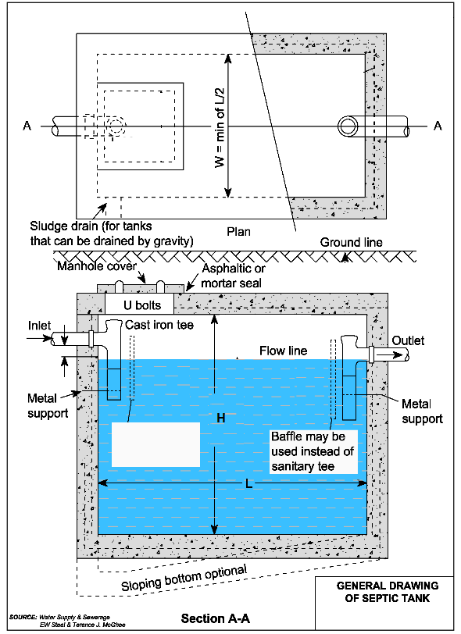
Figure 7-1: General Drawing of Septic Tank

Solid Waste (Construction, Municipal and Hazardous Waste)

Potential Impact

Considering the labour / staff (about 45 in numbers) residing in the construction camps and the locally available labour, an average solid waste generation rate of 0.5 kg/capita/day is adopted for the estimation of solid waste generation. Based on this assumption, a total of about 22.5 kg of solid waste will be generated from construction camps on daily basis. Different type of waste is likely to be generated during the construction phase of the project. The municipal waste will be in the form of food, cans, paper and wastewater from construction camps toilets and washing yards. Construction waste will include excavated soil, pieces of concrete, bricks etc. Whereas, hazardous waste can be comprised of paints and construction chemicals. All these, if left unattended, can become a source of nuisance and environmental pollution in the project area.

Insecure and unhygienic disposal of the solid wastes particularly garbage and trash may cause degradation of soil and land. Insecurely disposed off heaps of wastes containing kitchen garbage and food waste can serve as breeding grounds for the disease spreading vectors and rodents. Throwing away of solid wastes into water channels and the wastewater network can result into choking of the latter.

These impacts are temporary and major negative in nature.

Mitigation Measures

- Solid Waste generated during construction and camp sites will be safely disposed in demarcated waste disposal sites and the contractor will provide a proper waste management plan;
- Training of work force in the storage and handling of hazardous materials and chemicals Construction workers and supervisory staff should be encouraged and educated to practice waste minimization and reuse to reduce quantity of the waste;
- Proper labeling of containers, including the identification and quantity of the contents, hazard contact information etc.;
- Waste disposal plan must be reviewed during the entire construction phase in the light of changing weather conditions;
- Emergency Response plan shall be prepared to address the accidental spillage of fuels and hazardous goods;
- Immediate collection of spilled oils/fuels/lubricants by collection of contaminated soils and skipping oils from surface water by applying appropriate technologies;
- Used oil shall be collected in separate containers stored on impervious platform with restricted access and shall be sold to licensed contractor and the burning of waste oil shall be strictly restricted; and
- Segregating and stockpiling scarified/ milled bituminous material and reusing this material in sub grade/shoulders; and
- Construction waste such as cement, bricks, and plaster can be crushed and reused in other sites.

Resource Conservation

Potential Impact

Resources involved in the construction of proposed subprojects would include water, fuel and construction materials.

Excessive water consumption by the construction staff may stress water resources in the subproject areas and in certain cases may disturb the existing water supplies in the project area.

Construction material to be used for construction includes coarse aggregates, fine aggregates, asphalt, cement, lining material, earthworks, reinforced and structural steel etc. Almost all the materials to be used in the construction of proposed subprojects are non-renewable and therefore their efficient use is necessary for the future use.

Use of electricity will be insignificant. Diesel and residual fuel oils may be used to operate construction machinery. Sustainable use of energy resources is very important not only to continue future use, but it will also help to reduce air emissions.

Fuel may be used to operate construction machinery. Efficient use of energy resources is important to reduce air emissions. For conservation of energy, efficiency of the engines and burning processes is important. The impact is minor negative.

Mitigation Measures

Following practices shall be adopted to conserve these natural resources:

- Use potable water bowsers for construction works and mineral water bottles/ groundwater for drinking purpose;
- Reduction of wastage of water through training of workers involved in water use;
- Source of water shall be carefully selected. Water use shall not disturb the existing community water supplies;
- Reuse of construction waste materials may be adopted wherever possible;
- Diesel and fuels with low sulphur content should be used to operate construction machinery and equipment;
- Efficient and well maintained equipment and machinery should be used;
- The equipment and machinery should be turned off when not in use;
- Unnecessary equipment washings shall be avoided;
- Use optimum amount of bitumen for road surfacing;
- Use of solar panels at construction camps may be considered;
- A good camp design and an efficient worksite management plan can help the contractor to reduce the water demand, wastewater and solid waste volumes to the lowest level; and
- The contractor shall ensure the compliance with NEQS (as advised by Environmental Specialist).

Natural and Man-Made Disasters

Potential Impact

Natural disasters (earthquakes) and accidents such as fire, falls, slips and trips may result in injuries, financial losses and may even lead to deaths. The workers shall be trained and facilitated to cope with such disasters. This impact is short term, site specific and medium to high significant.

Mitigation Measures

Mitigation measures include the following:

- Emergency prevention, preparedness and response arrangements for earthquakes and manmade disasters may be developed by the Contractor in coordination with SC, C&WD and other relevant departments (where applicable);
- The contractor will prepare a Health and Safety Plan which is relevant to his chosen methodology;
- Training of workers;
- Documentation and reporting of occupational accidents, diseases and incidents;
- Provision of supply of PPEs will also be mandatory for all staffs and visitors; and
- Ensure the measures for fire prevention and firefighting.

Ecological Environment

Potential Impact

The proposed subprojects interventions will be undertaken in the area where presence of floral and faunal diversity is limited. Project construction activities might create disturbance to the flora and fauna of the subproject areas due to machinery movements and installation. No major impacts are anticipated. Moreover, the extent of the subprojects activities is low in terms of physical intervention as the proposed subprojects involves the construction /conservation/rehabilitation of existing and new structures (archaeological sites, sites offices, public washrooms, tuck shops, boring of tube well, provision of protection wall, sheds for tourists, electrification etc.).

The construction/conservation/rehabilitation activities will not involve any tree removal, so no tree will be felled. However, minor land clearance activities shall be involved for clearing the land of bushes and small plants. Only limited civil works are involved, therefore, no adverse impacts are envisaged on the biodiversity.

Mitigation Measures

- To protect the natural environment of each sub project sites, 250 plants shall be planted on each sub project site, which will play in rehabilitation and enhancement of local environment, creation of habitat for local wildlife and will also add part in the aesthetics of the area;
- The tree plantation will also compensate the removal of small plants and bushes as these may be impacted due to the proposed subprojects activities;
- KP Forest Ordinance 2002, Protection of Trees and Brushwood Act, 1949 and KP Wildlife & Biodiversity Act, 2015 to be followed.

Disturbance to Wildlife

Potential Impact

The proposed subprojects interventions may increase number of the worker’s activity, machinery movements and can impact animal movements by direct mortality or avoidance behavior. This impact is site specific, short term and low adverse.

Mitigation Measures

- Hunting, poaching and harassing of wild animals shall be strictly prohibited, and contractor shall be required to instruct and supervise its labor force accordingly and clear orders should be given in this regard;
- Safe speed limit will be strictly implemented during construction activities;
- Awareness material regarding wildlife will be developed and displayed prominently at the sites frequented by tourists;
- The engineering design to integrate the principles of green infrastructure including habitat conservation; and
- Noise produced by construction and other activities may be kept to acceptable level/kept minimum as per NEQS and IFC/WHO guidelines whichever is stringent (as advised by Environmental Specialist).

POTENTIAL ENVIRONEMNTAL Impacts during Operational Phase

The anticipated environmental impacts related to the proposed subprojects have been studied for the operational stage of the project as discussed hereunder.

Landscape

Potential Impact

After the completion of the proposed subprojects, the overall environmental conditions of the subproject areas will greatly improve due to elimination of stagnant wastewater, plantation of trees and ornamental plants around the proposed subprojects structures and road (near Shapula Stupa site), and exclusion of construction camps. This will be a major positive impact of the proposed subprojects.
Mitigation Measures

- Proper implementation of the tree plantation plan will improve landscape and aesthetics of the subproject areas; and
- Installation of sign boards with instructions for protection of plantation/trees at the project site.

Air Quality

Potential Impacts

Major sources of air emissions and dust pollution at all the archaeological sites will be visiting vehicular traffic especially during the peak seasons and generators (if installed).

Improvement in road condition will help to reduce traffic related emissions in the short term by allowing a smoother traffic flow. However, in the longer run, increased traffic levels and congestion may lead to PM₁₀ pollution levels, which may result in causing public nuisance and other impacts on bio-physical environment. These conditions will result in the rise of vehicular emissions (CO, NOx, SOx, PM₁₀) associated with the adverse effects on the environment and human.

This impact is permanent and positive, in case of improvement of road conditions and minor negative, when traffic volume is increased. This impact can be categorized as negative, local, low, long term and definite.

Mitigation Measures:

- Location of generators (if installed) at sites should be carefully selected;
- Use of gas generators (if possible) should be preferred for low emissions;
- Plantation of trees around the generators to create a buffer zone that will help in absorbing the emissions;
- Use of solar panels (renewable energy source) for running generators, as it will save the energy;
- Roadside tree plantations as applicable and feasible and plants should be selected in accordance to their ability to absorb emissions;
- Regular road maintenance to ensure good surface condition; and
- Provision of budget for regular monitoring of ambient air quality in accordance with NEQS and IFC/WHO guidelines whichever is stringent (as advised by Environmental Specialist).

Noise

Potential Impact

The operation of generators and movement of vehicles (residents, staff and visitor vehicles) on access road and main road near the proposed subprojects sites may create noise and vibration issues. The impact is local, negative, medium, definite and long term.

Mitigations Measures

- Use of horn should be prohibited in and around the all the archaeological sites;
- Trees should be planted along the boundary of proposed sub projects as a noise barrier;
- Employees working close to generators for extended periods should be encouraged to wear ear protection;
- To reduce the noise produced from loose vibrating parts all the noisy equipment’s should be maintained and tuned periodically; and
- Traffic signs/rules should be installed /placed in and around the outskirts of proposed subprojects sites regarding parking of vehicles and honking of horns.

Solid Waste Generation

Potential Impact

Municipal waste including tissue papers, packaging papers, papers and bottles etc. will be generated during operation phase especially during the peak seasons. Improper storage and dumping of waste may pollute soil, sewerage pipes and groundwater. It may also affect the aesthetics and can cause health problems to the staff and workers handling waste. Therefore, this impact will be negative, local, medium, long term and definite.

Mitigations Measures

- Waste collection bins should be provided within the and around the archaeological sites at suitable locations for collection of daily generated municipal waste;
- Assign color to collection bins according to the international standards;
- Waste bins should be emptied by sanitary workers on daily basis;
- Recyclable wastes such as newspaper, cardboard, plastics, glass and metals could be separated for individual collection;
- Storage areas should be cleaned regularly to minimize odor, pests and nuisances and preserve visual amenity;
- Installation of sign boards with instructions for the visitors;
- Waste should be transferred to the properly covered purpose-built vehicle (truck / pick-up van) and then be carried out of the sites to nearby municipal disposal points; and
- A proper waste management plan should be prepared for onsite storage, collection and disposal of waste.

Road Safety

Potential Impacts

Enhanced vehicular movement and speed may result in road safety issues like road side accidents. This impact is permanent but moderately adverse in nature, since the frequency of accidents may be lowered, but their intensity may be quite severe due to enhanced speeds at which vehicles will move. The impact may be considered permanent and high adverse in nature.

Mitigation Measures

Strict enforcement of speed limits speed limit sign boards and channelization of traffic with respect to categories (heavy vehicle traffic and light vehicle traffic) and enforcement of penalties for the violators will reduce the significance of this impact.

Drinking Water Quality

Potential Impact

The groundwater reservoirs may get contaminated during the operation phase which can cause health impacts on the occupants / visitors. This impact will be negative, local, medium, short term and definite.

Mitigations Measures

- Ensure the provision of potable water to the staff and visitors;
- The proponent should ensure the disinfection of groundwater reservoir periodically; and
- Regular testing should be conducted for groundwater quality in compliance with NEQS and IFC/WHO guidelines whichever is stringent (as advised by Environmental Specialist).

HSE Considerations

Potential Impact

During the operation phase, health and safety issues may arise. Operation and maintenance of the sites may cause safety risks to staff (electrical and mechanical staff, solid waste management staff and maintenance staff), that may include injuries due to electric shocks, arc flash and arc blast, slipping and falling, poor handling and storage of hazardous substances and during handling of the solid waste. The impact will be considered as negative, local, medium, long-term and probable.

Mitigation Measures

- Operation and maintenance of machinery and equipment shall be controlled and handled by efficient management, staff training, and other preventive measures;
- Proper storage and handling of generator fuel, chemicals and solvents;
- Ensure emergency prevention, preparedness and response arrangements;
- Emergency numbers should be clearly posted and communicated to the staff;
- Fire extinguishing equipment should be installed at sites;
- Provision of PPE’s to the skilled and unskilled labors including masks, gloves, safety jackets and ear muffs;
- Necessary health and safety rules should be enforced by the concerned authority for management;
- Proper training should be given to workers on health and safety measures;
- Hazardous materials should be well labeled and stored in their original containers;
- During maintenance of power supply, ensure that the live wire work is conducted by trained workers with strict adherence to specific safety and insulation standards (Pakistan Electric and telecommunication Safety Code-PETSAC-2014); and
- COVID-19 SOPs must be fully adopted in accordance with the updated / latest WHO and GoP guidelines (Annex-VI).

Soil Erosion and Contamination

Potential Impact

Any excavations required for maintenance would cause impacts similar to those from construction phase, but at a lesser spatial and temporal extent. The accidental spill of product such as accidental fuel and material spills would likely cause soil contamination. Except in the case of a large spill, soil contamination would be localized and limited in extent and magnitude.

Mitigation Measures

To minimize the disruption of top soil following remedial measures should be taken:

- The top soil that will be excavated from the area will be preserved and reused for the horticulture purpose;
- Proper solid waste management program is prepared and executed to ensure and Land waste containment, collection, transfer and disposal; and
- Monitoring is carried out at specific locations for strict compliance to the developed ESMP in implementing measures to waste management.

Ecological Impacts

No impact is anticipated during operational phase of the project both on flora and fauna. However, the maintenance of the saplings/new plants must be monitored efficiently.

POTENTIAL Social Impacts AND MITIGATION MEASURES

POTENTIAL Social Impacts during pre-construction Phase

The anticipated social impacts related to the proposed subprojects have been studied for the construction phase, as discussed hereunder.

Land Acquisition, Resettlement and Compensation

Potential Impact

The proposed subprojects involve the conservation / rehabilitation of the seven archeological and historical sites including construction of new structures. Therefore, proposed subprojects interventions will require land which will result in loss of land. For the proposed subprojects at three (03) sites, a total of 58.2 kanals of land will be acquired. Site wise detail is given below in Table 7.1.

Table 7-2: Details of Land Fencing and Access Road
Sr. No. | Location | Ownership Status
1. | Conservation and Development of Bhamala Stupa, Landi Kotal District Haripur. | Govt. / 4 Kanal 8 Marlas is private land. Will be acquired by the Govt. as per LAA 1894 and OP 4.12
2 | Conservation and Development of Hund Museum, District Swabi. | Govt. / 23 Kanal 4 Marlas is private land. Will be acquired by the Govt. as per LAA 1894 and OP 4.12
3 | Conservation and Development of Shapula Stupa, Landi Kotal District Khyber. | Govt. / 30 Kanal is private land. Will be acquired by the Govt. as per LAA 1894 and OP 4.12

The details of land under the impact with ownership status will be prepared by the Revenue Department. Therefore, the impact of land acquisition and resettlement will be moderate.

Mitigation Measures

A detailed Abbreviated Resettlement Action Plan will be prepared as per World Bank OP 4.12 and Land Acquisition Act, 1894 including later amendments for acquisition and compensation strategies.

Mitigation measures will involve land management and providing judicious compensation to the affectees by providing sufficient budget in the project cost. The process of land acquisition and compensation will be followed in a transparent manner to minimize the impacts.

Adequate budget will be provided in the Project cost for the compensation to the affected people as per Land Acquisition Act, 1894 and framing of a judicious and fair compensation package for provision of compensation on at least the prevailing market rates.

Public Utilities

Potential Impact

Due to the proposed subprojects, telephone lines, electric poles and wires, water lines within the proposed subprojects locations may require to be shifted. An electricity high tension (HT) pole inside the PCR shall need to remove at Bhamala Site. Moreover, electricity lines/HT pole at Dir Museum will also be removed.

Mitigation Measures

During the design phase, maximum effort will be made to avoid the above mentioned public utilities, and if these are unavoidable than these will be relocated timely through the concerned department to avoid any public inconvenience.

POTENTIAL Social Impacts during Construction Phase

Accessibility Issue

Potential Impact

Closure of existing road and other pathways during the construction phase of the subproject areas may cause inconvenience to the nearby residents, visitors and will affect their daily life activities. This impact is short term, site specific and medium adverse.

Mitigation Measures

Mitigation measures will include public awareness through media, appropriate sign boards and timely completion of the subprojects activities.

Community Health and Safety

Potential Impact

The construction activities and vehicular movement at construction sites may result in roadside accidents particularly inflicting local communities who are not familiar with presence of construction equipment. Quality of groundwater and surface water resources available in the nearby local communities may be affected due to the construction activities, oil spillage and leakage, roadside accidents, etc. The proposed subprojects will also have potential of air (dust pollution), noise and vibrational impacts on nearby community. The labour works with different transmittable diseases like HIV/AIDs and COVID-19 etc. may cause spread out of those diseases in the local residents and for visitors. Conflicts may arise between the local community and the construction workers, which may be related to religious, cultural or ethnic differences, or based on competition for local resources. Considering these consequences, this impact can be categorized as direct, moderate, site-specific, medium term, temporary, medium probability and irreversible.

Mitigation Measures

- The contractor will be required to strictly follow World Bank/IFC EHS Guidelines, 2007 (refer Annex-III). The Contractor will prepare the site specific community health and safety plan in compliance with relevant sections of the IFC General Environmental Health and Safety Guidelines (WB/IFC 2007) and Pakistan Labor Laws;
- The Contractor will clearly barricade work areas to prevent access by the public;
- Providing basic medical training to specified work staff and basic medical service and supplies to workers;
- There will be proper control on construction activities and oil spillage leakage of vehicles;
- The labourers with different transmittable diseases will be restricted within the construction site;
- Ensure that the site is restricted for the entry of irrelevant people particularly children;
- Efforts will be made to create awareness about road safety among the drivers operating construction vehicles;
- Timely public notification on planned construction works;
- Close consultation with local communities to identify optimal solutions for diversions to maintain community integrity and social links;
- Seeking cooperation with local educational facilities (school teachers)/religious at each village along the route for road safety campaigns;
- Provision of proper safety and diversion signage, particularly at urban areas and at sensitive/accident-prone spots;
- Setting up speed limits in close consultation with the local stakeholders;
- The mitigation measures provided in the following sub-sections for air and noise shall be adopted to reduce the air pollution, noise pollution and vibrational impacts on nearby community;
- Construction Camp Management Plan (CCMP) and effective implementation of GRM may reduce this impact;
- The Contractor shall ensure the compliance with NEQS and IFC/WHO guidelines whichever is stringent (as advised by Environmental Specialist);
- The communicable disease of most concern during construction phase, like Sexually-Transmitted Disease (STDs) such as HIV/AIDS, COVID-19 will be prevented by successful initiative typically involving health awareness, education initiatives, training heath workers in disease treatment; immunization program and providing health service. Updated / latest guidelines by WHO / GoP may be observed to combat with COVID-19 (Annex-VI);
- Reducing the impacts of vector borne diseases will be accomplished through implementation of diverse interventions aimed at eliminating the factors that lead to disease, which include prevention of larval and adult propagation of vectors through sanitary improvements and elimination of breeding habitat close to human settlements and by eliminating any unusable impounding of water;
- Water sprinkling will be carried out to suppress dust;
- Contractor will prepare the Method of treatment and disposal of sanitary wastes, disposal of hazardous waste, actions to be taken in the event of land and water based pollution events and procedures for the collection and disposal of wastes, including domestic and construction waste to protect the local community;
- The Contractor will prepare the construction camp management plan which, in addition to other components, will include the labor influx management plan. This will be reviewed and approved by C&WD (where applicable); and
- Contractor will take due care of the local community and observe sanctity of local customs and traditions by his staff. Contractor will warn the staff strictly not to involve in any unethical activities and to obey the local norms and cultural restrictions.

Any environmental condition that is disagreeable to the public and causes an avoidable nuisance can be addressed with additional provisions over and above those described above, as determined necessary by the supervisory consultant.

These requirements will be incorporated into the bidding specification and contract documents, and will be binding on the contractor, at risk of penalty for noncompliance, as charges to be recovered from contractor for unsafe act or condition.

Occupational Health and Safety

Potential Impact

Occupational Health and Safety (H&S) related impacts may arise during construction phase due to activities including earthworks, installation of concrete mixing plant, construction of Contractor camps (if required), movement of machinery and manual handling during loading unloading operation, as result of these works there will be a direct impact on the health and safety of all staffs working in subprojects. Eye injury can be caused by stone or metal particles. Hazard of being hit by falling objects, major hand-arm and whole body vibration hazards, skin and respiratory tract irritation from exposure to cement dust, overexertion and awkward postures etc. will be another impact. Welding hazards include electric shock, fumes and gases, fire and explosions, falls from height, eye and head injuries etc.

Other impacts will be fall from height, contact with heavy electrical and mechanical equipment, equipment failure, uncontrolled movement, unguarded moving mechanical equipment parts, fatigue, unbalanced load, falling objects, hand injury, slip and trip hazards, wind / storm activity, injury from releasing load too soon etc. Operating mechanical and electrical equipment will trigger the H&S issues e.g. struck by moving vehicles or other equipment, slips or trips, struck by flying objects, such as dirt or splashed fluids, caught in pinch points, shear points, crush points, falling from machine etc. Considering these consequences, this impact can be categorized as direct, moderate, site-specific, medium term, temporary, medium probability and irreversible.

Mitigation Measures

Following mitigation is given to avoid the accidental risks:

- The contractor will be required to strictly follow World Bank/IFC EHS Guidelines, 2007 (refer Annex-III). The Contractor will prepare the site specific community health and safety plan in compliance with relevant sections of the IFC General Environmental Health and Safety Guidelines (WB/IFC 2007) and chosen methodology;
- Occupational health and safety monitoring programs of the contractor (s) should verify the effectiveness of prevention and control strategies;
- Providing basic medical training to specified work staff and basic medical service to workers;
- Contractor will ensure the provision of medicines, first aid kits, ambulance etc. at the camp site;
- Complying with the safety precautions for the construction workers as per International Labour Organization (ILO) Convention No. 62,;
- Training of workers in construction safety procedures, environmental awareness, equipping all construction workers with safety boots, helmets, gloves and protective masks, goggles, shields and monitoring their proper and sustained usage;
- Moreover, proper planning should be done for food storage, setting up of kitchens, production of sewage and waste water may result in multiplication of rodents like rats, mice and shrew etc. and vectors like mosquitoes, bugs and flies which will have a negative impact;
- Work areas will be cordoned off where necessary;
- Ensure the provision of fire prevention and firefighting equipment;
- Contractors will instruct their staff to use PPEs (e.g., wire containment, displaying warning signs along the work site, communicating advance warnings to mats) to enhance the safety; and
- Ensure the provision of emergency prevention, preparedness and response arrangements by the Contractor.

These requirements will be incorporated into the bidding specification and contract documents, and will be binding on the contractor, at risk of penalty for noncompliance, as charges to be recovered from contractor for unsafe act or condition.

Coronavirus Disease (COVID-19)

Potential Impact

Coronavirus disease (COVID-19) may be introduced due to the immigration of workers associated with the proposed subprojects.

Ministry of National Health Services, Regulations and Coordination, GoP has issued guidelines in April, 2020 for Health & Safety of Building and Construction Workers during COVID-19 outbreak. These guidelines are prepared for the workers involved in building and construction work during the current epidemic of COVID-19. These guidelines provide the safety measure to be implemented at the construction site having a dusty environment, continuous flow of different materials and make-shift type of arrangements for storage, food and sanitation calls for implementation. This impact is site specific and medium to high adverse.

Mitigation Measures

- All workers must perform complete sanitization at the site as per updated / latest SOPs/guidelines issued by WHO and the national guidelines issued by the GoP;
- All workers must wear a mask and gloves as soon as they arrive at site and must keep wearing it at all times while present at the work site and their body temperature must be checked;
- Make alcohol-based hand sanitizer (at least 70%) available for the workers handling deliveries
- At the work site(s), social distancing measures must be strictly implemented and gathering of workers at any location at the work site(s) must be strictly forbidden.
- All workers will be strictly advised to wash their hands as frequently as practicable and not to touch their face during work.
- COVID awareness sign boards must be installed at the camp clinic and at the work site(s);
- Contact details of all workers will be kept in a register on site in order to efficiently trace and manage any possible workers that might experience symptoms of COVID-19;
- Prohibition of entry for local community/any unauthorized persons at work sites;
- Proper hygiene practices in the toilets and washrooms will be implemented with proper and adequate use of soaps and disinfectant spray;
- Everyone on the construction site must observe sneezing and coughing etiquettes;
- The lunch breaks and stretch breaks of the workers must be staggered to avoid the clustering of workers;
- Sick worker should immediately inform the focal person of health and safety and must get medical advice from nearby health center; and
- The contractor may ensure the vaccination of all working staff.

Measures for protecting staff and labour from exposure to, and infection with, the COVID-19 depend on the type of work being performed and exposure risk, including potential for interaction with infectious people and contamination of the work environment. Guidelines to combat with COVID-19 are attached as Annex-VI.

Labor Influx

Potential Impact

This can be particularly acute in smaller communities hosting male workforce and/or a workforce from other regions which may result in conflicts between locals and non-locals concerning employment opportunities, wages and natural resources. Mobile workers can also contribute significantly to gender-based social impacts and risks.

Risk of social conflict: Conflicts may arise between the local community and the construction workers, which may be related to religious, cultural or ethnic differences, or based on competition for local resources. Tensions may also arise between different groups within the labor force and pre-existing conflicts in the local community may be exacerbated. Ethnic and regional conflicts may be aggravated if workers from one group are moving into the territory of the other.

Increased risk of illicit behavior and crime: The influx of workers and service providers into communities may increase the rate of crimes and/or a perception of insecurity by the local community. Such illicit behavior or crimes can include theft, physical assaults, substance abuse, prostitution and human trafficking. Local law enforcement may not be sufficiently equipped to deal with the temporary increase in local population.

Increased burden on and competition for public service provision: Presence of construction workers and service providers (and in some cases family members of either or both) can generate additional demand for the provision of public services, such as water, electricity, medical services, transport, education and social services. This is particularly the case when the influx of workers is not accommodated by additional or separate supply systems.

Increased risk of communicable diseases and burden on local health services: The influx of people may bring communicable diseases to the project area, including sexually transmitted diseases (STDs), COVID- 19 or the incoming workers may be exposed to diseases to which they have low resistance. This can result in an additional burden on local health resources. Workers with health concerns relating to substance abuse, mental issues or STDs may not wish to visit the project’s medical facility and instead go anonymously to local medical providers, thereby placing further stress on local resources. Local health and rescue facilities may also be overwhelmed and/or ill- equipped to address the industrial accidents that can occur in a large construction site.

Inadequate waste disposal and illegal waste disposal sites: Large populations of workers generate increased amounts of waste, for which no sufficient local waste management capacities may exist, which would likely lead to improper disposal practices.

Mitigation Measures

- Local population will be given preference in construction related jobs. Most unskilled workers will be hired from local communities, while for skilled manpower also, first choice will be given to local area residents;
- The Contractor will prepare the construction camp management plan which, in addition to other components, will include the labor influx management plan. This will be reviewed and approved by PMU C&WD;
- The Contractor will select the specific timings for the construction activities particularly near the settlements, so as to cause least disturbance to the local population, particularly women;
- Contractor will take due care of the local community and observe sanctity of local customs and traditions by his staff. Contractor will warn the staff strictly not to involve in any unethical activities and to obey the local norms and cultural restrictions;
- The Contractor will carry out the construction activities in such a way that the open defecation timings by the local community should not be affected. The normal defecation timings are early in the morning and at late in the evening. So, the Contractor will have to take care of these timings;
- Updated / latest SoPs related to the construction industry to control spreading of COVID-19 may be observed and should be implemented monitored by the Contractor (refer Annex-VI);
- During construction activities, if privacy of the nearby households is affected, the Contractor will inform the house owner to make some arrangements. Similarly, Contractor will take care as much as possible that the construction activities should not affect the privacy;
- The Contractor will also ensure that solid waste and wastewater is disposed of in an environmentally friendly manner in designated areas and by approved methods only; and
- The contract will explore alternative water sources and ensure that water usage by the project does not affect or compete with water requirements of the local community.

Gender Issues

Potential Impact

Due to the proposed subprojects activities, local women many not be able to perform their daily outdoor chores (where applicable). The induction of outside labor may create social and gender issues due to the labor force being unaware of local customs and norms. It may also cause hindrance to the mobility of local women for working in the field, herding livestock, picking fuel wood, etc.

Construction workers are predominantly younger males. Those who are away from home on the construction job are typically separated from their family and act outside their normal sphere of social control. This can lead to inappropriate and criminal behavior, such as sexual harassment of women and girls, exploitative sexual relations and illicit sexual relations with minors from the local community. A large influx of male labor may also lead to an increase in human trafficking whereby women and girls are forced into sex work.

Mitigation Measures

- The contractor will be required to provide a nomitaed person to address the specific risks identified;
- The bidding documents will include specific requirements that minimize the use of expatriate workers and encourage hiring of local workers, thereby minimizing labor influx;
- The contractor will be required to establish anti-sexual harassment policies that governs conduct in the workplace; and
- The contractor will be required to provide mandatory and repeated training to workers on sexual exploitation and abuse and HIV/AIDS prevention and on the content and obligations derived from the code of conduct

POTENTIAL Social Impacts during Operational Phase

After completing the project, tourism will increase in the area which cause socio-economic uplift for the local community. The anticipated social impacts related to the proposed subprojects have been studied for the operational phase, as discussed hereunder.

Traffic Issues during Peak Seasons

Potential Impact

At present, parking is the major issue and point of conflict in the project areas. During the peak seasons, people do not find adequate parking spaces and they either end up parking at the main roads blocking the traffic. Since the subprojects are envisaged to increase the tourist influx, therefore, the parking issues shall be aggravated after the implementation of the project. This impact is medium adverse in nature.

Mitigation Measures

- Ensure provision of adequate parking facilities at cheap rates; and
- Indulge traffic police in traffic management plan and allocation of parking facilities.

Employment Opportunities

Due to the construction of the proposed subprojects, economic activity will be generated in the project areas as the laborers and semi-skilled staff will have an opportunity to work during the operation of the proposed subprojects. This will help in developing their skills and capacities. This is a moderate positive impact.

Change in Land Value

Potential Impact

The proposed subprojects are expected to increase the land values in the area, especially surrounding of these sites due to economic activities. After conservation/ rehabilitation/ construction of these sites, locals will have an opportunity to sell their land on increased prices and invest into new businesses. This impact will be major positive in nature.

Mitigation Measures

This is a positive impact, no mitigation required.

Economic Boost

After conservation/ rehabilitation/ construction of these sites, tourism will boost in the area and this will create new business opportunities in project region for the locals. In addition, the local community will be benefited with economic boost and better employment. This impact will be permanent and major positive in nature.

environmental and Social management Plan

GENERAL

This chapter summarizes the mitigation, monitoring, and institutional measures to be taken during implementation and operation to eliminate adverse environmental and social impacts.

Inclusion of ESMP in Bidding/ Contract Documents

The present ESMP will be included in the bidding/ contract documents and their implementation will be a contractual binding for the contractors. The document "contractor’s guidelines" prepared by C&WD and safeguards procedures will also be handed over to Contractor.

Institutional Arrangements

The proposed organizational structure under Project Steering Committee (PSC) for the implementation of the ESMP is presented in Figure 8.1 and roles and responsibilities of key role players are given in Table 8.1.

Overall responsible to look after the project implementation
C&W Department, KP
(The Proponent)
EPA KP
Supervisory role as a regulatory agency

Project Director
Directorate of Archaeology and Museums and PMU, C&W

Overall responsible to look after environmental and social issues
Environmental and Social Safeguard Unit – PMU C&WD

Responsible for monitoring of ESMP
MEC Consultant
(Third Party)
Third party auditing of ESMP
Construction Contractor
Responsible for implementation of ESMP
PSC
Ad. Secretary Tourism
World Bank
Supervisory role as a funding agency
Supervision Consultant
Supervision and reporting for implementation of ESMP
Figure 8-1: Institutional Arrangement for Implementation of ESMP

Table 8-1: Roles and Responsibilities of Key Role Player for Implementation of ESMP
Organization | Position | Responsibility
Directorate of Archaeology and Museums and PMU, C&WD | Project Director | - Ensure ESMP Implementation;  - Supervise procurement and hiring of staff; and  - Overall supervision of project.
PMU-C&WD | Environment and Social Safeguards Specialist  (assisted by Enviroemntal Inspector (01)/ Nominated Person and Social Inspector/ Nominated Person) | Environmental Aspects  - Ensure that the construction contracts include clauses for ESMP implementation;  - Ensure implementation of the ESMP during various phases of design and construction;  - Certify timely and robust environmental monitoring in the field by local facilitators and technical resource persons;  - Ensure that environmental trainings are planned and implemented;  - Overall monitoring and reporting of environmental impacts;  - Coordinate and ensure development of awareness material;  - Prepare Environmental Progress Reports e.g. Annual / Quarterly / Monthly Progress Reoprts inculing monitoring reports for the project.  - Monitor and check the proper implementation of all occupational health and safety mitigation measures as suggested in ESMP through field visits as well as site records;  - Ensure that environmental trainings regarding occuptaional health and safety are planned and implemented;  - Overall monitoring and reporting of occupational health and safety issues; and  - Prepare Progress reports regarding compliance of mitigatiom measures for occupational health and safety for the project.
PMU-C&WD |  | Social Aspects  - Monitor and check the proper implementation of all social mitigation measures as suggested in ESMP;  - Monitoring and evaluation of social related matters of the project and maintain a social complaint register to document social issues;  - Certify timely and robust social monitoring in the field by local facilitators and technical resource persons  - Ensure inclusion of ESMP requirements in project designs;  - Remain the focal point for managing the project GRM, and maintain analysis and reports on types of complaints received, resolved, time taken to action, etc.  - Provide technical lead to the field teams regarding gender mainstreaming activities of the project;  - Linkages development with NGOs and public-sector entities working on empowerment of women and marginalized segments of society;  - Ensure the GRM is gender friendly;  - Provide assistance and advice to field staff for resolving grievances related to gender arising on account of project implementation; and  - Prepare Grievance Reports as and when required basis.
MEC | Thrid Party | - Evaluation of ESMP implementation;  - Supervision of construction contractor; and  - Reporting to higher authorities.

Directorate of Archaeology and Museums and Communication and Works (C&W) Department-Project Management Unit (PMU)

The Directorate of Archaeology and Museums and C&W PMU will be headed by Project Director, monitor and coordinate all project implementation activities. The PMU, led by a Project Director, will be responsible for all aspects of project implementation including financial management, procurement, recruitment of staff, consultants and contractors, and overseeing the implementation of ESMP.

Environmental and Social Safeguard Unit (ESSU) – PMU C&WD

ESSU – PMU C&WD will be established under PMU C&WD consisting of the following staff:

- Environmental and Social Specialist;
- Environmental Inspector / Nominated Person; and
- Social Inspector / Nominated Person.

Overall responsibility of ESSU- PMU C&WD include:

- Supervising, facilitating and coordinating implementation of environmental and social plans including ESMP;
- Ensuring that contractors follow World Bank Safeguard Policies, EPA – KP regulations and other requirements mentioned in the ESMP;
- Identifying any issues of non-compliance and report these;
- Preparing monthly/quarterly monitoring and progress reports for submission to the World Bank;
- Suggesting mechanisms to link contractor performance in relation to the ESMP to the timing of financial payments, incentives or penalties;
- Interacting with stakeholders for their concerns about the construction activities.
- Assisting Project Director in addressing and resolving environment-related complaints and grievances;
- Identifying and preparing environmental training materials and conducting environmental trainings; and
- Reviewing ESMP and revising it if required.

Supervisory Consultant

Roles and responsibilities of SC will be:

- To oversee the performance of the Contractor to make sure that the Contractor is complying with ESMP including environmental and social mitigation and monitoring plan;
- Ensuring that the day-to-day construction activities are carried out in an environmentally and socially sound and sustainable manner;
- Strong coordination with the Contractor and ESSU-PMU C&WD;
- Preparing training materials and implementing programs;
- Ensure the implementation of the mitigation measures suggested in ESMP including environmental and social mitigation and monitoring plan;
- To supervise and monitor environmental activities being performed at site;
- To organize periodic environmental training programs and workshops for the consultant’s and contractor’s staff;
- Periodic reporting of ESMP including environmental and social mitigation and monitoring plan to ESSU-PMU C&WD; and
- Suggest any additional mitigation measures (if required).

Contractors

Contractors are also required to appoint/designate the following environmental staff/focal points for the implementation of ESMP in the field, particularly the mitigation measures.

- Environmental and Social Expert; and

- Community Liaison Officer.

The contractor will develop various plans directed towards health, safety and environment and social issues, and get them approved by the KITE PMU-C&WD. The contractor will also be responsible for communicating with and training of its staff in the environmental/social aspects before the commencement of the construction works. The construction contract will have appropriate clauses to bind the contractor for the above obligations.

Monitoring and Evaluation Consultant (MEC)

MEC will be recruited by PMU to carry out independent monitoring of implementation of ESMP. The MEC will have environmental and social experts and shall carryout intermittent third party monitoring of the project. MEC will also carry out annual third party auditing of ESMP and make further modifications if required.

Environmental Management

Mitigation Plans

Mitigation plans have been prepared on the basis of the detailed impact assessment given in Table 8.1. These plans are project-specific, and to the extent possible, site-specific, however contractors will be required to carry out further detailing of the key aspects, to prepare site-specific management plans as discussed below.

Project and Site-Specific Management Plan

Prior to mobilization, within 30 days of commencement, the Construction Contractor with the consent of Environmental and Social Specialist prepare the Site Specific Environmental Management Plan (SSEMP) and Site Specific Health and Safety Management Plan (SSHSMP), based on the WB EHS guidelines (refer Annex-III), which will be relevant to his chosen methodology and meet the requirement of this ESMP.

These plans may include the following:

- Pollution Prevention Plan (Air/Noise/Waste/Sanitary Waste);
- Tree Plantation Plan;
- Traffic Management Plan;
- EHS Training Plan;
- Occupational Health and Safety Plan;
- Emergency Plan; and
- Site Restoration Plan.

These Plans will be submitted to the ESSU- PMU C&WD for review and approval before contractor mobilization.

Environmental and Social MITIGATION AND MONITORING Plan

The impacts, mitigation measures, monitoring indicators, frequency and responsibility has been documented in ESMP and given in Table 8.2. This table is applicable for all the seven (07) archaeological sites including Bhamala Stupa, District Haripur, Dir Museum District Dir (Chakdara), Hund Museum District Swabi, Mardan Museum, District Mardan, Shapula Stupa, Landi Kotal District Khyber, Odigram Mosque District Swat and Kalam Mosque District Swat.

Conservation and Development of Bhamala Stupa, Landi Kotal District Haripur, Hund Museum, District Swabi and Shapula Stupa, Landi Kotal District Khyber involve the land acquisition. Conservation and Development of Shapula Stupa Landi Kotal District Khyber also include the road wotrk (800 m).

Table 8-2: Environmental and Social Mitigation and Monitoring Plan
Sr. No. | Parameter | Project Impacts | Mitigation Measure | Implemented by | Monitoring Location | Monitoring Frequency | Performance Monitoring Indicators | Monitored by
 |  |  |  |  |  |  |  | KITE-PMU-C&WD | Department of Archaeology & Museum | Supervisory Consultant | MEC (Third Party)
PRE-CONSTRUCTION DURING DESIGN PHASE
 | Technical Design and Layout Planning | Incompatible layout plan and engineering design of the project’s structures can undermine the overall aesthetic beauty and ambience of the project area. | - The technical design of the proposed subprojects incorporate the aesthetic considerations meeting the local context and best international practices (as explained above) in project design;. and  - Proponent must review and validate all the design considering the possible impacts (as listed/mentioned above) before the start of conservation, development and construction of new structures for all the archaeological sites.  (For detail section 7.6.1 shall be followed) | Design Consultant | Sub Project Area | Monthly | - Confirmation of design incorporation.  - Audits and Checks. | √ | √ | NA | NA
 | Drinking Water Contamination | Drinking water contamination can originate due to improper design of groundwater reservoir and internal water network of the proposed subprojects.  This may lead to bacteriological contamination of the potable/drinking water and thus will lead to infectious diseases/health problems to the staff of the proposed subprojects. | - Location of groundwater reservoir should be planned carefully. Groundwater reservoir meant for drinking should not be located directly beneath any sanitary plumbing or any other pipes conveying non-potable water; and  - Groundwater reservoir must be provided with a cover, designed to prevent the entry of dust, roof water, surface water, birds, animals or insects.  (For detail section 7.6.2 shall be followed) | Design Consultant | Sub Project Area | Monthly | - Confirmation of design incorporation.  - Audits and Checks. | √ | √ | NA | NA
 | Drainage | The subproject areas have high frequency of rainfall especially during monsoon, and water flows through the hills. Inadequate drainage design may lead to ponding on impervious surfaces such as roofs of proposed structures (sites offices, tuck shops, public washrooms etc.), road (near Shapula Stupa Site) and consequently may cause damage to the infrastructure in addition to vector breeding. | - Ensure provision of proper drainage structures with appropriate design capacity to avoid flooding especially during the rains complying relevant standards. Proper slopes shall be incorporated in design to avoid the stagnant water; and  - Encourage provision of rainwater harvesting techniques where applicable  (For detail section 7.6.3 shall be followed) | Design Consultant | Sub Project Area | Monthly | - Confirmation of design incorporation.  - Audits and Checks. | √ | √ | NA | NA
 | Seismology | A high intensity earthquake impacting the project site can adversely impact the proposed development (PGA: 0.16 to 0.32 g). | - Adopt Seismic Building Code of Pakistan 2007 (SBC-07) to mitigate the seismic hazard, for sub-project design. This code specifies minimum requirements for seismic safety of buildings and has to be applied and used by engineers in conjunction with the necessary understanding of the concepts of structural, geotechnical and earthquake engineering.  (For detail section 7.6.4 shall be followed) | Design Consultant | Sub Project Area | Monthly | - Confirmation of design incorporation.  - Audits and Checks. | √ | √ | NA | NA
 | Electrical Hazards | The workers/ staff may exposed to electrical hazards during external lighting/electrification including shocks, fires and burns caused by faulty electrical wiring, unsafe installations, frayed cords, substandard power trips, and defective equipment. | - Appropriately grounded and double insulation of every single piece of equipment, machine, and device should be kept in the design;  - Proper installation check and periodic maintenance by a competent electrician; and  - Power strips should be planned in the design to place in well-ventilated areas for adequate heat dispersion.  (For detail section 7.6.5 shall be followed) | Design Consultant | Sub Project Area | Monthly | - Confirmation of design incorporation.  - Audits and Checks. | √ | √ | NA | NA
 | Ecology | Subprojects interventions will be undertaken in northern areas of KP, therefore, care must be taken to protect the key natural features including wood trees, medicinal plants and resources of Non Timber Forest Products (NTFP). No significant impact is envisaged during design phase. | - During design, sites should be properly selected to avoid and minimize the cutting of trees, shrubs and herbs;  - Critical areas of animal breeding and nests should be avoided; if any; and  - Tree planation must be formulated;  (For detail section 7.6.6 shall be followed) | Design Consultant | Sub Project Area | Monthly | - Audits and Checks. | √ | √ | NA | NA
POTENTIAL ENVIRONMENTAL IMPACTS DURING CONSTRUCTION PHASE
 | Soil Erosion and Contamination | During the rain, the eroded soil mix with stagnant water to transform into slush, which can affect movement of vehicles and machinery and construction work as well as limit the movements of local people.  Soil erosion may occur at active construction sites and at contractors’ camps (if required), as a result of uncontrolled run-off from equipment washing yards, excavation of earth/cutting operations and clearing of vegetation.  Unauthorized use of borrow areas, resulting in degradation of landscape. Contamination of soil may be caused by solid waste generated at campsites and by oil and chemical spills at asphalt plant sites, workshop areas and equipment washing yards. | - Material Safety Data Sheets (MSDS) will be strictly followed during handling and storage of chemicals;  - Soil contamination by asphalt will be minimized by placing all containers in a bounded area away from water courses;  - Provision of impervious platform with oil and grease trap for collection of spillage during equipment and vehicle maintenance;  - Solid waste generated at the camp sites will be properly treated and safely disposed only in the demarcated waste disposal sites/areas;  - Ensure the use of modern, well-maintained machinery and vehicles by the contractor to avoid leakages; and  - Ensure the soils removed during construction would be stockpiled for reuse where possible.  (For detail section 7.7.1 shall be followed) | Contractor | Sub Project Area | Monthly | - Visual checks and photographic record  - Site restoration and rehabilitation. | √ | NA | √ | √
 | Excavation of Earth | There is a chance of finding archaeological remains.  Mismanagement of the archaeological remains may result loss of a valuable asset. | - Ensure immediate reporting through Supervision Consultant to Directorate of Archaeology and Museums, KP to take further suitable action to preserve those antiques or sensitive remains. Chance finds procedure is given in Annex- V must be followed.  - Ensure approval for excavation and submit the plan of rehabilitation of the site after excavation; and  - Time scheduling to avoid excavation during rain.  (For detail section 7.7.2 shall be followed) | Contractor | Sub Project Area | Monthly | - Visual checks and photographic record  - Check and audits | √ | NA | √ | √
 | Surface and Groundwater | Surface water may get contaminated due to the surface runoff. Construction activities may result in debris entering water body resulting in sedimentation. Storage and transport of construction material may also result in spills of chemical and contamination of water bodies.  Groundwater may also get contaminated from the wastewater generation from the construction camps (if required), leachate from improper dumping of solid waste. Consumption of water for construction activities may also affect other designated uses of water especially drinking water. | - Construction camps will be established in areas with adequate natural drainage channels in order to facilitate the flow of the treated effluents after ensuring that NEQS are met (as advised by Environmental Specialist);  - Regular water quality monitoring according to determined sampling schedule;  - Water required for construction shall be obtained in such a way that the water availability and supply to nearby communities remain unaffected;  - The contractor will ensure that construction debris do not find their way into the drainage or nullah and nearby river which may get contaminated; and  - Wastewater effluent from the Contractors’ workshops and equipment washing-yards may be treated before discharging into the natural streams as per NEQS Similarly, if the sewage after treatment is to be discharged on to the land it will meet the requirements of the NEQS for disposal of wastewater.  (For detail section 7.7.3 shall be followed) | Contractor | Sub Project Area | Quarterly | - Visual checks  - Regular environmental monitoring, sampling and testing reports (as advised by Environmental Specialist)  - Waste Management plan implementation | √ | NA | √ | √
 | Traffic Issues | Construction activities and movement of project vehicles for construction material supply, traffic problems may arise for the commuters and transporters travelling to the proposed areas.  The problems will include traffic jams and inconvenience to the public passing through the subproject areas.  Movement of vehicles along the haulage routes will cause soil erosion, debris flow, dust emissions, vibrational impacts, etc. | - Movement of vehicles carrying construction materials and equipment/machinery will be restricted during the nighttime to reduce traffic load and inconvenience to the local population;  - Construction vehicles, machinery and equipment will be parked at designated areas (at construction camps site) to avoid un-necessary congestions along the major roads;  - Speed of the vehicles will be controlled (at 15 to 25 km/hr) to reduce the probability of severe accidents, soil erosion, debris flows due to vibrations and dust emission;  - Damages of roads due to construction vehicles will be instantly repaired and/or compensated after the completion of work;  - Any closure of the roads (especially main roads) and deviations / diversions proposed should be informed to the riders through standard signs and displays; and  - Traffic Management Plan will be prepared by the contractor and implemented to avoid traffic accidents, jams/public inconvenience.  (For detail section 7.7.4 shall be followed) | Contractor | Sub Project Area | Monthly | - Vehicle maintenance record  - Training record  - Implementation of TMP  - Regular visual checks | √ | NA | √ | √
 | Air Quality | Decline in the ambient air quality within the vicinity of works is expected during the construction phase activities. Due to these activities release of exhaust emissions, containing carbon monoxide (CO), sulphur dioxide (SO₂), oxides of nitrogen (NO_{X}), and particulate matter (PM) is expected, which can deteriorate the ambient air quality in the subproject sites.  The objectionable impacts of settling of the suspended dust would be its dry deposition on vegetation, motor vehicles, structures, and other exposed surfaces.  Exhausts from fossil fuel burning in the construction machinery will also deteriorate local air quality. Similarly, exhausts from generators can also have impacts on air quality in the vicinity. | - Vehicles, machinery, equipment and generators used during construction activities should be kept in good working condition and be properly tuned and maintained in order to minimize the exhaust emissions;  - Construction materials (sand, cement, bricks, gravel etc.) and spoil materials will be transported through trucks covered with tarpaulins and all vehicles (e.g., trucks, equipment, and other vehicles that support construction works) may comply with NEQS and IFC/WHO guidelines whichever is stringent (if required / as advised by Environmental Specialist);;  - Provision of regular water sprinkling of the site;  - Existing idling control technologies, which automatically shut the engine off after a preset time can reduce emissions, without intervention of the operators;  - NEQS and IFC/WHO guidelines whichever is stringent applicable to gaseous emissions generated by construction vehicles, equipment and machinery should be enforced during construction works; and  - Construction workers should be provided with masks for protection against the inhalation of dust.  (For detail section 7.7.5 shall be followed) | Contractor | Sub Project Area | Quarterly | - Visual checks  - Regular environmental monitoring, sampling and testing reports, (as advised by Environmental Specialist)  - Vehicle maintenance records  - Water sprinkling records. | √ | NA | √ | √
 | Noise/ Vibration | The noise and vibration will be produced due to the operation of construction machinery such as excavators, concrete mixing plant, tractor trolley, water tanks and other equipment’s.  The above machinery is expected to generate noise levels that would be severe in the project area.  The cumulative effects from several machines may be significant and may cause significant nuisances. | - Selection of up-to-date and well-maintained plant or equipment with reduced noise levels;  - Working may be limited to daytime to reduce disturbance;  - Vehicles and equipment used shall be fitted, as applicable, with silencers and properly maintained;  - Comply with submitted work schedule, keeping noisy operations away from sensitive points; implement regular maintenance and repairs; and employ strict implementation of operation procedures;  - Personal Protective Equipments (PPEs) shall be provided and worn by the personnel involved in construction activities.  - First aid kit shall be available at easily accessible location; and  - The Contractor shall ensure the compliance with NEQS and IFC/WHO guidelines whichever is stringent (as advised by Environmental Specialist).  (For detail section 7.7.6 shall be followed) | Contractor | Sub Project Area | Quarterly | - Physical observation  - Regular environmental monitoring, sampling, and testing reports (as advised by Environmental Specialist)  - Vehicle maintenance records | √ | NA | √ | √
 | Borrow Areas | Borrow areas may result in potential sources of mosquito breeding and may prove hazardous to human beings, livestock and wildlife. | - Necessary permits will be obtained for any borrow pits from the competent authorities;  - The depth of borrow pit shall be restricted upto 5’ with side slope not steeper than 1:4;  - Soil erosion along the borrow pit shall be regularly checked to prevent/mitigate impacts on adjacent lands; and  - Ensure appropriate measures to prevent the creation of mosquito-breeding sites.  (For detail section 7.7.7 shall be followed) | Contractor | Sub Project Area | Monthly | - Visual checks and photographic record  - Check and audits | √ | NA | √ | √
 | Construction Camps / Camp Sites | Improper construction camp location and mismanagement of construction camp activities can lead to various social and environmental impacts which include health and safety, traffic problems, soil degradation, loss of vegetation and assets on the selected land, solid waste and water pollution. Furthermore, cultural differences, behavior of construction workers, potential disregard for local cultural norms can lead to increased tension between local communities and workers residing in the construction camps. | - Avoid setting camps where their presence might contribute to any conflicts with locals;  - Employment policies which aim to maximize job opportunities for local people will help to minimize tensions caused by different socio-cultural values;  - Comprehensive safety and security plan for the camps will be prepared which will comprise of a training manual, use of safety equipment and emergency preparedness.  - Waste Management Plan will be implemented to ensure safe handling, storage, collection and disposal of construction wastes and the training of employees who handle waste;  - Site for construction camp will be selected to minimize the removal of existing macro-plants at camp sites and at least 500 m away from the settlements;;  - Compensatory plantation to be done when construction work near ends; and  - Ensure rehabilitation of site upon completion.  (For detail section 7.7.8 shall be followed) | Contractor | Sub Project Area | Monthly | - Visual checks and photographic record.  - Waste Management plan implementation | √ | NA | √ | √
 | Wastewater Generation at Construction Camps | Generated wastewater is not properly treated or disposed of, this may contaminate the surface water sources such as nullahs, drains, water channels, river etc. apart from soil contamination. | - Domestic and chemical effluents from the construction camp will be disposed by the development of on-site sanitation systems i.e. septic tanks (if required);  - Proper monitoring to check the compliance of NEQS will be carried out (as per advise of Environmental Specialist); and  - Site-specific wastewater management plan along with details of wastewater collection, transportation and its disposal may be prepared and implemented (if required).  (For detail section 7.7.9 shall be followed) | Contractor | Sub Project Area | Quarterly | - Visual observation  - Regular environmental monitoring, sampling and testing reports (as advised by Environmental Specialist)Waste Management plan implementation | √ | NA | √ | √
 | Solid Waste Generation | The municipal waste will be in the form of food, cans, paper and wastewater from construction camps toilets and washing yards.  Construction waste will include excavated soil, pieces of concrete, bricks etc.  Whereas, hazardous waste can be comprised of paints and construction chemicals.  All these, if left unattended, can become a source of nuisance and environmental pollution in the project area.  Insecure and unhygienic disposal of the solid wastes particularly garbage and trash may cause degradation of soil and land, choking of drains etc. | - Solid Waste generated during construction and camp sites will be safely disposed in demarcated waste disposal sites and provide a proper waste management plan;  - Training of work force in the storage and handling of hazardous materials and chemicals Construction workers and supervisory staff should be encouraged and educated to practice waste minimization, reuse to reduce quantity of the waste;  - Emergency Response plan shall be prepared to address the accidental spillage of fuels and hazardous goods;  - Immediate collection of spilled oils/fuels/lubricants by collection of contaminated soils and skipping oils from surface water by applying appropriate technologies;  - Used oil shall be collected in separate containers stored on impervious platform with restricted access and shall be sold to licensed contractor and the burning of waste oil shall be strictly restricted; and  - Construction waste such as cement, bricks, and plaster can be crushed and reused in other sites.  (For detail section 7.7.10 shall be followed) | Contractor | Sub Project Area | Quarterly | - Visual checks and photographic record.  - Waste Management plan implementation | √ | NA | √ | √
 | Resource Conservation | Resources involved in the construction of proposed subprojects would include water, fuel and construction materials.  Excessive water consumption by the construction staff may stress water resources in the subproject areas.  Construction materials to be used in the construction of proposed subprojects are non-renewable and therefore their efficient use is necessary for the future use.  Use of electricity will be insignificant. Diesel and residual fuel oils will be used to operate construction machinery and asphalt and batching plants.  Sustainable use of energy resources is very important not only to continue future use, but it will also help to reduce air emissions. | - Use potable water bowsers for construction works and mineral water bottles/ ground water for drinking purpose;  - Water use shall not disturb the existing community water supplies;  - Reuse of construction waste materials may be adopted wherever possible;  - Diesel and fuels with low sulphur content should be used  - Efficient and well maintained equipment and machinery should be used;  - Solar panels at construction camps may be considered;  - Efficient camp design and worksite management plan can help the contractor to reduce the water demand, wastewater and solid waste volumes to the lowest level; and  - The contractor shall ensure the compliance with NEQS (as advised by Environmental Specialist). .  (For detail section 7.7.11 shall be followed) | Contractor | Sub Project Area | Monthly | - Work site management plan  - Resource conservation plan and its implementation.  - Regular visual checks | √ | NA | √ | √
 | Natural and Man-Made Disasters | Natural disasters (earthquakes) and accidents such as fire, falls, slips and trips may result in injuries, financial losses and may even lead to deaths. The workers shall be trained and facilitated to cope with such disasters. | - Emergency prevention, preparedness and response arrangements for earthquakes and manmade disasters may be developed in coordination with SC, C&WD and other relevant departments (where applicable);  - Site specific Health and Safety Plan based chosen methodology must be prepared and implemented;  - Training of workers;  - Documentation and reporting of occupational accidents, diseases and incidents;  - Provision of supply of PPEs will also be mandatory for all staffs and visitors; and  - Ensure the measures for fire prevention and firefighting.  (For detail section 7.7.12 shall be followed) | Contractor | Sub Project Area | Monthly | - Implementation of Emergency response plan. | √ | NA | √ | √
 | Ecology | The proposed subprojects interventions will be undertaken in the area where presence of floral and faunal diversity is limited.  Project construction activities might create disturbance to the flora and fauna of the subprojects areas due to machinery movements and installation.  No major impact is anticipated. Moreover, the extent of the project activities is low in terms of physical intervention.  The Construction / conservation / rehabilitation activities will not involve any tree removal.  However, minor land clearance activities shall be involved for clearing the land of bushes and small plants. | - 250 plants shall be planted on each sub project site, which will play in rehabilitation and enhancement of local environment, creation of habitat for local wildlife and will also add part in the aesthetics of the area.  (For detail section 7.7.13 shall be followed) | Contractor | Sub Project Area | Quarterly | - Visual checks  - Regular monitoring, audit and checks  - Departmental consultation record | √ | NA | √ | √
 | Disturbance to Wildlife | The proposed subprojects interventions may increase number of the worker’s activity, machinery movements and can impact animal movements by direct mortality or avoidance behavior. | - Hunting, poaching and harassing of wild animals shall be strictly prohibited, and required to instruct and supervise its labor force accordingly and clear orders should be given in this regard;  - Safe speed limit will be strictly implemented during construction activities;  - Awareness material regarding wildlife will be developed and displayed prominently at the sites frequented by tourists; and  - Noise produced by construction and other activities may be kept to acceptable level/kept minimum as per NEQS and IFC/WHO guidelines whichever is stringent (as advised by the Environmental Specialist).  (For detail section 7.7.14 shall be followed) | Contractor | Sub Project Area | Quarterly | - Visual checks  - Regular monitoring, audit and checks  - Departmental consultation record | √ | NA | √ | √
POTENTIAL ENVIRONMENTAL IMPACTS DURING OPERATIONAL PHASE
 | Landscape | Overall environmental conditions of the subprojects areas will greatly improve due to elimination of stagnant wastewater, plantation of trees and ornamental plants around the proposed subprojects structures and road works, and exclusion of construction camps. | - Proper implementation of the tree plantation plan will improve landscape and aesthetics of the subprojects areas; and  - Installation of sign boards with instructions for protection of plantation/trees at the subprojects site.  (For detail section 7.8.1 shall be followed) | Department of Archaeology & Museum | Sub Project Area | Biannually | - Monitoring of plant maintenance activities records | NA | √ | NA | NA
 | Air Quality | Major sources of air emissions and dust pollution at all the archaeological sites will be visiting vehicular traffic especially during the peak seasons and generators (if installed).  Improvement in road condition will help to reduce traffic related emissions in the short term by allowing a smoother traffic flow.  However, in the longer run, increased traffic levels and congestion may lead to rise in vehicular emissions (CO, NOx, SOx, PM₁₀) which may result in causing public nuisance and other impacts on the environment and human. | - Location of generators (if installed) at sites should be carefully selected;  - Gas generators (if possible) should be preferred for low emissions;  - Solar panels (renewable energy source) for running generators, as it will save the energy;  - Plantation of trees around the generators to create a buffer zone that will help in absorbing the emissions;  - Roadside tree plantations as applicable and feasible and plants should be selected in accordance to their ability to absorb emissions;  - Provision of budget for regular monitoring of ambient air quality in accordance with NEQS and IFC/WHO guidelines whichever is stringent (as advised by Environmental Specialist).  (For detail section 7.8.2 shall be followed) | Department of Archaeology & Museum | Sub Project Area | Biannually | - Visual checks  - Regular environmental monitoring, sampling and testing reports (if required). | NA | √ | NA | NA
 | Noise | The operation of generators and movement of vehicles (residents, staff and visitor vehicles) on access road and main road near the proposed subprojects sites may create noise and vibration issues. | - Horn should be prohibited in and around the all the archaeological sites;  - Trees should be planted along the boundary of proposed sub projects as a noise barrier;  - Noise produced from loose vibrating parts all the noisy equipment’s should be maintained and tuned periodically; and  - Traffic signs/rules should be installed /placed in and around the outskirts of proposed subprojects sites regarding parking of vehicles and honking of horns.  (For detail section 7.8.3. shall be followed) | Department of Archaeology & Museum | Sub Project Area | Biannually | - Physical checks.  - Regular environmental monitoring, sampling and testing reports (if required). | NA | √ | NA | NA
 | Solid Waste Generation | Municipal waste including tissue papers, packaging papers, papers and bottles etc. will be generated during operation phase especially during the peak seasons. Improper storage and dumping of waste may pollute soil, sewerage pipes and groundwater. It may also affect the aesthetics and can cause health problems to the staff and workers handling waste. | - Waste collection bins should be provided within the and around the archaeological sites at suitable locations for collection of daily generated municipal waste;  - Waste bins should be emptied by sanitary workers on daily basis;  - Recyclable wastes such as newspaper, cardboard, plastics, glass and metals could be separated for individual collection;  - Installation of sign boards with instructions for the visitors;  - Waste should be transferred to the properly covered purpose-built vehicle (truck / pick-up van) and then be carried out of the sites to nearby municipal disposal points; and  - Waste management plan should be prepared for onsite storage, collection and disposal of waste.  (For detail section 7.8.4 shall be followed) | Department of Archaeology & Museum | Sub Project Area | Biannually | - Visual checks and photographic record. | NA | √ | NA | NA
 | Road Safety | Enhanced vehicular movement and speed may result in road safety issues like road side accidents. | - Strict enforcement of speed limits speed limit sign boards and channelization of traffic with respect to categories and enforcement of penalties for the violators will reduce the significance of this impact.  (For detail section 7.8.5 shall be followed) | Department of Archaeology & Museum | Sub Project Area | Biannually | - Road safety enforcement record  - Accident record  - Audits and check regularly | NA | √ | NA | NA
 | Drinking Water Quality | Groundwater reservoirs may get contaminated during the operation phase which can cause health impacts on the occupants / visitors. This impact will be negative, local, medium, short term and definite. | - Ensure the provision of potable water to the staff and visitors;  - The proponent should ensure the disinfection of groundwater reservoir periodically; and  Regular testing should be conducted for groundwater quality in compliance with NEQS (as advised by Environmental Specialist)  (For detail section 7.8.6 shall be followed) | Department of Archaeology & Museum | Sub Project Area | Biannually | - Regular environmental monitoring, sampling and testing reports (if required).Audits and Checks. | NA | √ | NA | NA
 | HSE Considerations | Operation and maintenance of the sites may cause safety risks to staff (electrical and mechanical staff, solid waste management staff and maintenance staff), that may include injuries due to electric shocks, arc flash and arc blast, slipping and falling, poor handling and storage of hazardous substances and during handling of the solid waste. | - Operation and maintenance of machinery and equipment shall be controlled and handled by efficient management, staff training, and other preventive measures;  - Proper storage and handling of generator fuel, chemicals and solvents;  - Ensure emergency prevention, preparedness and response arrangements;  - Emergency numbers should be clearly posted and communicated to the staff;  - Fire extinguishing equipment should be installed at sites;  - Provision of PPE’s to the skilled and unskilled labors including masks, gloves, safety jackets and ear muffs;  - Proper training should be given to workers on health and safety measures;  - Hazardous materials should be well labeled and stored in their original containers;  - During maintenance of power supply, ensure that the live wire work is conducted by trained workers with strict adherence to specific safety and insulation standards (Pakistan Electric and telecommunication Safety Code-PETSAC-2014); and  - COVID-19 SOPs must be fully adopted in accordance with updated / latest the WHO and GoP guidelines (Annex-VI).  (For detail section 7.8.7 shall be followed) | Department of Archaeology & Museum | Sub Project Area | Biannually | - Implementation of HSE procedures  - Use of PPEs  - Community concerns record  - Medical reports of worker | NA | √ | NA | NA
 | Soil Erosion and Contamination | Excavations required for maintenance would cause impacts similar to those from construction phase, but at a lesser spatial and temporal extent.  The accidental spill of product such as accidental fuel and material spills would likely cause soil contamination.  Except in the case of a large spill, soil contamination would be localized and limited in extent and magnitude. | - The top soil that will be excavated from the area will be preserved and reused for the horticulture purpose;  - Ensure proper solid waste management program;; and  (For detail section 7.8.8 shall be followed) | Department of Archaeology & Museum | Sub Project Area | Biannually | - Visual checks and photographic record  - Site restoration and rehabilitation. | NA | √ | NA | NA
 | Ecology | No impact is anticipated during operational phase of the project both on flora and fauna. However, the maintenance of the saplings/new plants must be monitored efficiently.  (For detail section 7.8.8 shall be followed) |  | Department of Archaeology & Museum | Sub Project Area | Biannually | - Visual checks  - Regular monitoring, audits and check reports. | NA | √ | NA | NA
POTENTIAL SOCIAL IMPACTS DURING PRE-CONSTRUCTION DURING DESIGN PHASE
 | Land Acquisition, Resettlement and Compensation | The proposed subprojects at three (03) sites, involve land acquisition, a total of 58.2 kanals of land will be acquired. | - Abbreviated Resettlement Action Plan shall be prepared for the acquisition and compensation strategies as per WB OP 4.12 guidelines and Land Acquisition Act, 1894 including later amendments.  (For detail section 7.10.1 shall be followed) | Department of Archaeology & Museum | Sub-Project Area | Before start of construction | - Compensation and land acquisition records  Implementation record of ARAP | NA | ✓ | NA | NA
 | Public Utilities | Due to the proposed subprojects, telephone lines, electric poles and wires and water lines within the proposed subprojects location may require to be shifted. An electricity high tension (HT) pole inside the PCR shall need to remove at Bhamala Site. Moreover, electricity lines/HT pole at Dir Museum will also be removed. | - During the design phase, maximum effort will be made to avoid the public utilities, and if these are unavoidable than these will be relocated timely through the concerned department to avoid any public inconvenience.  (For detail section 7.10.2 shall be followed) | Design Consultant | Sub-Project Area | Monthly Basis | - Confirmation of design incorporation.  Audits and Checks | ✓ | ✓ | NA | NA
POTENTIAL SOCIAL IMPACTS DURING CONSTRUCTION PHASE
 | Accessibility Issues | Closure of existing unpaved / deteriorated road and other pathways during the construction phase of the project will cause inconvenience to the nearby residents and affecting their daily life activities. | - Ensure public awareness through media, proper traffic diversion plans, appropriate sign boards and timely completion of the proposed subproject activities.  (For detail section 7.11.1 shall be followed) | Contractor | Sub-Project Area | Monthly Basis | - Regular observation and photographic record of transportation route,  - Road/track repair records,  - Compensation records for damages of trees and other infrastructure (if happens) | ✓ | NA | ✓ | ✓
 | Community Health and Safety | Vehicular movement at construction sites may result in roadside accidents.  Quality of groundwater and surface water resources available in the nearby local communities may be affected.  The proposed subprojects will also have potential of air (dust pollution), noise and vibrational impacts on nearby community.  The labour works with different transmittable diseases may cause spread out of those diseases in the local residents.  Conflicts may arise between the local community and the construction workers, which may be related to religious, cultural or ethnic differences, or based on competition for local resources. | - Strictly follow World Bank/IFC EHS Guidelines, 2007 (refer Annex-III) andprepare the site specific community health and safety plan in compliance with relevant sections of the IFC General Environmental Health and Safety Guidelines (WB/IFC 2007) and Pakistan Labor Laws;  - Barricade work areas to prevent access by the public  - Ensuremedical training to specified work staff and basic medical service and supplies to workers;  - Ensure proper control on construction activities and oil spillage leakage of vehicles;  - Efforts will be made to create awareness about road safety among the drivers operating construction vehicles;  - Close consultation with local communities to identify optimal solutions for diversions to maintain community integrity and social links;  - Seeking cooperation with local educational facilities (school teachers)/religious at each village along the route for road safety campaigns;  - Provision of proper safety and diversion signage, particularly at urban areas and at sensitive/accident-prone spots;  - Setting up speed limits in close consultation with the local stakeholders;  - Ensure the mitigation measures provided for air and noise shall be adopted;  - Construction Camp Management Plan (CCMP) and effective implementation of GRM may reduce this impact;  - Communicable disease will be prevented by successful initiative typically involving health awareness; education initiatives; training heath workers in disease treatment; immunization program and providing health service;  - Updated / latest guidelines by WHO / GoP may be observed to combat with COVID-19 (Annex-VI);  - Reducing the impacts of vector borne diseases  - Ensure preparation and implementation of construction camp management plan (where applicable) and  - Observe sanctity of local customs and traditions by his staff.  - (For detail section 7.11.2 shall be followed) | Contractor | Sub-Project Area | Monthly Basis | - Implementation of HSE Plan  - Use of PPEs  - Community concerns record  Medical reports of worker | ✓ | NA | ✓ | ✓
 | Occupational Health and Safety | Eye injury can be caused by stone or metal particles. Hazard of being hit by falling objects, major hand-arm and whole body vibration hazards, skin and respiratory tract irritation from exposure to cement dust, overexertion and awkward postures etc. will be another impact.  Welding hazards include electric shock, fumes and gases, fire and explosions, falls from height, eye and head injuries etc.  Other impacts will be fall from height, contact with heavy electrical and mechanical equipment, equipment failure, uncontrolled movement, unguarded moving mechanical equipment parts, fatigue, unbalanced load, falling objects, hand injury, slip and trip hazards, wind / storm activity, injury from releasing load too soon etc.  Operating mechanical and electrical equipment will trigger the H&S issues e.g. struck by moving vehicles or other equipment, slips or trips, struck by flying objects, such as dirt or splashed fluids, caught in pinch points, shear points, crush points, falling from machine etc. | - Strictly follow World Bank/IFC EHS Guidelines, 2007 (refer Annex-III) and prepare the site specific community health and safety plan in compliance with relevant sections of the IFC General Environmental Health and Safety Guidelines (WB/IFC 2007);  - Ensure medical training to specified work staff and basic medical service and supplies to workers;  - Complying with International Labour Organization (ILO) Convention No. 62;  - Training of workers in construction safety procedures, environmental awareness, equipping all construction workers with safety boots, helmets, gloves and protective masks, goggles, shields and monitoring their proper and sustained usage;  - Ensure proper planning for food storage, setting up of kitchens, production of sewage and waste water may result in multiplication of rodents like rats, mice and shrew etc. and vectors like mosquitoes, bugs and flies which will have a negative impact; and  - Ensure the provision of emergency prevention, preparedness and response arrangements.  (For detail section 7.11.3 shall be followed) | Contractor | Project Site | Monthly Basis | - Implementation of HSE Plan  - Use of PPEs  - Training Records  - Work permits  - Implementation of Emergency response plan  Accident/Incident reported. | ✓ | NA | ✓ | ✓
 | Coronavirus Disease (COVID-19) | Coronavirus disease (COVID-19) may be introduced due to the immigration of workers associated with the proposed subprojects. | - Ensure complete sanitization of workers at the sites as per updated / latest SOPs/guidelines issued by WHO and the national guidelines issued by the GoP (refer Annex-VI);  - Ensure wearing of mask and gloves;  - Ensure social distancing measures;  - Ensure COVID awareness sign boards must be installed at the work site(s);  - Ensure prohibition of entry for local community/any unauthorized persons at work sites;  - Ensure proper hygiene practices in the toilets and washrooms will be implemented with proper and adequate use of soaps and disinfectant spray;  - Observe sneezing and coughing etiquettes;  - Ensure the lunch breaks and stretch breaks of the workers must be staggered to avoid the clustering of workers;  - Sick worker should immediately inform the focal person and get medical advice from nearby health center; and  - Ensure the vaccination of all working staff.  (For detail section 7.11.4 shall be followed)
 | Labor Influx | Workforce from other regions which may result in conflicts between locals and non-locals concerning employment opportunities, wages and natural resources. Mobile workers can also contribute significantly to gender-based social impacts and risks.  Other Issues related to labour influx includes Risk of social conflict, Increased risk of illicit behavior and crime, Increased burden on and competition for public service provision, communicable diseases and burden on local health services, etc. | - Preference should be given to locals for employment;  - ensure preparation and implementation of construction camp management plan;  - Ensure specific timings for the construction activities particularly near the settlements;  - Updated/latest SoPs related to the construction industry to control spreading of COVID-19, should be implemented and should be strictly monitored (refer Annex-VI);  - Ensure that the construction activities should not affect the privacy of nearby households;  - Ensure the proper disposal solid waste and wastewater; and  - Ensure water usage by the proposed subprojects do not affect or compete with water requirements of the local community.  (For detail section 7.11.5 shall be followed) | Contractor | Project Site | Monthly Basis | Record register of all the issues and rational expectations desired by the  local public; | ✓ | NA | ✓ | ✓
 | Gender Issues | The induction of outside labor may create social and gender issues due to the labor force being unaware of local customs and norms. | - Nominate person to address the specific risks ;  - Bidding documents will include specific requirements that minimize the use of expatriate workers and encourage hiring of local workers, thereby minimizing labor influx;  - Ensure establishment of anti-sexual harassment policies that governs conduct in the workplace; and  - Provision of mandatory and repeated training to workers on sexual exploitation and abuse and HIV/AIDS prevention and on the content and obligations derived from the code of conduct.  (For detail section 7.11.6 shall be followed) | Contractor | Sub-Project Area | Monthly Basis | - Grievance redress record  Minutes of meetings of community/ gender consultation | ✓ | NA | ✓ | ✓
POTENTIAL SOCIAL IMPACTS DURING OPERATION AND MAINTENANCE PHASE
 | Traffic Issues during Peak Seasons | The subprojects are envisaged to increase the tourist influx, therefore, the parking issues shall be aggravated after the implementation of the project. | - Ensure provision of adequate parking facilities at cheap rates; and  - Indulge traffic police in traffic management plan and allocation of parking facilities.  (For detail section 7.12.1 shall be followed) | Department of Archaeology & Museum | Sub-Project Area | Biannually | - Implementation of traffic management plan by the local traffic police  - Visual observations | NA | ✓ | NA | NA

Monitoring Plan

Monitoring Plan is also associated with mitigation plan during the different phases of the project. It ensures that mitigation measures are being effectively implemented. The monitoring of the project is very imperative for implementation of the ESMP. The ESSU-PMU C&WD will carry out the monitoring at the field level on a continuous basis while MEC will also carry out intermittent third-party monitoring of ESMP implementation.

Monitoring Mechanism

Safeguard monitoring is an essential tool for assessing whether the adopted environmental and social management measures are meeting their stated objectives. Two complementary methodology approaches are being applied to monitor the proposed actions under the ESMP:

- Compliance monitoring; which checks whether the actions proposed by the ESMP have been carried out by visual observation, photographic documentation and the use of checklists prepared for the ESMP; and
- Effects monitoring; which records the consequences of program activities on the biophysical and social environment; as applicable, these effects are repeatedly measured by applying selected indicators.

The plan also defines the monitoring mechanism and identifies a set of verifiable monitoring parameters to ensure that all proposed mitigation measures laid down in the ESMP are completely and effectively implemented.

Monitoring will be carried out to ensure that the mitigation plans are regularly and effectively implemented. It will be performed at three levels. At the PMU level, the environmental team supported by C&W will do ESMP monitoring to ensure that the mitigation plans are being effectively implemented. The ESSU- PMU C&WD will regularly monitor the ESMP implementation by the contractor. At contractor’s level, the environmental monitoring checklist will be filled on daily basis by their environmental manager and countersigned by the representative of ESSU- PMU C&WD .

Monitoring Plan

Proposed monitoring plan to be carried out during pre-construction, construction and operation phases of the project to establish the baseline condition and ensure contractors compliance with the mitigation measures and evaluation of the Project impact on post-completion is given in Table 8.3 along with the monitoring indicators and frequency. A template form for environment and social monitoring is provided as Annex-VII.
.
Table 8-3: Environmental Monitoring Plan
Sr. No. | Receptor | Monitoring Parameters / Performance Indicator | Locations | Monitoring Mechanism | Monitoring and Reporting Frequency | Responsibility
1 | Water Resources/ Water Quality  (as advised by Environmental Specialist) | Compliance with all parameters as per NEQS/ WHO Guidelines /FAO applicable standards | - Bhamala Stupa  - Dir Museum (Chakdara)  - Hund Museum  - Mardan Museum  - Shapula Stupa  - Odigram and Kalam Mosques  - Sampling from nearby water bodies.  - One (01) Surface / Wastewater sample for each site.  - One (01) Drinking / Groundwater sample for each site. | Visual checks  Discrete grab sampling and laboratory testing of water samples by EPA approved Laboratory for monitoring. | - Once before the start of construction by activity monitors and reported;  - On quarterly basis during the construction;  - One sampling testing and reporting should also be mandatory at the end of construction;  - Bi-annually for at least one year during O&M | - Construction Contractor  - Construction Contractor  - Construction Contractor  - Proponent
2 | Air Quality  (as advised by Environmental Specialist) | Monitoring of CO, CO₂, SOx, NO_{x}, HC and PM_{2.5} PM₁₀ and compliance with NEQS and IFC/WHO guidelines (whichever is stringent)  Vehicular emissions as per NEQS and IFC/WHO guidelines (whichever is stringent) | - Bhamala Stupa  - Dir Museum (Chakdara)  - Hund Museum  - Mardan Museum  - Shapula Stupa  - Odigram and Kalam Mosques  - Within the subproject area. One (01) point for each site. | Visual checks of laboratory activities  Onsite Ambient Air Monitoring equipment | - Once before the start of construction by activity monitors and reported;  - On quarterly basis during the construction;  - One sampling testing and reporting should also be mandatory at the end of construction;  - Bi-annually for at least one year during O&M. | - Construction Contractor  - Construction Contractor  - Construction Contractor  Proponent
3 | Noise Pollution  (as advised by Environmental Specialist) | Compliance with dBA Leq. as per NEQS and WHO guidelines (whichever is stringent) | - Bhamala Stupa  - Dir Museum (Chakdara)  - Hund Museum  - Mardan Museum  - Shapula Stupa  - Odigram and Kalam Mosques  - Within the project area. One (01) point for each site. | Visual checks of laboratory activities  Monitoring of noise level at site. | - Once before the start of construction by activity monitors and reported;  - On quarterly basis during the construction;  - One sampling testing and reporting should also be mandatory at the end of construction;  - Bi-annually for at least one year during O&M. | - Construction Contractor  - Construction Contractor  - Construction Contractor  - Proponent
4 | Public Infrastructure | Disturbance or damage to public infrastructure | - Bhamala Stupa  - Dir Museum (Chakdara)  - Hund Museum  - Mardan Museum  - Shapula Stupa  - Odigram and Kalam Mosques  - Public infrastructures within the project area. These structures will be verified prior to the start of construction. | Random visits and consultations with AP’s. | - Prior to the start of construction.  - Reporting will be done on the basis of recommendation. | Construction Contractor
5 | Community around the Project corridor | Use of common resources.  Hindrance to mobility.  Community health and safety | Communities within the AoI. | Community consultations. | - Prior to the start of construction and during the construction phase.  - Reporting will be done on the basis of recommendation. | Construction Contractor
6 | Labour Management | Child labour, employment conditions, workers’ accommodation, Housekeeping, HIV/STDs, COVID 19 etc. | At construction camps | Consultations and medical check ups | Daily | Construction Contractor
7 | Grievances Redressal | Type and number of grievances | At construction camps | Complaint register | Daily | Construction Contractor
8 | Community/occupational health & safety | Type and number of accidents | At construction camps | Consultations and complaint register | Daily | Construction Contractor
9 | Gender Based Violence | Number of incidents of women harassment | At construction camps | Community consultations | Daily | Construction Contractor

Tree Plantation

The basic purpose of afforestation/plantation of suitable species in the project area is to reduce the risk been made due to cutting of trees for the proposed subprojects and to enhance green cover and improve the overall environment of the area. Afforestation will not only reduce the risk been made but will also increase the carrying capacity of the area regarding many positive aspects.

Trees recommended for planting are 250 for each archaeological site. The tentative cost for the plantation / site is about Rs. 483,000/- and total cost estimated cost for all the archaeological sites is Rs. 3,381,000/-. Detailed Tree Plantation Plan is attached as Annex-VIII.

Change Management Plan

The present ESMP has been carried out on the basis of the Project information available at this stage. It is however possible that the changes are made in some components of the Project during the design and construction phases. In order to address the environmental and social implications of these changes, a simple framework has been devised, which is described in this section. The change management framework recognizes the three broad categories (A, B & C) of the changes in the Project as detailed below:

Category ‘A’ Change

The ‘Category A’ change is one that will lead to a significant departure from the Project described in the ESMP and consequently requires a reassessment of the environmental and socioeconomic impacts associated with the change. In such an instance, Client will be required to conduct a fresh ESMP of the changed aspect of the Project design and send the updated report to the relevant agencies for approval.

Category ‘B’ Change

The category ‘B’ change is one that will entail Project activities not significantly different from those described in the ESMP, which may result in the Project effects with overall magnitude to be similar to the assessment made in this report. In case of such changes, the ESMP will be required to reassess the environmental and socio-economic impacts of the activity, specify additional mitigation measures, if necessary and report the changes to the relevant agencies.

Category ‘C’ Change

A Category-C change is one that is of little consequence to the ESMP findings such as change in alignment. This type of change does not result in effects beyond those already assessed in the ESMP; rather it may be made onsite to minimize the impact of an activity, such as re-aligning a particular section to avoid cutting a tree or relocating construction campsites to minimize clearing vegetation. The only actions required for such changes are informing all the key personnel and document the change.

Capacity Building/Strengthening

The environmental and social trainings will help to ensure that the requirements of the ESMP are clearly understood and followed by all project personnel. The primary responsibility of providing these trainings to all project personnel will be that of the contractor and PMU-C&WD. The trainings will be provided to different professional groups separately such as managers, skilled personnel, unskilled labors, and camp staff. Capacity building will be aimed at strengthening the PMU-C&WD, and operational staff in the field of environmental management and social development. Members of the ESSU- PMU C&WD responsible for supervision of environmental and social mitigation measures would be trained in environmental management, environmental quality control, ecology, environmental awareness, participatory approach and social development. The contractor will also be required to provide environmental and social trainings to its staff, to ensure effective implementation of the ESMP. The training plan shall include a program for the delivery of intermittent training, to cover the subjects included in Table 8.4.

Table 8-4 : Training Subjects for Inclusion in Contractors Training Plan
Training Activity | Participants | Type of Training | Content | Scheduling
Construction Phase (01 years)
World Bank Safeguard policies  WB ESHGS  EPA  Regulation | Contractor and Supervision Consultant Staff | Presentation | - Awareness on WB operational policies and best practices on environment and social issue  - Awareness and  - Applicability of environmental practices  - Awareness and applicability of Community/ occupational health and safety  - Awareness on EPA rules, guidelines, regulation and standards for satisfactory compliance | Biannually
Awareness workshop regarding Covid19 and other vector borne diseases  Social Aspects  Gender Aspects | Contractor and Supervision Consultant Staff | Presentation | Risk, Prevention and available treatment.  Awareness about the social issues on site.  Awareness on gender inequalities/GBV | Biannually
Pollution prevention practices | Contractor Staff | Lecture | Awareness and importance of Practices to be adopted for pollution preventions | Biannually
Emergency Response  Driver safety | Contractor Staff | Workshop  Presentation | Potential natural and other hazard/emergencies and dealing with emergency to minimize damage  Risks, safe practices and responding to accidents | Biannually

Audits and Annual Review of ESMP

External third party environmental audits will be held with an objective to review the effectiveness of environmental and social management of the project. It is proposed that MEC carry out these audits on yearly basis and prepare audit reports. These audit reports would be used to re-examine the continued appropriateness of the ESMP and to provide advice on any updates required.

Grievances Redress Mechanism

The grievance redress mechanism will focus on the following during the implementation process:
- Record grievances, both written and oral, categorizing and prioritizing them, and providing solutions within an agreed timeframe;
- Discuss the grievances on a regular basis with relevant authorities and identify decisions/actions for issues that can be resolved at that level;
- Informing the PMU and project steering committee of any more serious issues;
- Reporting to the aggrieved parties about the developments regarding their grievances and the decisions;
- All expenses incurred in arranging grievance negotiations and meetings of Grievance Redress Committee (GRC) as well as logistics required, shall be arranged by the C&W Department being the executing agency; and
- All information about grievance procedures, grievance forms, and responses will be available in languages readily understandable to the locals.

Composition of GRC

GRM will be set up with a two-tiered structure; one GRC will be set up at PMU (C&W) head office level and one GRC will be set up at the field level enabling immediate local responses to grievances and higher-level review addressing more difficult cases not resolved at the field level. The GRCs will continue to function for the benefit of the PAPs, till complete implementation of ARAP. GRC composed at two (02) levels are explained below:

First Tier GRC at Field Level

PAPs can submit a formal complaint to the GRC located at the sub-project site at the field level, and headed by the SDO, C&W Department. Members of the GRC will include PMU social, environment and gender specialists, officials from the Swat, revenue department, and relevant official of the local district administration. The Social Development Specialist will serve as the Secretary to the GRC and will maintain its records. Once the complaint is submitted, it shall be recorded in the complaints register and uploaded to a computer excel sheet without delay and an acknowledgement sent to the complainant within three (3) business days. Project technical staff will be assigned to investigate the complaint by visiting the site location to meet complainants and all related stakeholders, and submit a fact-finding report and recommendations to the GRC within seven (07) business days of receipt of complaint. The GRC will have weekly meetings and will take decisions on all complaints and their fact-finding reports in accordance with the agreed entitlements and provisions in the ARAP/ entitlement matrix or ESMP. A decision will be communicated to the complainant within fifteen (15) business days and recorded in the complaint register and excel sheet. The 1st tier GRC will comprise the following members:

- Sub-divisional Officer (SDO), C&W (Chair);
- Notable Person from the Local Community (Member);
- Local Revenue Department Official (Member);
- Social Safeguard Specialist (Secretary);
- Environment Specialist;
- Representative of Project Supervision and Management Consultants;
- Two Representatives of PAPs (male and female); and
- A Representative of Contractor.

Second Tier GRC at PMU Level

If the complainant is not satisfied with the decision received, he/she can elevate the complaint to the 2nd tier grievance redress committee located at the PMU C&W headed by the Project Director. The PMU-GRC will receive secretarial support from the Social Safeguards Specialist and will meet fortnightly. The 2nd Tier GRC will acknowledge the complaint within three (03) business days, scrutinize the record of the 1st Tier GRC, meet with the complainant/s and relevant departments, and investigate the remedies available. After thorough review and scrutiny of the available record and conducting a visit of site to collect additional information if required, the 2nd Tier GRC will inform the complainant of the GRC’s decision within thirty (30) business days of receipt of the complaint. The 2nd tier GRC will comprise the following members:

- Project Director, PMU, C&WD (Chair) ;
- Revenue Department Official (Member);
- Social Safeguard Specialist (Secretary);
- Environment Specialist;
- A Representative of PAPs Committee; and
- A Representative of Contractor.

If the complainant is still dissatisfied with the decision, he can go to the court of law, if he/she wishes so.

Grievance Reporting

The GRC will record the grievance, investigate, and after subsequent actions, the results will be included in the monthly project progress reports. In the construction period and the initial operation and maintenance period covered by loan covenants, the project proponent will periodically report progress to the World Bank. This will include reporting of complaints and their resolution.

Flow chart of the proposed GRM is provided in Figure 8.2.

PAP will go to Court of Law
Grievance Unresolved
Decision to be made within 30 days
Grievance Resolved

Grievance is registered at PMU Level
To be resolved within 15 days by GRC (Field Level)

Complaint registered at Field Level
Grievance Unresolved

Grievance Resolved

Figure 8-2: Flow Chart of the Proposed Grievances Redress Mechanism

Reporting

The ESSU- PMU C&WD will prepare monthly reports covering various aspects of the ESMP implementation including compliance and effects monitoring, capacity building, and grievance redressal during project implementation. MEC will prepare reports during post-completion. List of reports to be prepared during implementation and operation phases are presented in Table 8.5.

Table 8-5: Reporting during Implementation and Operation Phases
Report | Contents | Prepared by | Submitted to
Monthly Progress Report for ESMP Compliance | Non-Compliances observed on sites and actions required | Supervision Consultant and Environmental/Social Safeguards Unit | PMU-C&WD, Contractor
Monthly Progress Report for ESMP Compliance | Actions taken on site in response to ESSU- PMU C&WD monthly report  Project progress and works to be undertaken in the coming three months  Details of training delivered Details of accidents reported  and actions taken | Contractor | ESSU PMU C&WD
Quarterly Progress Report for ESMP Compliance | Quarterly review on implementation of ESMP including compliance and monitoring, capacity building, OHS related issues and grievance redressal | ESSU- PMU C&WD | PMU- C&WD,  World Bank, EPA – KP, Contractor
Annual Report for ESMP Compliance | Results of effects monitoring Independent review of  environmental and social  performance on site Recommended actions  required by all parties | MEC | Supervision Consultant

Cost for Implementation of ESMP

Cost for Testing of Noise and Water Quality

Testing and analysis for noise and drinking / ground and surface water will be undertaken during pre- construction, construction and operational phases to ensure the effectiveness of the proposed mitigation measures. Certain environmental parameters will be selected and quantitative analysis will be carried out. The results of analysis will be compared with the guidelines; standards and pre-project conditions to investigate whether the ESMP and its implementation are effective for the mitigation of impacts or not. Parameters to be analyzed during pre- construction, construction and operation phase of the project and responsibilities for monitoring and reporting have been discussed in the Table 8.6.

Table 8-6: Environmental Monitoring and Testing Cost Estimate
Sr. No. | Parameter | Mechanism | Frequency | Unit Rate (PKR) | Quantity | Cost  (PKRs) | Remarks
A | Pre- Construction Phase
1 | Surface Water / Wastewater  (as advised by Environmental Specialist) | Discrete grab sampling and laboratory testing of water samples by EPA approved Laboratory for monitoring. | Once | 20,000 | 07 | 140,000 | One-time monitoring shall be carried out before the mobilization of Contractor for all the archaeological sites, one (01) sample for each site.
2 | Drinking Water  (as advised by Environmental Specialist) | Discrete grab sampling and laboratory testing of water samples by EPA approved Laboratory for monitoring. | Once | 20,000 | 07 | 140,000
3 | Noise Levels  (as advised by Environmental Specialist) | dBA Leq. as per NEQS | Once | 2,000 | 07 | 14,000
 | Total |  |  |  |  | 294,000
B | Construction Phase (1 Years Cost)
1 | Surface Water / Wastewater  (as advised by Environmental Specialist) | Discrete grab sampling and laboratory testing of water samples by EPA approved Laboratory for monitoring. | Quarterly | 20,000 | 07x04 | 560,000 | Quarterly monitoring cost for the one-year construction period. One (01) sample for each site.
2 | Drinking Water  (as advised by Environmental Specialist) | Discrete grab sampling and laboratory testing of water samples by EPA approved Laboratory for monitoring. | Quarterly | 20,000 | 07x04 | 560,000
3 | Noise Levels  (as advised by Environmental Specialist) | dBA Leq. as per NEQS | Quarterly | 2,000 | 07x04 | 56,000
Total |  |  |  |  |  | 1,176,000
C | OPERATION & MAINTENANCE PHASE (One Year Cost)
1 | Water Resources  (Surface water / wastewater =01 sample and Drinking Water =01 sample) | Discrete grab sampling and laboratory testing of water samples by EPA approved Laboratory for monitoring. | Biannually | 20,000 | 07x02 | 280,000 | Biannually monitoring cost for the one year O&M Phase and will be reproduced for next years of O&M based on updated rates.
2 | Noise Levels | dBA Leq. as per NEQS | Biannually | 2,000 | 07x2 | 28,000
Total |  |  |  |  |  | 308,000
Grand Total |  |  |  |  |  | 1,778,000

Cost for Training and Capacity Building/Strengthening

In order to ensure that the ESMP provisions are implemented efficiently and effectively, training and capacity building and strengthening are required for PMU staff, contractors’ staff/workers. Therefore, based on the assessment of the institutional capacities that will be involved in the implementation of the ESMP, the following broad areas of capacity building/strengthening have been identified. Table 8.7 shows the positions proposed for institutional strengthening for an effective implementation of environmental and social mitigation measures, whereas Table 8.8 shows various training.

Table 8-7: Cost for Institutional Strengthening
Institutional strengthening | Position | Scheduling  (Months) | Cost Estimates  Rs.
Establishment of ESSU –PMU C&WD | Environmental and Social Safeguard Expert (E&SSE) | 12 | 330,000 x 12 =  3,960,000/-
Establishment of ESSU –PMU C&WD | Environmental Inspector / Nominated Person | 12 | 80,000 x 12 =  960000/-
 | Social Inspector / Nominated Person | 12 | 80,000 x 12 =  960,000/-
Total |  |  | 5,880,000/-

Table 8-8: Institutional Training for Implementation
Training Activity | Participants | Type of Training | Content | Scheduling | Cost Estimates  Rs.
Construction Phase (01 years)
World Bank Safeguard policies  WB ESHGS  EPA  Regulation | Contractor and Supervision Consultant Staff | Presentation | - Awareness on WB operational policies and best practices on environment and social issue  - Awareness and  - Applicability of environmental practices  - Awareness and applicability of Community/ occupational health and safety  - Awareness on EPA rules, guidelines, regulation and standards for satisfactory compliance | Biannually | 200,000/-
Awareness workshop regarding Covid19 and other vector borne diseases  Social Aspects  Gender Aspects | Contractor and Supervision Consultant Staff | Presentation | Risk, Prevention and available treatment.  Awareness about the social issues on site.  Awareness on gender inequalities/GBV | Biannually | 200,000/-
Pollution prevention practices | Contractor Staff | Lecture | Awareness and importance of Practices to be adopted for pollution preventions | Biannually | 200,000/-
Emergency Response  Driver safety | Contractor Staff | Workshop  Presentation | Potential natural and other hazard/emergencies and dealing with emergency to minimize damage  Risks, safe practices and responding to accidents | Biannually | 200,000/-
Total |  |  |  |  | 800,000/-

Cost for Personal Protective Equipment (PPE)

The cost required for PPEs for forty five (45) staff including skilled and unskilled during the whole construction period of twenty-four (12) months is given in the Table 8.9.

Table 8-9: Break-up for Personal Protective Equipment Cost
Items | Quantity | Cost / Item (Rs.) | Total Cost (Rs.)
Dust masks - 20 box per site | 140 | 500 | 70,000
Safety Shoes - 10 pair per Site | 70 | 2000 | 140,000
Gloves - 50 pairs per site | 350 | 1000 | 350,000
First Aid Box – 01 per site | 7 | 5,000 | 35,000
Ear Plugs - 50 per site | 350 | 50 | 17,500
Safety Helmets – 10 per site | 70 | 1500 | 105,000
Sanitizers – 10 bottles per site | 70 | 1,000 | 70,000
Reflective Tape | 7 | 200 | 1,400
Safety Cones | 100 | 700 | 70,000
Safety Boards | 14 | 1,500 | 21,000
Total |  |  | 879,900
Time required for Construction = 12 months
Estimated No. of labor required during construction = 45

The cost required to effectively implement the mitigation measures is important for the sustainability of the Project and is summarized as under:

Items | Unit | Cost
Personal Protective Equipment cost | Rs. | 879,900
Environmental Monitoring and Testing Cost | Rs. | 1,778,000
Tree Plantation Cost | Rs. | 3,381,000
Institutional Strengthening Cost | Rs. | 5,880,000
Institutional Training Cost | Rs. | 800,000
Hiring of Monitoring and Evaluation Consultant (MEC) | Rs. | 3,000,000
Sub Total | Rs. | 15,718,000
Contingencies @10% | Rs. | 1,571,800
Total | Rs. | 17,289,800

ANNEXES

ANNEX-I: ESMP TEAM COMPOSITION

TEAM COMPOSITION FOR THE ESMP STUDY
Sr. No. | Name | Designation
 | Engr Aamir Jamal | Project Director, KITE - PMU C&WD
 | Mr. Fazal Rabbi | Technical Team Leader, Social and Environmental Safeguards.
 | Engr. Zahid Hussain | Infrastructure Engineer.
 | Mr. Samad Khan | Director Archeology Department.
 | Engr. Naseem Ahmad Shah | Road Engineer
 | Mr. Asad Khan | Computer Operator

ANNEX-II: ENVIRONMENTAL AND SOCIAL SCREENING CHECKLIST

Environmental and Social Screening
KITE-
Environmental and Social Screening, Bhamala Stupa
S/No | ISSUES | None | Minor/ Small | Moderate/ Medium | Significant  / Large | Remarks
A | Zoning and Land Use Planning
 | Will the subprojects affect land use zoning and planning or conflict with prevalent land use patterns? | _ | _ | X | _ | According to the list of activities i.e. Provision of electric supply, provision of electric facilities for, Wires, Electric meters, poles. This is expecting to affect, however, can be mitigated through mitigation and monitoring phases.
 | Will the subprojects involve significant land disturbance or site clearance? | _ | _ | X | _
 | Will the subprojects land be subject to potential encroachment by urban or industrial use or located in an area intended for urban or industrial development? | X | _ | _ | _
B | Utilities and Facilities
 | Will the subprojects require the setting up of ancillary facilities? | _ | _ | X |  | Electricity Cables, telephone and net cables, etc
 | Will the subprojects make significant demands on utilities and services? | _ | _ | X | _ | Water lines, gas pipelines, electricity lines, other utilities/ etc.
 | Will the subprojects require significant levels of accommodation or service amenities to support the workforce during construction | _ | _ | X | _ | Accommodation camps for workers, sanitation facilities for workers, cooking etc will be required by contractor. Inside premises of land will be used.
C | Water and Soil Contamination
 | Will the subprojects require large amounts of raw materials or construction materials? | _ | _ | X | _ | Yes require construction materials, such as sands, cement, bricks etc, and others as per activities given above.
 | Will the subprojects generate large amounts of residual wastes, construction material waste or cause soil erosion? | _ | _ | X | _ | Building materials, and excavated soil.
 | Will the subprojects result in potential soil or water contamination (e.g., from oil, grease and fuel from equipment yards)? | _ | _ | X | _ | Yes, from vehicles, if they change oil, or fill the tanks from petrol/ diesel etc.
 | Will the subprojects lead to contamination of ground and surface waters by herbicides for vegetation control and chemicals (e.g., calcium chloride) for dust control? | X | _ | _ | _
 | Will the subprojects lead to an increase in suspended sediments in streams affected by road cut erosion, decline in water quality and increased sedimentation downstream? | _ | _ | X | _ | Nearby Khanpur Dam, and water channels
 | Will the subprojects involve the use of chemicals or solvents? | _ | _ | X | _ | From machinery, trucks, oils etc, changing at site
 | Will the subprojects lead to the destruction of vegetation and soil in the right-of-way, borrow pits, waste dumps, and equipment yards? | _ | _ | X | _ | Very rare
 | Will the subprojects lead to the creation of stagnant water bodies in borrow pits, quarries, etc., encouraging for mosquito breeding and other disease vectors? | _ | _ | X | _ | Due to mis-management this is possible.
D | Noise and Air Pollution Hazardous Substances | _
 | Will the subprojects increase the levels of harmful air emissions? | _ | _ | X | _ | Due to construction activities, increased use of vehicles for transportation, cement de-bagging, and soil, and dismantling of old spots if any.
 | Will the subprojects increase ambient noise levels? | _ |  | X | _ | Due to machinery use and vehicular traffic
 | Will the subprojects involve the storage, handling or transport of hazardous substances? | _ | _ | X | _ | Stocking of old materials/ stocking of cement, de-bagging of cement by labor, and on-site oil change in the vehicles etc.
E | Fauna and Flora
 | Will the subprojects involve the disturbance or modification of existing drainage channels (rivers, canals) or surface water bodies (wetlands, marshes)? | X | _ | _ | _
 | Will the subprojects lead to the destruction or damage of terrestrial or aquatic ecosystems or endangered species directly or by induced development? | X | _ | _ | _
 | Will the subprojects lead to the disruption/destruction of wildlife through interruption of migratory routes, | _ | _ | X | _ | Localized birds on trees nearby the sub- project. This for the short time duration, and can be mitigated.
 | Disturbance of wildlife habitats, and noise-related problems? | _ | _ | X | _ | Due to machinery work, the local birds can be affected, for a short term duration during the construction work, for a short time duration, and can be mitigated.
F | Destruction/Disruption of Land and Vegetation
 | Will the subprojects lead to unplanned use of the infrastructure being developed? | X | _ | _ | _
 | Will the subprojects lead to long-term or semi- permanent destruction of soils in cleared areas not suited for agriculture? | X | _ | _ | _
 | Will the subprojects lead to the interruption of subsoil and overland drainage patterns (in areas of cuts and fills)? | _ | _ | X | _ | Due to sedimentation, solid waste production during dismantling, this is expected to overload the existing drainage system with sediments/ and waste materials such as plastic bags, and food waste. This will be temporary and can be mitigated.
 | Will the subprojects lead to landslides, slumps, slips and other mass movements in road cuts? | X | _ | _ | _
 | Will the subprojects lead to erosion of lands receiving concentrated outflow carried by covered or open drains? | _ | _ | X | _ | Excavated soil, due to rain. Increased vehicular traffic during construction period.
 | Will the subprojects lead to health hazards and interference of plant growth adjacent to roads by dust raised and blown by vehicles? | _ | _ | X | _ | Yes due to transportation of raw materials to the site. Painting/ fencing and decoration practices
G | Cultural Property
 | Will the subprojects have an impact on archaeological or historical sites, including historic urban areas? | _ | _ | X | _ | Positive impacts, however, the contractor will not interfere/ modify the existed condition. The department will hire contract to those, who have experience is such type of construction activities. The archeology department will strongly monitor the activities of the contractor. PCRMP needs to be prepared to ensure that adverse impacts on PCR can be avoided.
 | Will the subprojects have an impact on religious monuments, structures and/or cemeteries? | _ | _ | X | _ | Positive impacts, however, the contractor will not interfere/ modify the existed condition. The department will hire contract to those, who have experience is such type of construction activities. The archeology department will strongly monitor the activities of the contractor. PCRMP needs to be prepared to ensure that adverse impacts on PCR can be avoided.
H | Expropriation and Social Disturbance
 | Will the subprojects involve land expropriation or demolition of existing structures? | _ | _ | X | _ | Due to excavation of land for civil work activities.
 | Will the subprojects lead to induced settlements by workers and others causing social and economic disruption? | _ | _ | X | _ | Positive impacts/ to develop tourism. Temporary impacts during construction due to camp sites
 | Will the subprojects lead to environmental and social disturbance by construction camps? | _ | _ | X | _ | Yes/ the supply of water and sanitation for workers can be a significant problem.
 | Will the sub- project require of tree cutting, if yes how many, location, pictures | _ | _ | X | _ | This will be quantified during design phase of sub project activities.

Environmental and Social Screening (Site Related Issues)
S/No | Issues | Yes | No | Don’t Know | Remarks
 | Does the subprojects require land acquisition? [Note: Fill in the land acquisition form if YES] | _ | X | _
 | Does the subprojects negatively impact livelihoods [Note: Describe separately if YES] | X | _ | _ | By construction activities
 | Is the sub project located on land with contested ownership? | _ | X | _
 | Is the sub project located in an area with security problems | _ | X | _
 | Is the sub projected located on land reclaimed from floods ( the ownership here may be contested) | _ | X | _
 | Is the subprojects located in an area with designated natural reserves? | _ | X | _
 | Is the subprojects located in an area with unique natural features? | X | _ | _ | On both sides various shrubs, Khan pur dam, and water channels.
 | Is the subprojects located in an area with endangered or conservation-worthy ecosystems, fauna or flora? | _ | X | _
 | Is the subprojects located in an area falling within 500 meters of national forests, protected areas, wilderness areas, wetlands, biodiversity, critical habitats, or sites of historical or cultural importance? | _ | X | _
 | Is the subprojects located in an area which would create a barrier for the movement of conservation-worthy wildlife or livestock? | _ | X | _
 | Is the subprojects located close to groundwater sources, surface water bodies, water courses or wetlands? | X | _ | _ | KhanPur Dam, Surface water comes from Khanpur road, are situated in surroundings
 | Is the subprojects located in an area with designated cultural properties such as archaeological, historical and/or religious sites? | X | _ | _ | This is the archeological site to be re-habilitated/ reconstructed for tourism purpose.
 | Is the subprojects in an area with religious monuments, structures and/or cemeteries? | X | _ | _ | Budish statutes, their religious place are inside the project locations.
 | Is the project located in an area from where people have been displaced? | _ | X | _
 | Is the project located in an area where IDPs are temporarily settled? | _ | X | _
 | Is the project in a politically sensitive area? | _ | X | _
 | Is the subprojects in a polluted or contaminated area? | _ | X | _
 | Is the subprojects located in an area of high visual and landscape quality? | X | _ | _ | Yes/ nearby Khanpur Dam, mountains, and greenery around the site.
 | Is the subprojects located in an area susceptible to landslides or erosion? | _ | X | _
 | Is the subprojects located in an area of seismic faults? | X | _ | _ | seismic faults zone-3
 | Is the subprojects located in a densely populated area? | _ | X | _
 | Is the subprojects located on prime agricultural land? | _ | X | _
 | Is the subprojects located in an area of tourist importance? | X | _ | _ | The site is developing for tourism purpose, that will attract people from all over the country and abroad.
 | Is the subprojects located near a waste dump? | _ | X | _
 | Does the subprojects have access to potable water? | X | _ | _ | Nearby water channels, and Khanpur Dam.
 | Is the subprojects located far (1-2 kms) from accessible roads? | X | _ | _ | The road is also re-constructed by the tourism department/ C&W Government of KPK for reaching to this site.
 | Is the subprojects located in an area with a wastewater network? | _ | X | _
 | Is the subprojects located in the urban plan of the city? | _ | X | _
 | Is the subprojects located outside the land use plan? | _ | X | _

Environmental and Social Screening (Involuntary Resettlement Screening)

Potential Impacts | Yes | No | Expected | Remarks
Does the sub-project involve any physical construction?  work, i.e. rehabilitation, reconstruction or new construction? Specify in “remarks” column. | X | _ | _ | Yes as per Description of Work/Activity
Does the sub-project involve impacts on land, assets and  people, if “Yes” try to quantify the impacts and check following items. If “No” impacts, explain the situation in “remarks” and move to section 2. | X | _ | _ | Yes as per Description of Work/Activity
Potential impacts
Land (quantify and describe types of land in “remarks  column”. | Yes | _ | _ | Due to excavation for the activities mentioned in Yes as per Description of Work/Activity, as above.
Government or state owned land free of occupation  (agriculture or settlement) | X | _ | _ | The physical work be on government land, however, demarcation for fencing from the private land shall be ensured before starting of the work
Private land |  |  |  | As above
- Residential |  |  |  | As above
- Commercial |  |  |  | As above
- Agriculture |  |  |  | As above
- Communal |  |  |  | As above
- Others (specify in “remarks”).
Land-based assets:
- Residential structures |  | X
- Commercial structures (specify in “remarks”) | _ | X | _
- Community structures (specify in “remarks”) | _ | X | _
- Agriculture structures (specify in “remarks”) | _ | X | _
- Public utilities (specify in “remarks”) | _ | X | _
- Others (specify in “remarks”)
Agriculture related impacts
- Crops and vegetables (specify types and cropping area in “remarks). | X | _ | _ | Yes in surrounding of the proposed site. This will affected due to transportation of materials to the sites by contractor vehicles.
- Trees (specify number and types in “remarks”). | X | _ |  | Yes various types of trees/ shrubs as per site plan
- Others (specify in “remarks”).
Affected Persons (DPs)
- Number of DPs | _ | X | _
- Males | _ | X | _
- Females | _ | X | _
- Titled land owners | _ | X | _
- Tenants and sharecroppers | _ | X | _
- Leaseholders | _ | X | _
- Agriculture wage laborers | _ | X | _
- Encroachers and squatters (specify in remarks column). | _ | X | _
- Vulnerable DPs (e.g. women headed households, minors and aged, orphans, disabled persons and those below the poverty line). Specify the number and vulnerability in “remarks”. | _ | X | _
- Others (specify in “remarks”) |  | X
Section 2
Others (specify in “remarks”.
- Are there any indigenous or other minority groups  - affected by land acquisition or project activities? If  - “Yes” check the following items | _ | X | _
- Indigenous groups (specify groups in “remarks”).  - Describe nature of impacts | _ | X | _
- Minority groups (specify in “remarks”). Describe nature of impacts | _ | X | _

Summarized Screening Table

Type of Grant (s) | Physical |  |  |  |  | Biological |  | Social and Socioeconomic
Activities | Soil Erosion/ Contamination | Air Quality | Surface Water Quality | Groundwater Quality | Water Availability and Consumption | Natural Vegetation | Wildlife | Blocked Access Routes | Noise and Vibration | Impacts on Agriculture | Impacts on Irrigation Network | Livestock Grazing | Compensation Issues | Safety Hazard | Infrastructure Utilities | Public Health | Aesthetic Value | Cultural Issues | Gender Issues
Conservation and Development of Archaeological Site Bhamala Haripur  Construction activities. | B | B | B | C | B | B | B | B | B | B | B | B | B | B | B | C | C | C | B

KEY: A for high risk, B for medium risk, and C for negligible risk.
Environmental and Social Screening
KITE- Project
Environmental and Social Screening Dir Museum
S/No | ISSUES | None | Minor/ Small | Moderate/ Medium | Significant  / Large | Remarks
A | Zoning and Land Use Planning
 | Will the subprojects affect land use zoning and planning or conflict with prevalent land use patterns? | X | _ | _ | _
 | Will the subprojects involve significant land disturbance or site clearance? | _ | X | _ | _ | This is due to construction activities/ inside the premises. Minor disturbances expected due to various ( please see activities list), this will be temporary, for short time, and can be mitigated.
 | Will the subprojects land be subject to potential encroachment by urban or industrial use or located in an area intended for urban or industrial development? | X | _ | _ | _
B | Utilities and Facilities
 | Will the subprojects require the setting up of ancillary facilities? | _ | _ | X |  | Yes Cables, telephone and net cables, etc
 | Will the subprojects make significant demands on utilities and services? | _ | _ | X | _ | Yes, Water lines, gas pipelines, electricity lines, other utilities/ etc.
 | Will the subprojects require significant levels of accommodation or service amenities to support the workforce during construction | _ | X | _ | _ | Yes, Accommodation camps for workers, sanitation facilities for workers, cooking etc will be required by contractor. This is minor, because, the facilities will be provided inside the premises location for labor etc.
C | Water and Soil Contamination
 | Will the subprojects require large amounts of raw materials or construction materials? | _ | _ | X | _ | Yes require construction materials, such as sands, cement, bricks etc, and others as per activities given above.
 | Will the subprojects generate large amounts of residual wastes, construction material waste or cause soil erosion? | _ | _ | X | _ | Building materials, and excavated soil.
 | Will the subprojects result in potential soil or water contamination (e.g., from oil, grease and fuel from equipment yards)? | _ | _ | X | _ | Yes, from vehicles, if they change oil, or fill the tanks from petrol/ diesel etc. No designated spot we know during the screening. However, the impacts will be for short time duration, and can be mitigated.
 | Will the subprojects lead to contamination of ground and surface waters by herbicides for vegetation control and chemicals (e.g., calcium chloride) for dust control? | X | _ | _ | _
 | Will the subprojects lead to an increase in suspended sediments in streams affected by road cut erosion, decline in water quality and increased sedimentation downstream? | X | _ | _ | _
 | Will the subprojects involve the use of chemicals or solvents? | _ | _ | X | _ | From machinery leakages, changing of oil at site are expected. Paints can also be used for furnishing and decorating activities.
 | Will the subprojects lead to the destruction of vegetation and soil in the right-of-way, borrow pits, waste dumps, and equipment yards? | _ | _ | X | _ | At the time of screening, it was not clear, which type of tree/ or shrubs or waste dump. However, this is expected that waste can be generated during dismantling of structure for electrification, painting, and storage.
 | Will the subprojects lead to the creation of stagnant water bodies in borrow pits, quarries, etc., encouraging for mosquito breeding and other disease vectors? | _ | X | _ | _ | Due to mis-management this is possible, by construction workers/ and or by residential camp site of the workers.
D | Noise and Air Pollution Hazardous Substances | _
 | Will the subprojects increase the levels of harmful air emissions? | _ | _ | X | _ | Due to construction activities, cement de-bagging, and soil, and dismantling of old spots if any.
 | Will the subprojects increase ambient noise levels? | _ |  | X | _ | Due to machinery use
 | Will the subprojects involve the storage, handling or transport of hazardous substances? | _ | X | _ | _ | Stocking of old materials/ stocking of cement, de-bagging of cement by labor, and on-site oil change in the vehicles etc.
E | Fauna and Flora
 | Will the subprojects involve the disturbance or modification of existing drainage channels (rivers, canals) or surface water bodies (wetlands, marshes)? | X | _ | _ | _
 | Will the subprojects lead to the destruction or damage of terrestrial or aquatic ecosystems or endangered species directly or by induced development? | _ | X | _ | _ | The local birds sitting on the local trees in the building premises will be affected due to noise created by construction machinery, this is very small impacts, and can easily be mitigated.
 | Will the subprojects lead to the disruption/destruction of wildlife through interruption of migratory routes, | _ | X | _ | _ | The local birds sitting on the local trees in the building premises will be affected due to noise created by construction machinery, this is very small impacts, and can easily be mitigated.
 | Disturbance of wildlife habitats, and noise-related problems? | _ | _ | X | _ | The local birds sitting on the local trees in the building premises will be affected due to noise created by construction machinery, this is very small, and can easily be mitigated.
F | Destruction/Disruption of Land and Vegetation
 | Will the subprojects lead to unplanned use of the infrastructure being developed? | X | _ | _ | _
 | Will the subprojects lead to long-term or semi- permanent destruction of soils in cleared areas not suited for agriculture? |  | _ | _ | _
 | Will the subprojects lead to the interruption of subsoil and overland drainage patterns (in areas of cuts and fills)? | _ | _ | X | _ | The sub- soil interruption is expected due to civil work activities, and the soil can be accommodated in the drains, hence the drain will be block due to overloading of waste materials comes from the construction activities particular in rainy season. This also for the short duration/ and can be mitigated.
 | Will the subprojects lead to landslides, slumps, slips and other mass movements in road cuts? | X | _ | _ | _
 | Will the subprojects lead to erosion of lands receiving concentrated outflow carried by covered or open drains? | _ | _ | X | _ | The drain will be block due to overloading of waste materials comes from the construction activities particular in rainy season. It is also expected erosion of lands and keep barren during construction activities.
 | Will the subprojects lead to health hazards and interference of plant growth adjacent to roads by dust raised and blown by vehicles? | _ | _ | X | _ | Due to transportation of raw materials to the site.
G | Cultural Property
 | Will the subprojects have an impact on archaeological or historical sites, including historic urban areas? | _ | _ | X | _ | Positive impacts, however, the contractor will not interfere/ modify the existed condition. The department will hire contract to those, who have experience in such type of construction activities. The archeology department will strongly monitor the activities of the contractor. PCRMP needs to be prepared to ensure that adverse impacts on PCR can be avoided.
 | Will the subprojects have an impact on religious monuments, structures and/or cemeteries? | X | _ | _ | _
H | Expropriation and Social Disturbance
 | Will the subprojects involve land expropriation or demolition of existing structures? | _ | X | - | _ | Excavation for repairing of existing building, offices, Provision of sunshades for parking and structural repair, Development of lawns for visitors on back side of Museum etc.
 | Will the subprojects lead to induced settlements by workers and others causing social and economic disruption? | _ | X | - | _ | Short term/ settlements by workers, contractors and consultants.
 | Will the subprojects lead to environmental and social disturbance by construction camps? | _ | _ | X | _ | Environmental and social disturbance are expected due to the construction camps. This can be mitigated by providing employment to the local people, and strong monitoring of the worker of the construction camp for social and environmental safeguards.
 | Will the sub- project require of tree cutting, if yes how many, location, pictures | _ | _ | X | _ | This will be quantify during layout activities.

Environmental and Social Screening (Site Related Issues)
S/No | Issues | Yes | No | Don’t Know | Remarks
 | Does the subprojects require land acquisition? [Note: Fill in the land acquisition form if YES] | _ | X | _
 | Does the subprojects negatively impact livelihoods [Note: Describe separately if YES] | X | _ | _ | Surrounding communities/ small business shops. This due to vehicles transportation of sands/ gravel, granite, etc. I think a mitigation plan shall be prepared/ and signed by contractor for compliance.
 | Is the sub project located on land with contested ownership? | _ | X | _
 | Is the sub project located in an area with security problems | _ | X | _
 | Is the sub projected located on land reclaimed from floods ( the ownership here may be contested) | _ | X | _
 | Is the subprojects located in an area with designated natural reserves? | _ | X | _
 | Is the subprojects located in an area with unique natural features? | _ | X | _
 | Is the subprojects located in an area with endangered or conservation-worthy ecosystems, fauna or flora? | _ | X | _
 | Is the subprojects located in an area falling within 500 meters of national forests, protected areas, wilderness areas, wetlands, biodiversity, critical habitats, or sites of historical or cultural importance? | _ | X | _
 | Is the subprojects located in an area which would create a barrier for the movement of conservation-worthy wildlife or livestock? | _ | X | _ | Due to un-planned activities.
 | Is the subprojects located close to groundwater sources, surface water bodies, water courses or wetlands? | X | _ | _ | Surface water
 | Is the subprojects located in an area with designated cultural properties such as archaeological, historical and/or religious sites? | X | _ | _ | This is the archeological site to be re-habilitated/ reconstructed for tourism enhancements/ purposes.
 | Is the subprojects in an area with religious monuments, structures and/or cemeteries? | _ | X | _ | The screening was done on the available information/ and outsider/ inside location of the museum. No cemeteries.
 | Is the project located in an area from where people have been displaced? | _ | X | _
 | Is the project located in an area where IDPs are temporarily settled? | _ | X | _
 | Is the project in a politically sensitive area? | _ | X | _
 | Is the subprojects in a polluted or contaminated area? | _ | X | _
 | Is the subprojects located in an area of high visual and landscape quality? | _ | X | _
 | Is the subprojects located in an area susceptible to landslides or erosion? | _ | X | _
 | Is the subprojects located in an area of seismic faults? | X | _ | _ | seismic faults zone-3
 | Is the subprojects located in a densely populated area? | _ | X | _
 | Is the subprojects located on prime agricultural land? | _ | X | _
 | Is the subprojects located in an area of tourist importance? | X | _ | _ | The site is developing for tourism purpose, that will attract people from all over the country and abroad.
 | Is the subprojects located near a waste dump? | _ | X | _
 | Does the subprojects have access to potable water? | X | _ | _
 | Is the subprojects located far (1-2 kms) from accessible roads? | X | _ | _ | Yes. Malakand Swat road.
 | Is the subprojects located in an area with a wastewater network? | _ | X | _
 | Is the subprojects located in the urban plan of the city? | _ | X | _
 | Is the subprojects located outside the land use plan? | _ | X | _

Physical Culture Resource Management Screening
S/No | Issues | Yes | No | Don’t Know | Remarks
1 | Will the sub project involve significant excavations, demolition, etc. | - | X | - | Improvement activities, such as fencing, path ways, protection, signage and shelters security, conservation work etc. (please see the activities list as above.)etc.
2 | Is the sub project located in the vicinity of physical culture resource sites | X | - | - | Improvement activities, such as fencing, path ways, protection, signage and shelters security, conservation work etc. (please see the activities list as above.)etc.
3 | Is the sub project design to support management of physical culture resources? | X | - | - | Improvement activities, such as fencing, path ways, protection, signage, shelter, security, repair and conservation work etc. (please see the activities list as above.)

Summarized Screening Table

Type of Grant (s) | Physical |  |  |  |  | Biological |  | Social and Socioeconomic
Activities | Soil Erosion/ Contamination | Air Quality | Surface Water Quality | Groundwater Quality | Water Availability and Consumption | Natural Vegetation | Wildlife | Blocked Access Routes | Noise and Vibration | Impacts on Agriculture | Impacts on Irrigation Network | Livestock Grazing | Compensation Issues | Safety Hazard | Infrastructure Utilities | Public Health | Aesthetic Value | Cultural Issues | Gender Issues
Construction Activities and supply of various items | B | B | B | C | B | B | B | B | B | B | B | B | B | B | B | C | C | C | B

KEY: A for high risk, B for medium risk, and C for negligible risk.

Environmental and Social Screening
KITE- Project
Dated: 13/12/2019
Environmental and Social Screening, Hund Museum
S/No | ISSUES | None | Minor/ Small | Moderate/ Medium | Significant  / Large | Remarks
A | Zoning and Land Use Planning
 | Will the subprojects affect land use zoning and planning or conflict with prevalent land use patterns? | X | _ | _ | _ | All the activities are inside the museum. However, while, fixing sign board, or entrance board on the way, etc. there is possibility to fix on private land. However, it is suggested to fix the sign board within road limit.
 | Will the subprojects involve significant land disturbance or site clearance? | _ | X | _ | _ | No significant disturbance/ and disturbance are expected. Land disturbances and site clearance due to the civil work are expected.
 | Will the subprojects land be subject to potential encroachment by urban or industrial use or located in an area intended for urban or industrial development? | X | _ | _ | _
B | Utilities and Facilities
 | Will the subprojects require the setting up of ancillary facilities? | _ | _ | X |  | Yes Cables, telephone and net cables, etc
 | Will the subprojects make significant demands on utilities and services? | _ | _ | X | _ | Expansion of Water lines, or gas pipelines, electricity lines are expected. The impacts can be easily mitigated.
 | Will the subprojects require significant levels of accommodation or service amenities to support the workforce during construction | _ | X | _ | _ | Yes, Accommodation camps for workers, sanitation facilities for workers, cooking etc will be required by contractor.
C | Water and Soil Contamination
 | Will the subprojects require large amounts of raw materials or construction materials? | _ | _ | X | _ | Yes require construction materials, such as sands, cement, bricks etc, and others as per activities given above.
 | Will the subprojects generate large amounts of residual wastes, construction material waste or cause soil erosion? | _ | _ | X | _ | Building materials, and excavated soil and generation of wastes from camps etc.
 | Will the subprojects result in potential soil or water contamination (e.g., from oil, grease and fuel from equipment yards)? | _ | _ | X | _ | Yes, from vehicles, if they change oil, or fill the tanks from petrol/ diesel, chemicals used during construction including paints and solvents.
 | Will the subprojects lead to contamination of ground and surface waters by herbicides for vegetation control and chemicals (e.g., calcium chloride) for dust control? | X | _ | _ | _
 | Will the subprojects lead to an increase in suspended sediments in streams affected by road cut erosion, decline in water quality and increased sedimentation downstream? | X | _ | _ | _
 | Will the subprojects involve the use of chemicals or solvents? | _ | _ | X | _ | From machinery, trucks, oils etc.
 | Will the subprojects lead to the destruction of vegetation and soil in the right-of-way, borrow pits, waste dumps, and equipment yards? | _ | X | _ | _ | It is expected borrow pits, waste dumps during implementation of the project. This will be for short time duration, and can be mitigated.
 | Will the subprojects lead to the creation of stagnant water bodies in borrow pits, quarries, etc., encouraging for mosquito breeding and other disease vectors? | _ | X | _ | _ | Due to mis-management this is possible.
D | Noise and Air Pollution Hazardous Substances | _
 | Will the subprojects increase the levels of harmful air emissions? | _ | _ | X | _ | Due to construction activities, cement de-bagging, and dismantling of old spots if any, increased vehicular traffic during construction phase.
 | Will the subprojects increase ambient noise levels? | _ |  | X | _ | Due to machinery and vehicular use
 | Will the subprojects involve the storage, handling or transport of hazardous substances? | _ | X | _ | _ | Stocking of old materials/ stocking of cement, de-bagging of cement by labor, and on-site oil change in the vehicles solvents including paints, adhesives, and cleaning fluids etc.
E | Fauna and Flora
 | Will the subprojects involve the disturbance or modification of existing drainage channels (rivers, canals) or surface water bodies (wetlands, marshes)? | X | _ | _ | _
 | Will the subprojects lead to the destruction or damage of terrestrial or aquatic ecosystems or endangered species directly or by induced development? | _ | X | _ | _ | Due to loading/ unloading, transportation of raw materials to the site, increased human traffic. .
 | Will the subprojects lead to the disruption/destruction of wildlife through interruption of migratory routes, | _ | X | _ | _ | Due to machinery per Description of Work/Activity
 | disturbance of wildlife habitats, and noise-related problems? | _ | _ | X | _ | Due to operationalization of machinery per Description of Work/Activity
F | Destruction/Disruption of Land and Vegetation
 | Will the subprojects lead to unplanned use of the infrastructure being developed? | X | _ | _ | _
 | Will the subprojects lead to long-term or semi- permanent destruction of soils in cleared areas not suited for agriculture? |  | _ | _ | _
 | Will the subprojects lead to the interruption of subsoil and overland drainage patterns (in areas of cuts and fills)? | _ | _ | X | _ | The drainage nullah needs a sedimentation tank before discharge to the main nalla.
 | Will the subprojects lead to landslides, slumps, slips and other mass movements in road cuts? | X | _ | _ | _
 | Will the subprojects lead to erosion of lands receiving concentrated outflow carried by covered or open drains? | _ | _ | X | _ | Runoff from excavated soil.
 | Will the subprojects lead to health hazards and interference of plant growth adjacent to roads by dust raised and blown by vehicles? | _ | _ | X | _ | Due to transportation of raw materials to the site.
G | Cultural Property
 | Will the subprojects have an impact on archaeological or historical sites, including historic urban areas? | _ | _ | _ | X | Positive impacts, however, not interfere/ modify the existed condition of the statues etc from their original conditions.
 | Will the subprojects have an impact on religious monuments, structures and/or cemeteries? | _ | _ | X | _ | As above per activities plan.
H | Expropriation and Social Disturbance
 | Will the subprojects involve land expropriation or demolition of existing structures? | _ | _ | X | _ | Due to excavation of land during civil work.
 | Will the subprojects lead to induced settlements by workers and others causing social and economic disruption? | _ | _ | X | _ | Positive impacts/ to develop tourism.  Temporary adverse impacts due to camp sites.
 | Will the subprojects lead to environmental and social disturbance by construction camps? | _ | _ | _ | X | Yes/ the supply of water and sanitation for workers can be problem. Deterioration of environmental quality due to generation of solid and liquid wastes from camp sites.
 | Will the sub- project require of tree cutting, if yes how many, location, pictures | _ | _ | X | _ | This will be quantified during layout activities.

Environmental and Social Screening (Site Related Issues)
S/No | Issues | Yes | No | Don’t Know | Remarks
 | Does the subprojects require land acquisition? [Note: Fill in the land acquisition form if YES] | _ | X | _
 | Does the subprojects negatively impact livelihoods [Note: Describe separately if YES] | X | _ | _ | By construction activities due to activities as proposed. Transportation of trucks loading and unloading etc.
 | Is the sub project located on land with contested ownership? | _ | X | _
 | Is the sub project located in an area with security problems | _ | X | _
 | Is the sub projected located on land reclaimed from floods ( the ownership here may be contested) | _ | X | _
 | Is the subprojects located in an area with designated natural reserves? | _ | X | _
 | Is the subprojects located in an area with unique natural features? | X | _ | _ | Nearby, is the Indus river
 | Is the subprojects located in an area with endangered or conservation-worthy ecosystems, fauna or flora? | _ | X | _
 | Is the subprojects located in an area falling within 500 meters of national forests, protected areas, wilderness areas, wetlands, biodiversity, critical habitats, or sites of historical or cultural importance? | _ | X | _
 | Is the subprojects located in an area which would create a barrier for the movement of conservation-worthy wildlife or livestock? | _ | X | _ | Due to un-planned activities, there is possibility in movements of livestock in the area.
 | Is the subprojects located close to groundwater sources, surface water bodies, water courses or wetlands? | X | _ | _ | Close to surface water bodies. i.e. river indus.
 | Is the subprojects located in an area with designated cultural properties such as archaeological, historical and/or religious sites? | X | _ | _ | This is the archeological site to be re-habilitated/ reconstructed for tourism enhancements/ purposes.
 | Is the subprojects in an area with religious monuments, structures and/or cemeteries? | _ | X | _
 | Is the project located in an area from where people have been displaced? | _ | X | _
 | Is the project located in an area where IDPs are temporarily settled? | _ | X | _
 | Is the project in a politically sensitive area? | _ | X | _
 | Is the subprojects in a polluted or contaminated area? | _ | X | _
 | Is the subprojects located in an area of high visual and landscape quality? | _ | X | _
 | Is the subprojects located in an area susceptible to landslides or erosion? | _ | X | _
 | Is the subprojects located in an area of seismic faults? | X | _ | _ | seismic faults zone- 3
 | Is the subprojects located in a densely populated area? | _ | X | _
 | Is the subprojects located on prime agricultural land? | _ | X | _
 | Is the subprojects located in an area of tourist importance? | X | _ | _ | The site is developing for tourism purpose, that will attract people from all over the country and abroad.
 | Is the subprojects located near a waste dump? | _ | X | _
 | Does the subprojects have access to potable water? | X | _ | _ | Nearby is the Indus river/ Badri Nalla stream.
 | Is the subprojects located far (1-2 kms) from accessible roads? | X | _ | _ | Yes. Swabi- Jehangira Road.
 | Is the subprojects located in an area with a wastewater network? | _ | X | _
 | Is the subprojects located in the urban plan of the city? | _ | X | _
 | Is the subprojects located outside the land use plan? | _ | X | _

Environmental and Social Screening
(Involuntary Resettlement Screening)
Potential Impacts | Yes | No | Expected | Remarks
Does the sub-project involve any physical construction?  work, i.e. rehabilitation, reconstruction or new construction? Specify in “remarks” column. | X | _ | _ | Yes as per Description of Work/Activity
Does the sub-project involve impacts on land, assets and  people, if “Yes” try to quantify the impacts and check following items. If “No” impacts, explain the situation in “remarks” and move to section 2. | X | _ | _ | Yes as per Description of Work/Activity
Potential impacts
Land (quantify and describe types of land in “remarks  column”. | Yes | _ | _ | Due to excavation for the activities mentioned as per description of Work/Activity, transportation of construction material and establishment of camp sites
Government or state owned land free of occupation  (agriculture or settlement) | X | _ | _ | The physical work will be on government land, however, demarcation for fencing from the private land shall be ensured before starting of the work
Private land |  |  |  | reside
- Residential |  |  |  | Transportation of materials through residential land.
- Commercial |  |  |  | Few villages shops are also available
- Agriculture |  |  |  | On both side of the access road, agriculture activities are carried out
- Communal
- Others (specify in “remarks”).
Land-based assets:
- Residential structures |  | X
- Commercial structures (specify in “remarks”) | _ | X | _
- Community structures (specify in “remarks”) | _ | X | _
- Agriculture structures (specify in “remarks”) | _ | X | _
- Public utilities (specify in “remarks”) | _ | X | _
- Others (specify in “remarks”)
Agriculture related impacts
- Crops and vegetables (specify types and cropping area in “remarks). | X | _ | _ | Yes in surrounding of the proposed site. This will affected due to transportation of materials to the sites by contractor vehicles.
- Trees (specify number and types in “remarks”). | _ | _ | X | Yes of trees/ shrubs as per site plan. This will be expected / visible after layout activities by contractor.
- Others (specify in “remarks”).
Affected Persons (DPs)
- Number of DPs | _ | X | _
- Males | _ | X | _
- Females | _ | X | _
- Titled land owners | _ | X | _
- Tenants and sharecroppers | _ | X | _
- Leaseholders | _ | X | _
- Agriculture wage laborers | _ | X | _
- Encroachers and squatters (specify in remarks column). | _ | X | _
- Vulnerable DPs (e.g. women headed households, minors and aged, orphans, disabled persons and those below the poverty line). Specify the number and vulnerability in “remarks”. | _ | X | _
- Others (specify in “remarks”) |  | X
Section 2
Others (specify in “remarks”.
- Are there any indigenous or other minority groups  - affected by land acquisition or project activities? If  - “Yes” check the following items | _ | X | _
- Indigenous groups (specify groups in “remarks”).  - Describe nature of impacts | _ | X | _
- Minority groups (specify in “remarks”). Describe nature of impacts | _ | X | _

Summarized Screening Table

Type of Grant (s) | Physical |  |  |  |  | Biological |  | Social and Socioeconomic
Activities | Soil Erosion/ Contamination | Air Quality | Surface Water Quality | Groundwater Quality | Water Availability and Consumption | Natural Vegetation | Wildlife | Blocked Access Routes | Noise and Vibration | Impacts on Agriculture | Impacts on Irrigation Network | Livestock Grazing | Compensation Issues | Safety Hazard | Infrastructure Utilities | Public Health | Aesthetic Value | Cultural Issues | Gender Issues
Construction Activities and supply of various items. ( see description of proposed activities with proposed budget above) | B | B | B | C | B | B | B | B | B | B | B | B | B | B | B | C | C | C | B
KEY: A for high risk, B for medium risk, and C for negligible risk.
Environmental and Social Screening
KITE- Project
Environmental and Social Screening Mardan Museum
S/No | ISSUES | None | Minor/ Small | Moderate/ Medium | Significant  / Large | Remarks
A | Zoning and Land Use Planning
 | Will the subprojects affect land use zoning and planning or conflict with prevalent land use patterns? | _ | X | _ | _ | According to the list of activities i.e. Provision of electric facilities of the site, Wires, Electric meters, poles. This is expecting to affect the land, however, can be mitigated through mitigation and strong monitoring the activities during implementation activities.
 | Will the subprojects involve significant land disturbance or site clearance? | _ | X | _ | _
 | Will the subprojects land be subject to potential encroachment by urban or industrial use or located in an area intended for urban or industrial development? | X | _ | _ | _
B | Utilities and Facilities
 | Will the subprojects require the setting up of ancillary facilities? | _ | _ | X |  | Yes Cables, telephone and net cables, etc
 | Will the subprojects make significant demands on utilities and services? | _ | _ | X | _ | Yes, Water lines, gas pipelines, electricity lines, other utilities/ etc.
 | Will the subprojects require significant levels of accommodation or service amenities to support the workforce during construction | _ | X | _ | _ | Yes, Accommodation camps for workers, sanitation facilities for workers, cooking etc will be required by contractor.
C | Water and Soil Contamination
 | Will the subprojects require large amounts of raw materials or construction materials? | _ | _ | X | _ | Yes require construction materials, such as sands, cement, bricks etc, and others as per activities given above.
 | Will the subprojects generate large amounts of residual wastes, construction material waste or cause soil erosion? | _ | _ | X | _ | Building materials, and excavated soil.
 | Will the subprojects result in potential soil or water contamination (e.g., from oil, grease and fuel from equipment yards)? | _ | _ | X | _ | Yes, from vehicles, if they change oil, or fill the tanks from petrol/ diesel etc.
 | Will the subprojects lead to contamination of ground and surface waters by herbicides for vegetation control and chemicals (e.g., calcium chloride) for dust control? | X | _ | _ | _
 | Will the subprojects lead to an increase in suspended sediments in streams affected by road cut erosion, decline in water quality and increased sedimentation downstream? | X | _ | _ | _
 | Will the subprojects involve the use of chemicals or solvents? | _ | _ | X | _ | From machinery, trucks, oils etc, changing at site. The land and drain also be contaminated with use of paints.
 | Will the subprojects lead to the destruction of vegetation and soil in the right-of-way, borrow pits, waste dumps, and equipment yards? | _ | _ | X | _ | At this stage, it is not clear, which type of vegetation/ trees can be affected. However, due to dismantling and civil work/ paint etc, this is expected that the drain and soil can be contaminated, but this is for short time duration, and can be mitigated.
 | Will the subprojects lead to the creation of stagnant water bodies in borrow pits, quarries, etc., encouraging for mosquito breeding and other disease vectors? | _ | X | _ | _ | Due to mis-management this is possible.
D | Noise and Air Pollution Hazardous Substances | _
 | Will the subprojects increase the levels of harmful air emissions? | _ | _ | X | _ | Due to construction activities, cement de-bagging, and soil, and dismantling of old spots if any.
 | Will the subprojects increase ambient noise levels? | _ |  | X | _ | Due to machinery use
 | Will the subprojects involve the storage, handling or transport of hazardous substances? | _ | X | _ | _ | Stocking of old materials/ stocking of cement, de-bagging of cement by labor, and on-site oil change in the vehicles etc.
E | Fauna and Flora
 | Will the subprojects involve the disturbance or modification of existing drainage channels (rivers, canals) or surface water bodies (wetlands, marshes)? | X | _ | _ | _
 | Will the subprojects lead to the destruction or damage of terrestrial or aquatic ecosystems or endangered species directly or by induced development? | X | _ | _ | _
 | Will the subprojects lead to the disruption/destruction of wildlife through interruption of migratory routes, | _ | X | _ | _ | Due to machinery per Description of Work/Activity
 | Disturbance of wildlife habitats, and noise-related problems? | _ | _ | X | _ | Due to construction work, the local birds, on the local trees can be affected. This is for short time of duration.
F | Destruction/Disruption of Land and Vegetation
 | Will the subprojects lead to unplanned use of the infrastructure being developed? | X | _ | _ | _
 | Will the subprojects lead to long-term or semi- permanent destruction of soils in cleared areas not suited for agriculture? | X | _ | _ | _
 | Will the subprojects lead to the interruption of subsoil and overland drainage patterns (in areas of cuts and fills)? | _ | _ | X | _ | Due to sedimentation, solid waste production during dismantling, this is expected to overload the existing drainage system with sediments/ and waste materials such as plastic bags, and food waste. This will be temporary basis and can be mitigated.
 | Will the subprojects lead to landslides, slumps, slips and other mass movements in road cuts? | X | _ | _ | _
 | Will the subprojects lead to erosion of lands receiving concentrated outflow carried by covered or open drains? | _ | _ | X | _ | The excavated soil and sediments along with other solid materials can be transported to the nearby drains, and this mechanism can be accelerated during rainy season, this is for short time of duration, and can be mitigated.
 | Will the subprojects lead to health hazards and interference of plant growth adjacent to roads by dust raised and blown by vehicles? | _ | _ | X | _ | Due to transportation of raw materials to the site.
G | Cultural Property
 | Will the subprojects have an impact on archaeological or historical sites, including historic urban areas? | _ | _ | X | _ | Positive impacts, however, the contractor will not interfere/ modify the existed condition. The department will hire contract to those, who have experience in such type of construction activities. The archeology department will strongly monitor the activities of the contractor. PCRMP needs to be prepared to ensure that adverse impacts on PCR can be avoided.
 | Will the subprojects have an impact on religious monuments, structures and/or cemeteries? | _ | _ | X | _ | Positive impacts, however, the contractor will not interfere/ modify the existed condition. The department will hire contract to those, who have experience in such type of construction activities. The archeology department will strongly monitor the activities of the contractor. PCRMP needs to be prepared to ensure that adverse impacts on PCR can be avoided.
H | Expropriation and Social Disturbance
 | Will the subprojects involve land expropriation or demolition of existing structures? | _ | _ | X | _ | Due to excavation of land for civil work activities. Signboard, electricity poles, or demolition of existing structure, during electrification, pipelines, drainage etc is possible.
 | Will the subprojects lead to induced settlements by workers and others causing social and economic disruption? | _ | _ | X | _ | This is possible during construction activities/ site camps etc. this is for short time duration.
 | Will the subprojects lead to environmental and social disturbance by construction camps? | _ | _ | X | _ | Yes/ the supply of water and sanitation for workers can be a significant problem.
 | Will the sub- project require of tree cutting, if yes how many, location, pictures | _ | _ | X | _ | This will be quantify during layout activities.

Environmental and Social Screening (Site Related Issues)
S/No | Issues | Yes | No | Don’t Know | Remarks
 | Does the subprojects require land acquisition? [Note: Fill in the land acquisition form if YES] | _ | X | _
 | Does the subprojects negatively impact livelihoods [Note: Describe separately if YES] | X | _ | _ | Surrounding communities/ small business shops. This due to vehicles transportation of sands/ gravel, granite, etc. I think a mitigation plan shall be prepared/ and signed by contractor for compliance.
 | Is the sub project located on land with contested ownership? | _ | X | _
 | Is the sub project located in an area with security problems | _ | X | _
 | Is the sub projected located on land reclaimed from floods ( the ownership here may be contested) | _ | X | _
 | Is the subprojects located in an area with designated natural reserves? | _ | X | _
 | Is the subprojects located in an area with unique natural features? | X | _ | _
 | Is the subprojects located in an area with endangered or conservation-worthy ecosystems, fauna or flora? | _ | X | _
 | Is the subprojects located in an area falling within 500 meters of national forests, protected areas, wilderness areas, wetlands, biodiversity, critical habitats, or sites of historical or cultural importance? | _ | X | _
 | Is the subprojects located in an area which would create a barrier for the movement of conservation-worthy wildlife or livestock? | _ | X | _
 | Is the subprojects located close to groundwater sources, surface water bodies, water courses or wetlands? | X | _ | _ | Surface water/ Indus river
 | Is the subprojects located in an area with designated cultural properties such as archaeological, historical and/or religious sites? | X | _ | _ | This is the archeological site to be re-habilitated/ reconstructed for tourism enhancements/ purposes.
 | Is the subprojects in an area with religious monuments, structures and/or cemeteries? | X | _ | _ | The screening was done on the available information/ and outsider/ inside location of the museum. No cemeteries.
 | Is the project located in an area from where people have been displaced? | _ | X | _
 | Is the project located in an area where IDPs are temporarily settled? | _ | X | _
 | Is the project in a politically sensitive area? | _ | X | _
 | Is the subprojects in a polluted or contaminated area? | _ | X | _
 | Is the subprojects located in an area of high visual and landscape quality? | _ | X | _
 | Is the subprojects located in an area susceptible to landslides or erosion? | _ | X | _
 | Is the subprojects located in an area of seismic faults? | X | _ | _ | seismic faults zone-3
 | Is the subprojects located in a densely populated area? | _ | X | _
 | Is the subprojects located on prime agricultural land? | _ | X | _
 | Is the subprojects located in an area of tourist importance? | X | _ | _ | The site is developing for tourism purpose, that will attract people from all over the country and abroad.
 | Is the subprojects located near a waste dump? | _ | X | _
 | Does the subprojects have access to potable water? | X | _ | _ | Nearby is Kalpani river.
 | Is the subprojects located far (1-2 kms) from accessible roads? | X | _ | _ | Mardan Road.
 | Is the subprojects located in an area with a wastewater network? | _ | X | _
 | Is the subprojects located in the urban plan of the city? | _ | X | _
 | Is the subprojects located outside the land use plan? | _ | _ | X

Physical Culture Resource Management Screening
S/No | Issues | Yes | No | Don’t Know | Remarks
1 | Will the sub project involve significant excavations, demolition, etc. | - | X | - | Improvement activities, such as fencing, path ways, protection, signage and shelters security, conservation work etc. (please see the activities list as above.)etc.
2 | Is the sub project located in the vicinity of physical culture resource sites | X | - | - | Improvement activities, such as fencing, path ways, protection, signage and shelters security, conservation work etc. (please see the activities list as above.)etc.
3 | Is the sub project design to support management of physical culture resources? | X | - | - | Improvement activities, such as fencing, path ways, protection, signage, shelter, security, repair and conservation work etc. (please see the activities list as above.)

Summarized Screening Table

Type of Grant (s) | Physical |  |  |  |  | Biological |  | Social and Socioeconomic
Activities | Soil Erosion/ Contamination | Air Quality | Surface Water Quality | Groundwater Quality | Water Availability and Consumption | Natural Vegetation | Wildlife | Blocked Access Routes | Noise and Vibration | Impacts on Agriculture | Impacts on Irrigation Network | Livestock Grazing | Compensation Issues | Safety Hazard | Infrastructure Utilities | Public Health | Aesthetic Value | Cultural Issues | Gender Issues
Construction Activities and supply of various items | B | B | B | B | B | B | B | A | B | B | B | B | B | B | B | C | C | C | B
KEY: A for high risk, B for medium risk, and C for negligible risk.
Environmental and Social Screening
KITE- Project
Environmental and Social Screening, Shapula Stupa Landi Kotal
S/No | ISSUES | None | Minor/ Small | Moderate/ Medium | Significant  / Large | Remarks
A | Zoning and Land Use Planning
 | Will the subprojects affect land use zoning and planning or conflict with prevalent land use patterns? | X | _ | _ | _
 | Will the subprojects involve significant land disturbance or site clearance? | X | _ | _ | _
 | Will the subprojects land be subject to potential encroachment by urban or industrial use or located in an area intended for urban or industrial development? | X | _ | _ | _
B | Utilities and Facilities
 | Will the subprojects require the setting up of ancillary facilities? | _ | _ | X |  | Provision of electric supply LT line, 50 KV transformers and 3 Phase meter. Provision of electric facilities for illumination of the site. Wires, Electric meters, poles and provision for solar system.  Archaeological excavation and cleaning within the complex additions/ alterations in open areas for swift flow of tourists all around. Please see for activities list above.
 | Will the subprojects make significant demands on utilities and services? | X | _ | _ | _
 | Will the subprojects require significant levels of accommodation or service amenities to support the workforce during construction | _ | X | _ | _ | Yes, Accommodation camps for workers, sanitation facilities for workers, cooking etc will be required by contractor. This will create short term environmental and social problems/ and can be easily mitigated.
C | Water and Soil Contamination
 | Will the subprojects require large amounts of raw materials or construction materials? | _ | _ | X | _ | Yes require construction materials, such as sands, cement, bricks etc, and others as per activities list given above. This will also create an environmental and social problems, but can be easily manageable through environmental and social mitigation plan.
 | Will the subprojects generate large amounts of residual wastes, construction material waste or cause soil erosion? | _ | _ | X | _ | Disposal of debris and rubbish already thrown by the inhabitants in close vicinity and fresh demolition due to start of conservation and construction activities including periodical cleanliness exercise to keep the site presentable condition. Building materials, and excavated soil.
 | Will the subprojects result in potential soil or water contamination (e.g., from oil, grease and fuel from equipment yards)? | X | _ | _ | _
 | Will the subprojects lead to contamination of ground and surface waters by herbicides for vegetation control and chemicals (e.g., calcium chloride) for dust control? | X | _ | _ | _
 | Will the subprojects lead to an increase in suspended sediments in streams affected by road cut erosion, decline in water quality and increased sedimentation downstream? | X | _ | _ | _
 | Will the subprojects involve the use of chemicals or solvents? | _ | _ | X | _ | Painting surfaces and painting with emulsion paint.The land and drain also be contaminated with use of paints. Sort term during implementation of the activities.
 | Will the subprojects lead to the destruction of vegetation and soil in the right-of-way, borrow pits, waste dumps, and equipment yards? | X | _ | _ | _
 | Will the subprojects lead to the creation of stagnant water bodies in borrow pits, quarries, etc., encouraging for mosquito breeding and other disease vectors? | _ | X | _ | _ | Due to mis-management this is possible.
D | Noise and Air Pollution Hazardous Substances | _
 | Will the subprojects increase the levels of harmful air emissions? | _ | _ | X | _ | Due to construction activities, cement de-bagging, and soil, and dismantling if any. Vehicles dust etc.
 | Will the subprojects increase ambient noise levels? | X | _ | _ | _
 | Will the subprojects involve the storage, handling or transport of hazardous substances? | X | _ | _ | _
E | Fauna and Flora
 | Will the subprojects involve the disturbance or modification of existing drainage channels (rivers, canals) or surface water bodies (wetlands, marshes)? | X | _ | _ | _
 | Will the subprojects lead to the destruction or damage of terrestrial or aquatic ecosystems or endangered species directly or by induced development? | X | _ | _ | _
 | Will the subprojects lead to the disruption/destruction of wildlife through interruption of migratory routes, | X | _ | _ | _
 | Disturbance of wildlife habitats, and noise-related problems? | X | _ | _ | _
F | Destruction/Disruption of Land and Vegetation
 | Will the subprojects lead to unplanned use of the infrastructure being developed? | X | _ | _ | _
 | Will the subprojects lead to long-term or semi- permanent destruction of soils in cleared areas not suited for agriculture? | X | _ | _ | _
 | Will the subprojects lead to the interruption of subsoil and overland drainage patterns (in areas of cuts and fills)? | X | _ | _ | _
 | Will the subprojects lead to landslides, slumps, slips and other mass movements in road cuts? | X | _ | _ | _
 | Will the subprojects lead to erosion of lands receiving concentrated outflow carried by covered or open drains? | _ | X | _ | _ | The excavated soil and sediments along with other solid materials can be transported to the nearby drains, and this mechanism can be accelerated during rainy season, this is for short time of duration, and can be mitigated.
 | Will the subprojects lead to health hazards and interference of plant growth adjacent to roads by dust raised and blown by vehicles? | X | _ | _ | _
G | Cultural Property
 | Will the subprojects have an impact on archaeological or historical sites, including historic urban areas? | _ | _ | X | _ | Positive impacts, however, the contractor will not interfere/ modify the existed condition. The department will hire contract to those, who have experience in such type of construction activities. The archeology department will strongly monitor the activities of the contractor. PCRMP needs to be prepared to ensure that adverse impacts on PCR can be avoided.
 | Will the subprojects have an impact on religious monuments, structures and/or cemeteries? | _ | _ | X | _ | Positive impacts, however, the contractor will not interfere/ modify the existed condition. The department will hire contract to those, who have experience in such type of construction activities. The archeology department will strongly monitor the activities of the contractor. PCRMP needs to be prepared to ensure that adverse impacts on PCR can be avoided.
H | Expropriation and Social Disturbance
 | Will the subprojects involve land expropriation or demolition of existing structures? | _ | X | _ | _ | Due to excavation of land for civil work activities. Signboard, electricity poles, or demolition of existing structure, during electrification, pipelines, drainage etc is possible.
 | Will the subprojects lead to induced settlements by workers and others causing social and economic disruption? | _ | X | _ | _ | This is possible during construction activities/ site camps etc. this is for short time duration.
 | Will the subprojects lead to environmental and social disturbance by construction camps? | _ | _ | X | _ | Yes/ the supply of water and sanitation for workers can be a significant problem. This is short term problem and can be easily mitigated through regular monitoring.
 | Will the sub- project require of tree cutting, if yes how many, location, pictures | X | _ | _ | _ | This will be quantify during layout activities.

Environmental and Social Screening (Site Related Issues)
S/No | Issues | Yes | No | Don’t Know | Remarks
 | Does the subprojects require land acquisition? [Note: Fill in the land acquisition form if YES] | _ | X | _ | However, the surrounding land is required to be thoroughly checked, whether this is the government property/ or private land for fencing, parking, and paths etc, the path is also passing through the railway track. The railway track is not functional. However, the railway department shall be contacted before, construction activities.
 | Does the subprojects negatively impact livelihoods [Note: Describe separately if YES] | _ | X | _
 | Is the sub project located on land with contested ownership? | _ | X | _ | According to the activities list provided by archeological department as listed above, a thorough check is necessary for the land/ and for the path, whether, this belongs to government/ or the private land.
 | Is the sub project located in an area with security problems | _ | X | _
 | Is the sub projected located on land reclaimed from floods ( the ownership here may be contested) | _ | X | _
 | Is the subprojects located in an area with designated natural reserves? | _ | X | _
 | Is the subprojects located in an area with unique natural features? | _ | X | _
 | Is the subprojects located in an area with endangered or conservation-worthy ecosystems, fauna or flora? | _ | X | _
 | Is the subprojects located in an area falling within 500 meters of national forests, protected areas, wilderness areas, wetlands, biodiversity, critical habitats, or sites of historical or cultural importance? | _ | X | _
 | Is the subprojects located in an area which would create a barrier for the movement of conservation-worthy wildlife or livestock? | _ | X | _
 | Is the subprojects located close to groundwater sources, surface water bodies, water courses or wetlands? | _ | X | _
 | Is the subprojects located in an area with designated cultural properties such as archaeological, historical and/or religious sites? | X | _ | _ | The propose project itself is the archeological site to be re-habilitated/ reconstructed for tourism enhancements/ purposes.
 | Is the subprojects in an area with religious monuments, structures and/or cemeteries? | X | _ | _ | The stupa is the place of worship of budda religion.
 | Is the project located in an area from where people have been displaced? | _ | X | _
 | Is the project located in an area where IDPs are temporarily settled? | _ | X | _
 | Is the project in a politically sensitive area? | _ | X | _
 | Is the subprojects in a polluted or contaminated area? | _ | X | _
 | Is the subprojects located in an area of high visual and landscape quality? | _ | X | _
 | Is the subprojects located in an area susceptible to landslides or erosion? | Yes | _ | _ | The propose place is situated on the height, and there are chance of soil erosion, particularly in rain, therefore, all the barren soil structure, shall require maintenance.
 | Is the subprojects located in an area of seismic faults? | X | _ | _ | seismic faults zone-3
 | Is the subprojects located in a densely populated area? | _ | X | _
 | Is the subprojects located on prime agricultural land? | _ | X | _
 | Is the subprojects located in an area of tourist importance? | X | _ | _ | The site is developing for tourism purpose, that will attract people from all over the country and abroad.
 | Is the subprojects located near a waste dump? | _ | X | _
 | Does the subprojects have access to potable water? | _ | X | _
 | Is the subprojects located far (1-2 kms) from accessible roads? | X | _ | _ | Jamrud Road.
 | Is the subprojects located in an area with a wastewater network? | _ | X | _
 | Is the subprojects located in the urban plan of the city? | _ | X | _
 | Is the subprojects located outside the land use plan? | _ | X | _

Physical Culture Resource Management Screening
S/No | Issues | Yes | No | Don’t Know | Remarks
1 | Will the sub project involve significant excavations, demolition, etc. | - | X | - | Improvement activities, such as fencing, path ways, protection, signage and shelters security, conservation work etc.  Archaeological excavation and cleaning within the complex additions/ alterations in open areas for swift flow of tourists all around the stupa structure.
2 | Is the sub project located in the vicinity of physical culture resource sites | X | - | - | This stupa is the religion place of the budda and its followers, this site is rehabilitated.
3 | Is the sub project design to support management of physical culture resources? | X | - | - | Improvement activities, such as fencing, path ways, protection, signage, shelter, security, repair and conservation work etc. (please see the activities list as above.)

Summarized Screening Table

Type of Grant (s) | Physical |  |  |  |  | Biological |  | Social and Socioeconomic
Activities | Soil Erosion/ Contamination | Air Quality | Surface Water Quality | Groundwater Quality | Water Availability and Consumption | Natural Vegetation | Wildlife | Blocked Access Routes | Noise and Vibration | Impacts on Agriculture | Impacts on Irrigation Network | Livestock Grazing | Compensation Issues | Safety Hazard | Infrastructure Utilities | Public Health | Aesthetic Value | Cultural Issues | Gender Issues
Conservation and restoration of the ancient, fragile, bulged, leaned and shattered structural ruins, architecture and artistry work through appropriate Conservation measures, for instance preservation, restoration, anastylosis, under pinning, Water tightening, sheltering, shoring, buttressing and other associated activities as deemed necessary keeping in view site requirement, fulfil archaeological obligations, ensure quality and harmonious to site environment. Conservation work will be restricted to selected structures where it is necessary.  For detail please see the activities list above. | B | C | C | C | B | B | C | B | C | C | C | C | C | B | B | C | C | B | C

KEY: A for high risk, B for medium risk, and C for negligible risk.
E&S Screening Conservation and Development of Pishmal, Main Kalam and Odigram Mosques
KITE- Project
Environmental and Social Screening
S/No | ISSUES | None | Minor/ Small | Moderate/ Medium | Significant  / Large | Remarks
A | Zoning and Land Use Planning
 | Will the subprojects affect land use zoning and planning or conflict with prevalent land use patterns? | _ | X | _ | _ | According to the list of activities i.e. Provision of electric supply LT line , 50 KV transformers and 3 Phase meter. Provision of electric facilities for illumination of the site, Wires, Electric meters, poles and provision for solar system. This is expecting to affect, however, can be mitigated through mitigation and strong monitoring the activities during implementation activities.
 | Will the subprojects involve significant land disturbance or site clearance? | _ | X | _ | _ | Excavation and transportation of materials to site.
 | Will the subprojects land be subject to potential encroachment by urban or industrial use or located in an area intended for urban or industrial development? | X | _ | _ | _
B | Utilities and Facilities
 | Will the subprojects require the setting up of ancillary facilities? | _ | _ | X | - | Electricity, telephone and net cables, water etc
 | Will the subprojects make significant demands on utilities and services? | _ | _ | X | _ | Water lines, gas pipelines, electricity lines, other utilities/ etc.
 | Will the subprojects require significant levels of accommodation or service amenities to support the workforce during construction | _ | X | _ | _ | Accommodation camps for workers, sanitation facilities for workers, cooking etc will be required by contractor. Inside premises of land will be used.
C | Water and Soil Contamination
 | Will the subprojects require large amounts of raw materials or construction materials? | _ | _ | X | _ | Yes require construction materials, such as sands, cement, bricks etc, and others as per activities given.
 | Will the subprojects generate large amounts of residual wastes, construction material waste or cause soil erosion? | _ | _ | X | _ | Building materials, and excavated soil. Yes, waste disposal system will be develop, for collection of waste, storage and transportation and disposal to the safe side.
 | Will the subprojects result in potential soil or water contamination (e.g., from oil, grease and fuel from equipment yards)? | _ | _ | X | _ | Yes it is expected that vehicles change oil, on site, or fill the tanks from petrol/ diesel etc. It is also expected that paints can also deteriorate the soil and water.
 | Will the subprojects lead to contamination of ground and surface waters by herbicides for vegetation control and chemicals (e.g., calcium chloride) for dust control? | X | _ | _ | _
 | Will the subprojects lead to an increase in suspended sediments in streams affected by road cut erosion, decline in water quality and increased sedimentation downstream? | _ | X | - | _ | The polluted water from construction activities, painting etc can go to the drainage, and expected to pollute downward communities. Because, this is a practice, that drainage are finding their ways in stream and river.
 | Will the subprojects involve the use of chemicals or solvents? | _ | _ | X | _ | From construction machinery, leakages of oils are expected. Painting is also impact the environment. Proper mitigation will minimize/ control the impacts.
 | Will the subprojects lead to the destruction of vegetation and soil in the right-of-way, borrow pits, waste dumps, and equipment yards? | _ | _ | X | _ | Currently we only know the activities/ we don’t have layout of the activities, therefore, it is expected to lead to destruction of vegetation/ or some trees, if so, will prepare, the vegetation plan.
 | Will the subprojects lead to the creation of stagnant water bodies in borrow pits, quarries, etc., encouraging for mosquito breeding and other disease vectors? | _ | X | _ | _ | Due to mis-management, this is possible.
D | Noise and Air Pollution Hazardous Substances | _
 | Will the subprojects increase the levels of harmful air emissions? | _ | _ | X | _ | Due to construction activities, cement de-bagging, and soil, and dismantling of old spots, painting etc.
 | Will the subprojects increase ambient noise levels? | _ |  | X | _ | Yes due to machinery use/ vehicles use etc.
 | Will the subprojects involve the storage, handling or transport of hazardous substances? | _ | X | _ | _ | Stocking of old materials/ stocking of cement, de-bagging of cement by labor, painting, and on-site oil change in the vehicles etc.
E | Fauna and Flora
 | Will the subprojects involve the disturbance or modification of existing drainage channels (rivers, canals) or surface water bodies (wetlands, marshes)? | _ | X | _ | _ | Some trees/ shrubs will be affected due to construction activities.
 | Will the subprojects lead to the destruction or damage of terrestrial or aquatic ecosystems or endangered species directly or by induced development? | _ | X | _ | _ | Due to loading/ unloading, transportation of raw materials to the site.
 | Will the subprojects lead to the disruption/destruction of wildlife through interruption of migratory routes, | _ | X | _ | _ | Due to construction machinery and transportation of vehicle. This will be localized impacts.
 | Disturbance of wildlife habitats, and noise-related problems? | _ | X | _ | _ | Due to construction machinery
F | Destruction/Disruption of Land and Vegetation
 | Will the subprojects lead to unplanned use of the infrastructure being developed? | X | _ | _ | _
 | Will the subprojects lead to long-term or semi- permanent destruction of soils in cleared areas not suited for agriculture? | X | _ | _ | _
 | Will the subprojects lead to the interruption of subsoil and overland drainage patterns (in areas of cuts and fills)? | _ | _ | X | _ | Due to sedimentation, solid waste production during dismantling, this is expected to overload the existing drainage system with sediments/ and waste materials such as plastic bags, and food waste. This will be temporary and can be mitigated.
 | Will the subprojects lead to landslides, slumps, slips and other mass movements in road cuts? | X | _ | _ | _
 | Will the subprojects lead to erosion of lands receiving concentrated outflow carried by covered or open drains? | _ | _ | X | _ | Excavated soil, due to rain.
 | Will the subprojects lead to health hazards and interference of plant growth adjacent to roads by dust raised and blown by vehicles? | _ | _ | X | _ | Yes due to transportation of raw materials to the site. Painting/ fencing and decoration practices
G | Cultural Property
 | Will the subprojects have an impact on archaeological or historical sites, including historic urban areas? | _ | _ | _ | X | Positive impacts, however, the contractor will not interfere/ modify the existed condition. The department will hire contract to those, who have experience is such type of construction activities. The archeology department will strongly monitor the activities of the contractor. PCRMP needs to be prepared to ensure that adverse impacts on PCR can be avoided.
 | Will the subprojects have an impact on religious monuments, structures and/or cemeteries? | _ | _ | X | _ | As above.
H | Expropriation and Social Disturbance
 | Will the subprojects involve land expropriation or demolition of existing structures? | _ | _ | X | _ | Due to excavation of land for civil work activities. Civil work/ Construction will be on government land, however, for signboard etc is expected sometime on private land. This will be carefully clear during layout/ and in PC-1.
 | Will the subprojects lead to induced settlements by workers and others causing social and economic disruption? | _ | _ | X | _ | Positive impacts/ to develop tourism.
 | Will the subprojects lead to environmental and social disturbance by construction camps? | _ | _ | _ | X | Yes supply of water and sanitation for workers can be a significant problem.
 | Will the sub- project require of tree cutting, if yes how many, location, pictures | _ | _ | X | _ | This will be quantifying during layout activities.

Environmental and Social Screening (Site Related Issues)
S/No | Issues | Yes | No | Don’t Know | Remarks
 | Does the subprojects require land acquisition? [Note: Fill in the land acquisition form if YES] | _ | X | _
 | Does the subprojects negatively impact livelihoods [Note: Describe separately if YES] | X | _ | _ | Sometime, the contractor unload the sand/ gravel, cement bags, or other materials on the way passage, that affect the movement of people. This will be for short time duration, and can be mitigated.
 | Is the sub project located on land with contested ownership? | _ | X | _
 | Is the sub project located in an area with security problems | _ | X | _
 | Is the sub projected located on land reclaimed from floods ( the ownership here may be contested) | _ | X | _
 | Is the subprojects located in an area with designated natural reserves? | _ | X | _
 | Is the subprojects located in an area with unique natural features? | X | _ | _ | The natural beauty will be enhanced.
 | Is the subprojects located in an area with endangered or conservation-worthy ecosystems, fauna or flora? | _ | X | _
 | Is the subprojects located in an area falling within 500 meters of national forests, protected areas, wilderness areas, wetlands, biodiversity, critical habitats, or sites of historical or cultural importance? | _ | X | _ | The birds on the local trees inside the mosques can be affected.
 | Is the subprojects located in an area which would create a barrier for the movement of conservation-worthy wildlife or livestock? | _ | X | _
 | Is the subprojects located close to groundwater sources, surface water bodies, water courses or wetlands? | _ | X | _
 | Is the subprojects located in an area with designated cultural properties such as archaeological, historical and/or religious sites? | X | _ | _ | This is the historical mosques site to be re-habilitated/ reconstructed for tourism purpose.
 | Is the subprojects in an area with religious monuments, structures and/or cemeteries? | X | _ | _ | This is the historical mosques site to be re-habilitated/ reconstructed for tourism purpose.
 | Is the project located in an area from where people have been displaced? | _ | X | _
 | Is the project located in an area where IDPs are temporarily settled? | _ | X | _
 | Is the project in a politically sensitive area? | _ | X | _
 | Is the subprojects in a polluted or contaminated area? | _ | X | _
 | Is the subprojects located in an area of high visual and landscape quality? | X | _ | _ | Swat is famous for beauty and cold weather/ and visual landscape.
 | Is the subprojects located in an area susceptible to landslides or erosion? | _ | X | _
 | Is the subprojects located in an area of seismic faults? | X | _ | _ | seismic faults zone-3
 | Is the subprojects located in a densely populated area? | _ | X | _
 | Is the subprojects located on prime agricultural land? | _ | X | _
 | Is the subprojects located in an area of tourist importance? | X | _ | _ | The site is developing for tourism purpose, that will attract people from all over the country and abroad.
 | Is the subprojects located near a waste dump? | _ | X | _
 | Does the subprojects have access to potable water? | X | _ | _ | Nearby water channels, streams etc.
 | Is the subprojects located far (1-2 kms) from accessible roads? | X | _ | _
 | Is the subprojects located in an area with a wastewater network? | _ | X | _
 | Is the subprojects located in the urban plan of the city? | _ | X | _
 | Is the subprojects located outside the land use plan? | _ | _ | X

Summarized Screening Table

Type of Grant (s) | Physical |  |  |  |  | Biological |  | Social and Socioeconomic
Activities | Soil Erosion/ Contamination | Air Quality | Surface Water Quality | Groundwater Quality | Water Availability and Consumption | Natural Vegetation | Wildlife | Blocked Access Routes | Noise and Vibration | Impacts on Agriculture | Impacts on Irrigation Network | Livestock Grazing | Compensation Issues | Safety Hazard | Infrastructure Utilities | Public Health | Aesthetic Value | Cultural Issues | Gender Issues
Conservation and Development of Pishmal Mosque, Main Kalam Mosque and Odigram Mosque at Distritc Swat | B | B | B | C | B | B | B | A | B | B | B | B | B | B | A | C | B | C | B
- Access road: the local people can be affected, their transportation/ and movement in the area. This will be for short time duration, and can be mitigated.
KEY: A for high risk, B for medium risk, and C for negligible risk.

ANNEX-III: IFC EVIRONMENTAL, HEALTH AND SAFETY GUIDELINES
IFC Environmental, Health and Safety Guidelines
IFC Workers Occupational health and community health and safety guidelines

Workers health and safety guidelines
Employers and supervisors are obliged to implement all reasonable precautions to protect the health and safety of workers. This section provides guidance and examples of reasonable precautions to implement in managing principal risks to occupational health and safety. Although the focus is placed on the operational phase of projects, much of the guidance also applies to construction and decommissioning activities.
Companies should hire contractors that have the technical capability to manage the occupational health and safety issues of their employees, extending the application of the hazard management activities through formal procurement agreements.
Preventive and protective measures should be introduced according to the following order of priority:
- Providing appropriate personal protective equipment (PPE) in conjunction with training, use, and maintenance of the PPE.
- The application of prevention and control measures to occupational hazards should be based on comprehensive job safety or job hazard analyses.

General Facility Design and Operation

Integrity of Workplace Structures
Permanent and recurrent places of work should be designed and equipped to protect OHS:
- Surfaces, structures and installations should be easy to clean and maintain, and not allow for accumulation of hazardous compounds.
- Buildings should be structurally safe, provide appropriate protection against the climate, and have acceptable light and noise conditions.
- Fire resistant, noise-absorbing materials should, to the extent feasible, be used for cladding on ceilings and walls.
- Floors should be level, even, and non-skid.
- Heavy oscillating, rotating or alternating equipment should be located in dedicated buildings or structurally isolated sections.

Severe Weather and Facility Shutdown
- Work place structures should be designed and constructed to withstand the expected elements for the region and have an area designated for safe refuge, if appropriate.

Workspace and Exit
- The space provided for each worker, and in total, should be adequate for safe execution of all activities, including transport and interim storage of materials and products.
- Passages to emergency exits should be unobstructed at all times.
- Exits should be clearly marked to be visible in total darkness. The number and capacity of emergency exits should be sufficient for safe and orderly evacuation of the greatest number of people present at any time, and there should be a minimum two exits from any work area.
- Facilities also should be designed and built taking into account the needs of disabled persons.

Fire Precautions
The workplace should be designed to prevent the start of fires through the implementation of fire codes applicable to industrial settings. Other essential measures include:
- Equipping facilities with fire detectors, alarm systems, and fire-fighting equipment. The equipment should be maintained in good working order and be readily accessible. It should be adequate for the dimensions and use of the premises, equipment installed, physical and chemical properties of substances present, and the maximum number of people present.
- Provision of manual firefighting equipment that is easily accessible and simple to use
- Fire and emergency alarm systems that are both audible and visible
The IFC Life and Fire Safety Guideline should apply to buildings accessible to the public.

Lavatories and Showers and laundry
- Adequate lavatory facilities (toilets and washing areas) should be provided for the number of people expected to work in the facility and allowances made for segregated facilities, or for indicating whether the toilet facility is “In Use” or “Vacant”. Toilet facilities should also be provided with adequate supplies of hot and cold running water, soap, and hand drying devices.
- Where workers may be exposed to substances poisonous by ingestion and skin contamination may occur, facilities for showering and changing into and out of street and work clothes should be provided.
- Adequate laundry facilities should be provided.

Potable Water Supply
- Adequate supplies of potable drinking water should be provided from a fountain with an upward jet or with a sanitary means of collecting the water for the purposes of drinking.
- Water supplied to areas of food preparation or for the purpose of personal hygiene (washing or bathing) should meet drinking water quality standards

Clean Eating Area
- Where there is potential for exposure to substances poisonous by ingestion, suitable arrangements are to be made for provision of clean eating areas where workers are not exposed to the hazardous or noxious substances

Lighting
- Workplaces should, to the degree feasible, receive natural light and be supplemented with sufficient artificial illumination to promote workers’ safety and health, and enable safe equipment operation. Supplemental ‘task lighting’ may be required where specific visual acuity requirements should be met.
- Emergency lighting of adequate intensity should be installed and automatically activated upon failure of the principal artificial light source to ensure safe shut-down, evacuation, etc.
Safe Access
- Passageways for pedestrians and vehicles within and outside buildings should be segregated and provide for easy, safe, and appropriate access
- Equipment and installations requiring servicing, inspection, and/or cleaning should have unobstructed, unrestricted, and ready access
- Openings should be sealed by gates or removable chains
- Covers should, if feasible, be installed to protect against falling items
- Measures to prevent unauthorized access to dangerous areas should be in place

First Aid
- The employer should ensure that qualified first-aid can be provided at all times. Appropriately equipped first-aid stations should be easily accessible throughout the place of work.
- Eye-wash stations and/or emergency showers should be provided close to all workstations where immediate flushing with water is the recommended first-aid response.
- Where the scale of work or the type of activity being carried out so requires, dedicated and appropriately equipped first-aid room(s) should be provided. First aid stations and rooms should be equipped with gloves, gowns, and masks for protection against direct contact with blood and other body fluids
- Remote sites should have written emergency procedures in place for dealing with cases of trauma or serious illness up to the point at which patient care can be transferred to an appropriate medical facility.
Air Supply
- Sufficient fresh air should be supplied for indoor and confined work spaces. Air distribution systems should be designed so as not to expose workers to draughts
- Mechanical ventilation systems should be maintained in good working order. Point-source exhaust systems required for maintaining a safe ambient environment should have local indicators of correct functioning.
- Re-circulation of contaminated air is not acceptable. Air inlet filters should be kept clean and free of dust.

Work Environment Temperature
- The temperature in work, rest room and other welfare facilities should, during service hours, be maintained at a level appropriate for the purpose of the facility.

Communication and Training
Occupational Health and Safety (OHS) Training
- Provisions should be made to provide OHS orientation training to all new employees to ensure they are apprised of the basic site rules of work at / on the site and of personal protection and preventing injury to fellow employees.
- Training should consist of basic hazard awareness, site-specific hazards, safe work practices, and emergency procedures for fire, evacuation, and natural disaster, as appropriate. Any site-specific hazard or color coding in use should be thoroughly reviewed as part of orientation training.

New Task Employee and Contractor Training
The employer should ensure that workers and contractors, prior to commencement of new assignments, have received adequate training and information enabling them to understand work hazards and to protect their health from hazardous ambient factors that may be present. The training should adequately cover:
- Knowledge of materials, equipment, and tools
- Known hazards in the operations and how they are controlled
- Potential risks to health
- Precautions to prevent exposure
- Hygiene requirements
- Wearing and use of protective equipment and clothing
- Appropriate response to operation extremes, incidents and accidents

Prevention and Protection Measure
Prevention and protection measures should be implemented whenever a worker is exposed to the hazard of falling more than two meters; into operating machinery; into water or other liquid; into hazardous substances; or through an opening in a work surface. Fall prevention / protection measures may also be warranted on a case-specific basis when there are risks of falling from lesser heights. Fall prevention may include:
- Proper use of ladders and scaffolds by trained employees.
- Use of fall prevention devices, including safety belt and lanyard travel limiting devices to prevent access to fall hazard area, or fall protection devices such as full body harnesses used in conjunction with shock absorbing lanyards.
- Appropriate training in use, serviceability, and integrity of the necessary PPE
- Inclusion of rescue and/or recovery plans, and equipment to respond to workers after an arrested fall.

Personal Protective Equipment (PPE)
Personal Protective Equipment (PPE) provides additional protection to workers exposed to workplace hazards in conjunction with other facility controls and safety systems. PPE is considered to be a last resort that is above and beyond the other facility controls and provides the worker with an extra level of personal protection. Recommended measures for use of PPE in the workplace include:
- Active use of PPE if alternative technologies, work plans or procedures cannot eliminate, or sufficiently reduce, a hazard or exposure.
- Identification and provision of appropriate PPE that offers adequate protection to the worker, co-workers, and occasional visitors, without incurring unnecessary inconvenience to the individual.
- Proper maintenance of PPE, including cleaning when dirty and replacement when damaged or worn out. Proper use of PPE should be part of the recurrent training programs for employees Selection of PPE should be based on the hazard and risk ranking.

Accidents and Diseases monitoring
The employer should establish procedures and systems for reporting and recording:
- Occupational accidents and diseases
- Dangerous occurrences and incidents
These systems should enable workers to report immediately to their immediate supervisor any situation they believe presents a serious danger to life or health. The systems and the employer should further enable and encourage workers to report to management all:
- Occupational injuries and near misses
- Suspected cases of occupational disease
- Dangerous occurrences and incidents
All reported occupational accidents, occupational diseases, dangerous occurrences, and incidents together with near misses should be investigated with the assistance of a person knowledgeable/competent in occupational safety.
The investigation should:
- Establish what happened
- Determine the cause of what happened
- Identify measures necessary to prevent a recurrence

Community Health and Safety
This section complements the guidance provided in the preceding environmental and occupational health and safety sections, specifically addressing some aspects of project activities taking place outside of the traditional project boundaries, but nonetheless related to the project operations, as may be applicable on a project basis. These issues may arise at any stage of a project life cycle and can have an impact beyond the life of the project.

Water Quality and Availability
Project activities involving wastewater discharges, water extraction, diversion or impoundment should prevent adverse impacts to the quality and availability of groundwater and surface water resources.

Water Quality
Drinking water sources, whether public or private, should at all times be protected so that they meet or exceed applicable national acceptability standards or in their absence the current edition of WHO Guidelines for Drinking-Water Quality. Air emissions, wastewater effluents, oil and hazardous materials must not degrade soil and water resources.
Where the project includes the delivery of water to the community or to users of facility infrastructure (such as hotel hosts and hospital patients), where water may be used for drinking, cooking, washing, and bathing, water quality should comply with national acceptability standards or in their absence the current edition of with WHO Drinking Water Guidelines.
Any dependency factors associated with the delivery of water to the local community should be planned for and managed to ensure the sustainability of the water supply by involving the community in its management to minimize the dependency in the long-term.

Structural Safety of Project Infrastructure
Reduction of potential hazards is best accomplished during the design phase when the structural design, layout and site modifications can be adapted more easily. The following issues should be considered and incorporated as appropriate into the planning, siting, and design phases of a project:
- Incorporation of siting and safety engineering criteria to prevent failures due to natural risks posed by earthquakes, tsunamis, wind, flooding, landslides and fire.
- All project structures should be designed in accordance with engineering and design criteria mandated by site-specific risks, including but not limited to seismic activity, slope stability, wind loading, and other dynamic loads
- Application of locally regulated building codes to ensure structures are designed and constructed in accordance with sound architectural and engineering practice, including aspects of fire prevention and response
- Engineers and architects responsible for designing and constructing facilities, building, plants and other structures should certify the applicability and appropriateness of the structural criteria employed.
Although major design changes may not be feasible during the operation phase of a project, hazard analysis can be undertaken to identify opportunities to reduce the consequences of a failure or accident.

Emergency Response Plan
An Emergency Response Plan is a set of scenario–based procedures to assist staff and emergency response teams during real life emergency and training exercises. This chapter of the Fire and Life Safety Master Plan should include an assessment of local fire prevention and suppression capabilities.

Specific Requirements for Existing Buildings
All life and fire safety guideline requirements for new buildings apply to existing buildings programmed for renovation.
- A suitably qualified professional conducts a complete life and fire safety review of existing buildings slated for renovation.
- The findings and recommendations of the review are used as the basis to establish the scope of work of a Corrective Action Plan and a time frame for implementing the changes.
- If it becomes apparent that life and fire safety conditions are deficient in an existing building that is not part of the project or that has not been programmed for renovation, a life and fire safety review of the building may be conducted by a suitably qualified professional. The findings and recommendations of the review are used as the basis to establish the scope of work of a Corrective Action Plan and a time frame for implementing the changes.
- All such structures should be designed in accordance with the criteria mandated by situation-, climatic-, and geology-specific location risks (e.g. seismic activity, wind loading, and other dynamic loads).
- Structural engineers and architects responsible for facilities, buildings, plants and structures should certify the applicability and appropriateness of the design criteria employed.

Traffic Safety:
Traffic accidents have become one of the most significant causes of injuries and fatalities among members of the public worldwide. Traffic safety should be promoted by all project personnel during displacement to and from the workplace, and during operation of project equipment on private or public roads. Prevention and control of traffic related injuries and fatalities should include the adoption of safety measures that are protective of project workers and of road users, including those who are most vulnerable to road traffic accidents.
Road safety initiatives proportional to the scope and nature of project activities should include:
- Adoption of best transport safety practices across all aspects of project operations with the goal of preventing traffic accidents and minimizing injuries suffered by project personnel and the public.
- Emphasizing safety aspects among drivers
- Improving driving skills and requiring licensing of drivers
- Adopting limits for trip duration and arranging driver rosters to avoid overtiredness
- Avoiding dangerous routes and times of day to reduce the risk of accidents
- Use of speed control devices (governors) on trucks, and remote monitoring of driver actions
- Regular maintenance of vehicles and use of manufacturer approved parts to minimize potentially serious accidents caused by equipment malfunction or premature failure.
Where the project may contribute to a significant increase in traffic along existing roads, or where road transport is a significant component of a project, recommended measures include:
- Minimizing pedestrian interaction with construction vehicles
- Collaboration with local communities and responsible authorities to improve signage, visibility and overall safety of roads, particularly along stretches located near schools or other locations where children may be present.
- Collaborating with local communities on education about traffic and pedestrian safety (e.g. school education campaigns).
- Coordination with emergency responders to ensure that appropriate first aid is provided in the event of accidents
- Using locally sourced materials, whenever possible, to minimize transport distances. Locating associated facilities such as worker camps close to project sites and arranging worker bus transport to minimizing external traffic.

Incident Investigation:
Incidents can provide valuable information about transportation hazards and the steps needed to prevent accidental releases. The implementation of incident investigation procedures should ensure that:
- Investigations are initiated promptly
- Summaries of investigations are included in a report
- Report findings and recommendations are addressed

Employee Participation:
There should be a written plan of action regarding the implementation of active employee participation in the prevention of accidents.
Contractors: The plan should include procedures to ensure that:
- The contractor is provided with safety performance
- procedures and safety and hazard information
- Contractors observe safety practices
- Verify that the contractor acts responsibly
The plan should also include additional procedures to ensure the contractors will:
- Ensure appropriate training for their employees
- Ensure their employees know process hazards and applicable emergency actions
- Prepare and submit training records
- Inform employees about the hazards presented by their work

- Training:
- Good training programs on operating procedures will provide the employees with the necessary information to understand how to operate safely and why safe operations are needed. The training program should include:
- The list of employees to be trained
- Specific training objectives
- Mechanisms to achieve objectives (i.e. hands-on workshops, videos, etc.)
- Means to determine the effectiveness of the training program
- Training procedures for new hires and refresher programs

Disease Prevention
Communicable Diseases
Communicable diseases pose a significant public health threat worldwide. Health hazards typically associated with large development projects are those relating to poor sanitation and living conditions, sexual transmission and vector-borne infections. Communicable diseases of most concern during the construction phase due to labor mobility are sexually-transmitted diseases (STDs), such as HIV/AIDS. Recognizing that no single measure is likely to be effective in the long term, successful initiatives typically involve a combination of behavioral and environmental modifications.
Recommended interventions at the project level include providing surveillance and active screening and treatment of workers
Preventing illness among workers in local communities by:
- Undertaking health awareness and education initiatives.
- Training health workers in disease treatment
- Conducting immunization programs for workers in local communities to improve health and guard against infection
- Providing health services
- Providing treatment through standard case management in on-site or community health care facilities.
- Ensuring ready access to medical treatment, confidentiality and appropriate care, particularly with respect to migrant workers
- Promoting collaboration with local authorities to enhance access of worker’s families and the community to public health services and promote immunization

Vector-Borne Diseases
Reducing the impact of vector-borne disease on the long-term health of workers is best accomplished through implementation of diverse interventions aimed at eliminating the factors that lead to disease. Project sponsors, in close collaboration with community health authorities, can implement an integrated control strategy for mosquito and other arthropod-borne diseases that might involve:
- Prevention of larval and adult propagation through sanitary improvements and elimination of breeding habitats close to human settlements
- Elimination of unusable impounded water
- Considering the application of residual insecticide to dormitory walls
- Implementation of integrated vector control programs
- Promoting use of repellents, clothing, netting, and other barriers to prevent insect bites
- Monitoring and treatment of circulating and migrating populations to prevent disease reservoir spread
- Collaboration and exchange of in-kind services with other control programs in the project area to maximize beneficial effects
- Educating project personnel and area residents on risks, prevention, and available treatment
- Monitoring communities during high-risk seasons to detect and treat cases
- Following safety guidelines for the storage, transport, and distribution of pesticides to minimize the potential for misuse, spills, and accidental human exposure

ANNEX-IV: LIST OF PARTICIPANTS FOR STAKEHOLDER CONSULTATIONS
Participants List of Consultation- Kalam Bazar
Sr. No. | Name of participant | Designation/ local community | Address | Cell No.
 | Mr. SahibUllah | Masjid In charge | Kalam bazar | 0315- 9299736
 | Mr. Abdul Hameed | Member of the committee | Kalam bazar | 03149706070
 | Mr. Shabuddin Khan baba | Member of the committee | Kalam bazar | 0313-7835609
 | Mr. Faqir Jan | Member of the committee | Kalam bazar | 0314-9704030
 | Mr. Safir Ullah | Member of the committee | Kalam bazar | 0314-9724430
 | Mr. Shaukat Ali | Member of the committee | Kalam bazar | 0314-9737722
 | Mr. Abdul Aziz | Member of the committee | Cherat Kalam | 0314-9663665

Consultation in Dir Museum District Lower Dir
Sr. No. | Name | Designation | Address | Cell No.
 | Mr. Imran Khan | Carpenter | Upper Dir | 0302-8125615
 | Mr. Jawad Khan | From local Community | Charsadda | 03149867308
 | Mr. Umar Hayat | From local Community | Upper Dir | 0308-1937707
 | Mr. Hezar Hayat | From local Community | Charsadda | 0314-5858723
 | Mr. Asad Khan | Engineer | Dir | 03461717517
 | Mr. Sajid Khan | Worker | Dir | 0313-9008137
 | Mr. Fawad Khan | From local Community | Chakdara | 0315-9095798

Participant List of Mardan Museum Consultation/ Surrounding Communities
Sr. No. | Name | Designation | Address | Cell No
 | Mr. Tayeeb | Community Member / Engineer | Mardan | 03119304801
 | Mr. Asif ur Rehman | Community Member / Sub Engineer | Mardan | 03339145476
 | Mr. Jehangir Khan | Incharge Mardan Museum | Peshawar | 03459205845
 | Mr. Feroz Shah | Community Member | Charsadda | 03469887045
 | Mr. Shahab | Field Officer | Peshawar | 03459495089
 | Mr. Numan | Gallery Assistant | Peshawar | 03469993999
 | Mr. Salman | Community Member | Mardan | 03434585590
 | Mr. Abbas Khan | Community Member | Mardan | 03159467990
 | Mr.Amir Ali | Community Member | Mardan | 03009058145
 | Mr. Hafiz Ullah | Community Member | Mardan | 03159666489
 | Mr. Amjid | Museum Attendant | Mardan | 0345934841
 | Mr. Muhammad Gul | Museum Attendant | Mardan | 03471365992
 | Mr. Fazal-e-Wahid | Mali / Community Member | Mardan | 03028012556
 | Mr. Dost Muhammad | Community Member | Mardan | 03418012556
 | Mr. Midrar Ahmed | Community Member | Risalpur | 03124444088
 | Mr. Shahzad | Community Member | Risalpur | 03499618211
 | Mr. Musa Khan | Community Member | Mardan
 | Mr. Masood Khan | Attendant Mardan Museum | Mardan
 | Mr. Amjid Ali | Community Member | Mardan

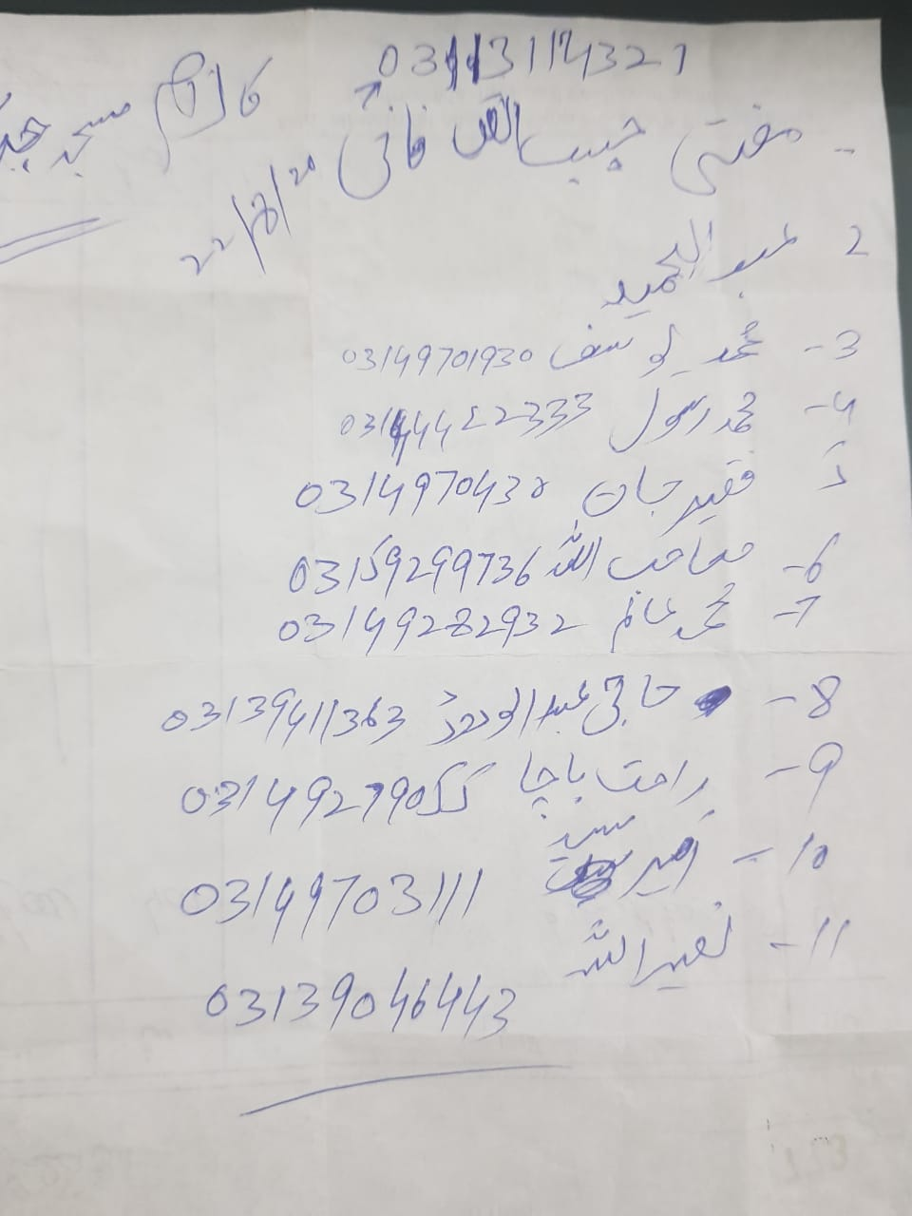

ANNEX-V: CHANCE FIND PROCEDURE

CHANCE FIND PROCEDURES

Project may involve deep excavation. Therefore, the possibility of chance find is not ignorable. In case of any chance find, the contractor will immediately report through Supervision Consultant to Directorate of Archaeology & Museums, Government of Khyber Pakhtunkhwa to take further suitable action to preserve those antique or sensitive remains. Representative of the DG will visit the site and observed the significance of the antique, artifact and cultural (religious) properties and significance of the project. The report will be prepared by representative and will be given to the DG. The documentation will be completed and if required suitable action will be taken to preserve those antiques and sensitive remains.

In case any artifact, antiques and sensitive remains are discovered, chance find procedures should be adopted by contractor workers as follows:

  - Stop the construction activities in the areas of chance find;
  - Delineate the discovered site or area;
  - Consult with the local community and provincial Archeological Department
  - The suggestion of the local communities and the concerned authorities will be suitably incorporated during taking the preventive measures to conserve the antique, artifact and cultural (religious) properties;
  - Secure the site to prevent any damage or loss of removable objects. In case of removable antiquities or sensitive remain, a night guard shall be arranged until the responsible local authorities take over; and
  - After stopping work, the contractor must immediately report the discovery to the Supervision Engineer.

The contact Address of Directorate of Archaeology & Museums, Government of Khyber Pakhtunkhwa, is given below:

Director General
Directorate of Archaeology & Museums,
Govt. of Khyber Pakhtunkhwa, Saddar Road,
Peshawar, opposite Governor House Peshawar & Civil Secretariat,
C/o Peshawar Museum.
Phone No. : 0092-91-9211194
Email : info@kparchaeology.com

ANNEX-VI: GUIDELINES FOR COVID-19 DURING CONSTRUCTION

PRECAUTIONARY ACTION AGAINST THE POTENTIAL RISK OF NOVEL CORONAVIRUS
INTRODUCTION

On February 11, 2020 the World Health Organization announced an official name for the disease that is causing the 2019 novel coronavirus outbreak, first identified in Wuhan China. The new name of this is coronavirus disease 2019, abbreviated as COVID-19. In COVID-19, ‘CO’ stands for ‘corona,’ ‘VI’ for ‘virus,’ and ‘D’ for disease. Formerly, this disease was referred to as “2019 novel coronavirus” or “2019-nCoV”.

The risk of exposure to COVID-19 is no different for employees of Employer, Engineer, Contractor, and suppliers than for the general population. Contractor, therefore, must consider the physical well-being and safety of all the persons entitled to be on the Site and follow reasonable guidelines and recommendations of Government authorities and healthcare professionals. As experience has shown in other countries, confirmed cases of COVID-19 expand exponentially if health and safety controls are left unheeded.

Contractor should enforce all health and safety procedures at Site including sanitary protocols, proper hygiene, social distancing, use of personal protective equipment (PPE), toolbox talks on special COVID-19 requirements, and prompt reporting of health issues related to COVID-19. Contractors must put safeguards in place to keep workers exposed to COVID-19 away from Site for at least 14 days after the last potential exposure.

WHO declared the COVID-19 as a Public Health Emergency of International Concern (PHEIC) in January 2020 and afterwards announced the COVID-19 outbreak as pandemic on 11th March 2020 due to the widespread of the disease in 114 countries at that time. WHO Director General urged the countries to take action now to stop the disease.

The rapid spread of COVID-19 hits all the provinces of Pakistan Sindh, Balochistan, Punjab & Khyber Pakhtunkhwa including the Gilgit Baltistan and Azad Jammu & Kashmir. The prevailing virus creates the menacing and distressing situation when it arrived around the closed proximities of the subproject areas.

Government of Pakistan has launched the National Action Plan for COVID-19 Pakistan to combat the challenge of prevailing virus, also available at https://www.nih.org.pk/wp-content/uploads/2020/03/COVID-19-NAP-V2-13-March-2020.pdf. The Government of Pakistan has launched the real-time data portal for COVID-19 http://covid.gov.pk/. These measures are mostly relating to the containment and awareness and capacity building. Besides this COVID-19 daily situation report is also available at https://www.nih.org.pk/wp-content/uploads/2020/04/COVID-19-Daily-Updated-SitRep-03-April-2020.pdf.

All the stakeholders are on board to jointly prevent/ limit/ control the spread of COVID-19. All of the staff is required to take precautionary measures as well as maintain social distances. The use of thermal guns for checking every single person body temperature, placement of relevant flyers and disinfection spray inside of all the containers are few of the measures to combat COVID-19.

OBJECTIVE

Following are the objectives of this report to jointly prevent / limit/ control the spread of COVID-19 at Site that can hamper the progress of proposed subprojects:

- To enhance understanding of the evolving COVID-19;
- To share knowledge on COVID-19 and preparedness measures being implemented at Site;
- To generate recommendations for adjusting COVID-19 containment and response measures; and
- Outline the measures taken at Site. The advised measures will help all the stakeholders to plan their work continuity in response to the COVID-19.

Due to the evolving situation of the COVID-19, this document should be read in conjunction with the latest relevant advisories issued by WHO (especially “Getting your workplace ready for COVID-19, 3 March 2020”) and Government of Pakistan.

WHAT IS CORONA VIRUS (COVID-19)

The symptoms of the COVID-19 are similar to that of regular pneumonia. Typical symptoms include;

- Fever;
- Cough;
- Difficulty in breathing;
- Pneumonia;
- Runny nose;
- Sore throat; and
- Feeling of being unwell.

MODE OF SPREAD

Infected person – person transmission; Infected people can spread COVID-19 through their respiratory secretions via droplets produced when an infected person coughs or sneezes, similar to how influenza and other respiratory pathogens spread. The spread from person-to person is most likely among close contacts (about 6 feet);

- Infected animals’ dead or Alive;
- Air by coughing and sneezing;
- Close personal contact, such as touching or shaking hands;
- Touching an object or surface with a virus on it; and
- Touching your mouth nose or eyes before washing your hands.

GENERAL STANDARDIZED PRECAUTIONARY MEASURES

Following measures/recommendations are suggested as a general guidance to be followed for the protection of potential impacts of COVID-19:

Since, there is no vaccine available to protect against human Coronavirus infections. Therefore, transmission can be prevented through following measures:

- Cover your mouth while cough or sneeze;
- Avoid close contact with people who are sick;
- Avoid the use of hard soap;
- Wash your hands often with liquid soap and water for at least 20 seconds;
- All the employees should ensure sanitization of hands at appropriate time;
- Avoid touching your eyes, nose, and mouth with unwashed hands;
- If you are concerned about your symptoms you should see your health care provider at site or in office;
- Use of Personal Protective Equipment (PPE) according to risk (a surgical or N95 mask);
- Do not spit, wrap your oral and nasal secretion with tissue and throw it in a covered dustbin;
- Balance your nutrition and exercise moderately;
- Sterilization / disinfection of medical devices at Site dispensaries; and
- Do not touch, buy or eat wild animals (gamey). Try to avoid visiting markets that sell such animals.

PROJECT SITE SPECIFIC PRECAUTIONARY MEASURES

WB Guidelines for COVID-19 during construction activities shall be followed. Measures for protecting staff and labour from exposure to, and infection with, the COVID-19 depend on the type of work being performed and exposure risk, including potential for interaction with infectious people and contamination of the work environment. Regardless of specific exposure risks, following are the main actions that have been jointly taken at Site to combat the COVID-19:

Employer’s Side / PMU-C&WD/ DOAM

Employer should issue the notification containing the precautionary measures in the light of updated / latest WHO / GoP guidelines to be implemented at Site. Upon receiving the Employer notification all the mentioned precautionary measures will be communicated to Engineer staff for compliance. Employer technical staff is also complying with the updated / latest WHO / GoP guidelines and Contractor suggestion to control the spread of COVID-19 at Site in the best interest of the Project and country.

Consultant’s Side

Consultant’s top management will issue the orders in the light of updated / latest WHO / GoP guidelines containing the precautionary measures to control the spread of COVID-19 for the staff working at Site.

Consultant staff at Site will fully complying with the orders including photographic evidence. Considering the severity of the prevailing virus Engineer devised the Standard Operating Procedure (SOP) containing precautionary action against the potential risk of novel corona virus.

Besides, above Consultant will ensure the following precautionary measures at Site.

- Adequate signage and information at all entrances and exits showing what is Corona Virus, how it spreads, what are the symptoms, standard precautions;
- The awareness session for the Contractor staff is equally important as of Consultant staff to combat the COVID-19 at Site. The Consultant will ensuring that Contractor is arranging such session at Site from time to time to reduce the potential risk of COVID-19. Further, all the newly inducted and existing staff have been given HSE training by the Consultant & Contractor.

Contractor’s Side

Contractor will communicate various precautionary measures to Employer and Engineer through letters to control the spread of COVID-19 at Site. Following are the major steps to be taken by the Contractor:

- Contractor will convey the instructions and requirements of its superior unit for the prevention and control of COVID-19 epidemic at Site.
- Contractor will establish a special organization for epidemic prevention and control on the Project Site that is responsible for arranging, implementing, publicizing and supervising the epidemic prevention and control measures.
- Launch the plan for epidemic prevention and control on the project Site that includes:
  - All personnel in temporary camp are required to wear masks;
  - Contractor personnel incharge of Site to wear masks;
  - Arranged special personnel to measure and record the temperature of all personnel when entering or leaving the temporary camp;
  - If any person with fever, cold and other symptoms are found, they will be admonished to go home for isolation and asked about the development of the disease every day; and
  - Propagate and implement the epidemic prevention measures for the staffs and labours and warn them not to go outside and home as much as possible.
- All these meetings should carried out through video conference.

Contractor is not limited to the above precautionary measures but practicing and implementing the following;

- Contractor will prepare a pamphlet for the awareness of Site staff to combat the COVID-19. It will also place/posted at strategic points at Site.
- Launch awareness campaign to inform all the staff and labour about the coronavirus, to use facemask, hand hygiene, cough etiquette, and avoidance of close contact with animals and consumption of their raw products.
- Everyday awareness speech in English and Urdu in the temporary camp.
- All the employees are not allowed to go outside of the Project Area or on vacation to their homes and on daily basis visit to sites;
- Contractor will provide medical masks and antibacterial liquid hand wash to all personnel.
- Contractor will prepare the isolation facility at Site and provided three isolated rooms for such patients inside the temporary camp. Each room have three beds, oxygen cylinder, sanitizers, isolation kit, hand wash.
- Thermal scanning will be carried out continuously in the morning for everybody at the main gate of temporary camp.
- Record will be maintained for everyone that includes the temperature value of each person with their names, every morning and afternoon go to each department for scanning separately and noted down their name with temperature values.
- Contractor carry out disinfectant spray on daily basis morning and afternoon in each office and rooms and all the area of the camp.
- SSWMB and Consultant staff will also requested by Contractor to do not interact physically rather through electronically by emails or video conferencing.

RECOMMENDATIONS FOR THE CONTROL OF COVID-19 AT SITE

To Avoid Transmission

For all personnel at Site, it is always a good to practice the following precautionary measures:

- Workers to remain at least two meters apart from each other at all times (social distancing) – i.e. spread out and reduce the number of people working together in one area of the site;
- Avoid eating lunch in the form of group in available mess/canteens at Site;
- Close site canteens/ food preparation and eating areas (avoid gatherings) – workers to bring their own prepared lunch to site and eat alone e.g. in their van, car, or in an open space;
- Avoid in-person meetings if possible. In the case that an in-person meeting is unavoidable, make sure to have it in a well-ventilated area with sufficient space for attendees to distance themselves from one another. For meetings such as toolbox talks, consider breaking them up into smaller group meetings versus one large meeting;
- Introduce enhanced cleaning procedures across the Site and touch points e.g. office equipment, plant and machinery controls, taps/toilet/washing facilities, handrails;
- Stagger start times on site to avoid congestion in entrance areas;
- Reduce the number of people on site inductions at any one time and hold them outdoors if possible;
- Stop workers moving across various sites (potential for cross contamination);
- No outsiders should be at the Project Site;
- Contractor, Consultant and Employer personnel are advised to avoid travelling and in case traveling is unavoidable, prior approval from the management should be essential. In case of travelling, the above mentioned measures need to be strictly followed by the traveller;
- Prompt identification and isolation of potentially infectious individuals is a critical first step in protecting workers and other Site staff. An isolated area should be available at Site to immediately isolate suspected person, as it is most important to stop its spread at Site.
- Rapid Response Team should be formed and be informed immediately in case of suspect and confirmed case of COVID-19.
- Medical team at Site should separate the suspected person displaying fever, cough or difficulty breathing from other personnel; and
- If a person has had close contact with an individual that has confirmed COVID-19, that person will not be allowed to return to the Site until he/she has been symptom free for 14 days.
- Clean and fumigate all the workplaces at Site on daily basis;
- Ask people to stay at home if they have fever, cough, difficulty in breathing, runny nose, sore throat as per organizational rules;
- An immediate replacement of solid soap with liquid anti-bacterial soap bottles may be appropriate.
- Provision of alcohol-based hand sanitizer need to available for all staff;
- Clean the religious places carpets and rugs. Have them washed in place over the weekend and then do regular cleaning;
- Have the cleaners/ maintenance crews regularly clean surfaces that are touched frequently by personnel with disinfectants such as in and out doors;
- Fresh medical tests of staff working should be carried out at Site;
- Dispose of all contaminated waste (gloves, paper, swab handles, etc.) into biohazard waste bags for disposal;
- Ensure that panic is not created. In fact the posters should start with statements such as do not panic and fear the virus but know and prevent; and
- Ensure proper ventilation system for all the personnel at Site.

Use of Personal Protective Equipment (PPEs)

- Necessary PPE should be available at Site all the times and are being issued to each personnel at Site;
- Practice of using masks is also being ensured by all parties at Site (a surgical or N95 masks);
- Re-usable PPE should be thoroughly cleaned after use and not shared between workers. Single use PPE should be disposed of so that it cannot be reused;

Outside Visitors

- Visitors should enter with strictly wearing visitors card;
- Ensure sanitization of hands;
- All parties should ensure that the sick persons should be wearing a surgical or N95 masks;
- Note down the complete information of outsiders before entrance;
- Proper screening should be carried out before entering the Site;
- Refrain from handshakes. Rather than shaking hands, visitors may explain why handshakes can contribute to the risk of spread;
- Attempt to maintain a general six (6) feet distance between themselves. This will be challenging to follow at all times but it is Engineer recommendation to follow;
- Refrain from and/or limit touching of workplace surfaces; and
- In addition to these on-site procedures, it is advised to follow their respective organizational instructions related to Site visits.

ANNEX-VII: TEMPLATE FORM FOR ENVIRONMENTAL AND SOCIAL MONITORING

KHYBER PAKHTUNKHWA INTEGRATED TOURISM
DEVELOPMENT PROJECT

TEMPLATE FORM FOR ENVIRONMENTAL AND SOCIAL MONITORING

Date:________________________ Time:_______________

Sr. No. | Receptor | Monitoring Parameters | Locations | Monitoring Mechanism | Monitoring and Reporting Frequency |  |  |  | Remarks
 |  |  |  |  | Daily | Monthly | Bi-Annual | Annual | Remarks
1 | Water Quality
2 | Soil Contamination
3 | Land Resources
4 | Dust Emissions
5 | Noise Pollution
6 | Fumes and gases
7 | Ecological Resources
8 | Houses
9 | Public Infrastructure
10 | Community around the Project corridor
11 | Labour Management
12 | Labour Influx
13 | Grievances Redressal
14 | Community/occupational health & safety
15 | Gender Based Violence
16 | Training

Name of Monitoring Person:_______________________ Designation:______________ Signature:______________________

ANNEX-VIII: TREE PLANTATION PLAN
TREE PLANTATION PLAN

The basic purpose of afforestation/plantation of suitable species in the project area is to reduce the risk been made due to cutting of trees for the proposed subprojects and to enhance green cover and improve the overall environment of the area. Total 250 number of plants are recommended for each sub project site. Afforestation will not only reduce the risk been made but will also increase the carrying capacity of the area regarding many positive aspects.
Importance of Tree Plantation

- Trees contribute to their environment by providing oxygen, improving air quality, climate amelioration, conserving water, preserving soil, and supporting wildlife.
- Trees control climate by moderating the effects of the sun, rain and wind. Leaves absorb and filter the sun’s radiant energy, keeping things cool in summer.
- Trees also preserve warmth by providing a screen from harsh wind.
- Trees also lower the air temperature and reduce the heat intensity of the greenhouse effect by maintaining low levels of carbon dioxide.
- Both above and below ground, trees are essential to the eco-systems in which they reside.
- Trees absorb and store rainwater which reduce runoff and sediment deposit after storms. This helps the ground water supply recharge, prevents the transport of chemicals into streams and prevents flooding.
- Trees, shrubs and turf also filter air by removing dust and absorbing other pollutants like carbon monoxide, sulfur dioxide and nitrogen dioxide.
Objectives
- To Restore native species
- To improve the quality of air and reduce its pollution
- To add color to the landscape and enhances the beauty of the environment
- To uplift the quality of our living environment through active planting, proper maintenance and preservation of trees together with other vegetation.
- To Protect and conserve flora and fauna of the project area.
- To attract rain which is a positive impact on the project area at all.
- To reduce sedimentation by plantation in the project area which will act as protection wall against wind born dust particles.
PLANTATION TECHNIQUE

Plantation of conifers and broad leaved species is to be carried out in the immediate vicinity of the project area. The project area can be afforested and vegetation cover can be improved by adopting standard afforestation technique of digging pits. The project area is suitable for plantation activities and can be managed thoroughly with care.

Pits

Pits should be dug in the project area at a spacing of 10’ linearly. The pits should be of 1.5 feet dia at the top and 1 feet dia at the bottom with a depth of 1-3/4” ft. The earth taken out of the pits will be deposited below each pit in a crescent shape, so as to form a ridge with a clear berm of 9 inches in front. The consecutive crescents will be joined to catch the maximum quantity of moisture. Moreover, planting should be carried out in the pits and sowing on the berms, before or immediately after the first shower of rain. The choice of species (Forest Department may change as per actual requirement and suitability *standards & Species as well) for the project area is given below.

Table: Recommended Species for Plantation of the Project Area
Sr. No. | English/ Common Name | Scientific Name
1 | Chir-Pine/Nakhtar | Pinus roxburghii
2 | Mulbery/ Tooth | Morus alba
3 | Bakain/Dhrek | Melia azedarach

When to plant
Planting should be completed early in the rains in as short a time as possible. The trees must be given time to become well established prior to the dry season. A good rule of thumb is to start planting when the soil is moist to a depth of 15-25 cm or to the bottom of the planting hole. Failures because planting is too late are more common than failures because of planting too early. To obtain good results and avoid labor shortage in these areas considerable preparatory planning is needed. The size of the plantation might have to be adapted to the availability of labor. If dry sites cannot be planted in time, planting should be postponed until the next season.
Plantation Plan for Archeological Sites

Plants will be raised along the around each sub project area or in nearby available spaces, and two (02) rows on either side of the proposed road. Thus in one kilometer and total, 250 number of plants are to be raised in single row.

*KP Forest Department will implement may update the standards of planting and choice of species as per the requirements and suitability.
Cost
Break-up of Expenditure per Avenue kilometer @ Rs. 1500/- per diem: Break-up of Expenditure per Avenue kilometer or 250 plants @ Rs. 1500/- per diem:
FIRST YEAR
Sr. No. | Item | Quantity | Rate | Amount (Rs.)
1. | Layout | 1 Av.km | 2 MD/Av.km | 3000.00
2. | Digging of Pits 2.5 ft. each 2.5x250 = 625 cft. | 625 cft. | 5 MD/Av.km | 7500.00
3. | Cost of Plants including | 250 No. | Rs100/- plant | 25,000.00
4. | Cost of planting of plants | 250 No. | Rs. 25/- plant | 6250.00
5. | Carriage of plants from private nursery to site including loading/unloading | 250 No. | Rs. 10/- plant | 2500.00
6. | Cost of Manure and Bhall (silt) including carriage | 1 Av. Km |  | 20,000.00
7. | H/watering 50 times 250x50 with water bowser, one driver and one coolie | 12500 no. | 5MD/per %0 | 100,000.00
8. | Weeding twice 250x2 | 500 no. | 2 MD/per % | 15,000.00
9. | Reopening of Pits twice (250x2)/cft/pit | 500 cft. | 2 MD/per % | 15,000.00
10. | Unforeseen |  |  | 5750.00
Total |  |  |  | 200,000.00

SECOND YEAR
Sr. No. | Item | Quantity | Rate | Amount (Rs.)
1. | Cost of Plants 20% Restocking | 50 No. | Rs.100/- plant | 5,000.00
2. | Cost of planting | 50 No. | Rs. 25/- plant | 1250.00
3. | Carriage of plants | 50 No. | Rs. 10/- plant | 500.00
4. | H/watering 50 times with water bowser, one driver and one coolie | 12500 no. | 5MD/per %0 | 100,000.00
5. | Reopening of Pits twice (250x2) | 500 cft. | 2 MD/per % | 1,5000.00
6. | Weeding twice 250x2 | 500 no. | 2 MD/per % | 1,5000.00
7. | Unforeseen |  |  | 1250.00
Total |  |  |  | 1,38,,000.00

THIRD YEAR
Sr. No. | Item | Quantity | Rate | Amount (Rs.)
1. | Cost of Plants 10% Restocking 25 No. | 25 No. | Rs.100/- plant | 2500.00
2. | Cost of planting | 25 No. | Rs. 25/- plant | 625.00
3. | Carriage of plants | 25 No. | Rs. 10/- plant | 250.00
4. | H/watering 40 times x250 no. | 10,000 no. | 5MD/per %0 | 75000.00
5. | Reopening of Pits twice (250x2) | 500 | 5MD/per %0 | 3750.00
6. | Unforeseen |  |  | 2875.00
Total |  |  |  | 85,000.00

FOURTH YEAR
Sr. No. | Item | Quantity | Rate | Amount (Rs.)
1. | H/watering 30 times | 7500 no. | 5MD/per %0 | 56250.00
5. | Pruning and cleaning of plants | 250 no. | 5MD/per %0 | 1875.00
6. | Unforeseen |  |  | 1875.00
Total |  |  |  | 60,000.00

Cost for raising 1 Av. Km and Maintenance or 250 plants in single for each subproject = Rs.4,83,000/-
For 4 years.

Note: The above rates and calculations are approximate and tentative which will be updated according to the standard rates of concerned Forest Departments/Implementing Agency, during implantation stage.

PHOTOLOG

PICTORIAL VIEW OF BHAMALA SITE
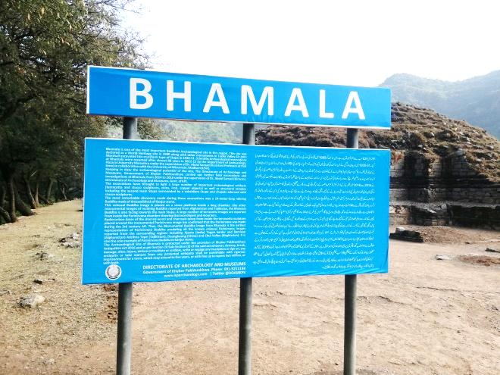 | 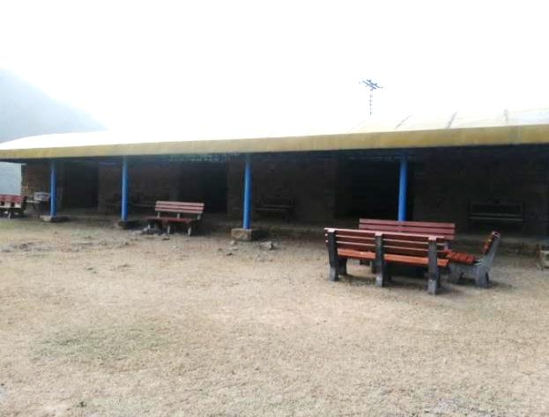
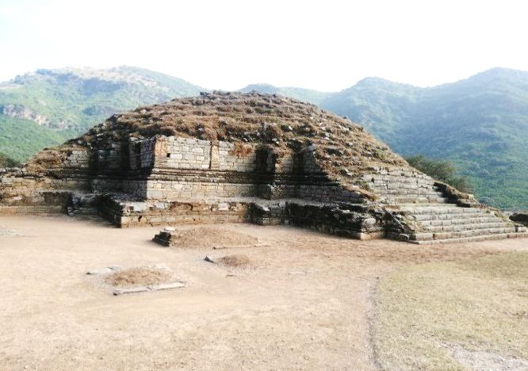 | 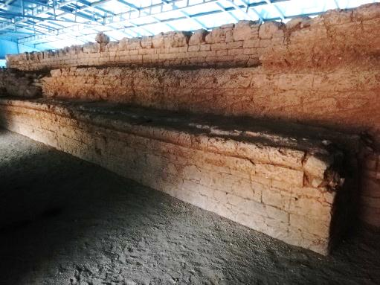
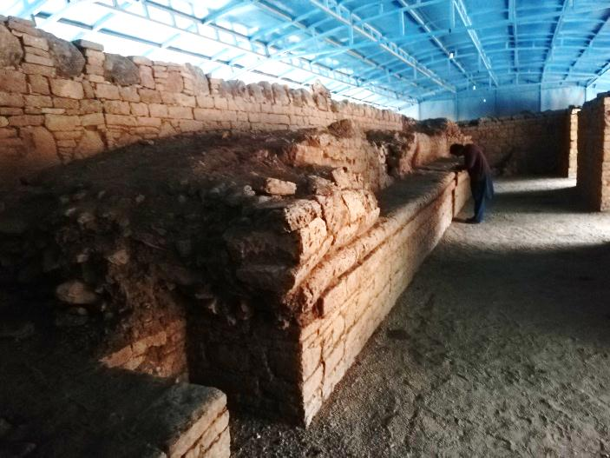 | 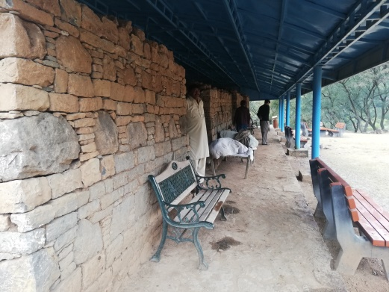
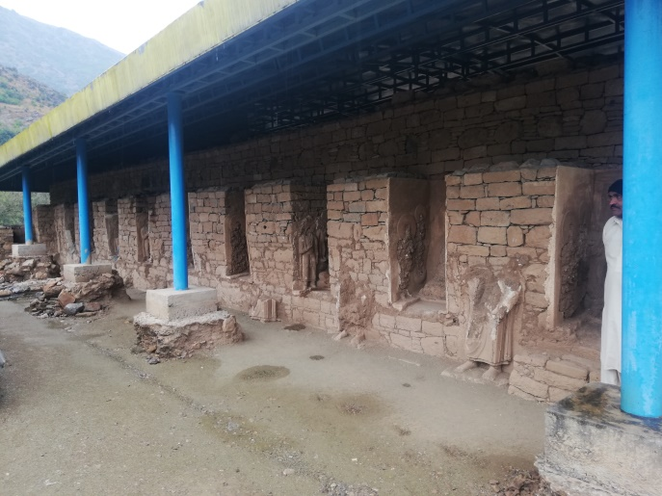 | 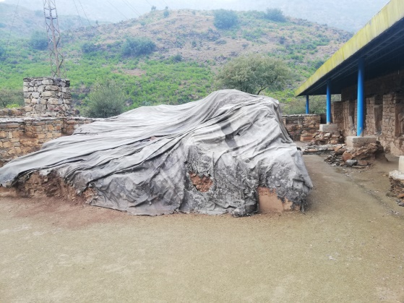
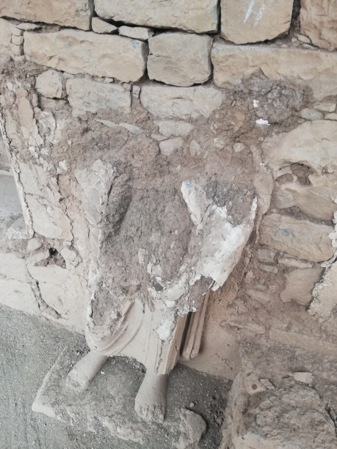 | 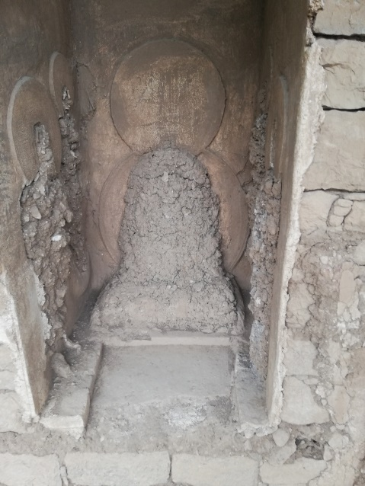
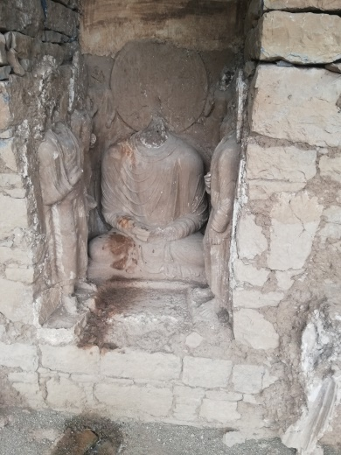 | 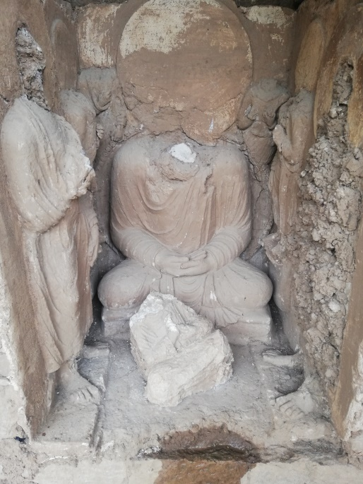
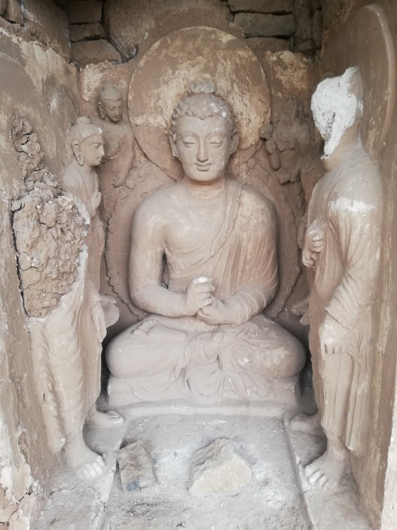 | 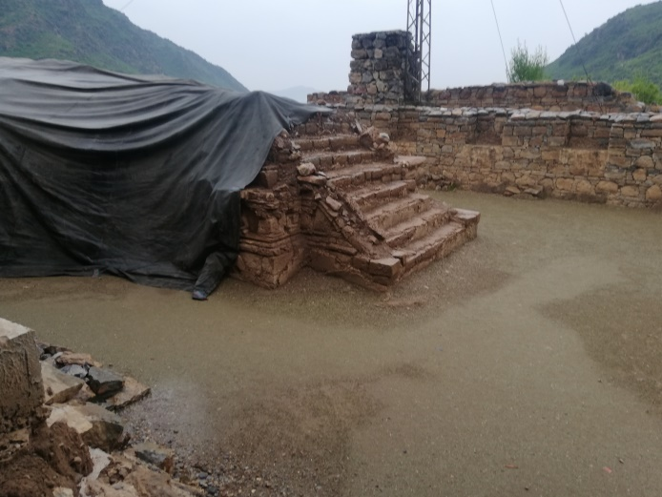
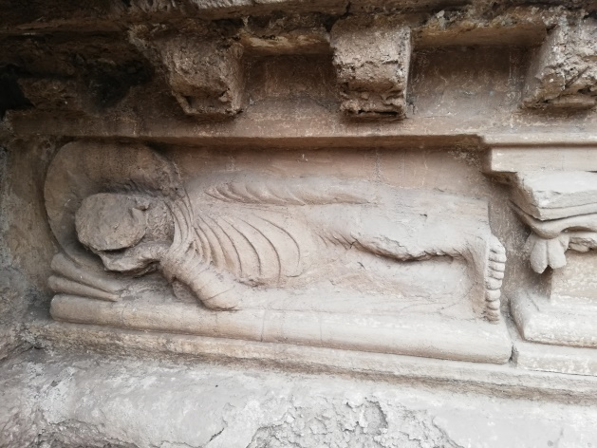 | 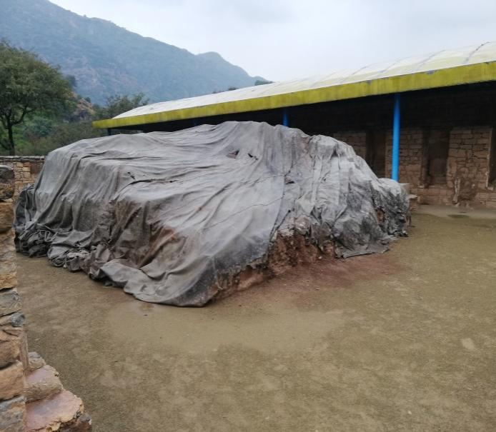
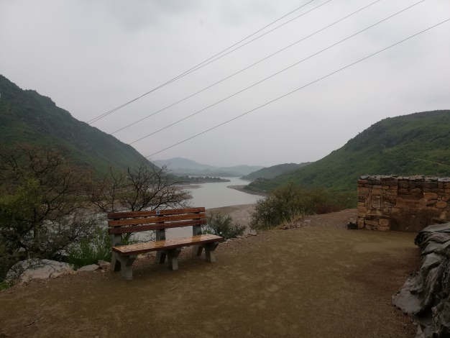 | 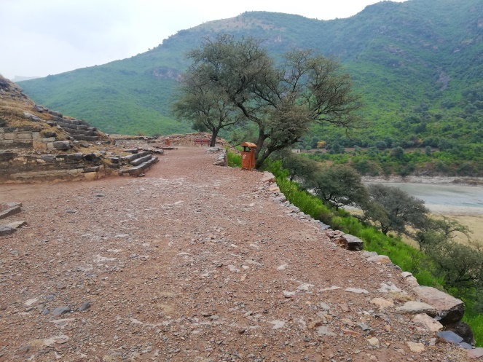
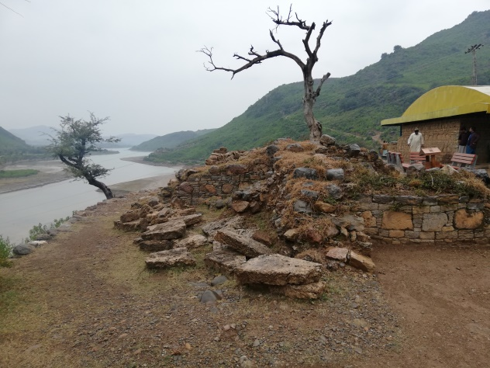
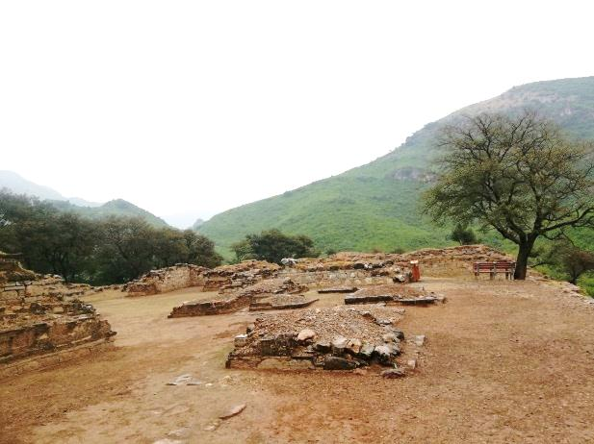 | 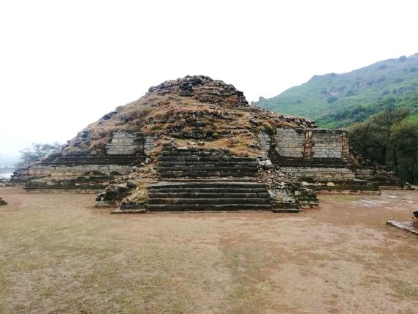
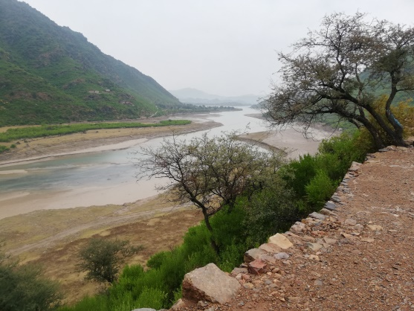 | 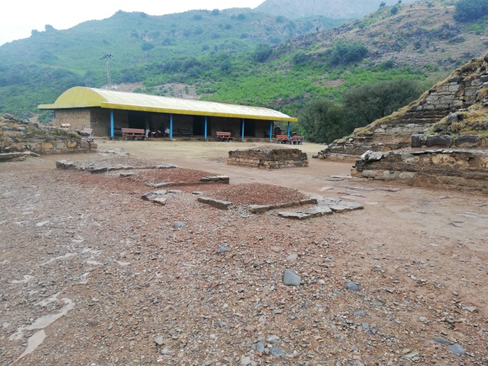
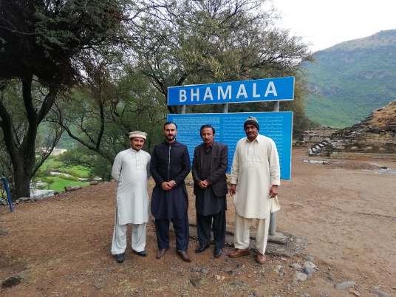 | 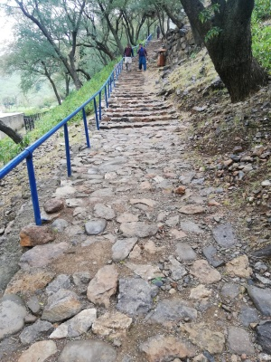
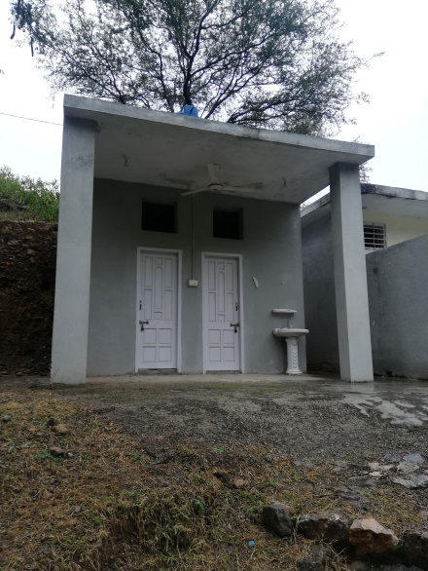 | 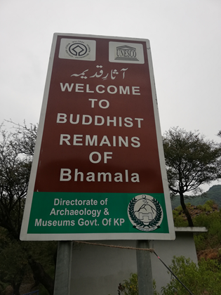

PICTORIAL VIEW OF DIR MUSEUM DISTRICT DIR

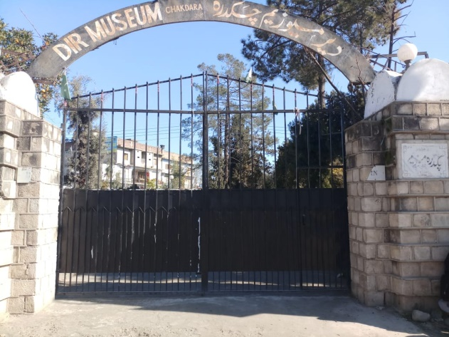 | 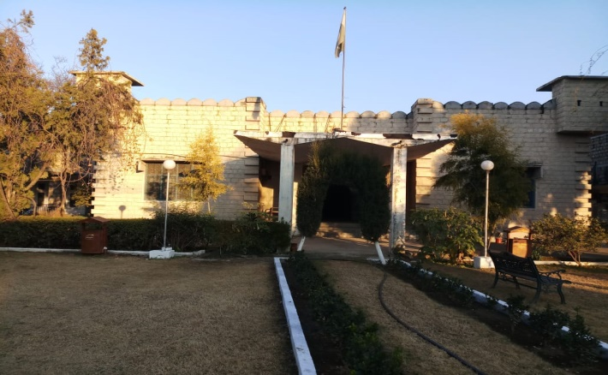
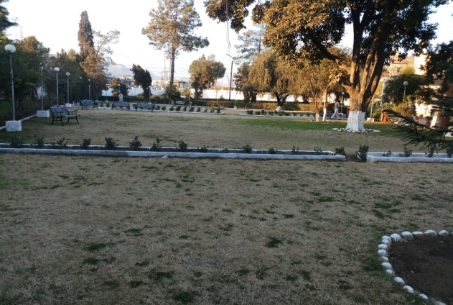 | 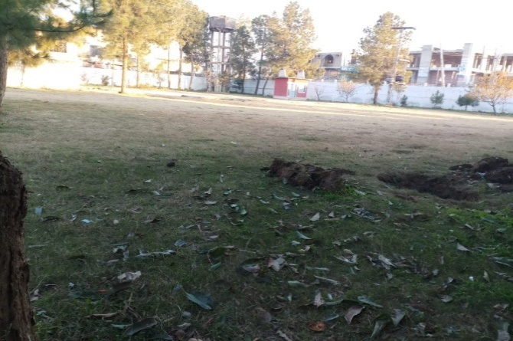
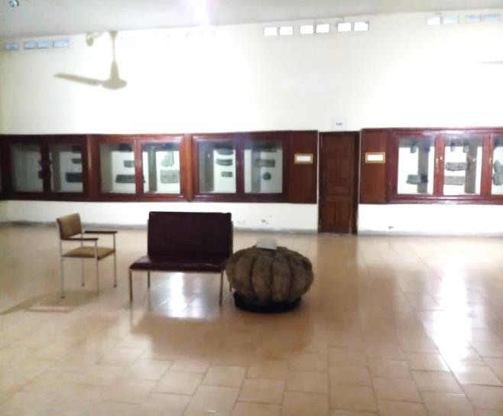 | 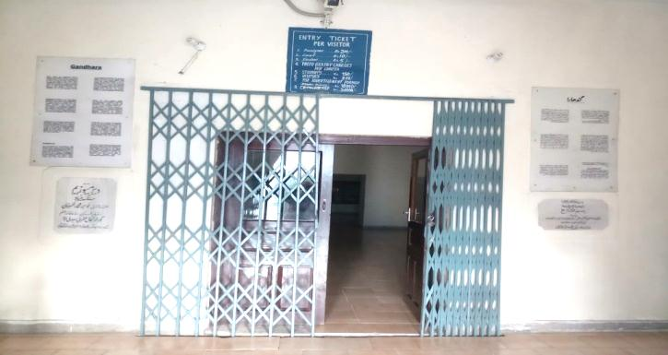
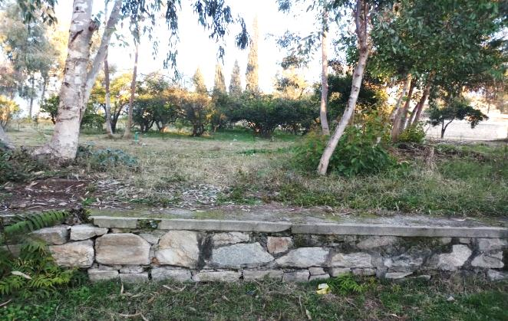 | 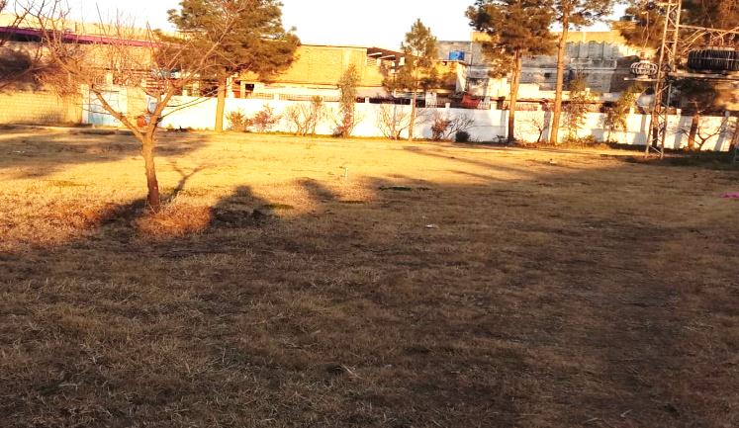
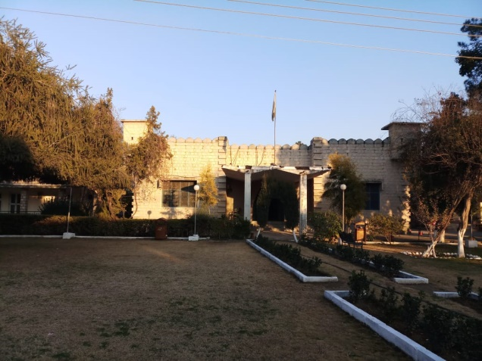 | 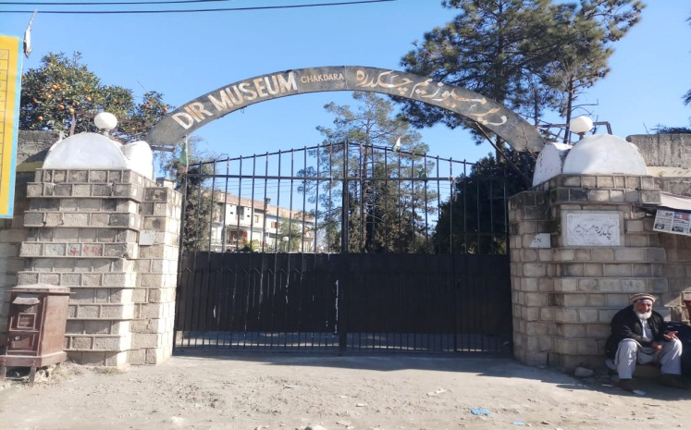

PICTORIAL VIEW OF HUND MUSEUM DISTRICT SWABI

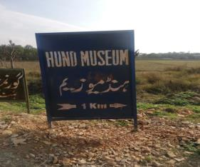 | 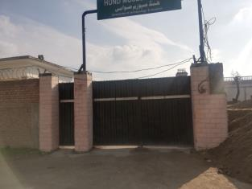
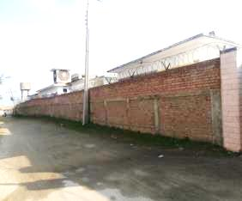 | 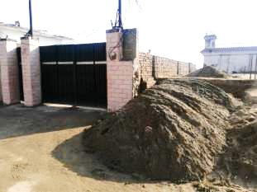
 | 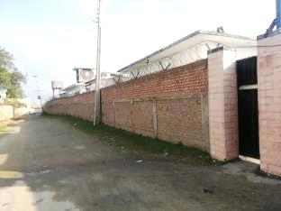

PICTORIAL VIEW OF SHAPOLA STUPA DISTRICT KHYBER

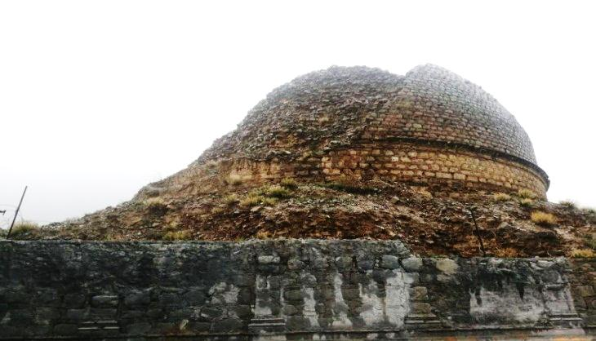 | 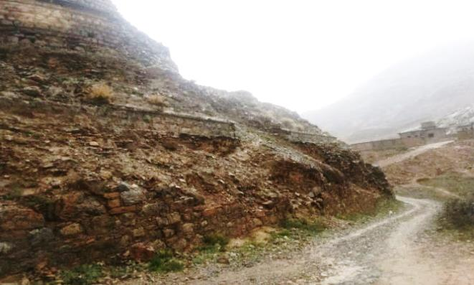
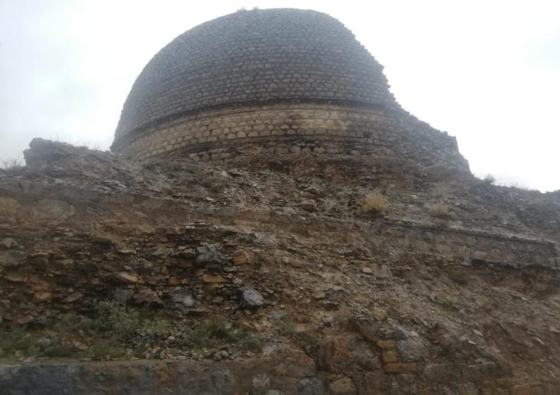 | 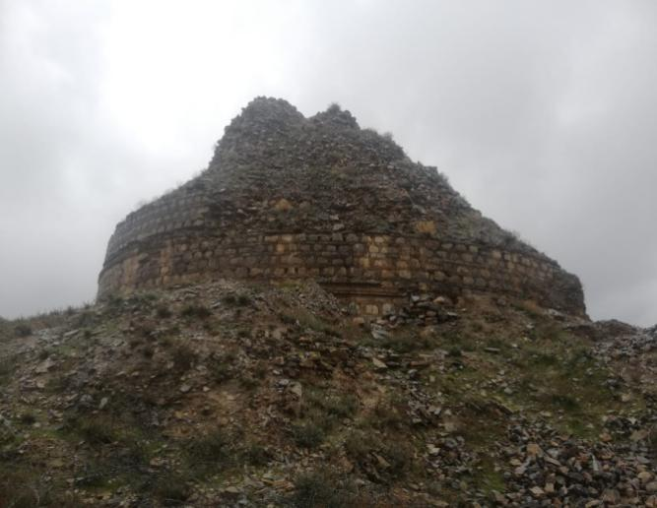
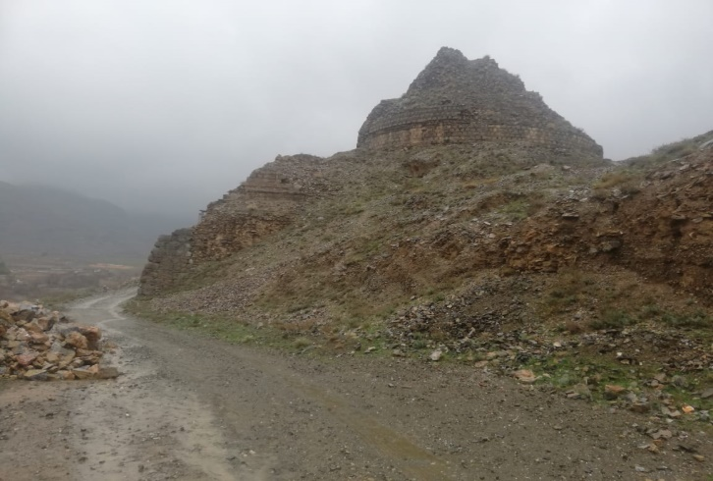 | 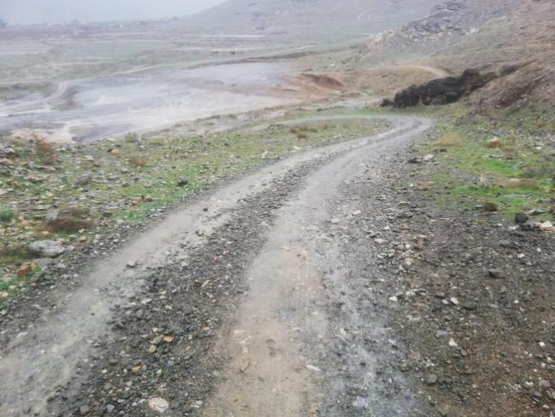
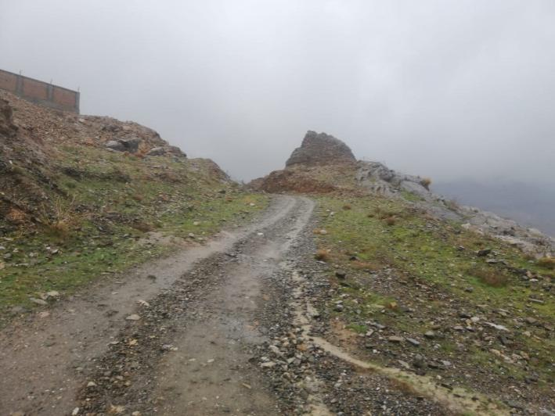 | 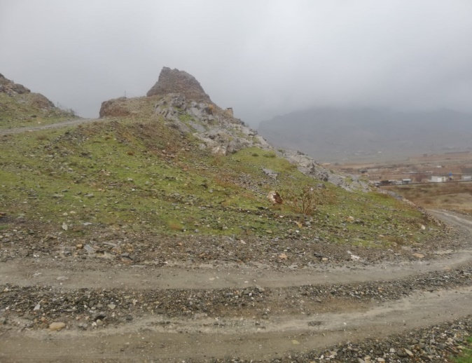

PICTORIAL VIEW OF ODIGRAM MOSQUE DISTRICT SWAT

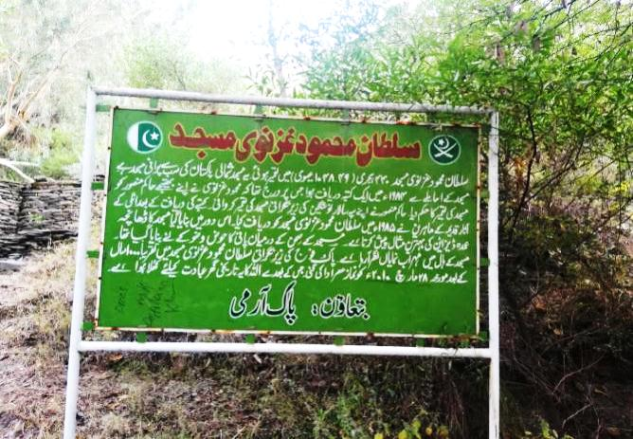 | 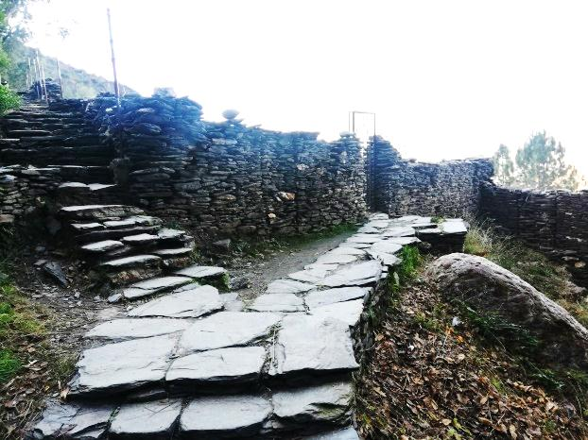
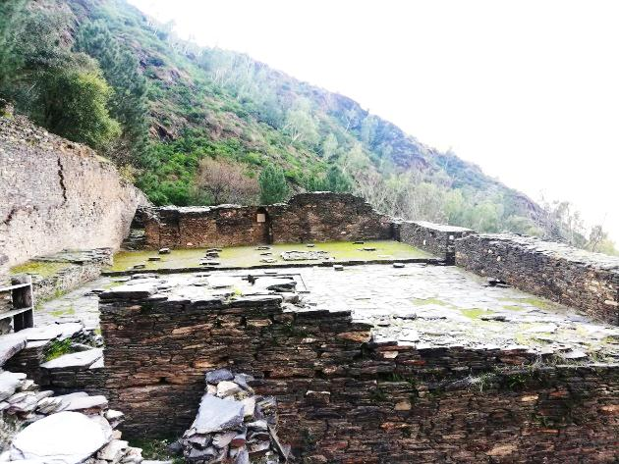 | 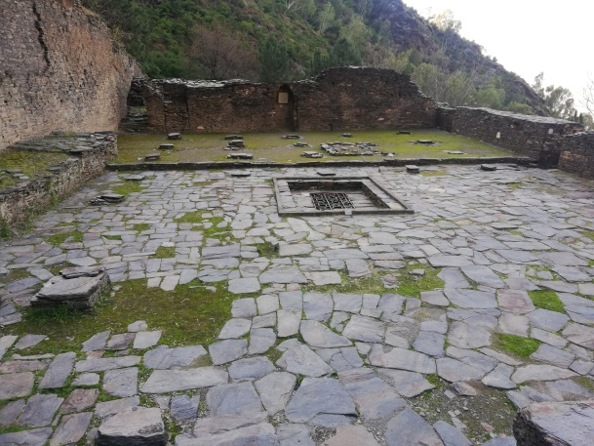
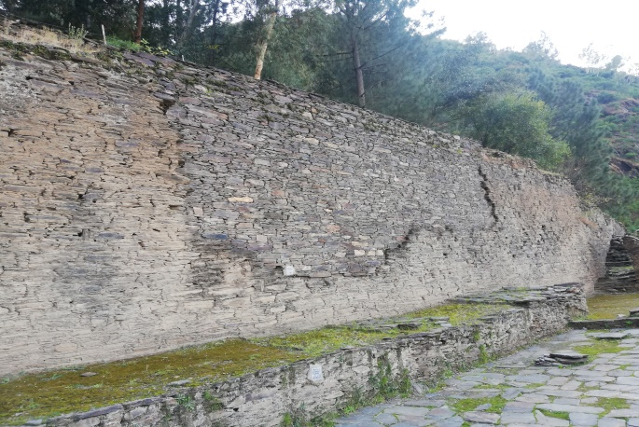 | 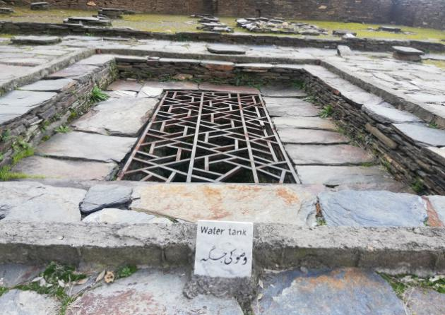
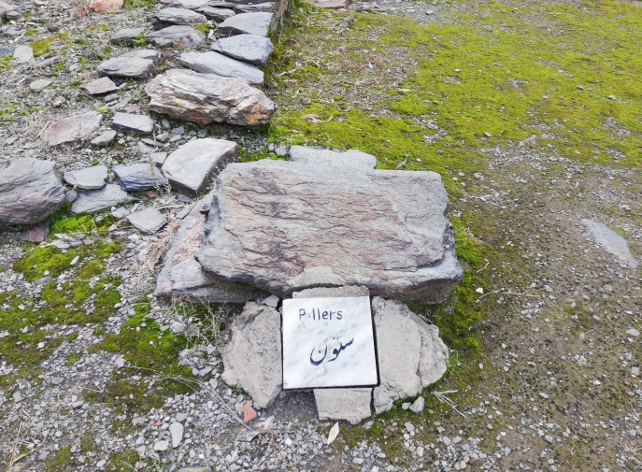 | 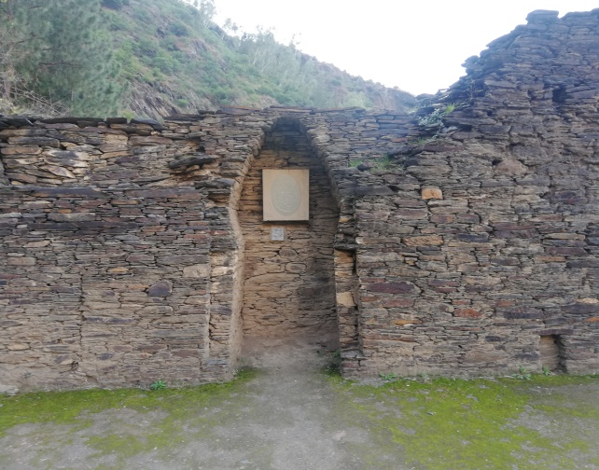
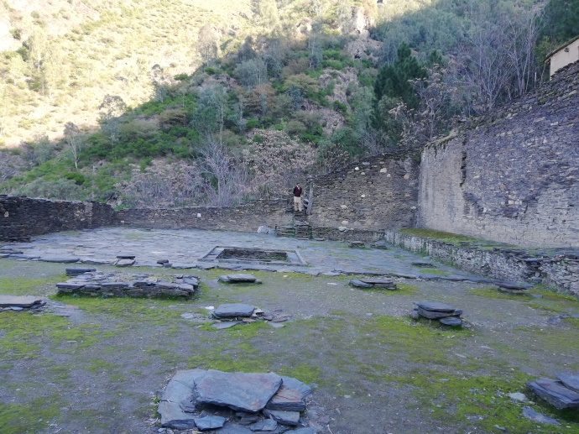 | 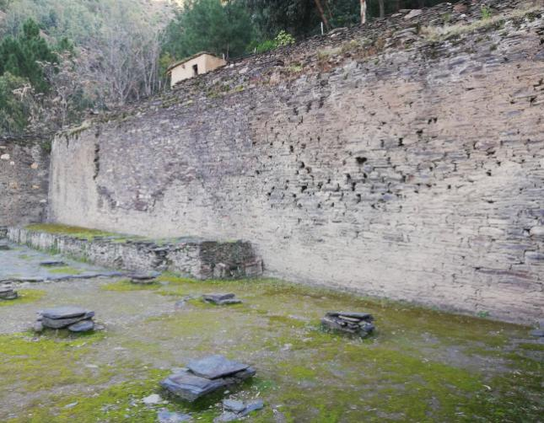
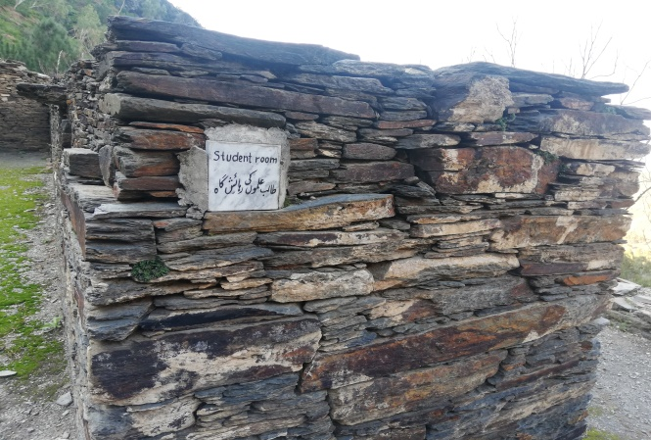 | 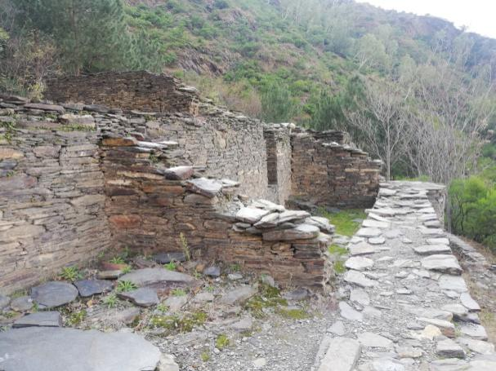
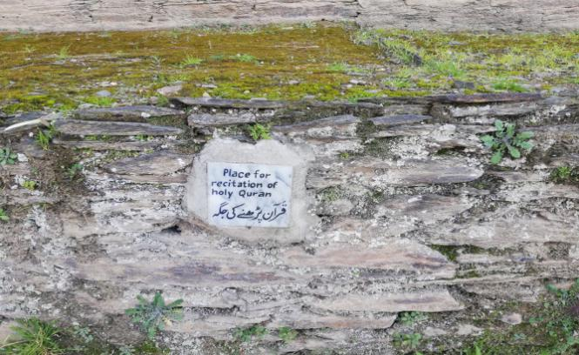 | 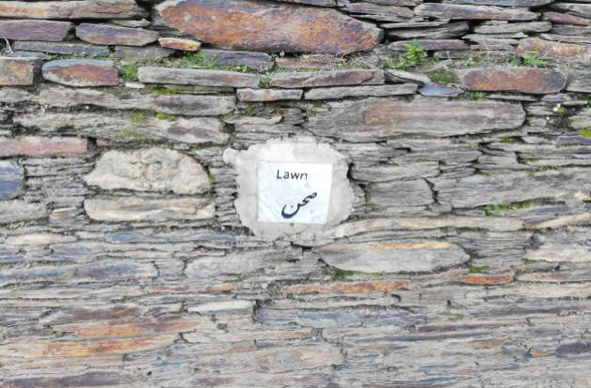
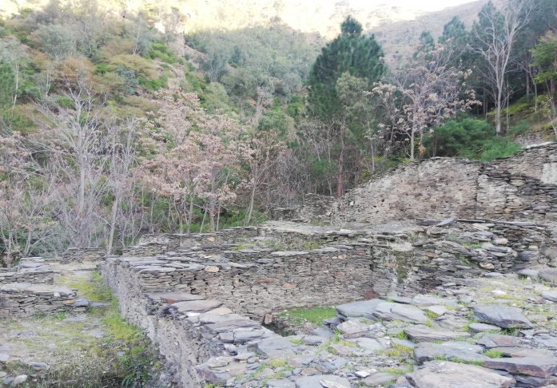 | 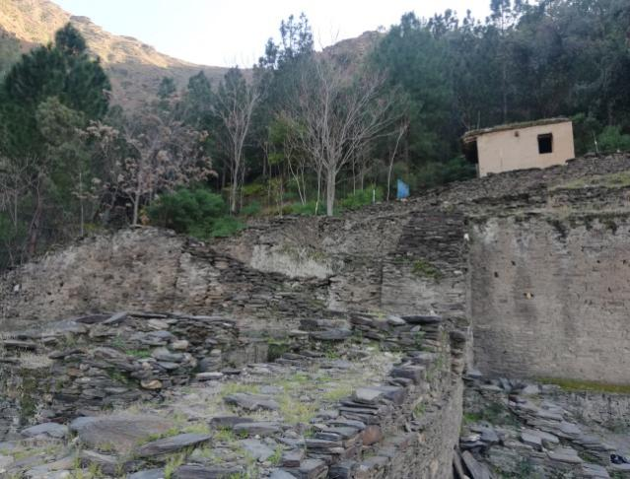
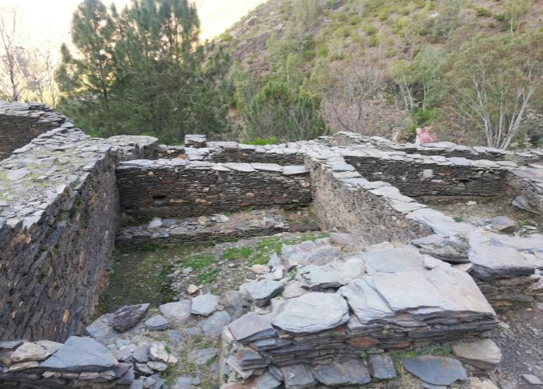 | 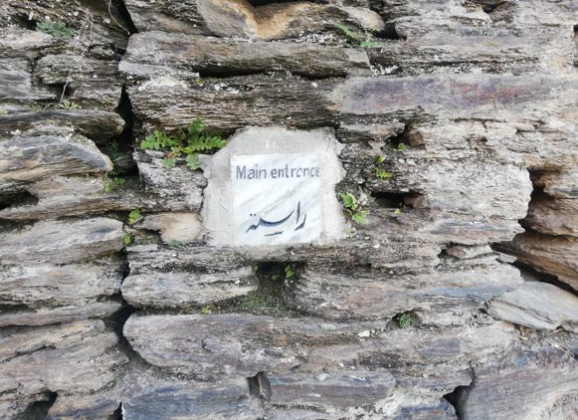
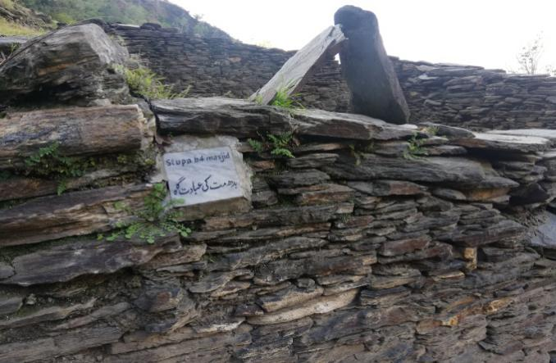 | 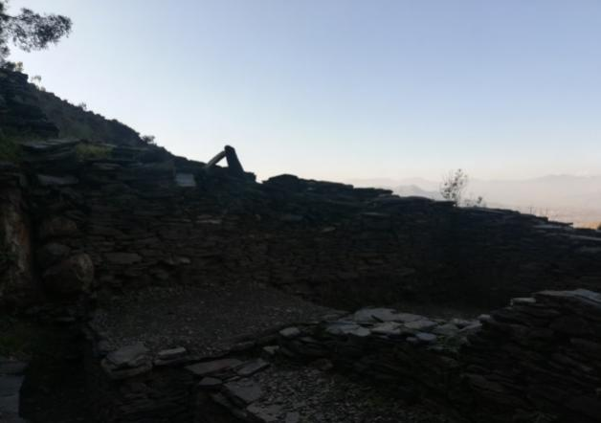
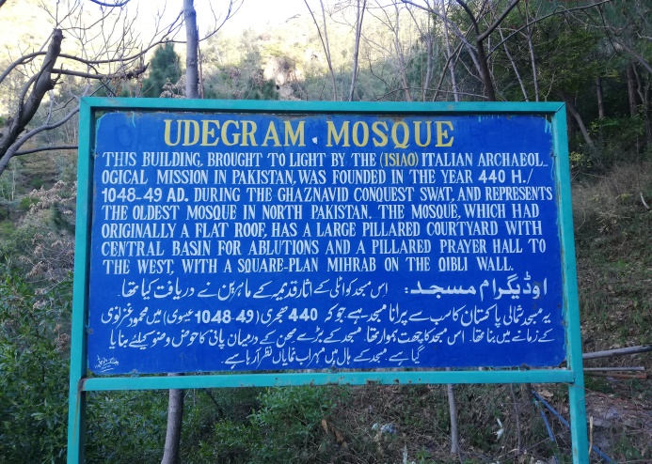 | 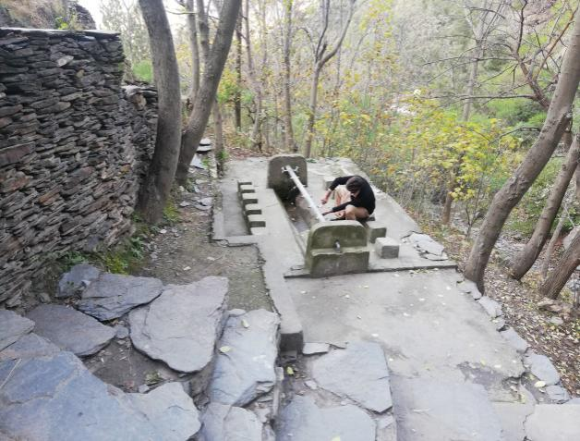
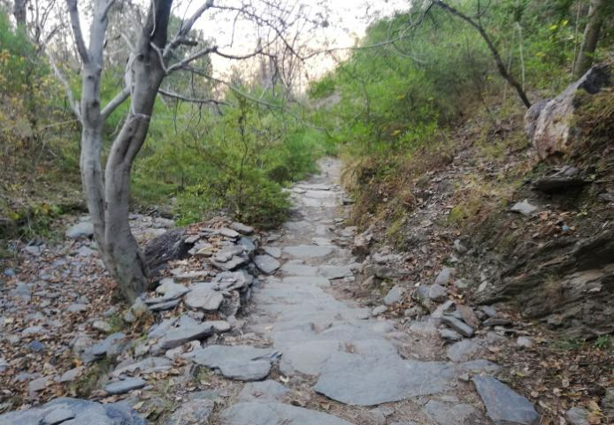

PICTORIAL VIEW OF MAIN KALAM MOSQUE DISTRICT SWAT

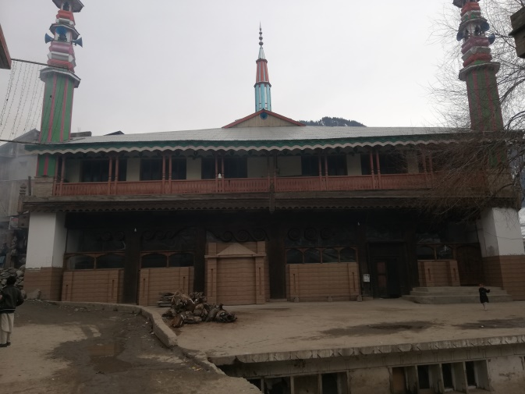 | 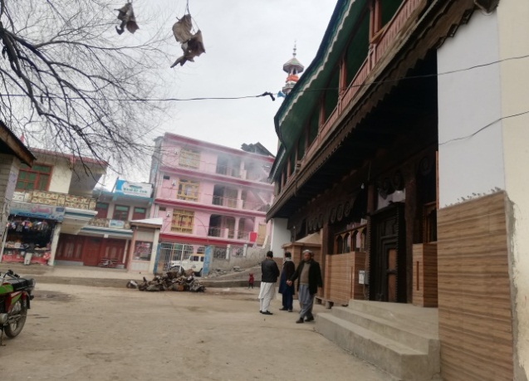
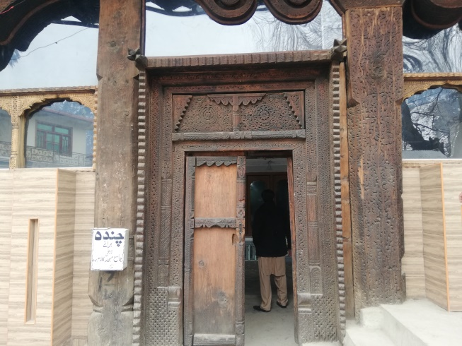 | 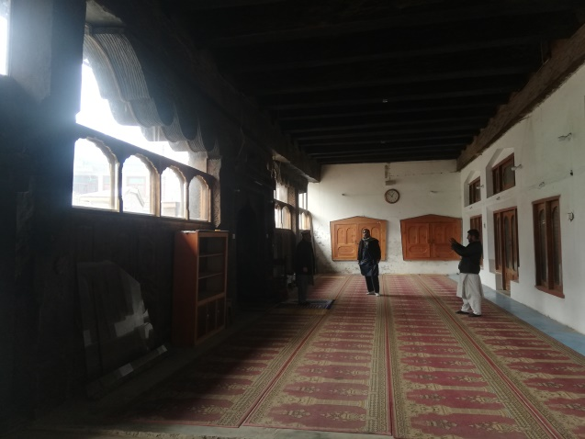
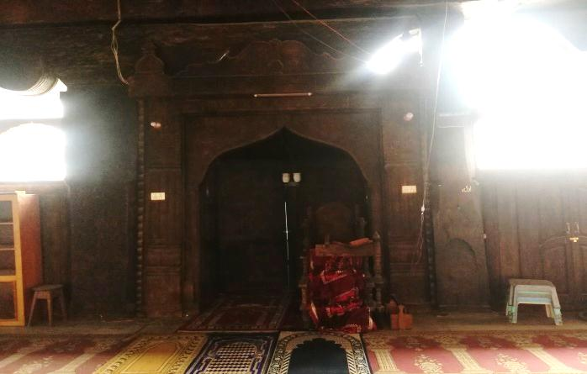 | 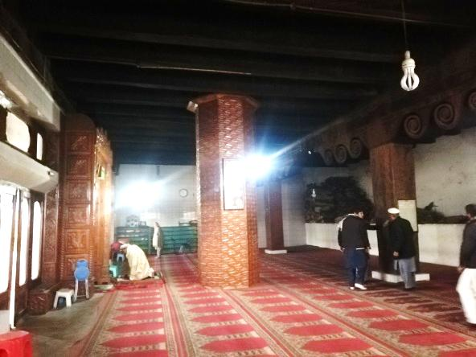
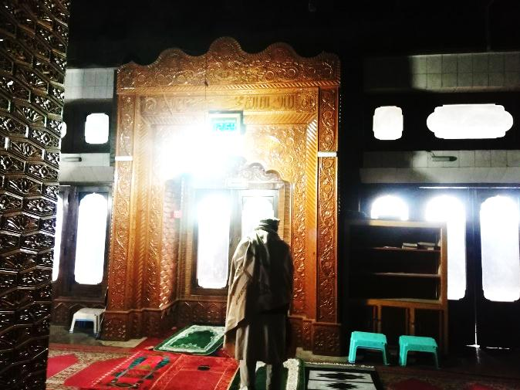 | 
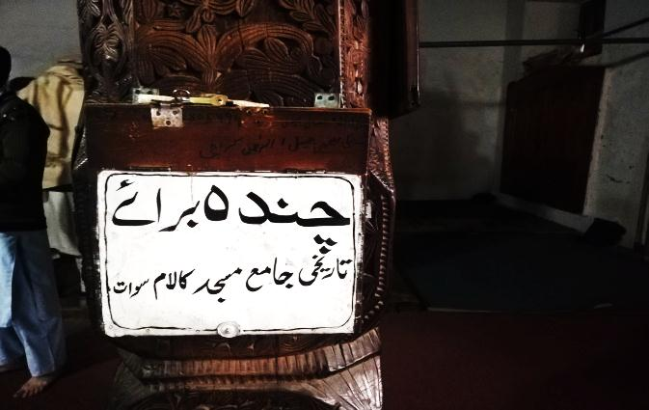 | 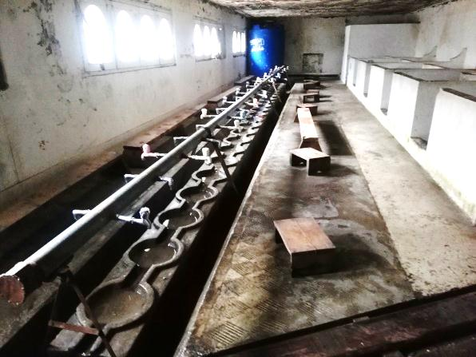
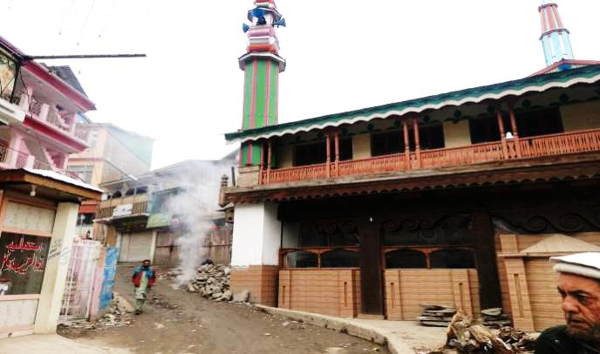 | 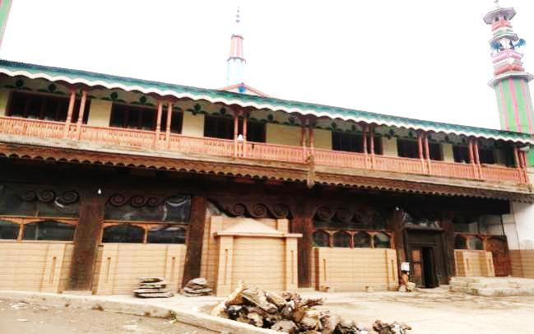

Environmental and social management framework, updated with covid-19 checklists, April 2020
Identified subproject sites are located in 6 districts of KP
Building Code of Pakistan-Seismic Provisions, Ministry of Housing and Works, Government of Pakistan, 2008
Building Code of Pakistan-Seismic Provisions, Ministry of Housing and Works, Government of Pakistan, 2008
Pakistan Bureau of Statistics
DCR Haripur, 1998
Environmental and social management framework, updated with covid-19 checklists, April 2020
Mostly the local labor would be hired due to small works, the establishing regular construction camps by the contractor(s) is unlikely. However, given measures would be taken, if needed.
Feasibility Study, Master Planning and Design of Pakistan Digital City, Haripur, Khyber Pakhtunkhwa, 2021
Pakhtunkhwa Energy Development Organization, Feasibility Study of Shigo Kas Hydropower Project (District Lower Dir), 2012
IEE of Rehabilitation of Swabi Roads, 2012
Building Code of Pakistan-Seismic Provisions, Ministry of Housing and Works, Government of Pakistan, 2008
WAPDA, 2008.
District Census Report Mardan district, 1998.
Environmental and Social Impact Assessment for Peshawar – Torkham Expressway (District Khyber), 2018
Building Code of Pakistan-Seismic Provisions, Ministry of Housing and Works, Government of Pakistan, 2008
IEE of Federally Administered Tribal Areas Water Resources Development Project, 2014.
IEE of Federally Administered Tribal Areas Water Resources Development Project, 2014.
ESIA for Peshawar – Torkham Expressway (Component I), April 2018.
Building Code of Pakistan-Seismic Provisions, Ministry of Housing and Works, Government of Pakistan, 2008
The term study area and Area of Influence (AoI) are interchangeable.
Pakistan Bureau of Statistics
DCR Haripur, 1998
Mostly the local labor would be hired due to small works, the establishing regular construction camps by the contractor(s) is unlikely. However, given measures would be taken, if needed
Mostly the local labor would be hired due to small works, the establishing regular construction camps by the contractor(s) is unlikely. However, given measures would be taken, if needed
Mostly the local labor would be hired due to small works, the establishing regular construction camps by the contractor(s) is unlikely. However, given measures would be taken, if needed
Source: The World Bank Report 2012 – What a Waste: A global review of solid waste management. Based on UNEP estimates for waste generation in the Asia Pacific. Average is 0.45 kg/capita/day.
https://covid.gov.pk/guideline
It is expected that for all proposed subprojects, local labor / workers may be hired and returned to their residences on daily basis. However, this impact may be applicable where the contractor (s) needs to established the construction camp.
Shapula Stupa Landi Kotal District Khyber. Bhamala Stupa, District Haripur. Hund Museum, District Swabi.
https://covid.gov.pk/guideline
For road works in Shapula Stupa subproject, district Khyber.

